NEW IEEE MEMBERS WELCOME! IEEE APPLICATIONS AVAILABLE ONLINE!

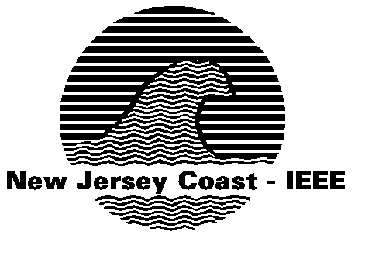

Department of Software Engineering at Monmouth University and
Signal Processing/Circuit and System Chapter of
The IEEE NJ Coast Section
Presents
Big Company to Small Company (and Back): How to Make a Successful Transition

Bill Gartner
Meriton Networks, Inc.
Email: bill.gartner@meriton.com

Abstract
The marketplace is hopping and so are engineers! The days of lifetime employment are long gone and engineering professionals need to be prepared to transition and get up to speed fast to function effectively in multiple types of environments - small companies and large, pre and post acquisition.
This session will address the job function in different and changing environments, focusing on differences between large and small company environments.
About the Speaker
Bill Gartner became Chief Operating Officer for Meriton Networks in October 2005. Previously Bill was president and COO for Mahi Networks and Photuris before that. Prior to Photuris, he was VP and GM of Optical Networking Systems at Lucent Technologies, where he led the access, metro and long-haul DWDM product suite. In this role, he was responsible for generating over $1B in revenue, while managing 500 R&D resources in five locations. His earlier tenure in the telecommunications industry includes roles at AT&T Paradyne and Bell Labs. Mr. Gartner received a bachelor's degree in electrical engineering from Georgia Tech, a master's degree in electrical engineering from Cornell University, and an executive master's in management of technology from the University of Pennsylvania. He is a University of Pennsylvania Moore Fellow in the Management of Technology and holds three patents.
Date: Monday, September 25, 2006

Dinner: 6:00 PM

Presentation: 6:45 PM
Location: Magill Commons Club Room 107, Monmouth University, West Long Branch, NJ 07764
RESERVATION: Make reservations at website http://ewh.ieee.org/r1/njcoast/
(Click on “REGISTER for Talk” link, refresh your browser, and fill the form.)
CONTACT: Jiacun Wang 732-571-4449 (jwang@monmouth.edu)
George Miao 732-462-7447 (g.j.miao@ieee.org)
Terry Powers 732-571-7501 (tpowers@monmouth.edu )

