The Monmouth University
IEEE Student Chapter Software Engineering Speaker Series
Presents
Broadband Services for the Fiscally Challenged
with Dr. Charles N. Judice
Visiting Professor, Monmouth University

Wednesday, March 24 at 5:30pm for dinner and a talk at McGill Commons, on the Monmouth University campus, at the corner of Cedar and Norwood Avenues in West Long Branch, New Jersey.
Open to the public at no cost.

To register please call or send e-mail to Trish Lamarca, 732-571-7501, plamarca@monmouth.edu.

Abstract

In the mid 1980s communication labs around the world were working on the enabling digital technologies such as MPEG, DSL, ATM, PCS, and multiple generations of wireless communications. Many of those researchers, including our speaker, were concerned about the growing disparity between the digital haves and the have-nots, or what has become known as the “digital divide”. In the recently passed Economic Recovery Act, $4.7 billion was earmarked for the National Telecommunications and Information Administration (NTIA) to even the playing field for the underserved and the unserved. This grant program, called the Broadband Technology Opportunity Program (BTOP), is now in its first phase of awarding grants. The speaker has submitted a proposal to BTOP on the topic: “Broadband Training and Usability Institute”. This presentation will have three parts. First he will review the “glory days of MPEG,” with a firsthand account of how many of these enabling technologies were created, socialized, and eventually adopted. Then he will review three particularly exciting approaches to delivering broadband applications in a useful, usable, and affordable manner. Finally Dr. Judice will discuss his BTOP proposal and its status.

About Dr. Charles Judice
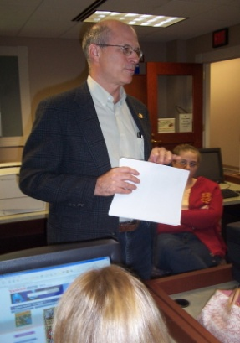
Dr. Judice has had two successful careers, the first at Bell Laboratories/Bellcore, where he was Executive Director of Image and Speech Research and the second at Eastman Kodak, where he was a Kodak Fellow and Director of Networked Imaging Research. He has taught computer literacy at Flagler College, directed graduate students at Rutgers University and taught Multimedia Communications at Monmouth University where, with a grant from Eastman Kodak, he set up a Digital Story Telling Laboratory and where he is still a Visiting Professor in the Computer Science and Software Engineering Department. He started a third career in 2008 when he founded Elaze Digerati, LLC, a small consulting company. Throughout his careers he has been heavily involved with basic developments in the area of telecommunications. He is the co-inventor of the Digital Subscriber Line (DSL), a family of technologies that provides digital data transmission over the wires of a local telephone network. He has also been involved with a variety of video display technologies, including video-on-demand, MPEG standards and packet video.

