Trip report – IEEE Consumer Electronics Society - SRM Institute - Student Branch Inauguration – Apr 2, 2018

On the 2nd of April, the IEEE Student Branch, SRM Institute of Technology, Chennai had one of its most awaited events. This day marked the beginning of its two milestones, launch of the IEEE Consumer Electronics Society, SRM and the Workshop Marathon’18. With good support from IEEE, Consumer Electronics Society Bangalore section and IEEE CE Headquarters, and the faculty at SRM Institute, the launch event was well coordinated, and various departments from the institute were part of the sessions.
The inauguration ceremony started at 0900 hrs. The event was chaired by Mr. Prabindh Sundareson, founder chairman IEEE Consumer Electronics Society, Bangalore (Chief guest), Dr. K. Vijayakumar, Head of Department, Department of EEE, SRM University (Guest of Honour) and Dr. Vivek Maik, Faculty Advisor, IEEE Consumer Electronics Society, SRM. Around 100 students from various departments attended the event.
The event started with the introduction of the chairpersons of IEEE Student Branch, WIE, AG and CE society, SRM. This was followed by highlighting the purpose and importance of the Consumer Electronics Society and the role played by IEEE in the growth of an Engineer – from a student to a career professional, and the various opportunities provided by IEEE CE Society to participate in standardisation activities. After the felicitation ceremony, the inauguration of CE society was done.
The presentation is archived at,
https://www.slideshare.net/prabindh/ieee-consumer-electronics-society-presentation-2018
After the launch of the CE Society, an in-depth guest lecture was delivered by Mr. Prabindh Sundareson on Machine Learning. This provided a great platform to the young brains to increase their knowledge, and this was demonstrated by the active question and answer session at the end.
The workshop was completed by 1 PM. Post workshop discussions included coming up with a planned calendar of events containing IEEE activities every year.
We would like to especially thank Sudeendra Kaushik, Sharon Peng, and Stefan Mozar for their support.
- Report prepared by Dr Vivek Maik, SRM, and Prabindh Sundareson, IEEE CE Bangalore chapter
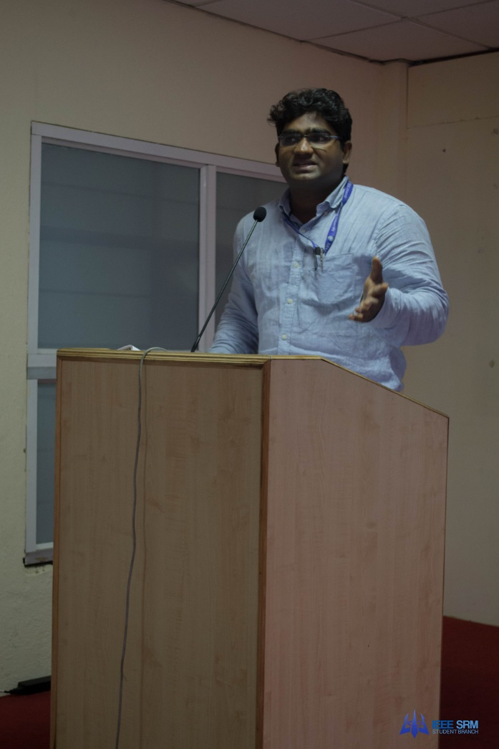
Figure 1 Prof Vijay introducing the event
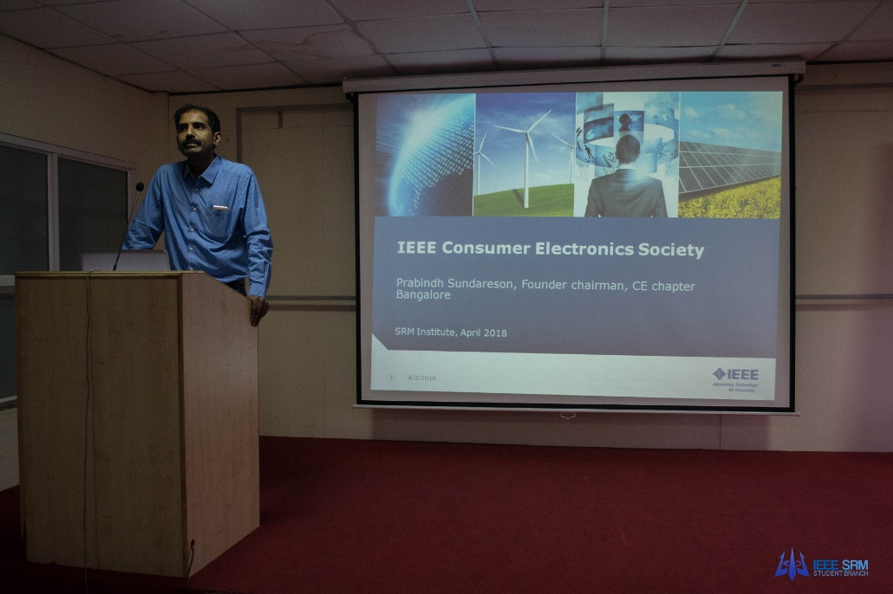
Figure 2Prabindh Sundareson delivering the guest lecture
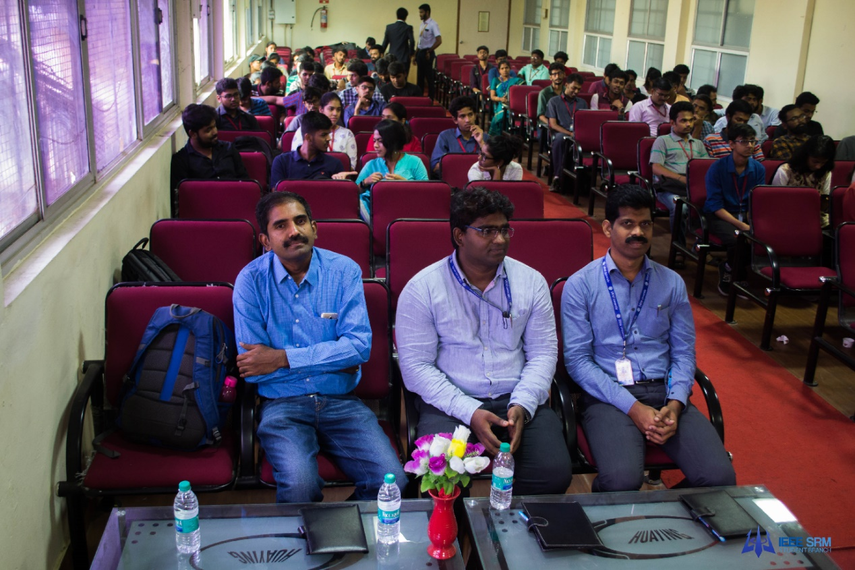
More pictures at,
https://www.flickr.com/photos/prabindh/albums/72157694874439614

