Report of Innovation Workshop iQ 2013
July 20, 2013, Bangalore – Conducted by Sudeendra Koushik

Report by Harsha G

The highly acclaimed seccond edition of one day workshop on Innovation was held at the Royal Orchid Hotel, Manipal Center, Bangalore on 20th of July, under IEEE Consumer Electronics Chapter. Sudeendra Koushik , Chairman of the Chapter conducted the workshop . The workshop was attended by professionals representing diverse sectors, including a repeat participant from last year’s workshop.
The workshop focused on the individual skills and habits of innovation. The skills and habits were explained with real life examples to drill down the points. Further parts concentrated on how it fits into organization expectations of being innovative which included both kinds of career for a student – entrepreneur or intrapreneur.
Next the tools and techniques were covered and how the multiple intelligence models helps understand an individual’s abilities and tendencies. Several assessments and tests to evaluate an individual’s understanding and abilities, were also conducted. Finally an exercise to ensure a complete innovation process was carried out and was well received by all the 20 participants.
The session started and 9.30 in the morning and went till 5.15 in the evening, with adequate breaks in between for Tea , Light Refereshments and an hour break in the noon for Lunch, which was also arranged at the venue. Introduction was done by Kousik Sankar and Prajit Nair briefed the audience about the activities of the IEEE CE Chapter.
Participation was from companies like Continental, Rockwell Automation, Schneider, Cadence, Continental, Samsung, Maxim, Dell and also educationist and entrepreneur. One of the participants, a practicing Patent Attorney who also brought some interesting dimensions from the world of Patent Filing Process and IP Rights protections, which was a very good input to the workshop.
Written feedback was collected from all the participants. The feedback was positive and encouraging . Distribution of Participation Certificates with their name printed on it , Receipts and Coffee Mugs, as a memoir were co-ordinated by Kousik Sankar and Harsha at the end of the workshop. The workshop was possible with the able support of Kousik Sankar, Prajit Nair, Arun Naik and Harsha.
The venue was at Maple Wood, Royal Orchid Hotel, Manipal Center in the heart of city.
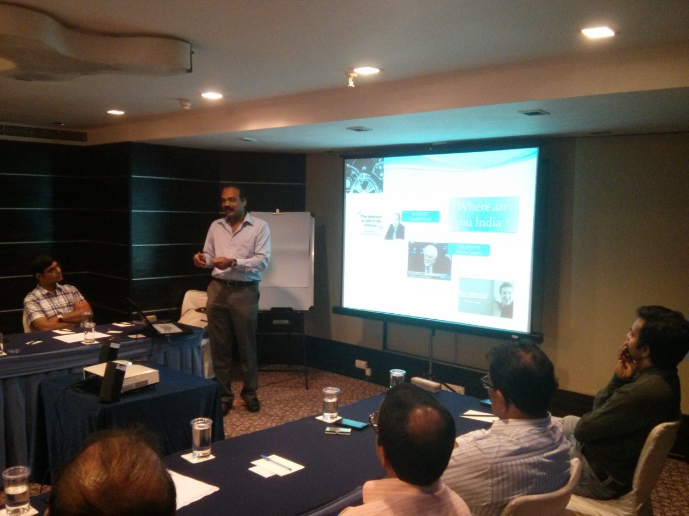
Sudeendra Koushik(Trainer)
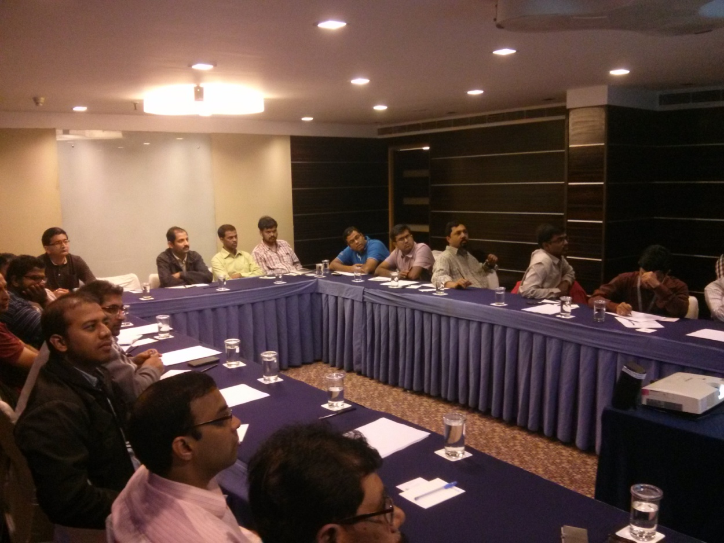
Workshop participants
A formal , professional feedback form was used to collect the feedback from the participants on the content, trainer and venue.

The key for the feedback is below:
Strongly Agree | Agree | Neutral | Disagree | Strongly Disagree
Excellent | Good | Average | Poor | Unsatisfactory
5 | 4 | 3 | 2 | 1

The summary of the feedback from participants is below:
- Trainer: 4.57 out of 5
- Content: 4.42 out of 5
- Venue: 4.37 out of 5

Harsha G
IEEE CE Chapter , Bangalore
August 2, 2013

