2013 Distinguished Lecture by Joe Decuir
The IEEE Consumer Electronics Society, in cooperation with DESE, IISc, conducted the first 2013 IEEE CE Distinguished Lecture, by Joe Decuir, Vice Chair, Bluetooth Architectural Review Board, and Standards Architect, CSR, on March 21st, 2013.

The title of the lecture was "Smart connectivity in consumer devices: Bluetooth 4.0 Low Energy Standard and Its Applications". This was conducted at the Department of Electronic Systems Engineering (DESE) Auditorium, Indian Institute of Science, Bangalore.

The Distinguished Lecture was attended by more than 80 registrants, from students, to working professionals in Bangalore. Companies from Broadcom, Cypress Semiconductors, Texas Instruments, Ingersoll Rand, and students and faculty from IISc, and from Zero Energy Labs, were among the attendees.

The welcome address and agenda was introduced by Prabindh Sundareson, founder chairman, IEEE CE society. Dr. Prabhakar T.V, from Zero Energy Labs, introduced Joe Decuir, the speaker and Distinguished Lecturer. A key highlight of the day was the demonstration of BT-LE + dongle pair, that showed distance from the dongle on the screen as it was moved away.

A summary of the talk – “Bluetooth has been reinvented! Bluetooth 4.0, also known as “Bluetooth Smart”, will enable many new applications that require a radio that is simple, secure and everywhere. Simple: much less so than traditional Bluetooth or Zigbee. Secure: AES-128 encryption. Everywhere: the current estimate is that 370 million smart phones were sold “Smart Ready” in 2012. In this interactive lecture, details of the new standard, and applications in low energy consuming smart devices will be discussed”.

There were number of queries from the audience, ranging from handling multiple radios, to smart capabilities, and roadmaps. Post the lecture, Joe Decuir interacted with the audience for further discussions about IEEE activities, and Bluetooth standards.

The IEEE CE Society Bangalore chapter would like to thank the IEEE CE Adcom, specially Dr. Robin Bradbeer, for arranging this lecture, and to CSR Bangalore for the coordination, and DESE for the venue arrangements.
- Prabindh Sundareson, on behalf of the IEEE CE Society, Bangalore chapter, 2013

http://ewh.ieee.org/r10/bangalore/ces/ieeece_dl_2013_joe.html

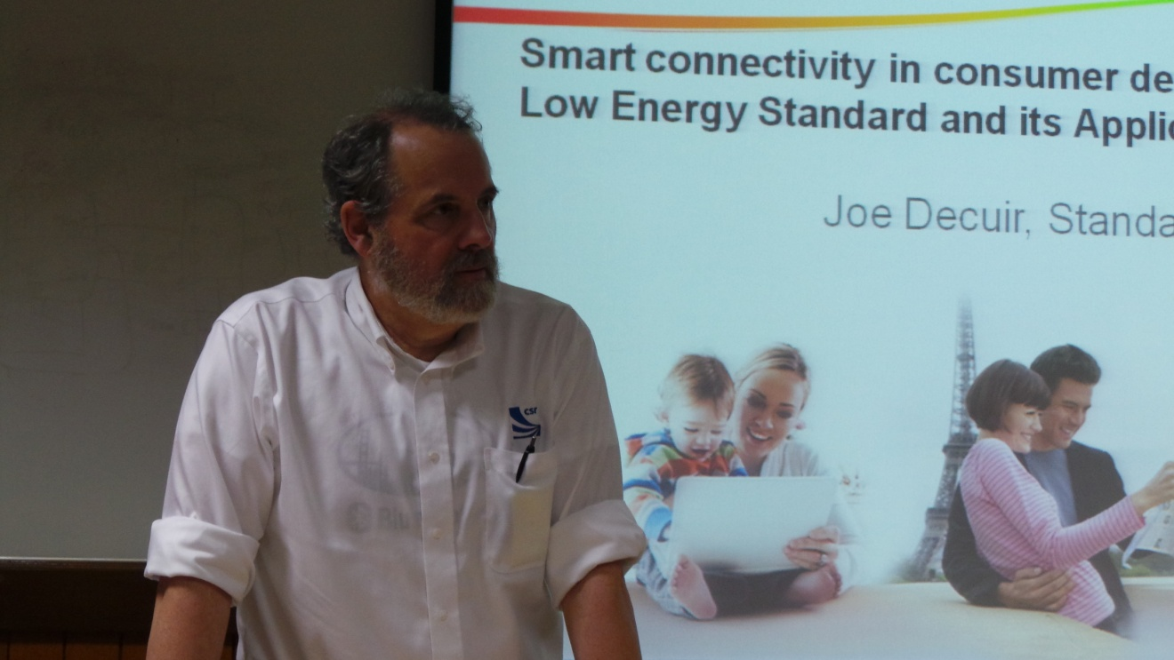

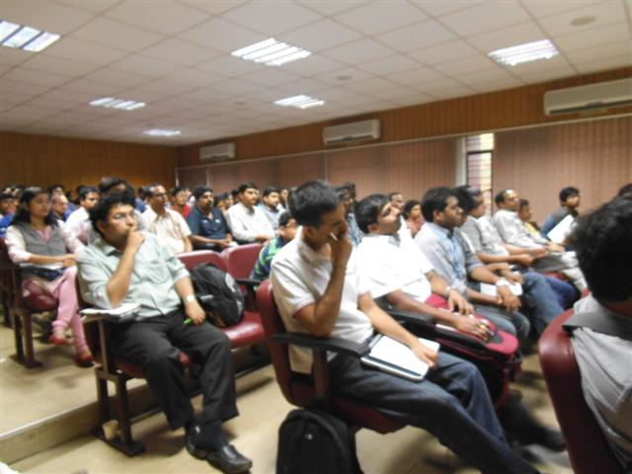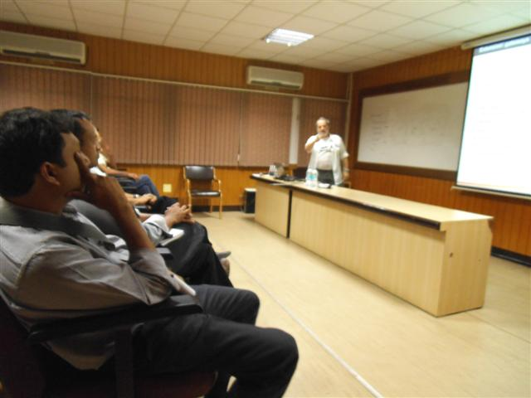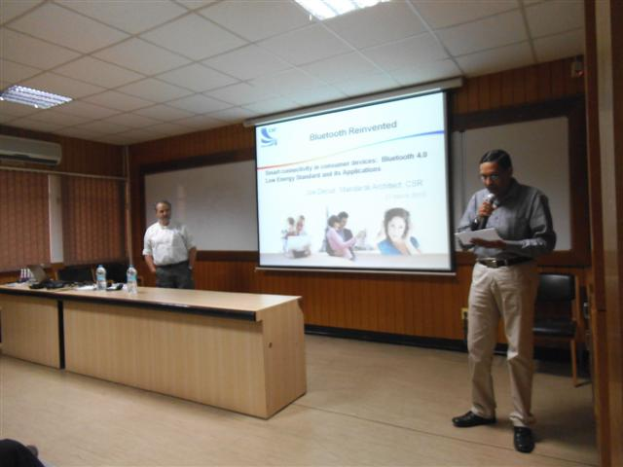

More high resolution pictures are available at,

http://www.flickr.com/photos/71344617@N02/

