R10 Medium Section of the Month – Western Australia Section
Prepared by: Dr. Amit Kunwar, Newsletter Editor, IEEE Western Australia Section
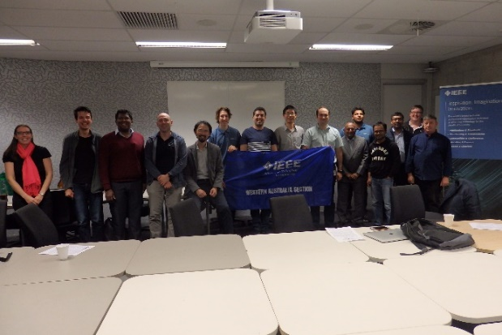
IEEE Western Australia Section was established on 24th May 1984, and presently, there are 535 members associated with the section. Since its establishment, this section has been serving the needs of all IEEE members in Western Australia. This section has several sub-units formed under its umbrella, which includes 10 specialist section chapters, 2 affinity groups and 4 student branches. These chapters include Circuits and Systems; Communications; Computational Intelligence; Computer; Joint Electron Devices/ Solid-State Circuits/ Photonics; Industrial Electronics; Joint Power and Energy/ Power Electronics; Signal Processing; Society on Social Implications of Technology (SSIT) – National Chapter; and Systems, Man, and Cybernetics. The affinity groups include Young Professionals and Women in Engineering. Likewise, the student branches within the section are Curtin University, Edith Cowan University (ECU), Murdoch University, and University of Western Australia (UWA).
This section has an ongoing program of social and technical activities for its members through seminars, conferences and workshops. Additionally, the activities for student members are also a regular feature of the section annual program. This section meets approximately every 6 weeks for face-to-face meetings to discuss activities, plans and achievements within the section and its sub-units. However, due to the current Covid-19 situation, the last section meeting in May 2020 was conducted successfully as an online meeting with full participation from its committee members.
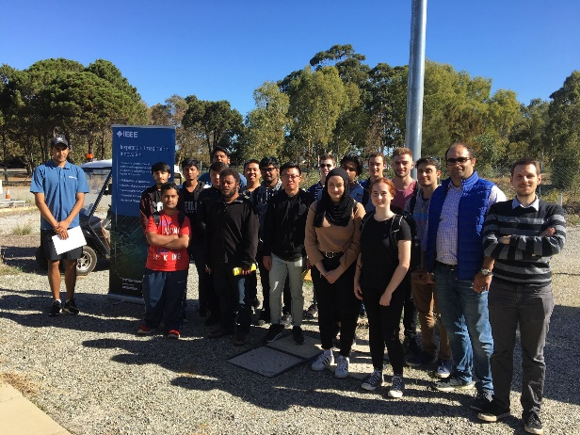
The key focus areas of this section are to increase membership within the section and to encourage members to take advantages of the social and technical activities. The section is preparing a member development plan and individual membership benefits (member support plans) for membership development. Additionally, the section aims to improve the support networks and funding opportunities for its student branches.
In order to recognize the contribution of our volunteers, from 2019, the section has started IEEE WA section outstanding volunteer awards. Dr. Douglas Chai and Mr Chris Scherini received outstanding volunteer award and outstanding student volunteer award respectively for their invaluable contribution to the section. Likewise, the section annually provides outstanding student prizes to the electrical engineering students in Curtin University, Murdoch University and Edith Cowan University based on their academic achievements.
Some of the key IEEE WA section seminars were:
1. Title: Sensing and Signal Processing Based on Microwave Photonics, Presenter: Dr Linh Nguyen, Date: 17th January 2020.
2. Title: The Future Aerospace Transportation System, Presenter: Dr Graham Wild, RMIT University, Date: 13th December 2019.
3. Title: On the Observer Design with Application to Battery State of Charge Estimation, Presenter: Mohamed Darouach, Date: 9th December 2019.
4. Title: Self-adaptive Biologically Inspired Signal Processing for Salience Enhancement, Presenter: Dr Russell SA Brinkworth, Date: 5th December 2019.

This section regularly posts and updates its key events and activities on the section web page. More information can be accessed through the link: https://ewh.ieee.org/r10/w_australia/.

