IEEE Western Australia Section
IEEE WA Section Report March 2021
Muhammad Adnan Hayat, Newsletter Editor for IEEE WA Section
- Event: IEEE Western Australia Training Workshop
This training workshop was particularly essential to provide new committee members with the information they need to have more focused effort for the forthcoming year to achieve the Section’s mission and objectives. This virtual training was organised on Saturday morning 6th February 2021 and was organised by IEEE WA Section and total of 25 Participants attended the training. This was the first time such much needed training was organised by WA Section. 2021 Chair of IEEE WA Section, Associate Professor Farhad Shahnia conducted the workshop. The event attracted widespread audience from variety of industry, academic groups. The Chair provided training to the new committee members and general audience on the history of IEEE to attract more interest on the activities of IEEE from the audience, IEEE Strategic Plan for 2020-2025 was shared with the attendees so that the section efforts align with the mission and vision of IEEE. To further intrigue the attendees interesting details, such as history of IEEE logo was shared with the attendees. Structure of Section and role and responsibilities of committee members and what is expected of them was also outlined. Attendees were briefed on following areas:
- details of members classification and membership numbers.
- activities and structure of Technical Activities Board (TAB)
- Member and Geographic Activities (MGA) and where IEEE WA section sits.
- existing technical chapters, affinity groups and student branches within IEEE WA Section
- procedure around the formation of new chapter, affinity groups and student branches.
- reporting requirements and minimum activities requirement for the organisational units.
- objective of IEEE WA Section and how these objectives will be achieved through technical activities and social events.
- Membership development campaigns.
- Financial aspects of chapter around rebates, expenses, section finances, cash flow.
- IEEE’s online reporting Vtools, e-notices and voting.
- planning, execution and decision-making aspects of section meetings.
This training workshop was very comprehensive and beneficial for the new committee members and general audiences and attracted a positive feedback from the attendees.
- Event: IEEE Western Australia Planning Workshop
This Section meeting was targeted on discussing the section plans for the forthcoming year and sought approval from committee members on such plans. This event was held on Saturday 20th February 2021 at Murdoch University and was attended by 14 Committee members. The Chair highlighted the Section activities for the year 2020 and briefed on the 2021 committee and the role of its members. The Chair sought approval of activities for the year 2021. These activities include Section meetings, Mid-year networking dinner, Section conference, Student Educational Workshop, IEEE Day Networking event, Family Day BBQ and Annual General Meeting. The timeline for the Student Competition, Section Volunteer Award and other committee awards were also discussed and finalised. Finally, the amendments to the IEEE Western Australia Section Bylaws were explained and approved to start the amendment process.

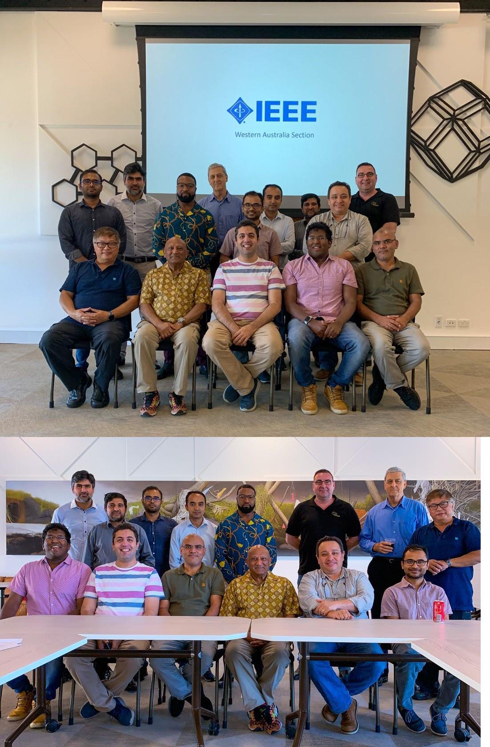
Photo: WA Section committee members at the Section Planning workshop.

