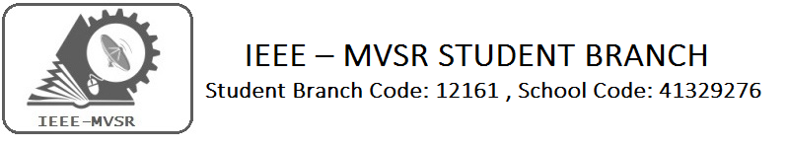
A Field Visit to Shadnagar/Shahbad - Public Education Campaign to reduce deaths due to Fatal Electrical Accidents
The first field visit to Shahbad mandal was organised by IEEE Hyderabad Section’s PES/IAS/PELS Chapter on 10 Jan 2016.The purpose was to get facts and first hand evidence for the condition of electrical supply and use in rural sector. Fatal accidents are increasing in the state as reported to state regulatory commission.Shahbad was chosen as it is just 50 kms from Hyderabad and some fatal accidents were seen in the official accident records.Due to lack of time the information collection could not be done adequately in the first field visit.So a second visit by a group of 15 members including students and faculty was made on 14 feb 2016 to shahbad.
Student Branch Mentor: WIE Student Branch Advisor:

Dr. Atul Negi, Mrs. Dr. G. Kanaka Durga,
Professor, School of CIS, Head, IT Department,
University of Hyderabad. MVSR Engineering College.

Student Branch Advisor: Student Branch Counselor:
Mr. V. Ashwini Kumar, Mrs. A.V.Vahini
Assoc. Professor, IT Dept., Asst. Professor, IT Dept.,
MVSR Engineering College. MVSR Engineering College.

PES Student Branch Advisor:
Mr. B.Sarveshwar Reddy,
Asst. Professor, EEE Dept.,
MVSR Engineering College

Student Branch Executive Committee:
E.Sanjana - Chairman
K.V.Sirisha - Vice Chairperson
G.K.Anirudh - Secretary
T.Anirudh - Joint Secretary
G.Vinay - Treasurer

PES Affinity Group:
V.B.Mounika - Chairman
Rahul Bhalla - Vice Chair
T.Sai Yashwanth - Secretary
B.Ujwala - Treasurer
WIE Affinity Group:
D.Sreeya reddy - Chairman
B.Jayasree - Vice Chair
B.Makarand - Secretary
P.Harshitha - Treasurer
Event details:

First Field Visit Details – At Shahbad Mandal

Date : 10 Jan 2016
Time : 10 am to 6 pm
Number of Attendees :

PES Student Members
1.Pranav - VBIT ,IEEE Student Representative
2.Harshavardhan - VBIT ,IEEE Student Representative
3.V.B.Mounika - MVSREC,IEEE PES Chairman
4.K.V.Sirisha - MVSREC ,IEEE Vice Chair

PES Hyderabad Section Members
1.C.Satish - Life SMIEEE, IEEE PES EX-Chairman
2.M.Srujana - IEEE PES Hyderabad Section Secretary
3.Mohd. Osman - IEEE Member
4.Akilan - IEEE Member
5.Rachappa - IEEE PES Hyderabad Section Treasurer

Second Field Visit Details – At Shahbad Mandal

Date : 14 feb 2016
Time : 10 am to 6pm
Number of Attendees :
List of Faculty Members:
1. Dr.D.Venu Madhava Chary - Head of Department[EEE]

2. B.Sarveshwar Reddy - AssistantProfessor[EEE], IEEE PES Faculty Advisor

3. D.Harikrishna – Assistant Professor [EEE]

List of IEEE PES ,EEE Student Members:

- V.B.Mounika - MVSR IEEE PES ,Chairman
- K.V.Sirisha - MVSR IEEE , Vicechair
- Rahul Bhalla - MVSR IEEE PES , Vicechair
- B.Ujwala - MVSR IEEE PES, Treasurer
- P.Ramya – IEEE PES Student Member, EEE 4/4
- Samhitha - IEEE PES Student Member,EEE 3/4
- 7.Supriya - IEEE PES Student Member,EEE 3/4
- Manoj - IEEE PES Student Member,EEE 3/4
- Divija - IEEE PES Student Member,EEE 3/4

Part : 1
Below are the findings and some possible / feasible solutions to reduce the fatalities. The group visited 4 sites in the village .
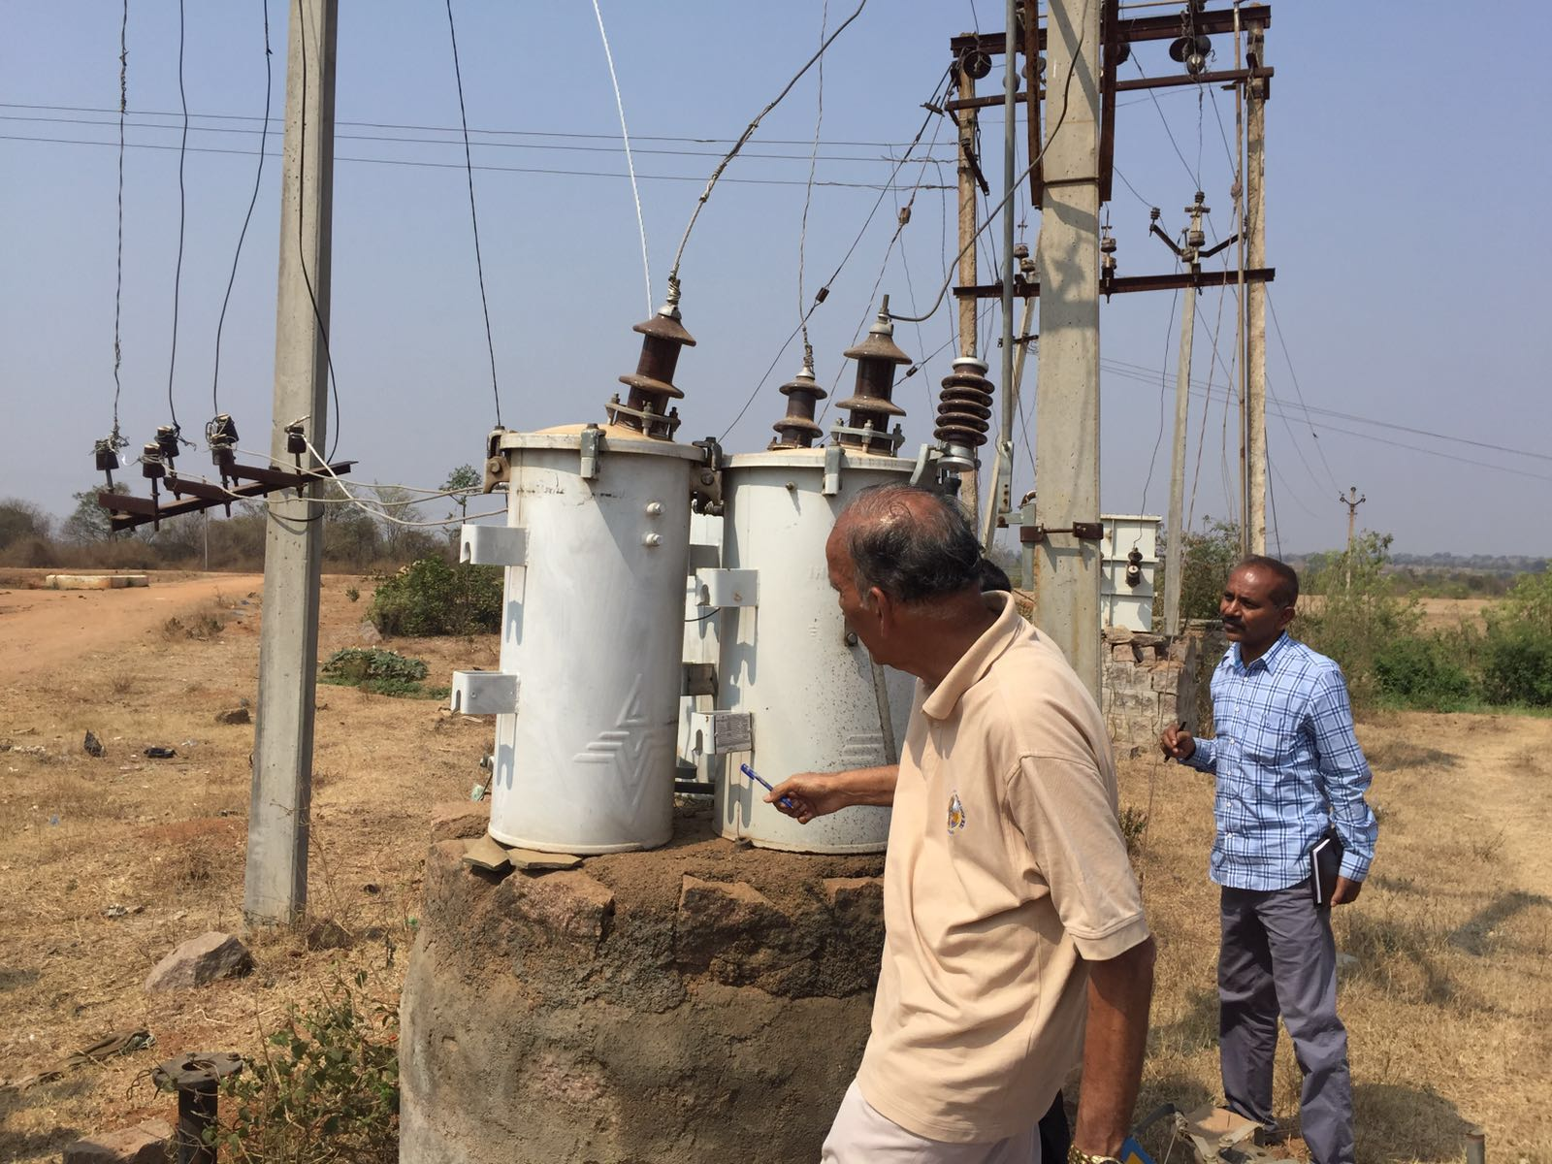
Two 25 KVAR SWER H V DTRs were studied. For HT winding, out of two terminals, one terminal (earth side one) insulating bushing is not there. The terminal with bushing is connected to one phase conductor of the 11 KV supply system. The other terminal of the transformer was earthed locally. The ohp supply system is 11 KV line to line,3 phase 3 wire- no neutral or ground wire. There was either no LA or it is not connected. There was no external AB Switch. The HT side, LT side and transformer tank earth are all interconnected.
In detail Explanation was delivered by Satish.C ,Ex- Chair of IEEE HYDERABAD PES Chapter,Beside Observations were taken by Rachappa ,IEEE PES HYDERABAD SECTION Treasurer.

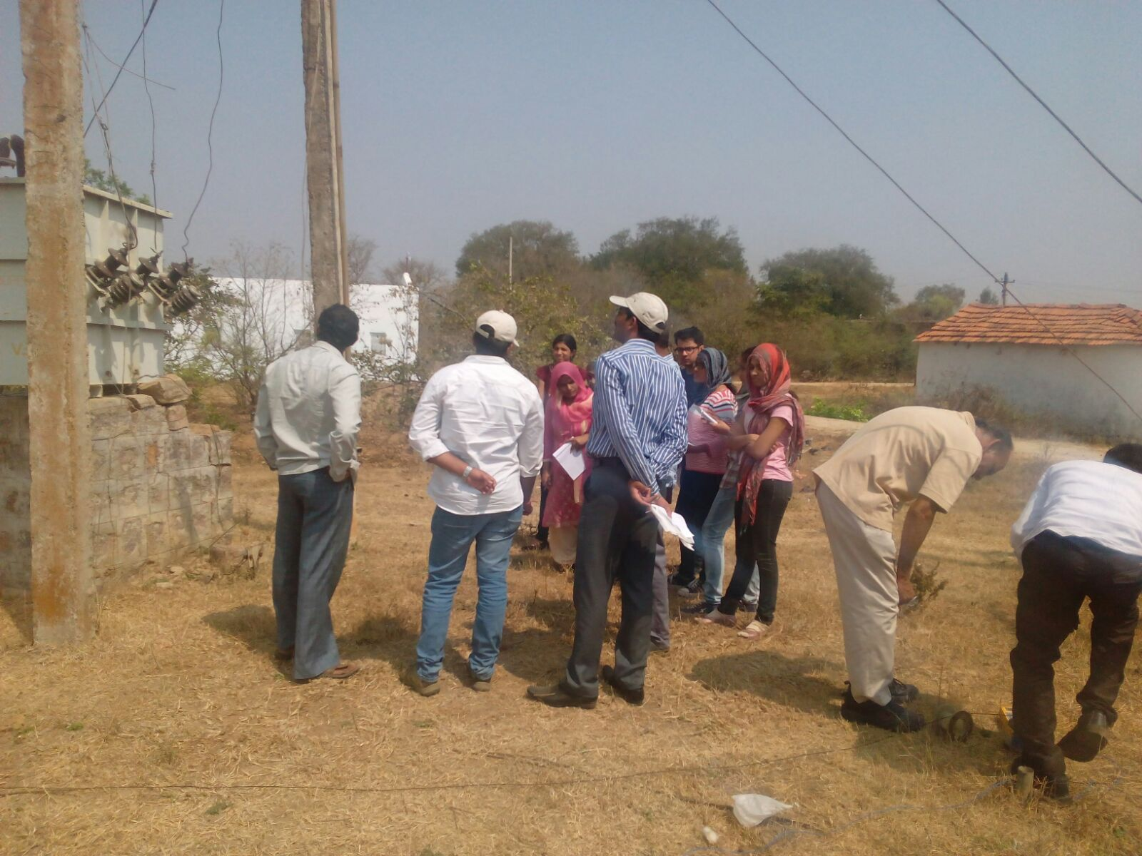

A picture of faculty and students involved in observing electrical measurements

We isolated LT side earth pit connection and tested two earth pit resistances with a meter and found it as 4.5 and 3.4 ohms.HT side earth electrode resistance could not be measured as it is unsafe to open HT voltage connection at this pit. We measured load current in earth conductor on HT side. It was 4 amps. Rated load current is 4 amps. So the potential gradient around HT earth pit is unlikely to be dangerous during normal running even if the HT earth resistance is 5 ohms.If there is a winding fault to frame, built-in h t fuse will blow. It is not possible to see its condition as it is inside the tank.
We inspected two consumer loads
In the first case – home load,no earth wire is provided by utility. Consumer does not have his own earth pit. So earth loop resistance measurement was not feasible.
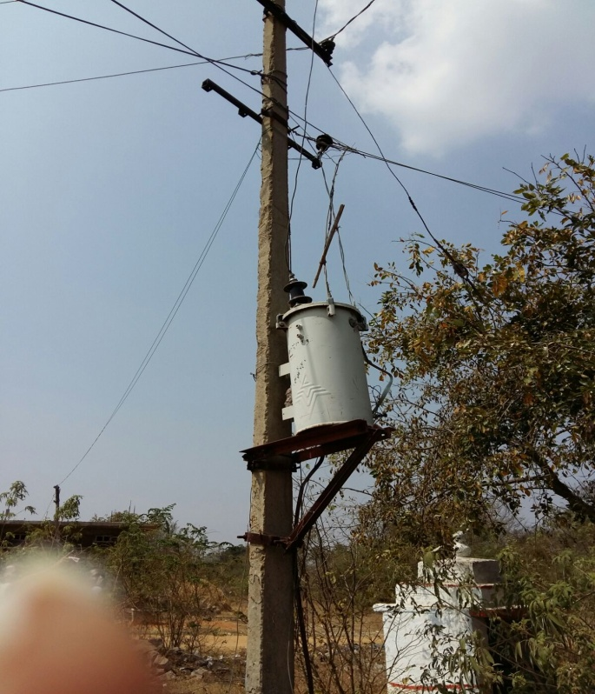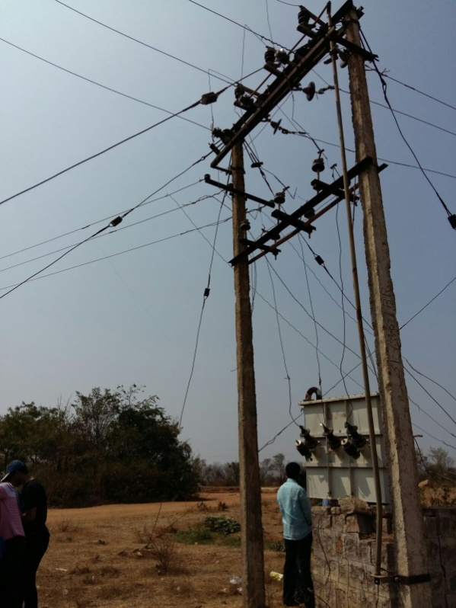
Pictures of Dangerous Connections of Power Supply through cables in absence with protective system.
The second case is a pump motor starter in the fields. Here too supplier runs LT 3 phase conductors only (no neutral wire) to prevent any non agricultural single phase load. Consumer’s motor as well as starter does not need neutral. Consumer’s motor starter is standard DOL contactor based unit with rewirablefuses. It has a switch in the control circuit which bypasses On Off buttons and pump starts as soon as power supply comes and stops as soon as power is cut by supplier. The consumer has neither earth electrode (TT system) and RCD norhas he a ground wire supplied by utility.
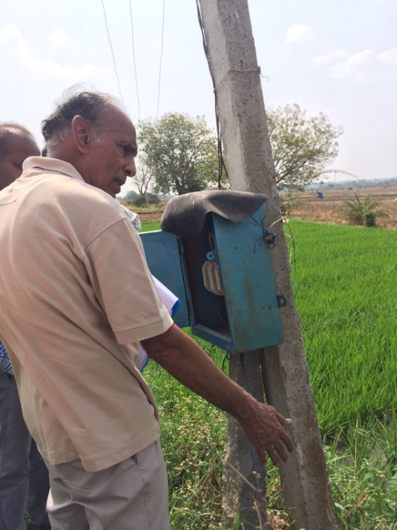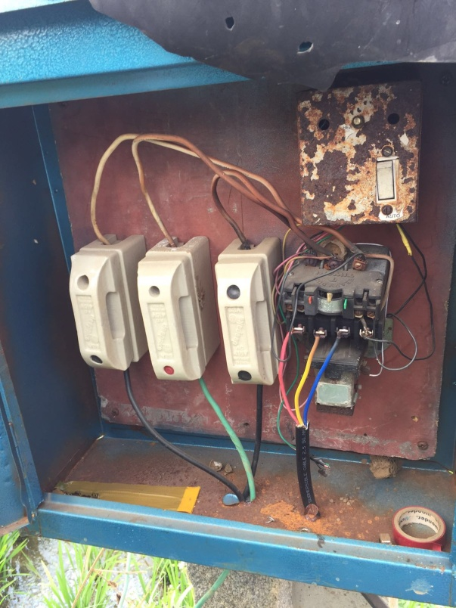
A clear view of pump motor starter which is in improper utilization,is being analysed by the IEEE Professionals.

Part II :
Fatal electrical accidents can be reduced if the following are taken care.
- Protection against Direct Contact
- Protection against Indirect contact
- Deenergising before touching
- Qualified / trained workers
- Periodical Auditing & Testing
- Public awareness
- Rewards and punishments
- Safety by R&D

Later we visited the 33 KV / 11KV Substation located in Shabad and the 33 / 11 KV transformer is delta / Wye only and outgoing 11 KV Overhead feeders were 3 phase, 3 wire (no neutral wire or ground wire).

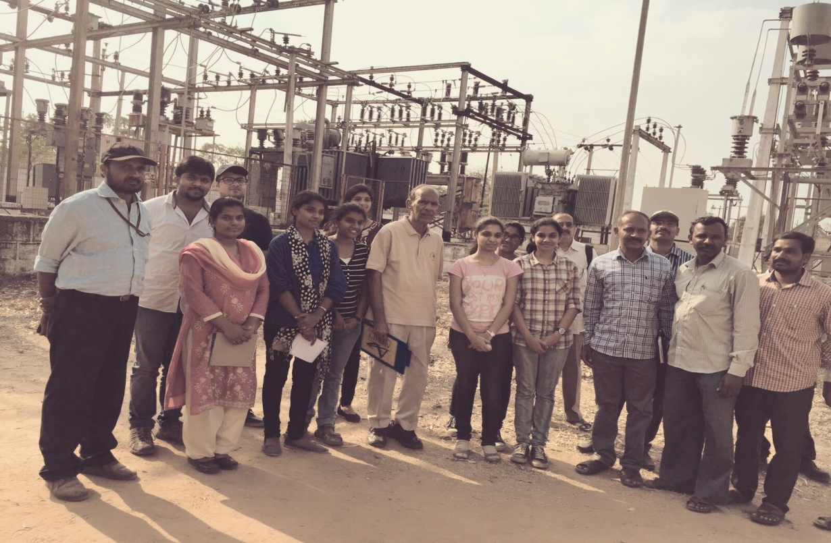
A group picture of the team involved in field visit at nearby substation

In the picture at right - From left to right:
Dr.Venu Madhava Chary, Head,EEE dept.,
Mr.B.Sarveshwar Reddy,Asst.professor,EEE Dept.,
C.Satish ,Life SMIEEE
Mr.D.Harikrishna, Asst.professor,EEE Dept.,
Along with MVSR IEEE Members and Substation Officers.

Reported by:
V.B .Mounika ,
Chairman, Power and Energy Society.
IEEE – SB, MVSREC.

