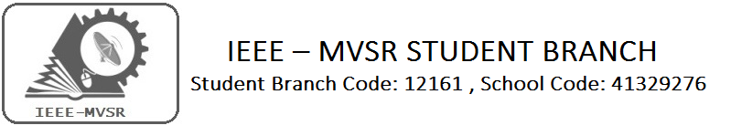

Technovanza 2016

Student Branch Mentor: Student Branch Advisor:
Dr.Atul Negi, Mr. V. Ashwini Kumar,
Professor, School of CIS, Assoc.Professor , IT Dept.,
University of Hyderabad. MVSR Engineering College.

Student Branch Counsellor: WIE Student Branch Advisor:
Dr.Anil Kumar Dr. G. Kanaka Durga,
Professor, ECE Dept., Head, IT Department,
MVSR Engineering College. MVSR Engineering College.

PES Student Branch Advisor:
Mr. B.Sarveshwar Reddy,
Asst. Professor, EEE Dept.,
MVSR Engineering College

Student Branch Executive Committee: WIE Affinity Group: G.K.Anirudh - Chairperson B.Jayasree-Chairperson
T.Yashwanth- Vice Chairperson Achsah - Vice chair
T.Anirudh – Secretary G.Srinidhi - Secretary
Bhanu Teja - Joint Secretary Hari Priya - Joint Secretary
Jagadeesh– Treasurer B.Aparna- Treasurer

Power and Energy society: Membership drive head:
Ujwala- Chairman Nikhil Varun Raj
Divija-Vice Chair
Anusha- Secretary
Alok- Joint Secretary
Manoj– Treasurer

On March 19, 2016, the IEEE MVSR Student Branch organized its very own fest, Technovanza. The fest was aimed at students from several different colleges to give everyone an opportunity to participate in a variety of activities, both technical and for fun.
Technovanza was initiated with a grand inauguration by the Principal of MVSR Engineering College, Dr. V Chandrasekhar. The college witnessed an impressive turnout of students who took part in a wide array of events, including competitions, paper presentations, project expos, gaming contests and much more.

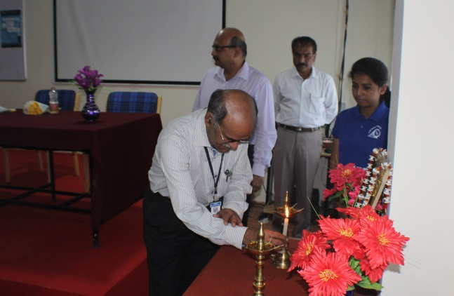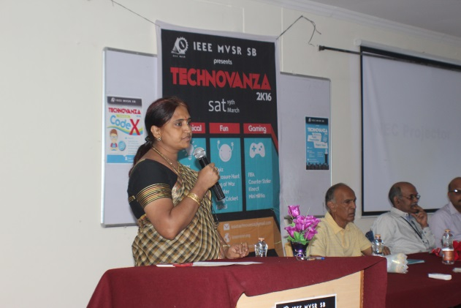

Technical Events

Project Expo
The Project Expo was conducted to encourage people to present their work on an interactive platform, where students were able to discuss their projects with each other and answer questions as well. Several projects related to different fields were displayed and demonstrated.

Paper Presentation
One of the main highlights of the fest was the Paper Presentation. A number of papers on varying topics related to science and technology were presented by students of different institutions. It was a valuable opportunity for students to learn and gain exposure to present trends and issues in the technology sector.

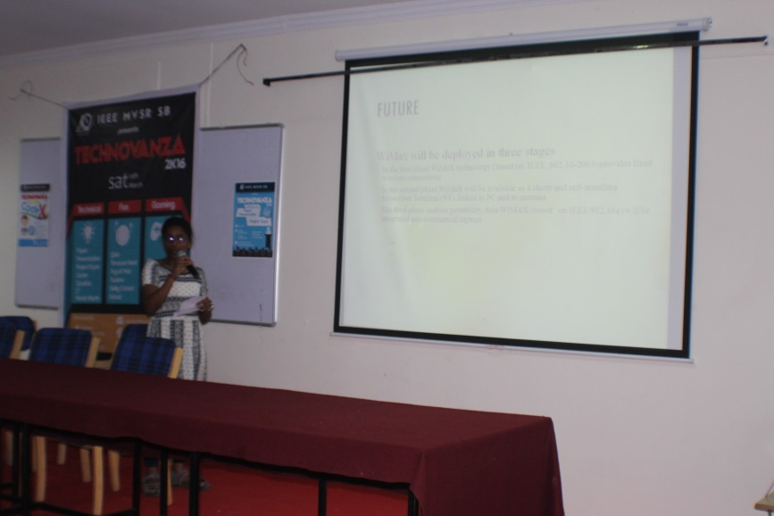

Codex
For the programming lovers, Codex was a coding contest held to allow programmers to compete with each other on numerous coding challenges. Prizes were distributed to the winners and a few of them were also provided with the opportunity to do an internship at Crowd Bytes.

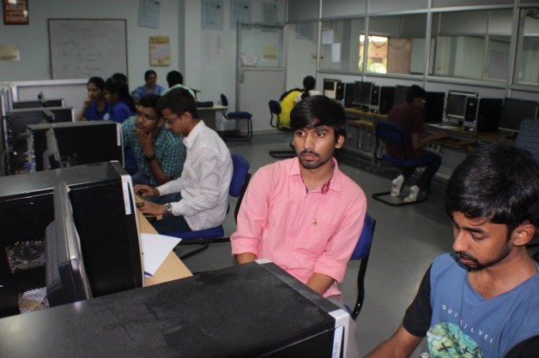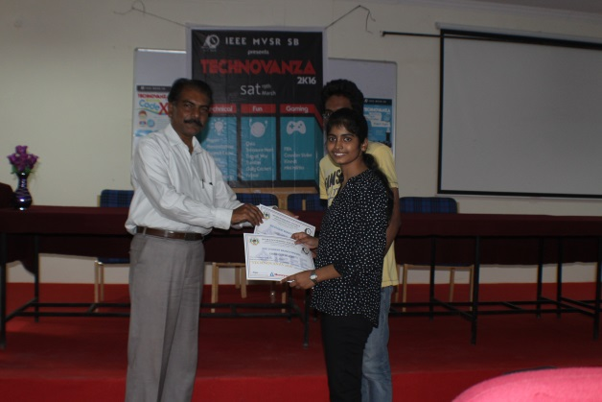

Circuitrix
Circuitrix was a competition aimed at testing participants’ abilities to solve problems based on circuits. A few rounds of varying difficulties were conducted and prizes were awarded to the winners.

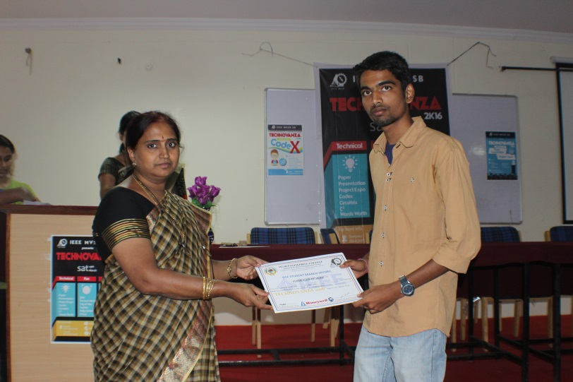

Wordsworth
Wordsworth was a creative game which challenged the students’ vocabulary skills, where participants were required to come up with as many words as possible, using the letters in a given word. They were motivated to come up with as many words as possible to win a prize.

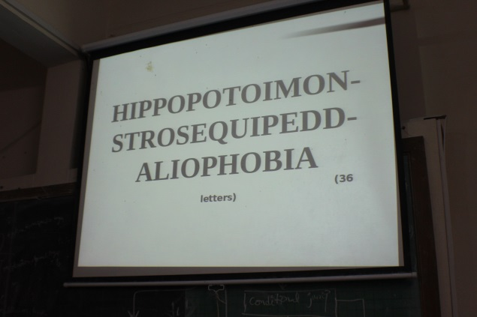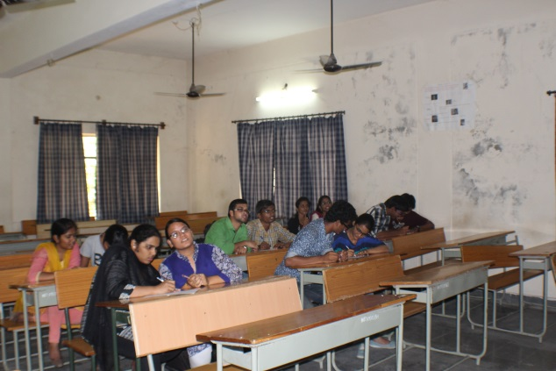

$$C^{2}$$
$C^{2}$ was an event which quizzed students on their knowledge of cinema. Based on random movie facts, students were made to answer different questions in order to win.

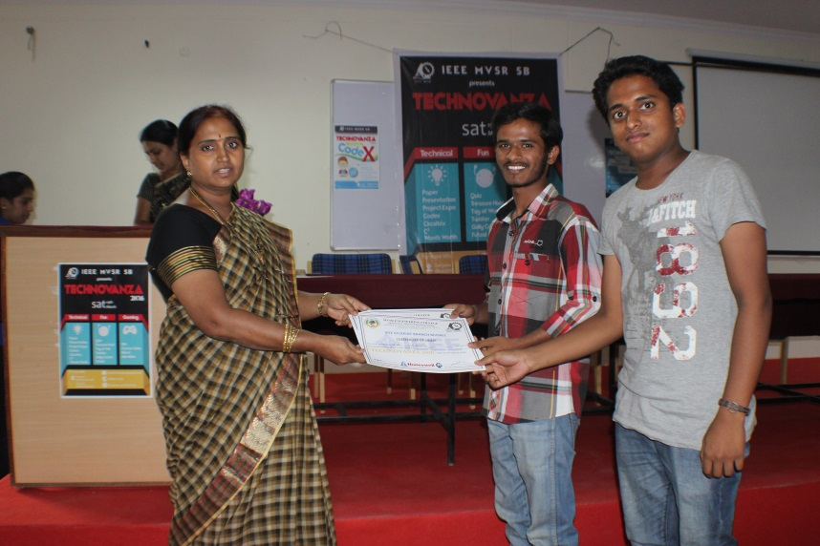

Gaming Events

Technovanza organized several many gaming events and challenges targeted at all the gamers who were willing to put their skills to the test. These included FIFA, Counter Strike, Kinect and Mini Militia. Many rounds were conducted to choose the winners who received awards for their performance.

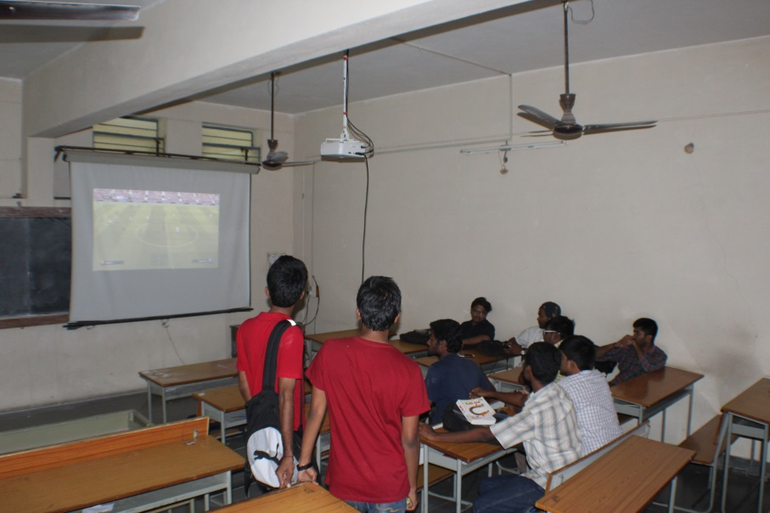

Fun Events

Quiz
The quiz competition questioned students on their general knowledge skills and those who answered the best were rewarded. The participants were tested on their knowledge in a large number of general topics.

Treasure Hunt
The treasure hunt took place on the entire college campus and was a fun event for students to form teams and use their analytical skills. Participants were required to search for various items based on the clues they found along the way.

Twister
A game of physical skill, Twister was a fun event conducted so students could try and win prizes depending on their performance.

Gully Cricket
For all the cricket fans, Gully Cricket was an event which allowed students to divide into games to play their favorite sport, cricket, within a confined area or gully.

Futsal
A variation of football, Futsal required two teams consisting of five members each to play football on a smaller pitch. The winning teams were given prizes.

Tug of War
This was a fun event which involved students to form two teams to play the classic game of Tug of War. The winners were rewarded cash prizes.

