GENERAL BODY MEETING

The General Body Meeting of the IEEE MVSR Student Branch took place virtually on October 18th, 2023. The meeting had several key objectives, including emphasizing the importance of report writing, raising awareness about IEEE Awards, increasing participation in IEEE Xtreme 17.0, and discussing upcoming events. 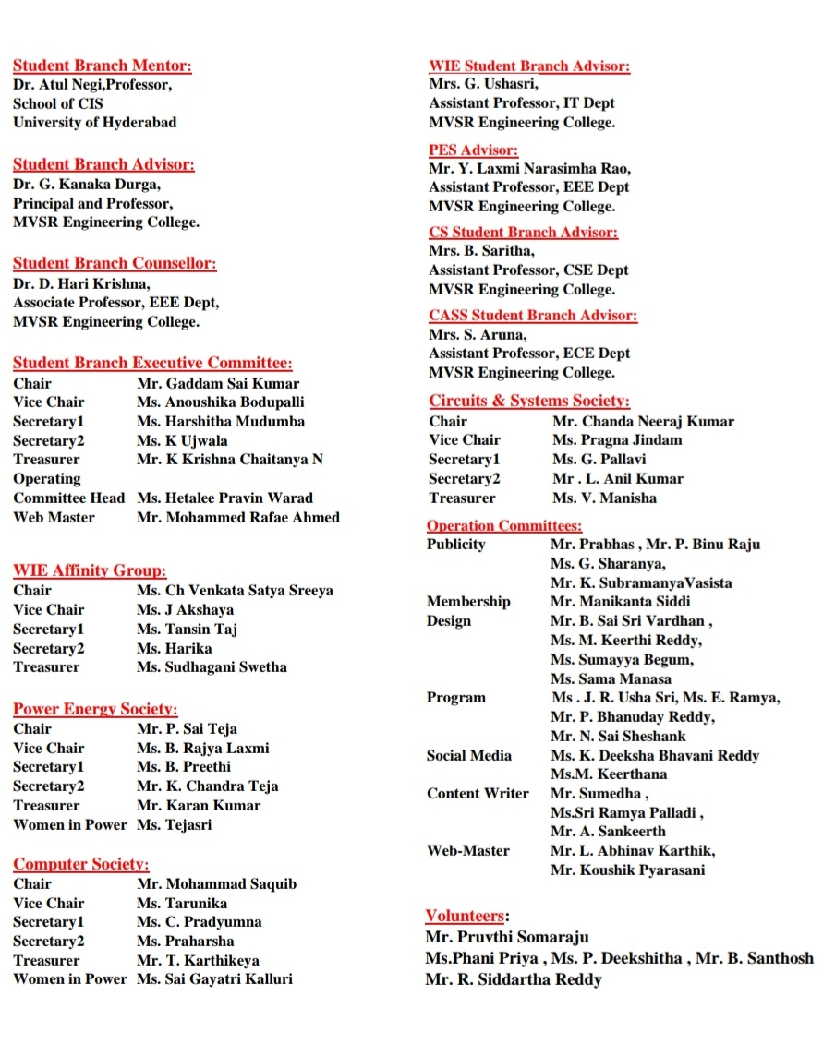
Session Details:

Date: 18th October 2023
Timings: 10:00 am to 11:30 am Number of Participants: 45
Mr. G. Sai Kumar, Chairperson of IEEE MVSR SB, began the session by warmly welcoming Dr. D Hari Krishna, the IEEE MVSR Student Branch Counselor. Subsequently, he proceeded to outline the various activities within the Section focusing on the responsibility of monitoring the society's operations, ensuring timely event reporting and enhancing the quality of events.

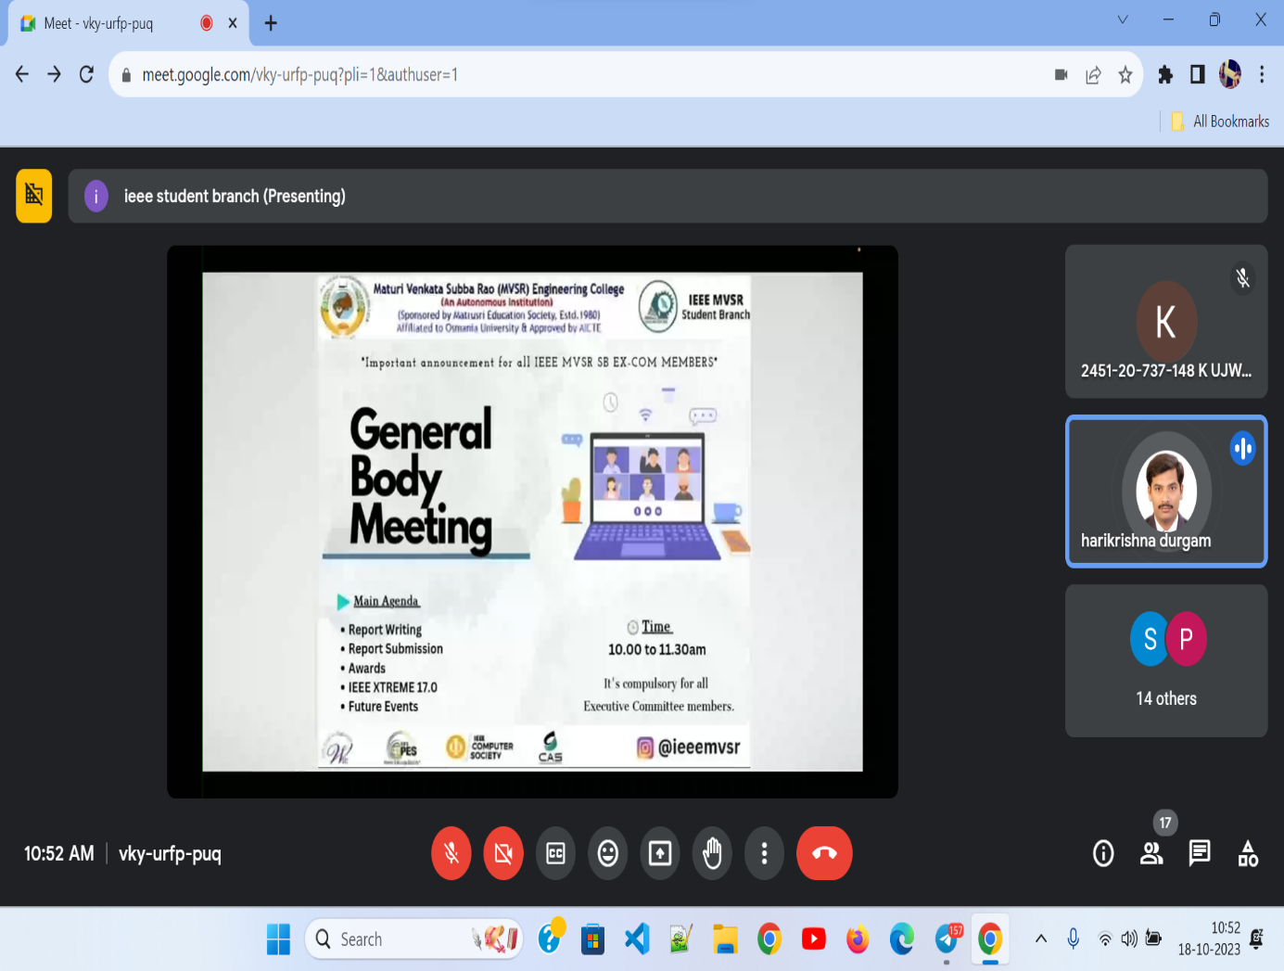
Mr Sai Kumar welcomes Dr D Hari Krishna

Dr. D. Hari Krishna highlighted the importance of reports and their content by specifying the format to be followed. He emphasized the need for secretaries to draft an error-free report within a timeframe of 2-3 days from the event’s conclusion. These final reports are to be published on vTools and the college’s website, data.mvsrec after getting verified by the Student Branch Counsellor.

He provided insights into the various IEEE Awards available to a wide range of IEEE students including Ricard E. Merwin, upsilon pi epsilon and numerous Student Branch and Volunteer awards. Furthermore, he extended his congratulations to Ms. B. Anoushika, Vice Chairperson of IEEE MVSR SB, for her outstanding achievement in winning the REM award.

He highlighted the significance of the IEEE Xtreme 17.0, global coding contest and shed light on the impact and benefits of participating in the competition, which encouraged members to take part. To inspire and motivate the attendees, he also shared past participation statistics.

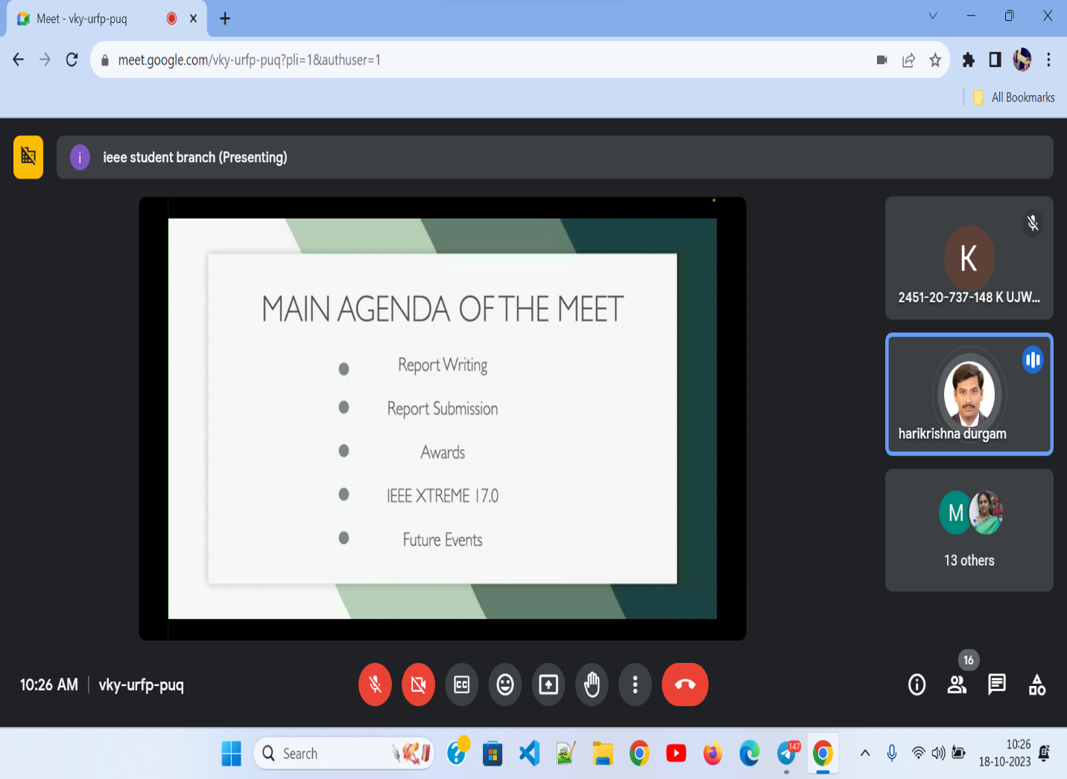
Dr D Hari Krishna briefing about the session

Later, all the Student Chapter chairs provided an overview of their planned events for the upcoming IEEE events.
Here are the events and activities that the respective Chapter chairs have proposed:

Computer Society Student Chapter
- Webinar on Generative Artificial Intelligence
- Teaching technology at a school or orphanage
- Donation Drive

Women In Engineering Affinity Group
- Workshops on UI/UX and Neural Networks
- Resume and LinkedIn Profile Building Session
- Data Science Seminar
- Seminar on Business Analytics and Entrepreneurship
- Winter Cloth Distribution Drive (In Collaboration with MVSR Street Cause)

Power Energy Society Student Chapter
- BEE quiz in collaboration with WIE Affinity Group.
- Organizing a technical webinar
- Article Writing

Circuits And System Society Student Chapter
- Collaboration with PES for an E-waste drive
- Webinar on Career Opportunities in the ECE domain
- Webinar on Embedded Systems by CDAC Company
- Value Added Course on VLSI Design

Upon getting ideas about all the upcoming events and workshops scheduled for the following term, the IEEE MVSR Student Branch Counselor and Student Chapter Advisors shared their thoughts and offered suggestions regarding the same.

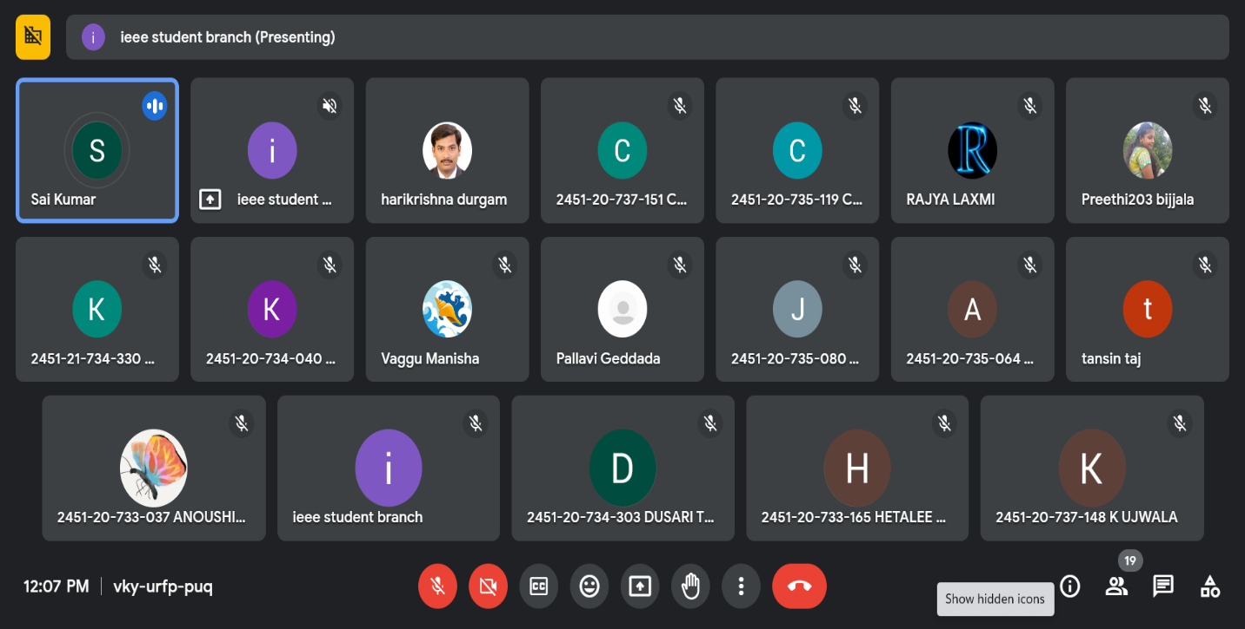ExCom members discussing future events

The meeting concluded with a vote of thanks delivered by Mr. Sai Kumar, Chair of the IEEE MVSR Student Branch.

List of Attendees:
S.no | Name of the Participant | Roll Number | IEEE ID
 | Dr. D. HariKrishna | Faculty | 90436180
 | Chanda Neeraj Kumar | 2451-20-735-119 | 98194538
 | G. Pallavi | 2451-21-735-102 | 99295467
 | Pragna Jindam | 2451-20-735-080 | 98194494
 | Arigala Sankeerth | 2451-20-734-055 | 99456401
 | Sumedha | 2451-22-734-031 | 99494585
 | V Manisha | 2451-20-735-309 | 98197389
 | Chacham Pradyumna | 2451-21-733-066 | 99228779
 | D Mohammad Saquib | 2451-20-733-132 | 97496648
 | Puram SaiTeja | 2451-20-734-316 | 98610543
 | Gaddam Sai Kumar | 2451-20-735-069 | 98196838
 | K Ujwala | 2451-20-737-148 | 97508428
 | Harshitha Mudumba | 2451-20-735-063 | 98194561
 | Krishna Chaitanya N | 2421-20-734-052 | 97520855
 | Anoushika Boddupalli | 2451-20-733-037 | 98196593
 | N.Sai Shashank | 2451-20-734-311 | 98935065
 | Manikanta Siddi | 2451-21-735-007 | 99454271
 | Hetalee Pravin Warad | 2451-20-733-165 | 97520755
 | J Ramesh Usha Sri | 2451-20-735-092 | 98196240
 | L Abhinav Karthik | 2451-21-733-009 | 99228794
 | Ramya Edla | 2451-20-734-069 | NA
 | Sama manasa | 2451-21-733-122 | NA
 | K Diksha Bhavani Reddy | 2451-21-733-124 | 99229107
 | M. Keerthana | 2451-21-733-137 | 99220455
 | Bandari Sai Sri Vardhan | 2451-20-732-103 | 99237169
 | B.Preethi | 2451-21-734-304 | NA
 | Karan Krishna Kumar | 2451-20-734-040 | 98873400
 | Karan Krishna Kumar | 2451-20-734-040 | 98873400
 | B. Rajyalaxmi | 2451-20-734-033 | 97501899
 | Dusari Teja Sri | 2451-20-734-303 | 98935003
 | P Bhanodaya reddy | 2451-20-735-105 | 99494661
 | K. Subrahmanya Vasista | 2451-21-734-071 | 99450211
 | P Binu raju | 2451-21-735-048 | 99469450
 | Chandra Teja Kudikala | 2451-21-734-330 | 99479404
 | Santosh Bonagiri | 2451-20-734-004 | NA
 | Siddartha Reddy Rikkala | 2451-20-735-116 | 99494252
 | Puttam Deekshitha | 2451-20-735-071 | 99225055
 | Pruthvi Somaraju | 2451-20-735-062 | 98708642
 | Pendyala Phani Priya | 2451-20-734-015 | 98862733
 | Koushik Pyarasani | 2451-21-733-083 | 99228518
 | Sudhagani Swetha | 2451-20-734-060 | 99241090
 | Ch Venkata Satya Sreeya | 2451-20-737-151 | 97488096
 | Tansin Taj | 2451-21-733-059 | 99228530
 | Ponugoti Harika | 2451-21-737-194 | 99229064
 | Akshaya Jureddy | 2451-20-735-064 | 99216652

Reported by:
IEEE MVSR SB

