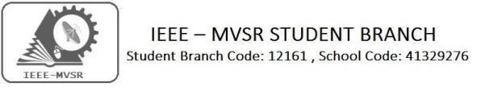

Two Day Workshop on Statistical Foundation for Data Science

The IEEE-CS Student Branch of MVSR Engineering college has conducted a two-day hands-on workshop on Statistical Foundation for Data Science. The main motto behind conducting this workshop is to give a brief information regarding the definition of data science, collection of data, and to escalate the importance of statistics in data science.

Student Branch Mentor:

Dr. Atul Negi,
Professor, School of CIS,
University of Hyderabad.

Student Branch Advisor:

Mr. V. Ashwini Kumar, Assoc. Professor, IT Dept., MVSR Engineering College.

PES Advisor:
Dr. D. Hari Krishna,
Assoc. Professor, EEE Dept.,
MVSR Engineering College.

Student Branch Executive Committee:

R. Ramyasri - Chairperson
K. Akshitha - Vice Chair
M. Shreya - Secretary
K. Vinay Kumar - Joint Secretary
V. Vineeth - Treasurer
P. Varun kumar-Operating committee Head

Computer Society:
S. Sai teja - Chair
G. Suradhya - Vice Chair
M. Vamsi Krishna - Secretary
A. Phani Sahasra - Joint Secretary

V. Manikanta - Treasurer

Circuits and Systems Society:
D.Siddartha -Chair
K.Jaideep -Vice Chair
D.V.B Parthiv -Secretary
D.Venkat -Joint Secretary
P.Shravya -Treasurer
WIE Student Branch Advisor:

Mrs. Dr. G. Kanaka Durga,
Principal,
MVSR Engineering College.

Student Branch Counsellor:

Dr. D. Hari Krishna,
Assoc. Professor, EEE Dept.,
MVSR Engineering College.

CS student branch advisor:
Mrs. B. Saritha
Assoc. Professor, CSE Dept.,
MVSR Engineering College

CASS Student Branch Advisor:
Mrs. S. Aruna
Assoc. Professor, ECE Dept.,

MVSR Engineering College.

WIE Affinity Group:

A. Sai Pratyusha - Chairman
M. Shresta - Vice Chair
Sahithya namani - Secretary

L. Ruthvika - Joint Secretary
R. Ruchitha - Treasurer
Power Energy Society:
E. Pavan Kumar - Chair
Jayasree k - Vice Chair

N. Avinash - Secretary
B.Nikita - Joint Secretary

S. Satvika - Treasurer
Operating Committees:
Ch. Jinesh - Publicity Committee
M.V.S.S.S.R Sahith -Membership Committee
V.Hemish & Y. Sai sameer - Design Committee

M. Sai Sri Teja - Program Committee
Session details:

Date : 24th, 25th October 2019.

Time : 10:00 am – 4:00 pm.
Venue: CSE Seminar Hall, MVSR Engineering College.

No. of IEEE students attended: 10
No. of guests attended: 30

Guest Speaker: Madhu Vadlamani

Senior lead at Web & Data Analytics at Kony, Inc.

On first day, workshop was inaugurated by Mr. Prasanna Kumar, CSED-HOD giving a succinct speech to the attenders to make the two days to draw a lot of information from the speaker. Then it was followed by introduction of guest speaker Mr. Madhu Vadlamani’s career at his office, and his achievements by Mr. P. Varun kumar-Operating committee Head.

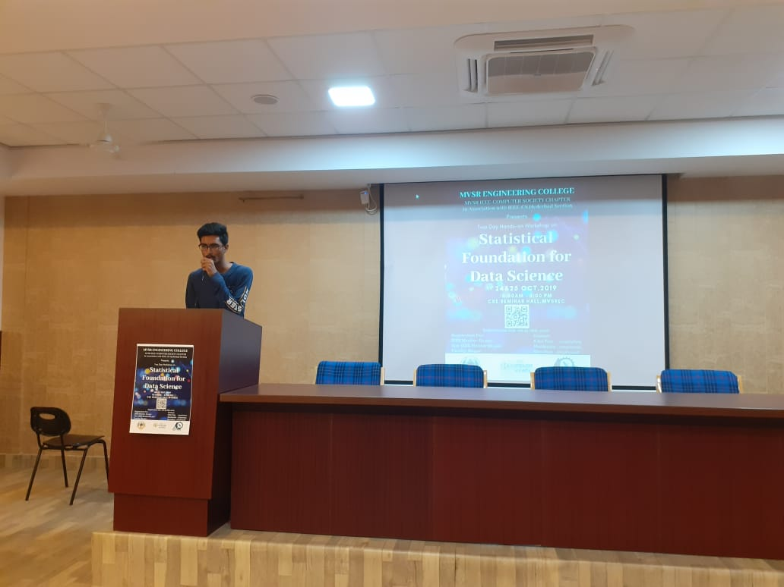
Welcoming the guest by Mr. P. Varun kumar-Operating committee Head.

After the inaugural and introduction, the speaker drove right into differentiating between the analysis and analytics with real time examples. He made sure that any his speech was not lagging by making it more interactive when students involvement was considering the most important. He has given equal time each topic so that any topic would not be left unexplained or ambiguous in a particular matter. Stating the power of data, connection of database systems to data science is a crucial step in analyzing data; basic view of working of statistics and machine learning was also delineate to the attenders.

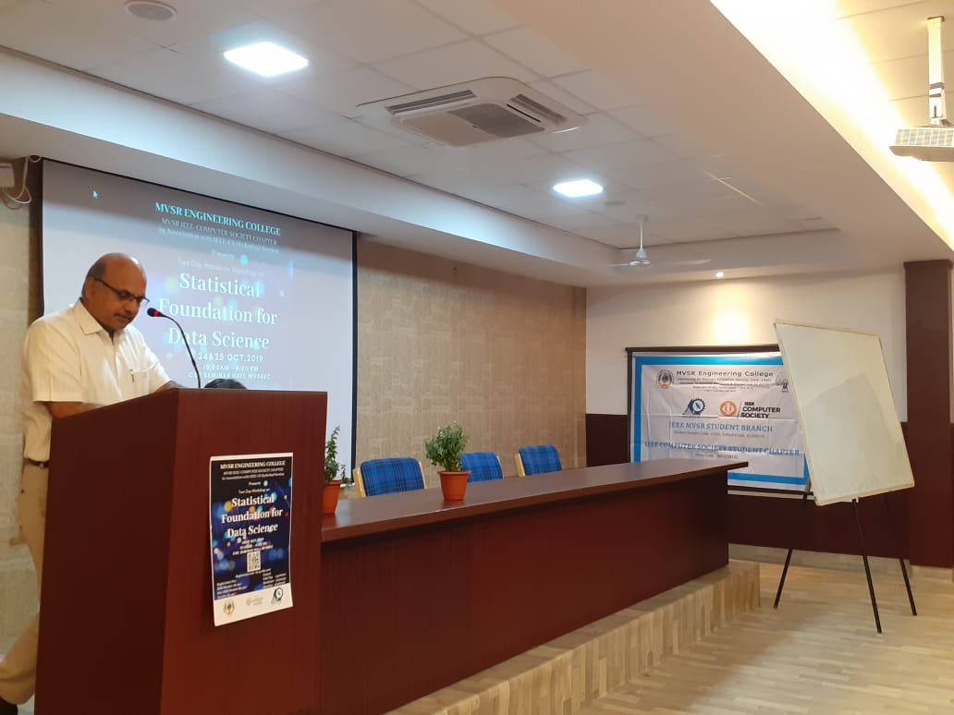
Mr. J.Prassana Kumar CSED,HOD addressing the gathering.

During the second half of first day, he showed realistic characteristics of working in extraction of information from data is a meticulous and dauting task. It apprehension the extraction of information of data was followed by analysis of data, model creation and prediction of raw data. But when it comes to real life examples, most of the data is in the form of pictorial representation, therefore, studying of image recognition and preprocessing of data. Advanced technologies of machine learning models were explained briefly for example, voice recognition, processing of data, etc.

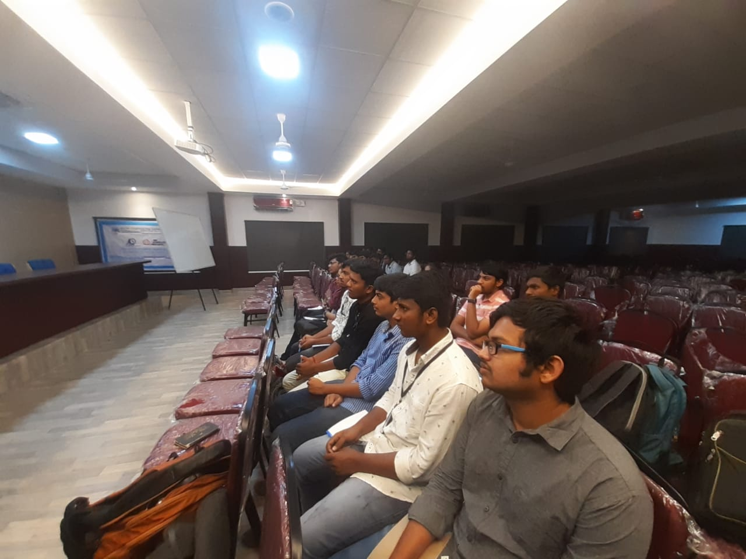
Attenders listening keenly to the thesis.
On the second day, with same enthusiasm and alacrity, the session began by revising the previous topics. Questing and answering method has giving a lively approach so that discussion would not be dull and mundane. This day dealt with discussion on topics that were related to prediction analysis of data when an algorithm is trained to a machine.
First half has dealt with linear regression; which tells how unknown data could be classified into two or more categories. And another algorithm which is used to classify is K-means which used clustering technique to classify the data.

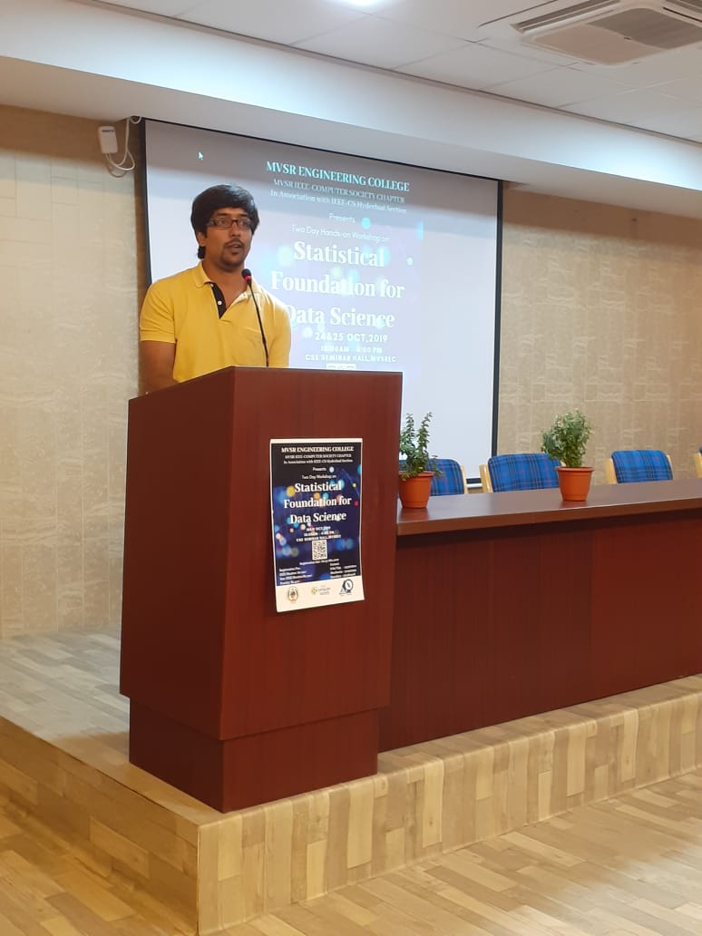
Mr.Madhu Vadlamani while describing a topic.

The second half of second day has continued by discussion of neural networks and how data could be interpreted with the help of neural with respect to human minds. Naïve Bayes, Support vector machines which are used to classify nonlinear data, nonlinear data consists of raw data which has no labels or attributes so, this algorithms are used to classify them. Regressions are used to rectify the errors and update the weights to minimize the error. And finally, the session was ended by delineating about the binary tree and decision tree algorithms which uses tree data structures to classify and predict the data.

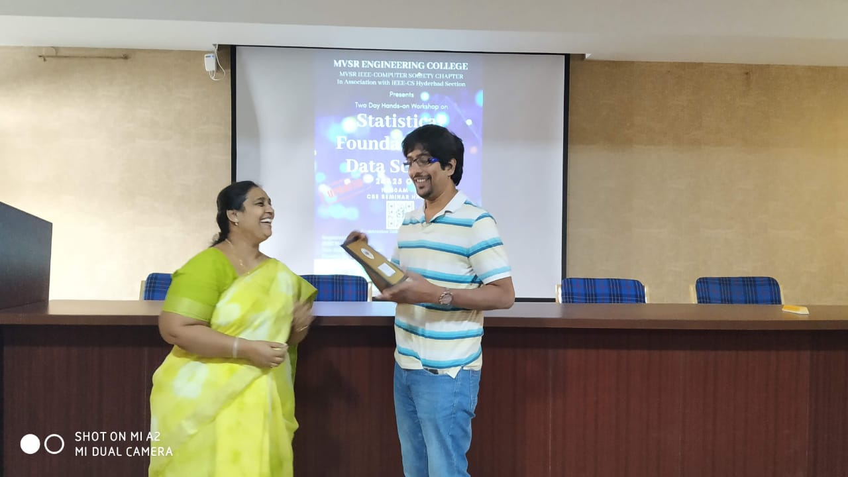
Mrs.B.Saritha, Student Advisor presenting a memento to the speaker

At the end of the day, the speaker was bestowed with a memento by Mrs. B.Saritha Student Advisor, CSED. She appreciated the efforts taken by the speaker to come down to college and for helping the students with doubts on data science, and he also gave his social sites links so that students could future discuss their topics.

Reported by:
IEEE , MVSR SB.

