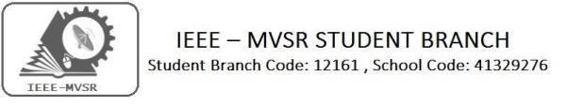
GENERAL BODY MEET

IEEE MVSR Student Branch Counsellor as well as advisors has conducted a General Body Meet on 1st October, 2019. The main motto of the meet is to discuss the upcoming events to be conducted under IEEE MVSR Student Branch, Technovanza and regarding research papers.

Student Branch Mentor:

Dr. Atul Negi,
Professor, School of CIS,
University of Hyderabad.

Student Branch Advisor:
Mr. V. Ashwini Kumar, Assoc. Professor, IT Dept., MVSR Engineering College.

PES Advisor:
Dr. D. Hari Krishna,
Assoc. Professor, EEE Dept.,
MVSR Engineering College.

Student Branch Executive Committee:

R. Ramyasri - Chairperson
K. Akshitha - Vice Chair
M. Shreya - Secretary
K. Vinay Kumar - Joint Secretary
V. Vineeth - Treasurer
P. Varun Kumar-Operating committee Head

Computer Society:
S. Sai Teja - Chair
G. Suradhya - Vice Chair
M. VamsiKrishna - Secretary
A. Phani Sahasra - Joint Secretary

V. Manikanta- Treasurer

Circuits and Systems Society:
D.Siddartha -Chair
K.Jaideep -Vice Chair
D.V.B Parthiv -Secretary
D.Venkat -Joint Secretary
P.Shravya -Treasurer
WIE Student Branch Advisor:

Mrs. Dr. G. Kanaka Durga,
Principal,
MVSR Engineering College.

Student Branch Counsellor:

Dr. D. Hari Krishna,
Assoc. Professor, EEE Dept.,
MVSR Engineering College.

CS student branch advisor:
Mrs. B. Saritha
Assoc. Professor, CSE Dept.,
MVSR Engineering College

CASS Student Branch Advisor:
Mrs. S. Aruna
Assoc. Professor, ECE Dept.,

MVSR Engineering College.

WIE Affinity Group:

A. Sai Pratyusha - Chairman
M. Shresta - Vice Chair
Sahithya namani- Secretary

L. Ruthvika- Joint Secretary
R. Ruchitha - Treasurer

Power Energy Society:
E. PavanKumar - Chair
Jayasree k - Vice Chair

N. Avinash - Secretary
B.Nikita Reddy - Joint Secretary

S. Satvika - Treasurer

Operating Committees:
Ch. Jinesh- Publicity Committee
M.V.S.S.S.R Sahith-Membership Committee
Hemish& Y. Sai Sameer - Design Committee

M. Sai Sri Teja- Program Committee
Session details:

Dates : 1st October 2019.

Time : 10.00 am–11.30 am.
Venue: Principal office, Civil Department, MVSR Engineering College

IEEE MVSR Student Branch Counsellor and advisors visited Mrs. Dr. G. Kanaka Durga, Principal of MVSREC, and WIE advisor, to invite her for IEEE day celebrations.
Mrs. Dr. G. Kanaka Durga, congratulated Dr. D. Hari Krishna for getting senior grade and she proposed one more society i.e., Robotics under IEEE MVSR SB.

The advisors of all the societies discussed various events to be conducted under IEEE MVSR SB.

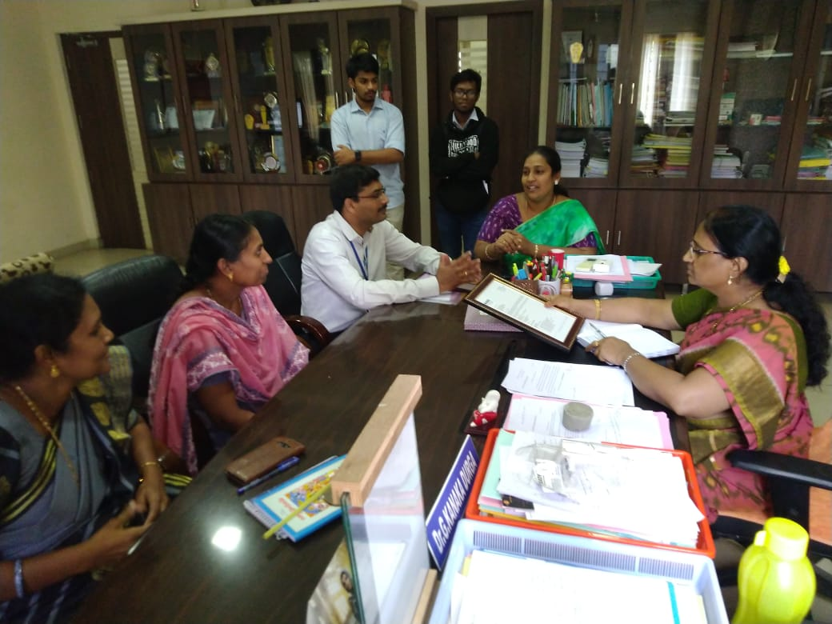
IEEE MVSR SB Counsellor and advisors discussing various events to be conducted.

Mrs. B. Saritha , IEEE CS student branch advisor , planned three workshops to be conducted under IEEE MVSR CS .Statistical logic, Augmented Reality and IOT workshops respectively..

Mrs. S. Aruna, CASS Student Branch Advisor, proposed a Guest lecture on embedded systems and VLSI. She also proposed to conduct a three day workshop on IOT under IEEE MVSR CASS.

Dr. D. Hari Krishna, Student Branch Counsellor, IEEE PES Advisor, proposed three workshops to be conducted under IEEE MVSR PES, i.e., Smart Grid, Renewable Energy and Power Electronics workshops respectively.
Mrs. Dr. G. Kanaka Durga, Principal of MVSREC and WIE advisor, proposed to conduct awareness programs on Health and Hygiene, Nutrition in Girls schools.
IEEE MVSR SB in collaboration with MVSREC planned MUN and CONCLAVE. All the advisors and counsellor discussed about those events. Later, R. Ramyasri , Chairperson of IEEE MVSR SB has proposed dates for TECHNOVENZA 2020 and the advisors and counsellor discussed about TECHNOVENZA 2020.

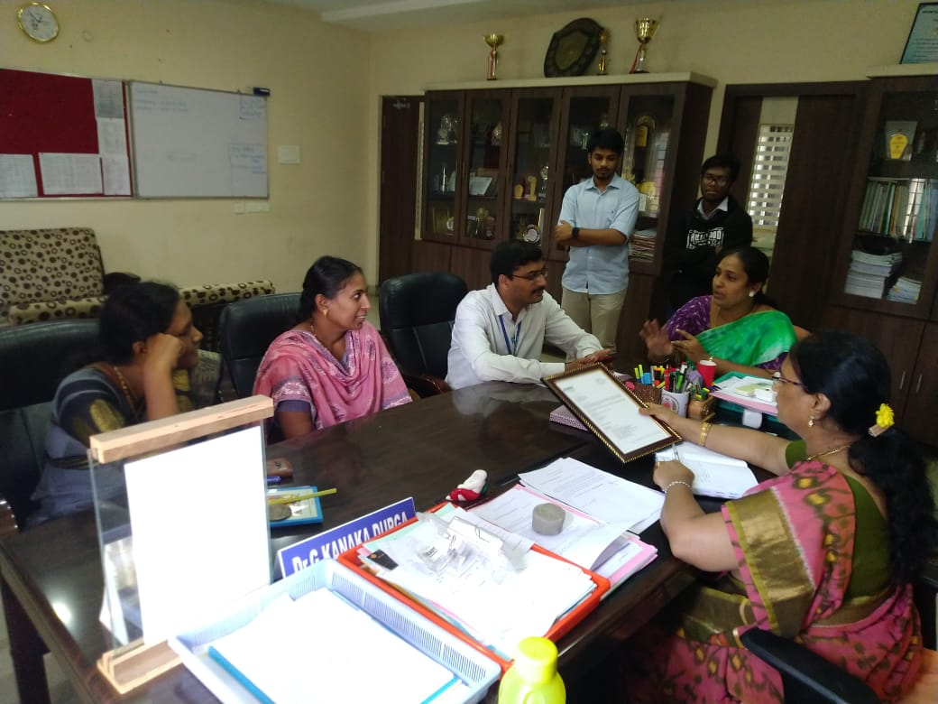IEEE MVSR SB Counsellors and advisors discussing about CONCLAVE.

Reported by:
IEEE MVSR SB.

