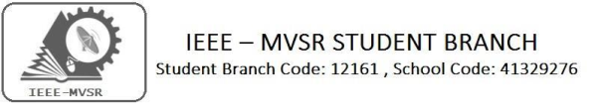

GENERAL BODY MEETING

IEEE MVSR SB had conducted a General body meeting on 15th July 2019. The aim of the Session was to plan the upcoming events and prepare the academic calendar.

StudentBranchMentor: WIEStudentBranchAdvisor:

Dr. AtulNegi, Dr. G. Kanaka Durga,
Professor, School of CIS, Principal & Professor,
University of Hyderabad. MVSR Engineering College.
StudentBranchAdvisor: PES Advisor:
Mr. V. AshwiniKumar, Dr. D. Hari Krishna,
Assoc.Professor,ITDept., Assoc.Professor,EEEDept.,
MVSR Engineering College. MVSR Engineering College.
CS Student Branch Advisor:
Mrs. B. Saritha,
Assoc. Professor, CSE Dept.,
MVSR Engineering College.
StudentBranchCounsellor:
Dr. D. Hari Krishna,
Assoc. Professor, EEE Dept.,
MVSR Engineering College.

WIEAffinityGroup:
A.Prathyusha-Chairman
M.Shresta Reddy-Vice Chair
N.Sahitya-SecretaryL.Ruthvika- JointSecretary
Ruchitha Reddy -Treasurer

Student Branch Executive Committee:
R.Ramya Sri - Chairperson
K.Akshitha - Vice Chair
Shreya Maqtedar - Secretary
K.Vinay Kumar - Joint Secretary
V.Vineeth - Treasurer

Power Energy Society:
E.Pavan Kumar - Chair
K.Jaya Sree - Vice Chair
N.Avinash - Secretary
B.Nikitha Reddy - Joint Secretary
S.Satvikka - Treasurer

––

Computer Society:
S.Sai Teja - Chairperson
G.Suradhya - Vice Chair
M.Vamshi Krishna - Secretary
Phani Sahasra - Joint Secretary
V.Manikanta - Treasurer
Operating Committees:
P.Varun Kumar-Operating Committee Head
Ch.Jinesh- Publicity Committee Head
MVSSR Sahith Rao-MembershipCommittee Head
Sai Sameer & Hemish - Design Committee Head
M.Sai Sri Teja - Program Committee Head

Session details:
Date : 15thJuly 2019.
Time : 10:30am – 12:30am.
Venue: M102, EEE Department, MVSR Engineering College.

No. of attendees: 26.

The session began with a brief introduction regarding the origin and development of IEEE MVSR Student Branch by Dr D. Hari Krishna, Student Branch Counsellor, followed by the introduction of new Executive Committee members of IEEE MVSR SB.

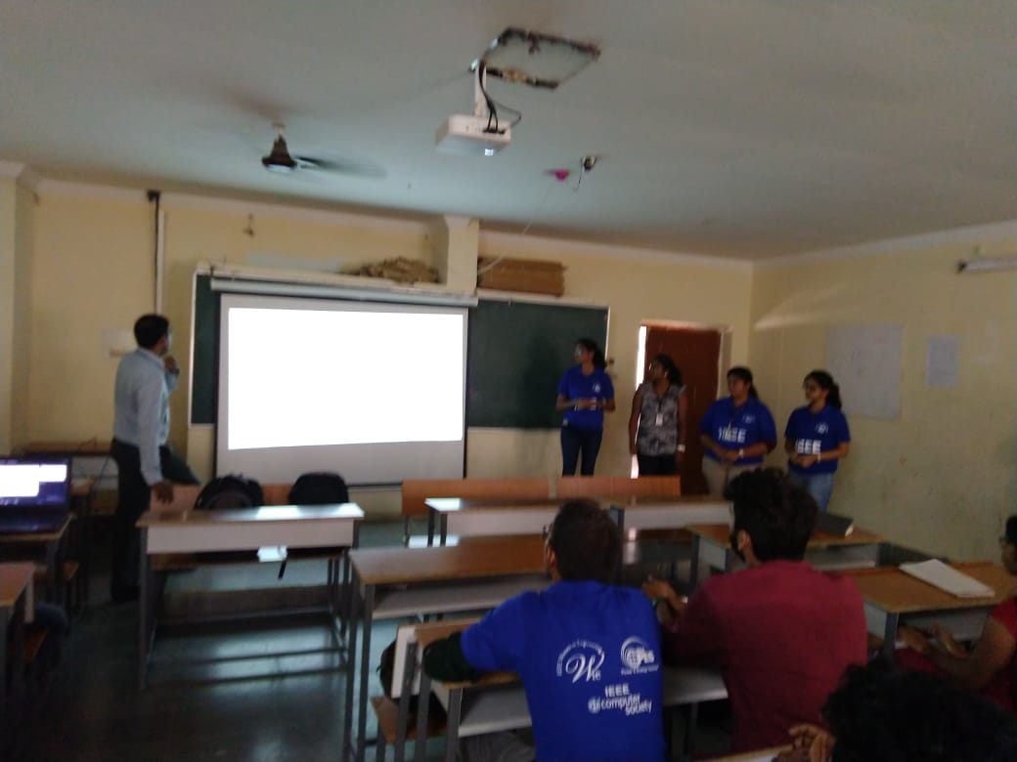
Dr . D. Hari Krishna introducing the Ex-Com members of WIE IEEE MVSR SB.
This was followed by a brief introduction about IEEE Hyderabad Section Student Network and the activities being held by IEEE MVSR SB. He also briefly explained the upcoming events and agenda planned. Dr D. Hari Krishna interacted with the IEEE Excom and students and suggested them to make use of IEEE platform to excel in their problem solving and computing skills.

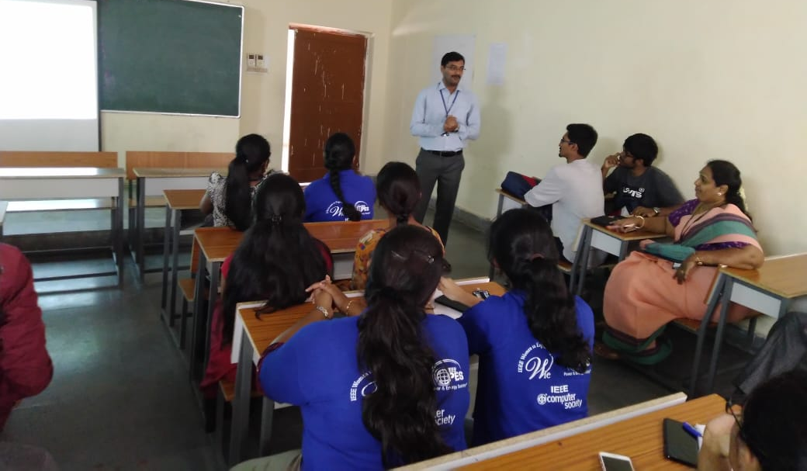
Dr. D. Hari Krishna interacting with IEEE Students

Later, Mr. V. Ashwini Kumar, Student Branch Advisor, explained the outcomes of IEEE, steps that can be implemented for the betterment of the student branch and motivated the members to participate in all the events actively, explaining the benefits of being one. He also created awareness in the student branch members regarding various platforms available for presenting their innovative inventions and ideas.

Mr . V. Ashwini Kumar explaining the measures to be taken for development of SB.

The session was continued by Mrs. B. Saritha, Computer Society Student Branch Advisor, who explained the upcoming events in detailed and also a brief idea was given regarding the organisation of further events.

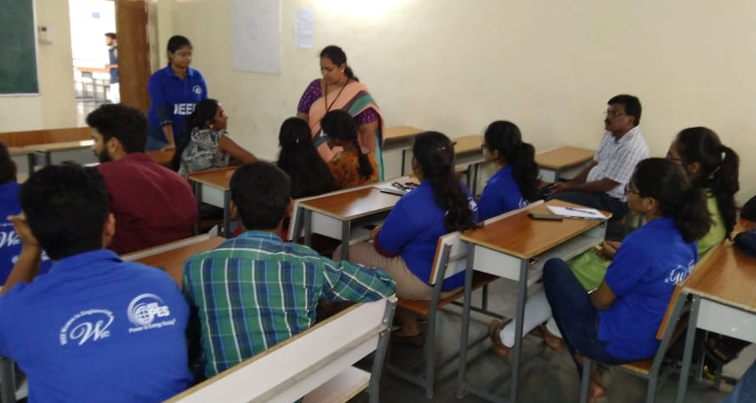
Mrs. B. Saritha giving an explanation regarding the upcoming events.

The session further continued by Mr. P. Varun Kumar, Operating Committee Head, by explaining resources for an IEEE member and also about the awards that can be achieved by a student member and also student branch.

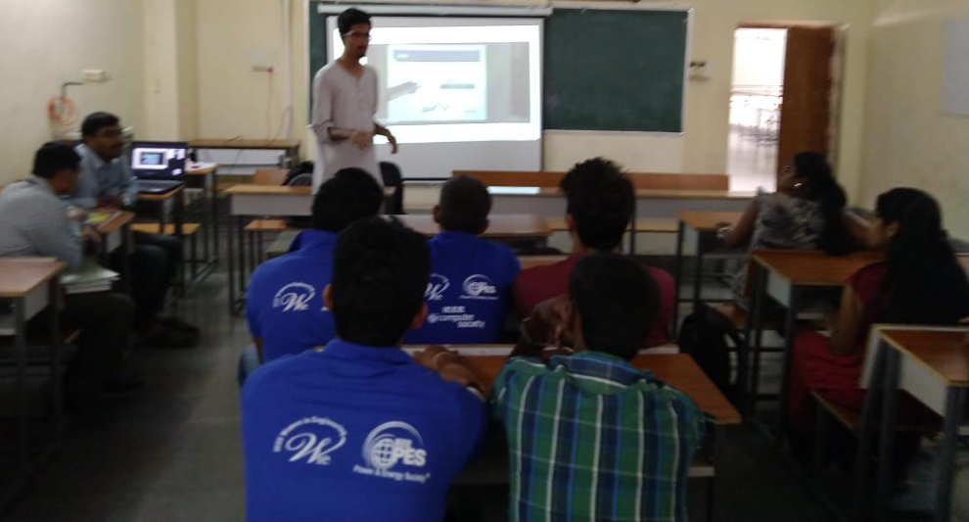
Mr. P. Varun Kumar explaining the resources for an IEEE member.
The General Body Meeting continued with the plan for coming events proposed by Power and Energy Society and Computer Society and WIE of the student branch. The meet concluded with a discussion related to various possible events for HYDCON 2020 by IEEE Hyderabad Section.

Reported by:
IEEE MVSR SB.

