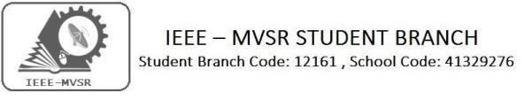
IEEE Day Celebrations
The IEEE Student Branch of MVSR Engineering College has marked its IEEE day celebrations on 1st October, 2019. The event became more scintillating when enthusiastic students and advisors have attended to such impeccable and stunning event.

Student Branch Mentor:

Dr. Atul Negi,
Professor, School of CIS,
University of Hyderabad.

Student Branch Advisor:

Mr. V. Ashwini Kumar, Assoc. Professor, IT Dept., MVSR Engineering College.

PES Advisor:
Dr. D. Hari Krishna,
Assoc. Professor, EEE Dept.,
MVSR Engineering College.

Students Branch Executive Committee:

R. Ramya Sri - Chairperson
K. Akshitha - Vice Chair
M. Shreya - Secretary
K. Vinay Kumar - Joint Secretary
V. Vineeth - Treasurer
P. Varun kumar-Operating committee Head

Computer Society:
S. Sai teja - Chair
G. Suradhya - Vice Chair
M. Vamsi Krishna - Secretary
A. Phani Sahasra - Joint Secretary

V. Manikanta - Treasurer

Circuits and Systems Society:
D.Siddartha -Chair
K.Jaideep -Vice Chair
D.V.B Parthiv -Secretary
D.Venkat -Joint Secretary
P.Shravya -Treasurer
WIE Student Branch Advisor:

Mrs. Dr. G. Kanaka Durga,
Principal,
MVSR Engineering College.

Student Branch Counsellor:

Dr. D. Hari Krishna,
Assoc. Professor, EEE Dept.,
MVSR Engineering College.

CS student branch advisor:
Mrs. B. Saritha
Assoc. Professor, CSE Dept.,
MVSR Engineering College

CASS Student Branch Advisor:
Mrs. S. Aruna
Assoc. Professor, ECE Dept.,

MVSR Engineering College.

WIE Affinity Group:

A. Sai Pratyusha - Chairman
M. Shresta - Vice Chair
Sahithya namani - Secretary

L. Ruthvika - Joint Secretary
R. Ruchitha - Treasurer

Power Energy Society:
E. Pavan Kumar - Chair
JayaSri k - Vice Chair

N. Avinash - Secretary
B.Nikita - Joint Secretary

S. Satvika - Treasurer

Operating Committees:
Ch. Jinesh - Publicity Committee
M.V.S.S.S.R Sahith -Membership Committee
V.Hemish & Y. Sai sameer - Design Committee

M. Sai Sri Teja - Program Committee
Session details:

Date : 01st October 2019.

Time : 10:00 am – 1:00 pm.
Venue: IT Seminar Hall, MVSR Engineering College.

No. of IEEE students attended: 39
No. of guests attended: 76

The event was commenced by IEEE Chairperson R. Ramya Sri by stating about the history of IEEE and how it proliferated through years, delineated about evolving of Student Branch -MVSR and shared some mind interesting facts of how one could make an eminent use of their IEEE accounts. Then it was taken over by P. Varun kumar-Operating committee Head who gave fascinating details about special interest groups and IEEE Xtreme which is of great advantageous to Computer background students; insisting attendees to explore the IEEE explorer and to gather knowledge from experts in their field of interest.

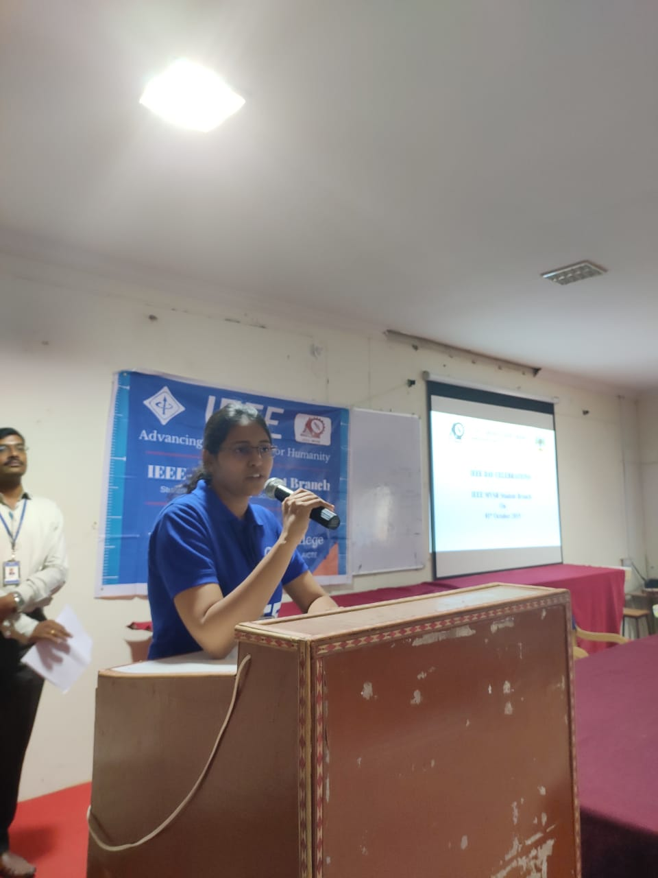
IEEE Chairperson initiating the event
This was followed by the speech given by Dr. D. Hari Krishna Student Branch Advisor -MVSR; telling the crowd about the IEEE web browser and how could one take complete advantage by building their own profile and viewing the tech-papers written by professors all around the world; many events could be attended using IEEE membership. One could always make connections with peers using IEEE and always welcomed with great enthusiasm towards innovation.

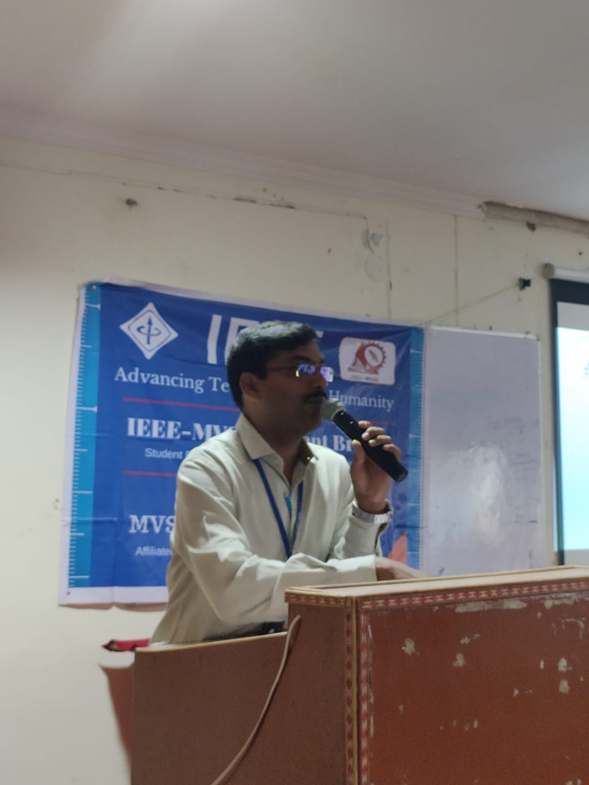
Student Advisor Dr.Hari Krishna

Then WIE advisor Mrs. Dr. G. Kanaka Durga, Principal, MVSREC spoke few words on how there’s been a drastic change in course of IEEE SB in MVSR; reminiscing about the awards bragged by MVSR SB by sharing some memories of triumph; she appreciated all the volunteers and IEEE members and advisors who took such arduous tasks to make all the events to end in success. She ended by wishing all the best for further achievements.
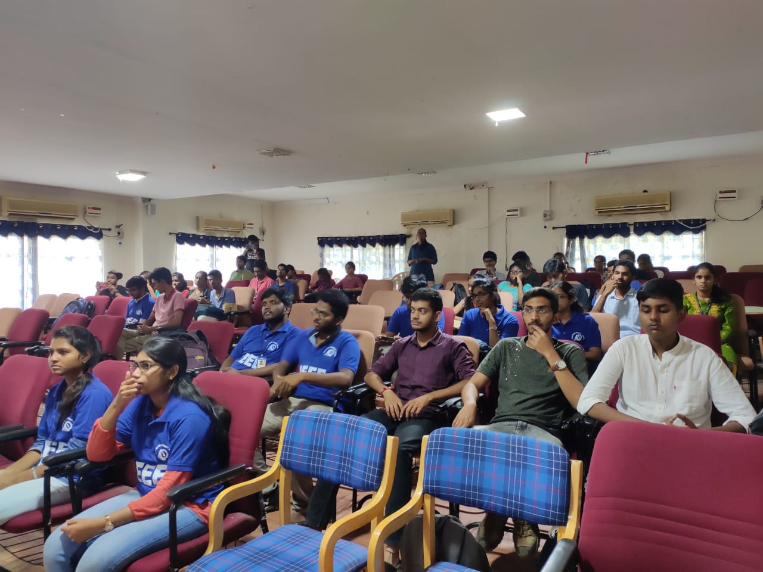
Students listening to the speaker.
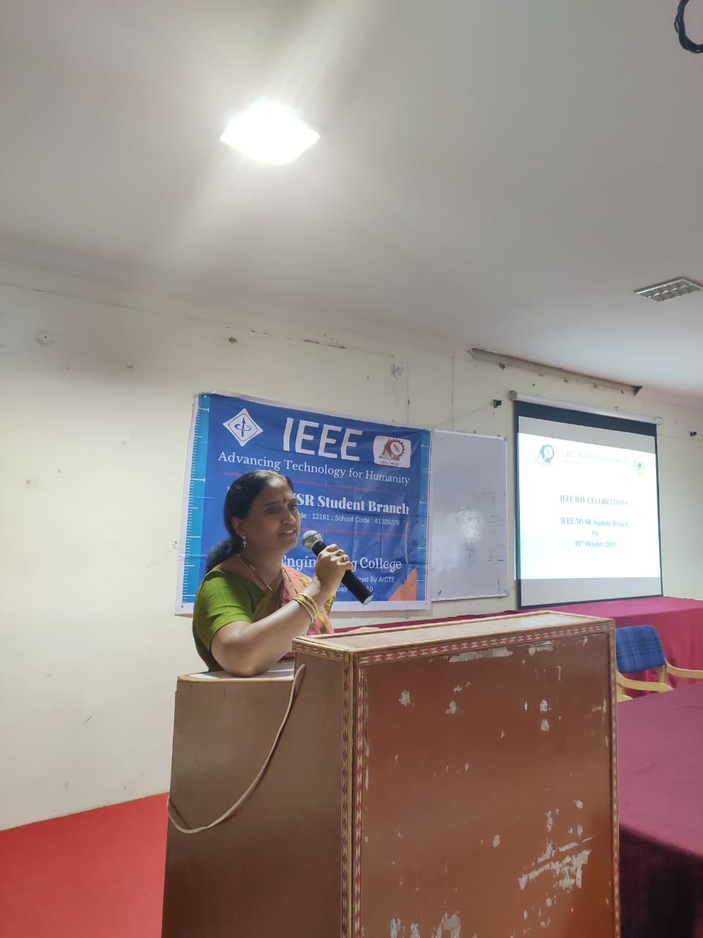
Mrs. Dr. G. Kanaka Durga, WIE Advisor.
Last but not the least, the ending of the session had become more alacrity when Mr.Ahwini Kumar took over the mike and told the attendees about how one should increase their imagination towards betterment of the society and building a solution to the daily faced problems.
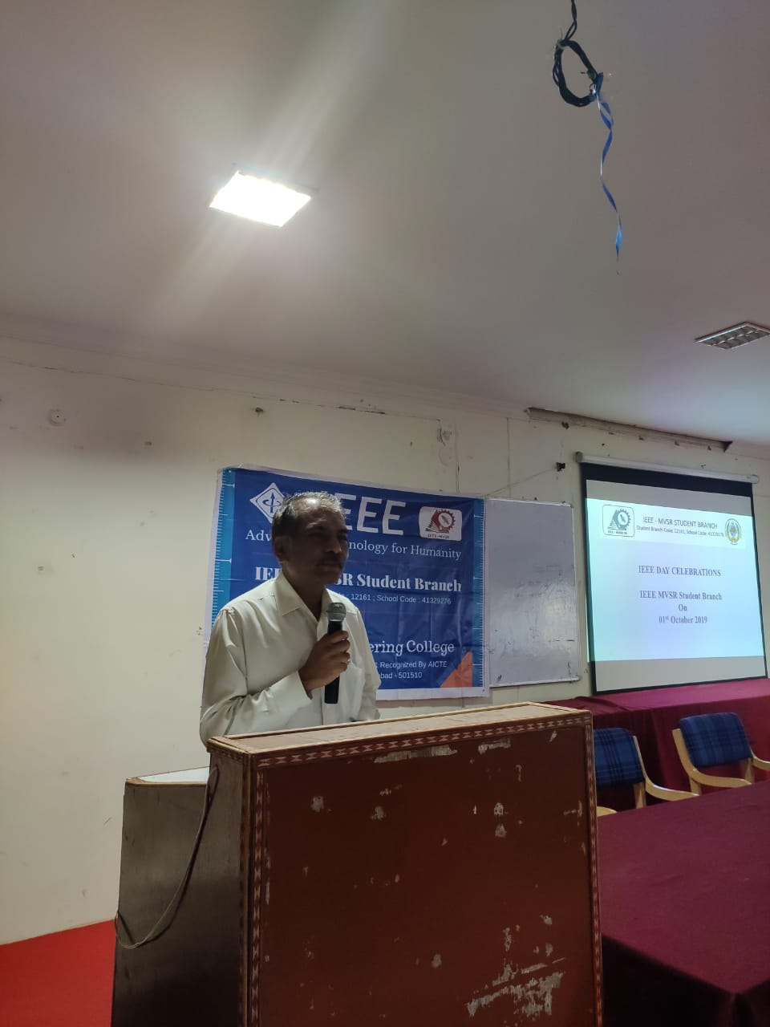
Mr.Ashwini Kumar addressing the gathering
Reported by:
IEEE MVSR SB.

