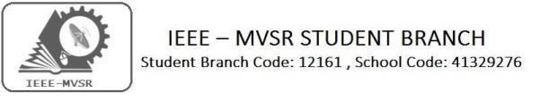

ROBOTS- MADE IN INDIA
Power Energy Society:
E. PavanKumar - Chair
Jayasree k - Vice Chair

N. Avinash - Secretary
B.Nikita Reddy - Joint Secretary

S. Satvika - Treasurer

WIE Affinity Group:

A. Sai Pratyusha - Chair
M. Shresta - Vice Chair
Sahithya namani - Secretary
L. Ruthvika - Joint Secretary

R. Ruchitha - Treasurer

Students Branch Executive Committee:

R. Ramya Sree - Chairperson
K. Akshitha - Vice Chair
M. Shreya - Secretary
K. Vinay Kumar - Joint Secretary
V. Vineeth - Treasurer
P. Varun Kumar- Operating committee
Head

CASS Student Branch Advisor:
Mrs. S. Aruna
Assoc. Professor, ECE Dept.,

MVSR Engineering College
CS student branch advisor:
Mrs. B. Saritha
Assoc. Professor, CSE Dept.,
MVSR Engineering College.

Student Branch Counsellor:

Dr. D. Hari Krishna,
Assoc. Professor, EEE Dept.,
MVSR Engineering College.

WIE Student Branch Advisor:
Mrs. Dr. G. Kanaka Durga,
Principal and Professor,
MVSR Engineering College.

Circuits and Systems Society:
D.Siddartha -Chair
K.Jaideep -Vice Chair
D.V.B Parthiv -Secretary
D.Venkat -Joint Secretary
P.Shravya -Treasurer
Computer Society:
S. Sai Teja - Chair
G. Suradhya - Vice Chair
M. Vamsi Krishna - Secretary
A. Phani Sahasra - Joint Secretary

V. Manikanta - Treasurer

Student Branch Mentor:
Dr. Atul Negi,
Professor, School of CIS,
University of Hyderabad.

Student Branch Advisor:

Mr. V. Ashwini Kumar, Assoc. Professor, IT Dept.,
MVSR Engineering College.

PES Advisor:
Dr. D. Hari Krishna,
Assoc. Professor, EEE Dept.,
MVSR Engineering College.

The IEEE MVSR is on a quest of enhancing the reachability towards emerging technologies. To strengthen the student’s interest, a lecture on “Robots – made in India” was organized on 30th October 2019, which was given by Mr. Kisshhan, CEO and founder of Hbots.
Operating Committees:
Ch. Jinesh- Publicity Committee
M.V.S.S.S.R Sahith-Membership Committee
Hemish & Y. Sai Sameer -Design Committee
M. Sri Sai Teja – Program Committee

Session Details:
Date: 30th October 2019.
Time: 11:30 am – 01:00pm
Venue: IT AV hall, MVSREC.
No. of students attended: 46

Guest Speaker: Mr.Kisshhan,
CEO and Founder H-Bots.

The main aim of the lecture was to create interest among the students about the emerging robotic world of excellence and to involve them with some of the concepts of robotics.

The session was started by Mr. Varun Kumar, IEEE MVSR Operating Committee Head, introducing Mr.Kisshhan and Miss Harshitha. Mr. Varun gave a brief about H-Bots Company.

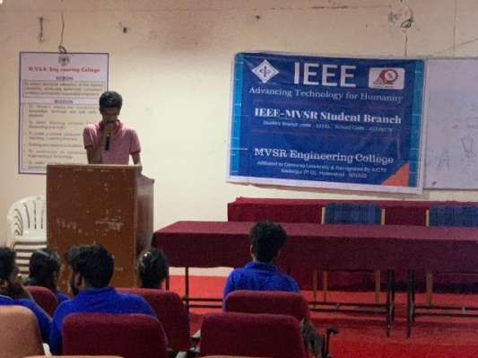
Mr. Varun introducing Mr. Kisshhan and Miss Harshitha
A lecture on ‘Robots made in India’ was rendered by Mr. Kisshhan. He first shared his experiences and reasons behind his inspiration towards robotics. With this support the designing of first humanoid started in India. H-labs were then started to support innovators.

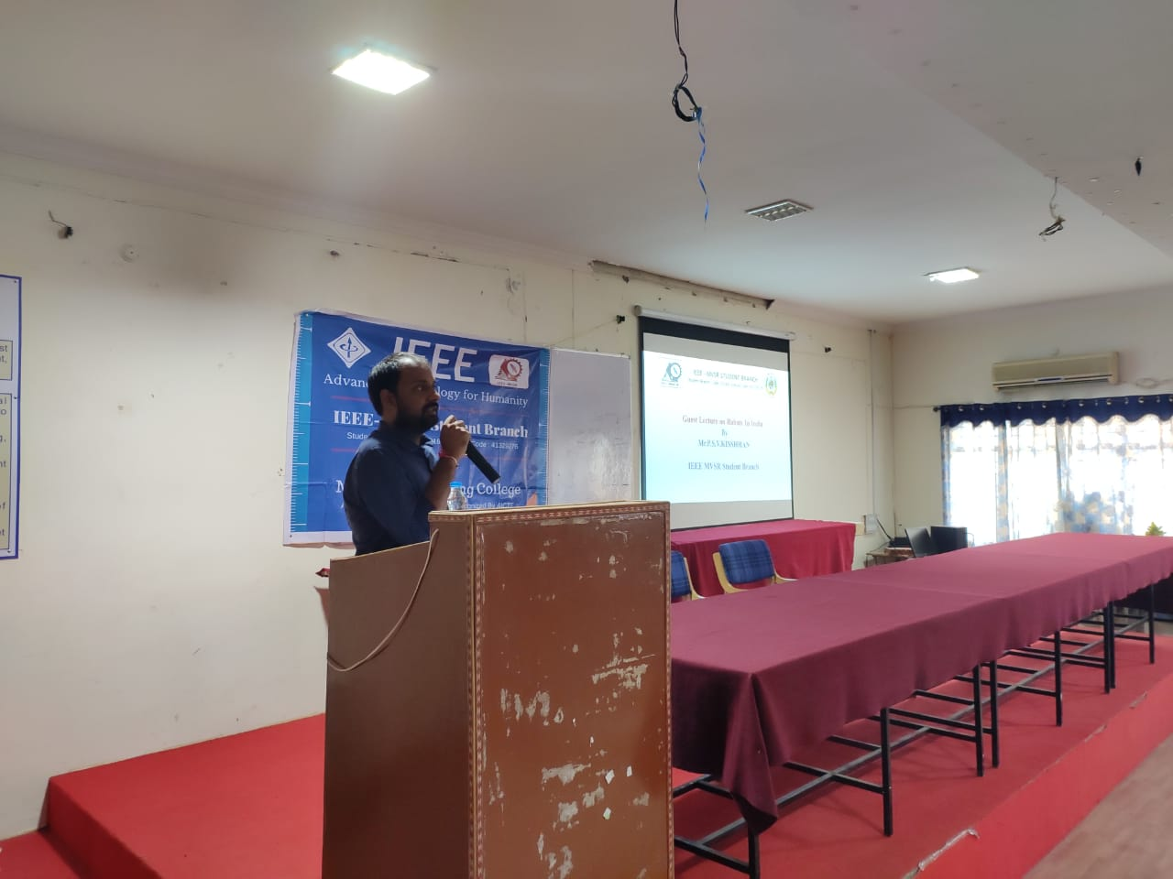
Lecture by Mr. Kisshhan(CEO & Founder of HBOTS)
Mr.Kisshhan explained how H-BOT'S is a next-generation global technology company that helps enterprises re imagine their businesses for the digital age. HBOTS is the first system to use AI for most critical HR processes.

He talked about how H-BOTS AI tools augment existing SAP, Peoplesoft, SuccessFactors or Workday systems as individual add-ons or as an integrated suite of multiple solutions. All HBOTS solutions include actions and predictive analytics allowing the leadership, HR team and workforce to leverage the power that AI brings to HR scenarios.

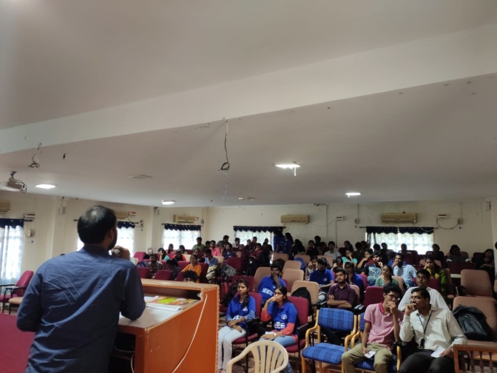
Enthusiast audience attending the lecture to enhance their skill on robotics.

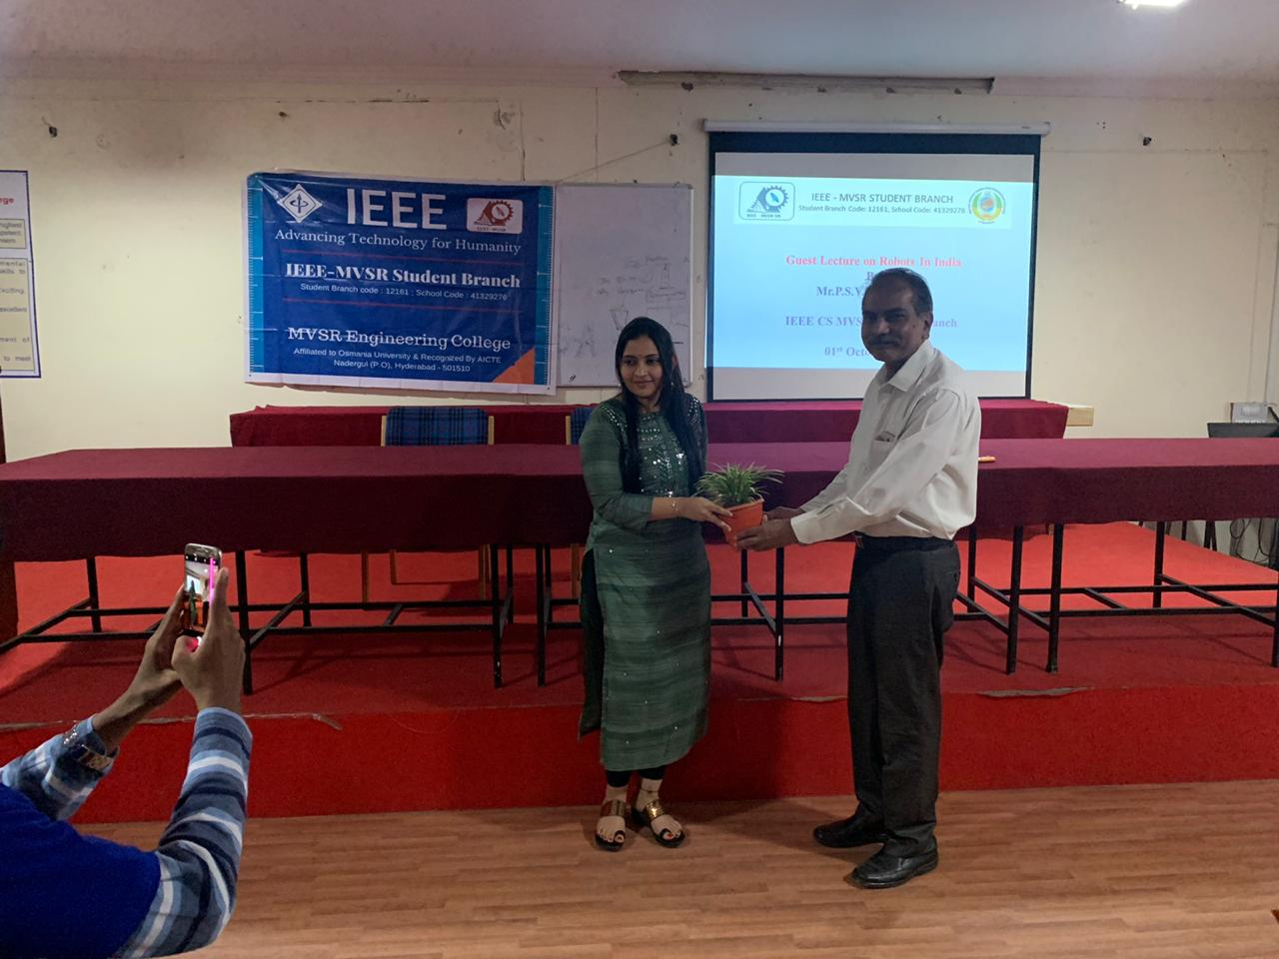
Mr.Ashwin kumar IEEE MVSR SB Advisor handing over the sapling to Miss Harshitha.

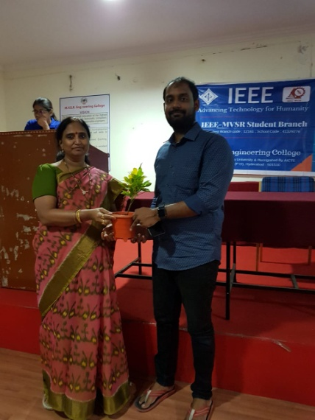
Dr.G.Kanaka Durga (IEEE MVSR WIE Advisor and Principal, MVSREC) presenting the sapling to Mr. Kisshhan
Later saplings were presented to the guests as a token of appreciation for spending their valuable time with the students of MVSR in collaboration with IEEE MVSR and providing essential inputs to them.

Reported by:
IEEE MVSR SB.

