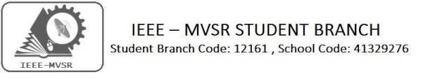

GENERAL BODY MEETING

IEEE MVSR Student Chapter Power and Energy Society (PES) had conducted its General body meet on 23rd September 2019. The aim of the session was to plan the upcoming events.

Student Branch Mentor:

Dr. Atul Negi,
Professor, School of CIS,
University of Hyderabad.

Student Branch Advisor:

Mr. V. Ashwini Kumar, Assoc. Professor, IT Dept., MVSR Engineering College.

PES Advisor:
Dr. D. Hari Krishna,
Assoc. Professor, EEE Dept.,
MVSR Engineering College.

Student Branch Executive Committee:

R. Ramyasri - Chairperson
K. Akshitha - Vice Chair
M. Shreya - Secretary
K. Vinay Kumar - Joint Secretary
V. Vineeth - Treasurer

Computer Society:
S. Sai teja - Chair
G. Suradhya - Vice Chair
M. VamsiKrishna - Secretary
A. PhaniSahasra - Joint Secretary

V. Manikanta- Treasurer

Circuits and Systems Society:
D.Siddartha -Chair
K.Jaideep -Vice Chair
D.V.B Parthiv -Secretary
D.Venkat -Joint Secretary
P.Shravya -Treasurer
WIE Student Branch Advisor:

Mrs. Dr. G. Kanaka Durga,
Principal,
MVSR Engineering College.

Student Branch Counsellor:

Dr. D. Hari Krishna,
Assoc. Professor, EEE Dept.,
MVSR Engineering College.

CS Student Branch advisor:
Mrs. B. Saritha
Assoc. Professor, CSE Dept.,
MVSR Engineering College

CASS Student Branch Advisor:
Mrs. S. Aruna
Asst. Professor, ECE Dept.,

MVSR Engineering College.

WIE Affinity Group:

A. Sai Pratyusha - Chairman
M. Shresta - Vice Chair
N. Sahithya- Secretary

L. Ruthvika- Joint Secretary
R. Ruchitha - Treasurer

Power Energy Society:
E. PavanKumar - Chair
Jayasree k - Vice Chair

N. Avinash - Secretary
B.Nikita Reddy - Joint Secretary

S. Satvika - Treasurer

Operating Committees:
P. Varun kumar-Operating committee Head
Ch. Jinesh- Publicity Committee
M.V.S.S.S.R Sahith-MembershipCommittee
V.Hemish& Y. Sai sameer - Design Committee

M. Sai Sri Teja- Program Committee
Session details:
Date : 23rd September, 2019.
Time : 10:30am – 12:30pm.
Venue: QEEE room, EEE department, MVSR Engineering College.

No. of attendees:25

The session began with a brief introduction regarding the origin and development of IEEE MVSR SB and IEEE MVSR PES by Dr. D. Hari Krishna, Student Branch Counsellor, followed by the introduction of IEEE MVSR PES Executive Committee members.

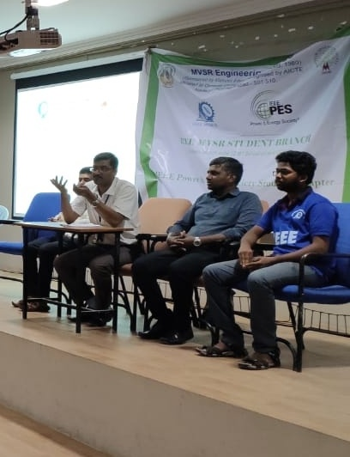
Dr. D. Hari Krishna, Student Branch Counsellor, talking about the development of IEEE PES

This was followed by a brief introduction of various societies to the new members of IEEE. Dr D. Hari Krishna, Student Branch Counsellor, also briefly explained the upcoming events and suggested students to plan various events and encouraged students to attend various workshops which are useful to improve their skills. He also suggested students to make use of IEEE platform to excel in their problem solving and computing skills.

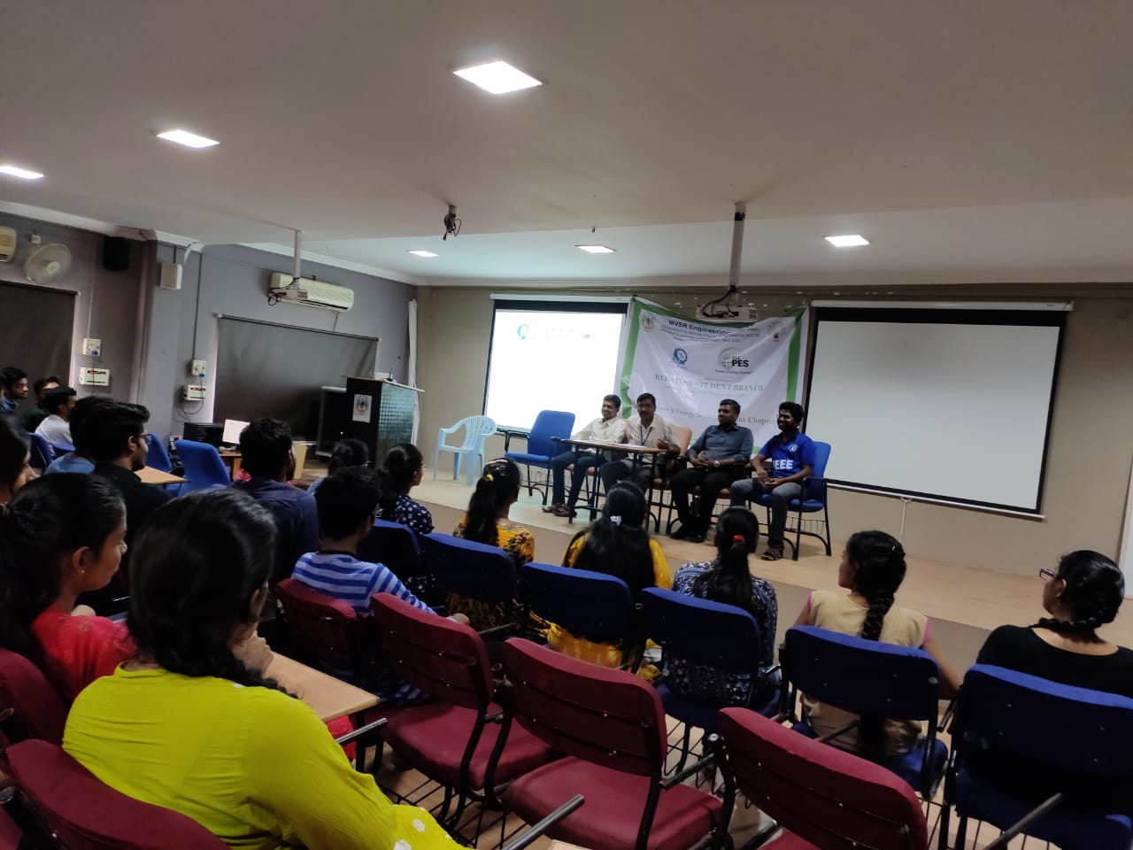
I.N.Swamy faculty coordinator addressing the gathering

As many of the students are unaware of various IEEE journals and papers, Dr. D. Hari Krishna, explained how to access the journals and papers of IEEE. He suggested all the students to attend various webinars, workshops, PDP conducted by IEEE as they are very useful to them.
He also mentioned about the access of IEEE Xplore.
Dr. More Raju, Mr. IN Swamy, IEEE Department Coordinator discussed about the events to be conducted in PES such as Smart Grid, Nuclear Energy, MATLAB, as well as HYDCON
The session was concluded by Dr. D. Hari Krishna, Student Branch Counsellor and PES Advisor by saying various awards present in IEEE PES and encouraged students to achieve many awards in the future .

Reported by:
IEEE MVSR SB.

