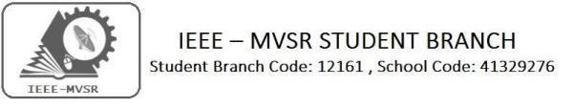

Workshop on Quantum computing for Women Organized by Microsoft
Power Energy Society:
E. PavanKumar - Chair
Jayasree k - Vice Chair

N. Avinash - Secretary
B.Nikita Reddy - Joint Secretary

S. Satvika - Treasurer

WIE Affinity Group:

A. Sai Pratyusha - Chair
M. Shresta - Vice Chair
Sahithya namani - Secretary
L. Ruthvika - Joint Secretary

R. Ruchitha - Treasurer

Students Branch Executive Committee:

R. Ramya Sree - Chairperson
K. Akshitha - Vice Chair
M. Shreya - Secretary
K. Vinay Kumar - Joint Secretary
V. Vineeth - Treasurer
P. Varun Kumar- Operating committee
Head

CASS Student Branch Advisor:
Mrs. S. Aruna
Assoc. Professor, ECE Dept.,

MVSR Engineering College
CS student branch advisor:
Mrs. B. Saritha
Assoc. Professor, CSE Dept.,
MVSR Engineering College.

Student Branch Counsellor:

Dr. D. Hari Krishna,
Assoc. Professor, EEE Dept.,
MVSR Engineering College.

WIE Student Branch Advisor:
Mrs. Dr. G. Kanaka Durga,
Principal and Professor,
MVSR Engineering College.

Circuits and Systems Society:
D.Siddartha -Chair
K.Jaideep -Vice Chair
D.V.B Parthiv -Secretary
D.Venkat -Joint Secretary
P.Shravya -Treasurer
Computer Society:
S. Sai Teja - Chair
G. Suradhya - Vice Chair
M. Vamsi Krishna - Secretary
A. Phani Sahasra - Joint Secretary

V. Manikanta - Treasurer

Student Branch Mentor:
Dr. Atul Negi,
Professor, School of CIS,
University of Hyderabad.

Student Branch Advisor:

Mr. V. Ashwini Kumar, Assoc. Professor, IT Dept.,
MVSR Engineering College.

PES Advisor:
Dr. D. Hari Krishna,
Assoc. Professor, EEE Dept.,
MVSR Engineering College.

The students and faculty advisors of IEEE MVSR SB had the opportunity to attend workshop on Quantum Computing at Microsoft Hyderabad in collaboration with IEEE Hyderabad CS SIG on the 21st of September 2019.The aim of the session was that, participants would be taken through elements on Qubit, Quantum Gates, Entanglement, Quantum algorithms and q#.

Session details:

Date: 21stSeptember 2019.
Time: 10:00 am – 01:00 pm.
Venue: Garage India, Microsoft Building 3 (Gachibowli, Hyderabad, Telangana 500032, IN)
No. of students attended: 11

Agenda:
To have a discussion on the following:
  - Quantum computing
  - Introduction
  - History
  - Why quantum computing
  - What special about quantum computing
  - Superposition and entanglement
  - What are the gates in quantum computing
  - Theorems in quantum computing
  - Applications of quantum computing
  - Problems
  - Conclusion
  - Queries
The workshop was divided into 2, a morning session and a post-lunch afternoon session.

Morning Session:
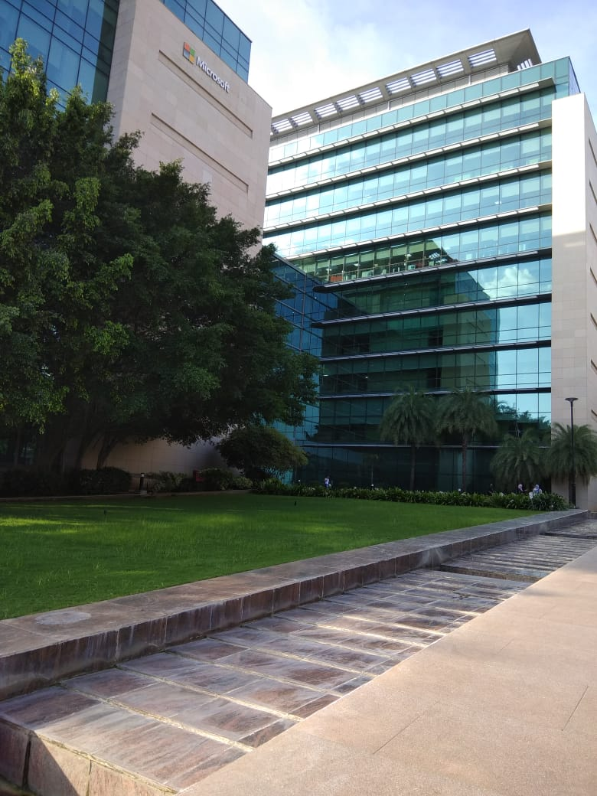
The session started with the inauguration of the workshop by the garage head, moderated by Microsoft employees. Then Ms Deepika Head of Women Entrepreneurship Cell (WE-HUB) gave a speech about the same. The workshop was started by Ms Deeksha who is a Microsoft employee, w discussed the growth of the quantum computer and explained some of the desirable features of quantum computing. Later she has briefly explained about the decoherence, superposition and quantum gates
Microsoft Campus 3, Gachibowli.
We have learnt the advantages of quantum computing that they arise from the way they encode a bit, the fundamental unit of information. Quantum computers can support qualitatively new algorithms based on quantum principles!
We were walked through the installation process of Microsoft QDK and Visual Studio 2019. At 1:00 PM we broke for lunch.

Afternoon Session:
The session recommenced at 1:45 PM with a review on all the software installed in the previous session. Then we were familiarised with the software used in quantum computing. How to write a program on superposition was explained and a session on doubts clarification was done. Programming on NOT Gates was explained along with vector matrices. Quantum entanglement, Controlled NOT Gates and implementation of C-Not gate using 2Qubits in Q# were explained.

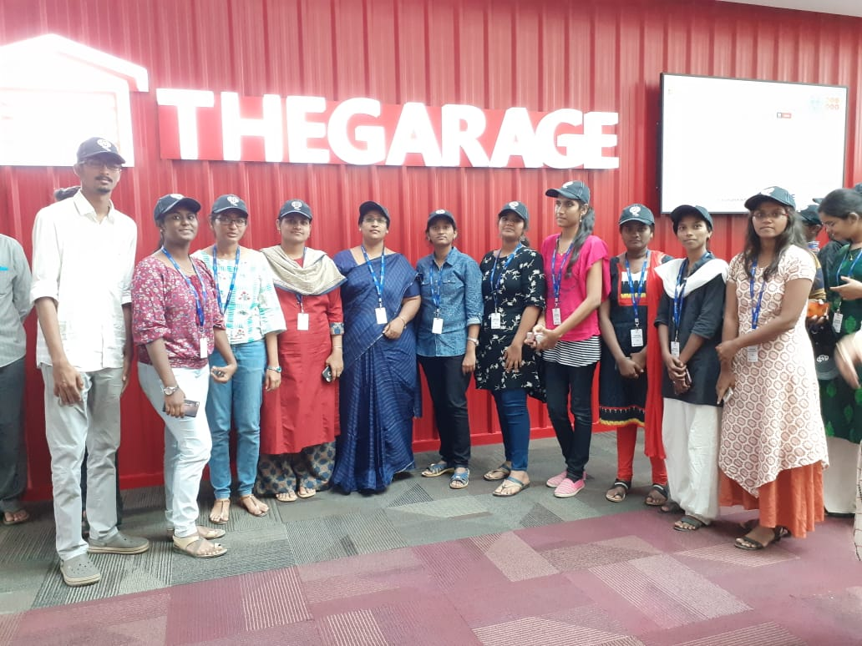
Mrs B.Saritha (IEEE-Advisor) and Mrs Subashini with students at the venue.

Then an intensive doubt clarification session on Quantum Programming was done. Later the attendees were familiarized with IEEE – SIG. Ramesh B. Ketharaju conducted the Closing Ceremony. Attendees broke for a photo session.

The whole workshop was very informative. All the attendees gained more skill and knowledge on Quantum Computing.

Reported by:
IEEE MVSR SB.

