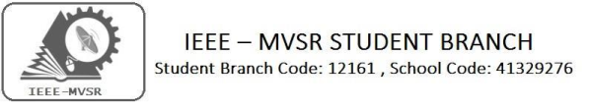
WORKSHOP ON VIRTUAL LABS

IEEE MVSR SB has conducted a one day workshop on Virtual labs on 22nd August 2019.The main motto is to enthuse students to conduct experiments by arousing their curiosity which would help them in learning basic and advanced concepts through remote experimentation.

Student Branch Mentor: WIE Student Branch Advisor:

Dr.AtulNegi, Dr. G. Kanaka Durga,
Professor, School of CIS, Principal & Professor,
University of Hyderabad. MVSR Engineering College.
Student Branch Advisor: PES Advisor:
Mr.V.AshwiniKumar, Dr.D.HariKrishna,
Assoc.Professor,ITDept., Assoc.Professor,EEEDept.,
MVSR Engineering College. MVSR Engineering College.
CS Student Branch Advisor:
Mrs. B. Saritha,
Assoc. Professor, CSE Dept.,
MVSR Engineering College.
WIE Affinity Group:
A.Prathyusha - Chairman
M.Shresta Reddy - Vice Chair N.Sahitya - Secretary L.Ruthvika - Joint Secretary
Ruchitha Reddy - Treasurer

Power Energy Society:
E.Pavan Kumar - Chair
K.Jaya Sree - Vice Chair
N.Avinash - Secretary
B.Nikitha Reddy - Joint Secretary
S.Satvikka - Treasurer

Student Branch Counsellor:
Dr. D. Hari Krishna,
Assoc. Professor, EEE Dept.,
MVSR Engineering College.

Student Branch Executive Committee:
R.Ramyasri - Chairperson
K.Akshitha - Vice Chair
Shreya Maqtedar - Secretary
K.Vinay Kumar - Joint Secretary
V.Vineeth - Treasurer

Computer Society:
S.Sai Teja - Chairperson
G.Suradhya - Vice Chair
M.Vamshi Krishna - Secretary
Phani Sahasra - Joint Secretary
V.Manikanta - Treasurer

Operating Committees:
P.Varun Kumar-Operating Committee Head
Ch.Jinesh- Publicity Committee Head
M V S S R Sahith Rao-Membership Committee Head
Sai Sameer & Hemish - Design Committee Head
M.Sai Sri Teja - Program Committee Head

Session details:
Date : 22nd August 2019.
Time : 10:30am – 4:15pm.
Venue: IT-103, IT- 104 , Department of IT, MVSREC.

Guest Lecturers:
Mr. Ravi Shankar and Ms D. Mrudhulika from Virtual Labs Notch team.

About Virtual Labs:
Virtual Labs project is an initiative of Ministry of Human Resource Development (MHRD), Government of India under the aegis of National Mission on Education through Information and Communication Technology (NMEICT). This project is a consortium activity of twelve participating institutes and IIT Delhi is coordinating institute. It is a paradigm shift in ICT-based education. For the first time, such an initiative has been taken-up in remote‐experimentation. Under Virtual Labs project, over 100 Virtual Labs consisting of approximately 700+ web-enabled experiments were designed for remote-operation and viewing. The intended beneficiaries of the projects are:
- All students and Faculty Members of Science and Engineering Colleges who do not have access to good lab‐facilities and/or instruments.
- High‐school students, whose inquisitiveness will be triggered, possibly motivating them to take up higher‐studies. Researchers in different institutes who can collaborate and share resources.
- Different engineering colleges who can benefit from the content and related teaching resources.
Virtual Labs do not require any additional infrastructural setup for conducting experiments at user premises. The simulations-based experiments can be accesses remotely via internet.
There were two sessions where the first session was meant for ECE/CSE/IT students from 10:30am – 1:30pm & the second session was meant for EEE/MECH/CIVIL/AUTO students from 2:15pm – 4:15pm.
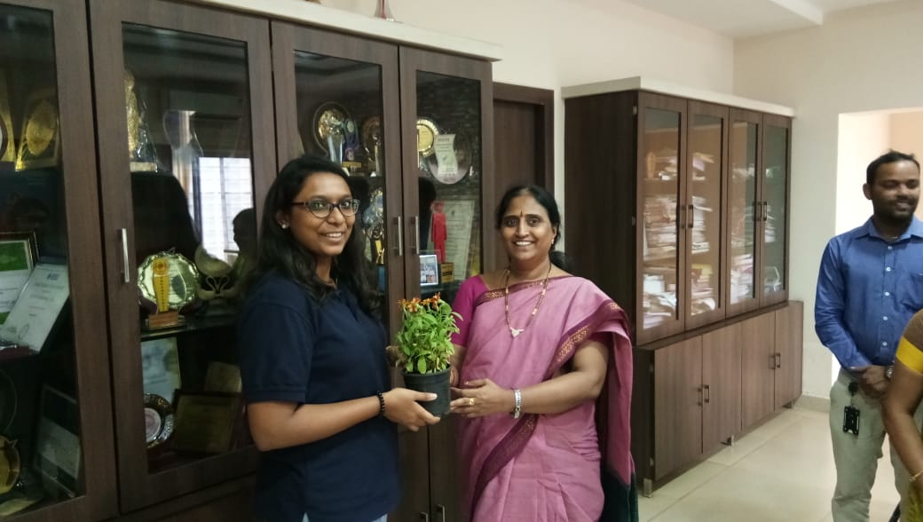
Dr.G. Kanaka Durga presenting a sapling to Ms D. Mrudhulika.
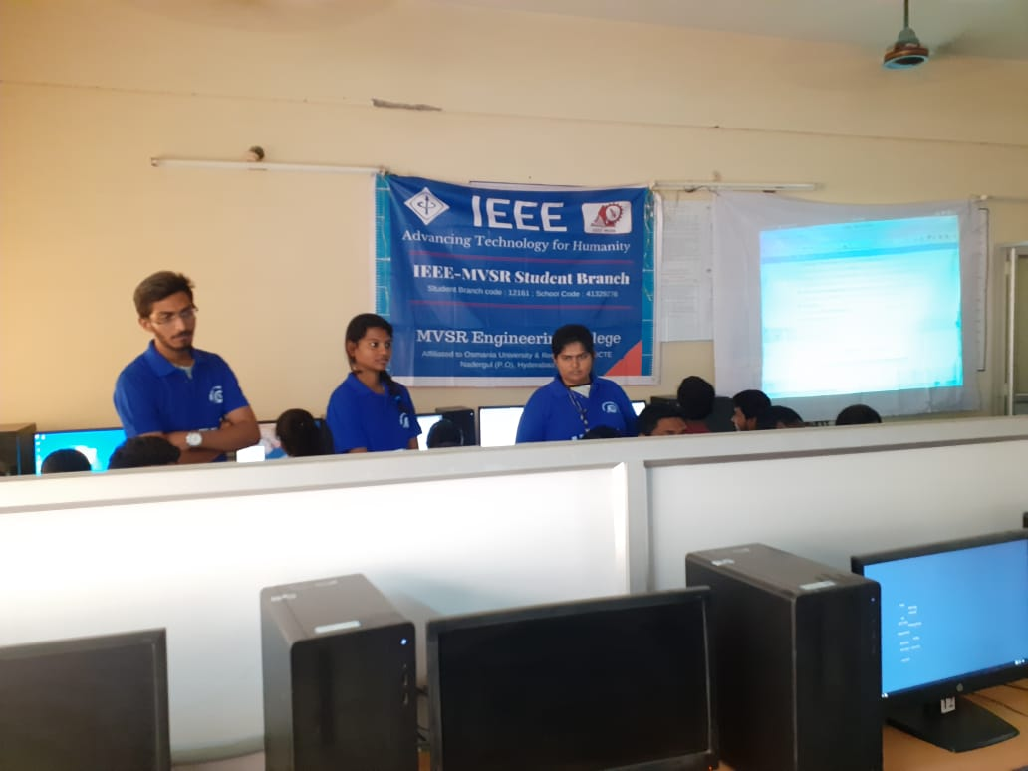
Resource persons explained the students about virtual labs, its importance & advantages. Students were impressed by its wide range of use.
Later both the speakers had met the principal Dr. G. Kanaka Durga, and spoke about MOU. Then, our Student Branch Advisor Mr. V. Ashwini Kumar presented mementos to the speakers.
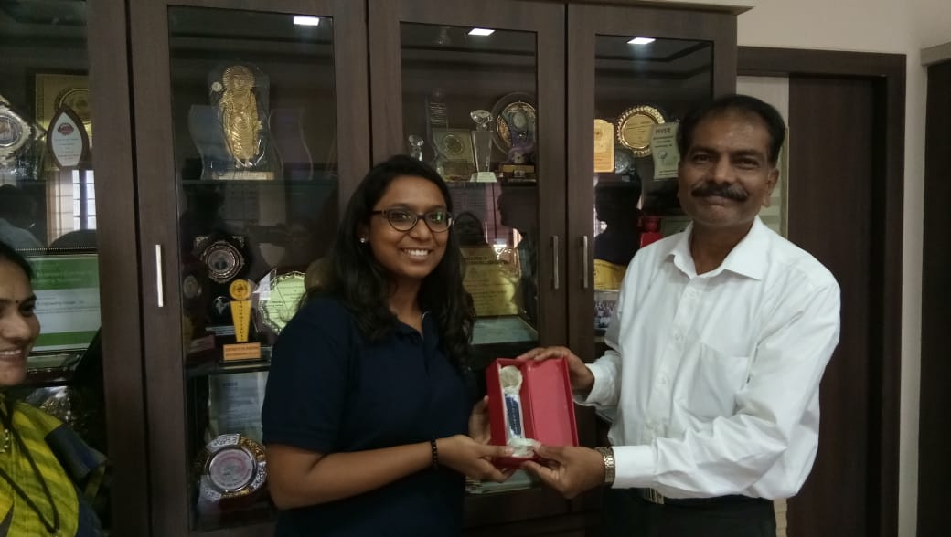
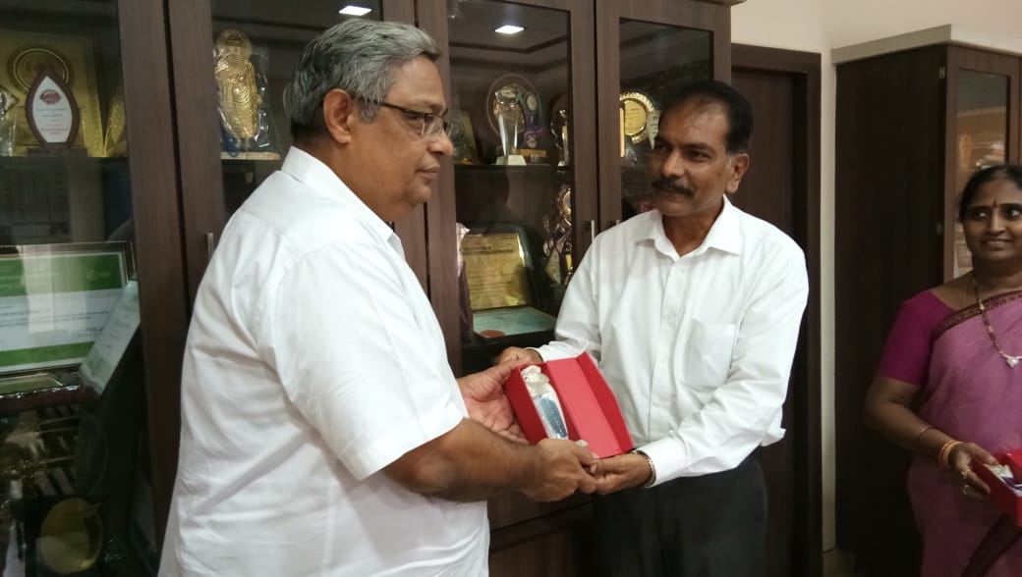
Mr. V. Ashwini Kumar presenting the mementos to Ms. D. Mrudhulika and Mr. Ravi Shankar.

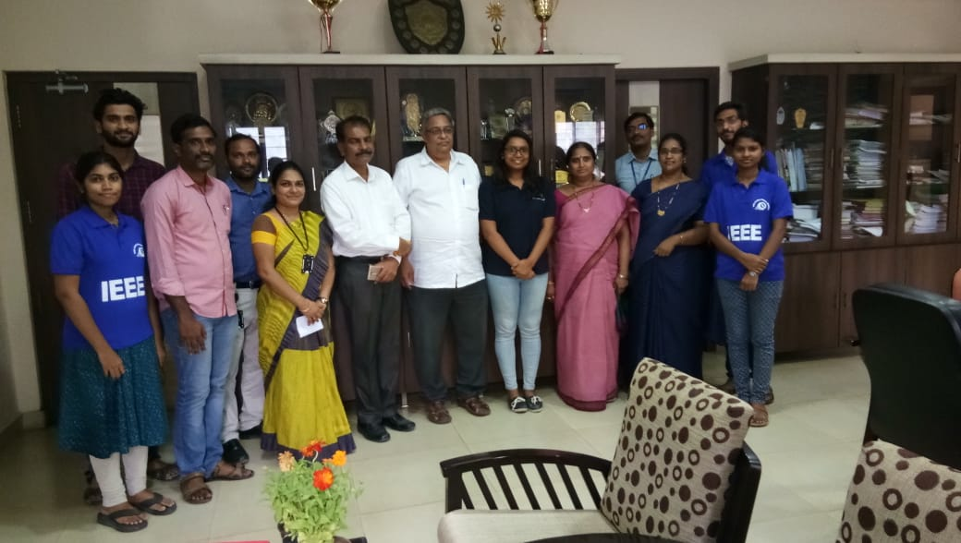
IEEE Volunteers with Speakers, Principal and Faculty coordinators

Reported by:
IEEE MVSR SB.

