Upcoming Event: IEEE Orlando Section Meeting
Please join the IEEE Orlando Section for their monthly meeting with us here at the Valencia College West Campus in Building 11 Room 106 on Tuesday, September 19th, 2023, at 6:30 pm.
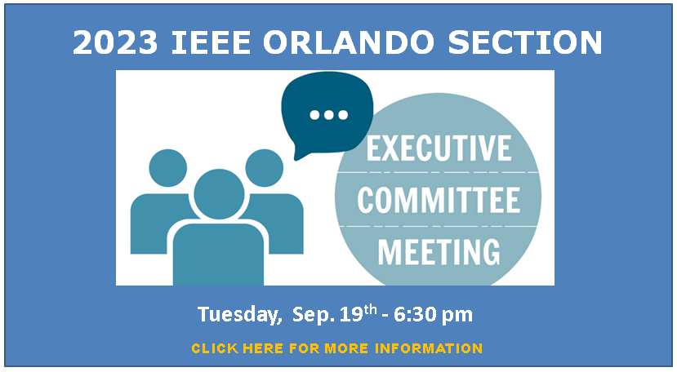

We will have a guest speaker from the FBI Special Agent Justin Crenshaw and cover group business. Come network with local engineering industry professionals, listen and Engage with a Cyber Crimes SA, and share refreshments. Please RSVP with the Orlando Section by emailing Kimberly Fullenkamp, kimfullenkamp@ieee.org More information below.
Guest Speaker Bio:
SA Justin Crenshaw entered the FBI as a special agent in 2004. He has served as a counterintelligence agent in Portland Oregon, Miami Florida, and Counterintelligence Division at FBI Headquarters. Since 2013, SA Crenshaw has supervised multiple programs at the FBI Orlando field office: Counterintelligence, Violent Crime, and Violent Crime Against Children. In 2019, SA Crenshaw was promoted to Assistant Section Chief for the Information Management Division, Records and Information Management Section, in Winchester, Virginia. In 2021, SA Crenshaw returned to Orlando to supervise a newly formed Cyber squad. SA Crenshaw also serves as an Intelligence Officer in the Navy Reserves. He holds a Master of Business Administration (MBA) degree from Florida Atlantic University, and a Bachelor of Science degree in business and management from the University of Maryland.

IEEE Orlando Section Executive Committee Meeting
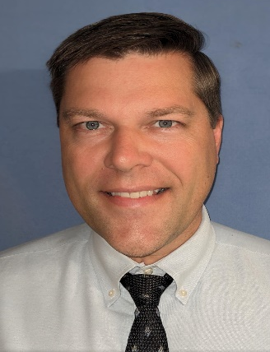
Date: Tuesday, September 19th, 2023
Time: 6:30 pm
Location: Valencia West Campus in Room 11-106
Cost: Meeting attendance is free to all IEEE members and Non-IEEE members but please RSVP for the food count.
RSVP: Kimberly Fullenkamp, kimfullenkamp@ieee.org
Website: www.ieee.org/orlando
A non-profit organization, IEEE is the world's largest professional association for the advancement of technology.

