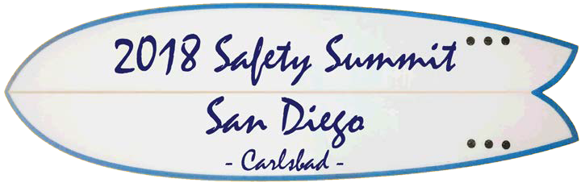

2018 SSSD
Safety Summit San Diego
Sand Diego, California, USA October 9, 2018

ORGANIZERS
IEEE PSES San Diego Chapter
General Chair
Leszek Langiewicz – IEEE/PSES leszekl@ieee.org
Co-Chair
Bansi Patel – IEEE/PSES bansi.patel@ieee.org
Treasurer
Andrew Bera – IEEE/PSES a.bera.us@ieee.org
Secretary/Advertising Gabriel Alcala – IEEE/PSES galcala@atecorp.com
Technical Program Co-Chairs Leszek Langiewicz - IEEE/PSES Andrew Bera – IEEE/PSES
The IEEE Product Safety Engineering Society San Diego Chapter hosts SSSD (Safety Summit San Diego), on all relevant topics for So-Cal professionals in area of product safety.
Join us in San Diego for 1 day of technical sessions and exhibits.

PAPER SUBMISSION
Please contact SSSD organizers for details & submission instructions, including presentation templates.
Presentation not submitted per submission instructions by the initial deadline may need to be held over until next year depending on the number of submissions.

TOPIC AREAS
IMPORTANT DATES
Indicated deadlines require that the associated documents be loaded into the submission portal, by the due date:
August 10, 2018
Presentation Submittal Deadline
Augu 31, 2018
Acceptance Notification Deadline
September 14, 2018
Final Presentation Submission Deadline
October 9, 2018
2018 Safety Summit San Diego
Please visit:
www.SSSD.org (under construction)
The SSSD seeks original and unpublished tutorials on all aspects of product safety including, but not limited to:
- Medical Devices
- Safety of ITE / A/V&ICT Equipment
- New Standards and Hazard Based Safety Engineering
- Functional Safety
- Batteries and Battery Systems
