 | IEEE Product Safety Engineering Society | 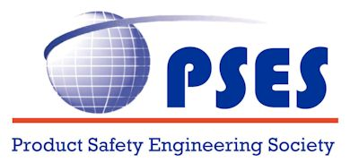

Meeting Report - BoG
April 07, 2022

.************************.
Board of Governors Members:
Mike Nicholls, Stefan Mozar, Daniece Carpenter, Wen-Chung Kao, Michael Anderson, JM (Jong Moon) Chung, Steli Loznen, Bansi Patel, Kim Fung (KF) Tsang, Supavadee Aramvith,
Leszek Langiewicz, Fabio Furlan, Silvia Diaz Monnier, Grant Schmidbauer, John Allen, Jeff Pasternak, Paul Robinson, Tom Lanzisero

Participants:
Mike Nicholls, Daniece Carpenter, , JM (Jong Moon) Chung, Steli Loznen, Bansi Patel, Kim Fung (KF) Tsang, Fabio Furlan, Jeff Pasternak, Paul Robinson,

Guests:
Jim Bender

Call to order 9:07 am Central USA time
Adjourn 10:47 am Central USA time

Welcome:
- No items to add to the agenda
  - Motion to approve Agenda
  - Motion passed
- Dashboard
  - Items need to be updated
- PSES Society Review – IEEE
  - We will undergo the Society Review this year
  - Will schedule a meeting to review our plans
- Review cloud storage options
  - Need a location to store our documents
  - Will review the current cloud storage options available

Housekeeping and Secretary's Report:
- Approval of Meeting Report
  - Motion made and passed

Past President Report:
- BoG Election
  - Time to help find some strong candidates for nomination
- Co-operation with IAS
  - Continue to hold meetings with IAS
- ByLaw changes
  - Will discuss at an upcoming meeting
- VP elections this year
  - Need to investigate term limits

Treasurer's Report:
- Reviewed the status of 2021 year end in the report
- Planned expenses for 2022
- Fellows Committee
  - One candidate
  - Building the evaluation committee
- Report: ______________

VP Conferences:
- ISPCE 2022
  - Funding for PSES Corporate Sponsor complimentary attendees was discussed
  - Symposium Budget is approved
  - Need volunteers to help with the activities at the conference
  - Technical program is progressing well
    - The paper platform has changed from EDAS and is easier to navigate
    - Have received 7 presentations so far
  - Need IEEE to sign with hotel, then can announce the venue
  - Working on a digital program platform for attendees
  - BoG face2face meeting planned for Monday before ISPCE
  - Discussed concerns
- SPCE2022
  - Will not have a conference because of change of dates for ISPCE
- Asia ISPCE 2022
  - Planned for November in Guangzhou, China
- EMC + SIPI – Spokane, WA
- Product Compliance Tutorial is registered
  - Compliance 101, 201, GMA;
  - Open item
    - Currently Ken K/Comp 101, John A/Comp 201 and Grant/GMA will present, but r other volunteers are encouraged
  - This is planned as physical event, so you have to be able to travel to attend.
- ISPCE2023
  - Jim Bender volunteered to host symposium
- Report: __________

VP Member Services:
- Awards
- Kicking off the PSES awards
  - Request for nominations will be issued soon.
  - The awards, as in previous years, will be:
1) Sustained Service Award - IEEE PSES Plaque Award;
2) Service Acknowledgement Award - IEEE PSES Certificate of Appreciation
Award;
3) Service Acknowledgement Award - IEEE PSES Certificate of Recognition
Award; and
4) IEEE PSES Chapter-of-the-Year Award.

- Screen shots from the report

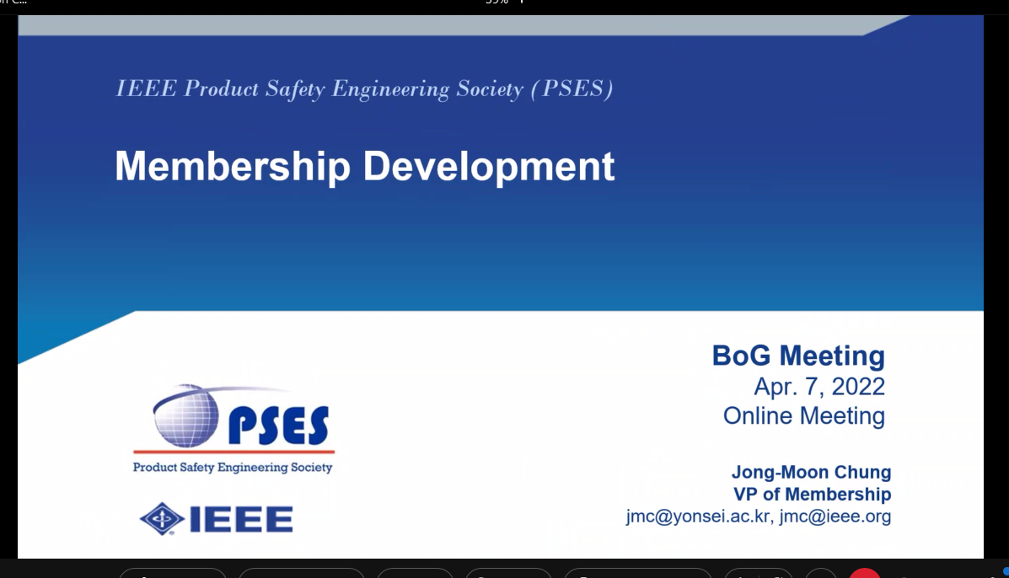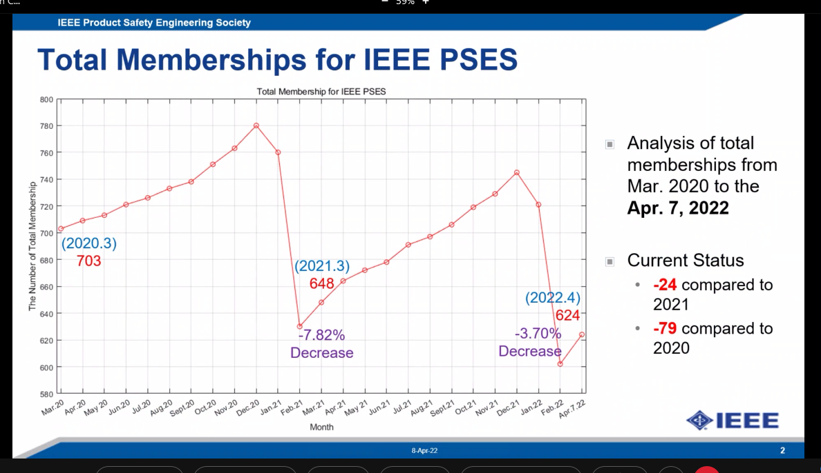

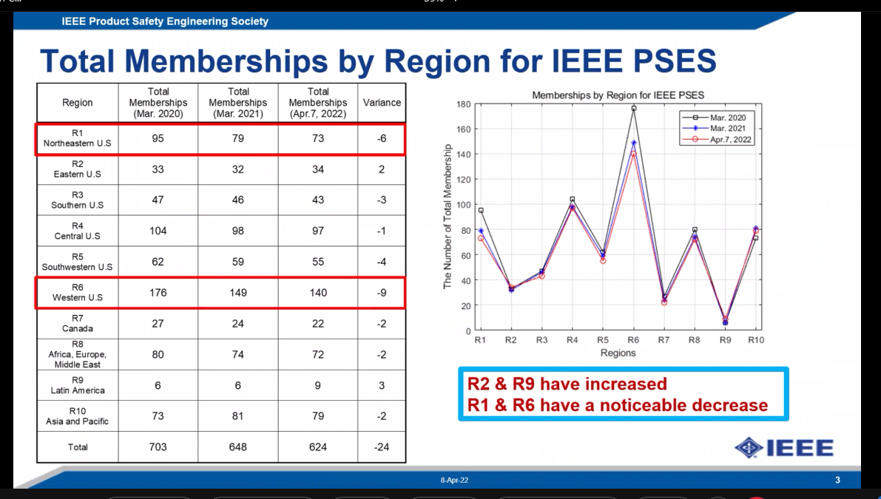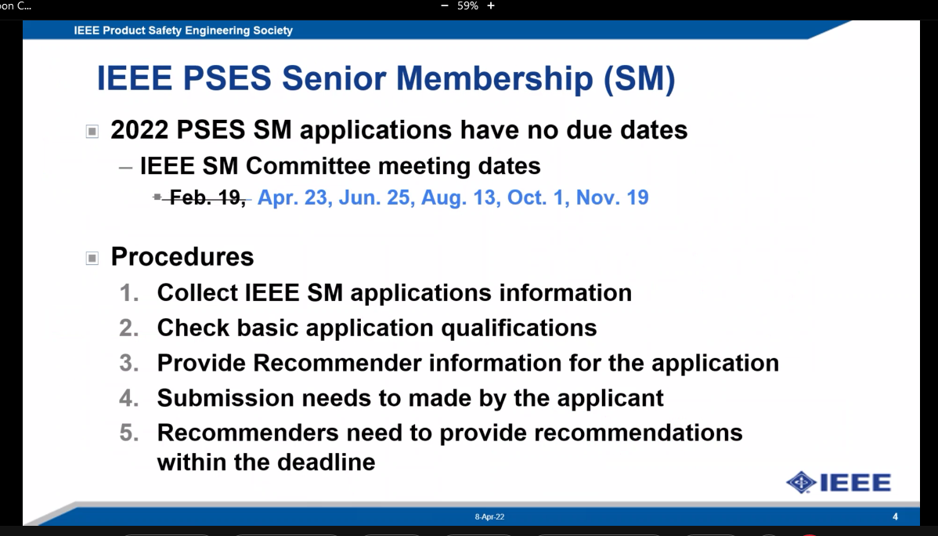

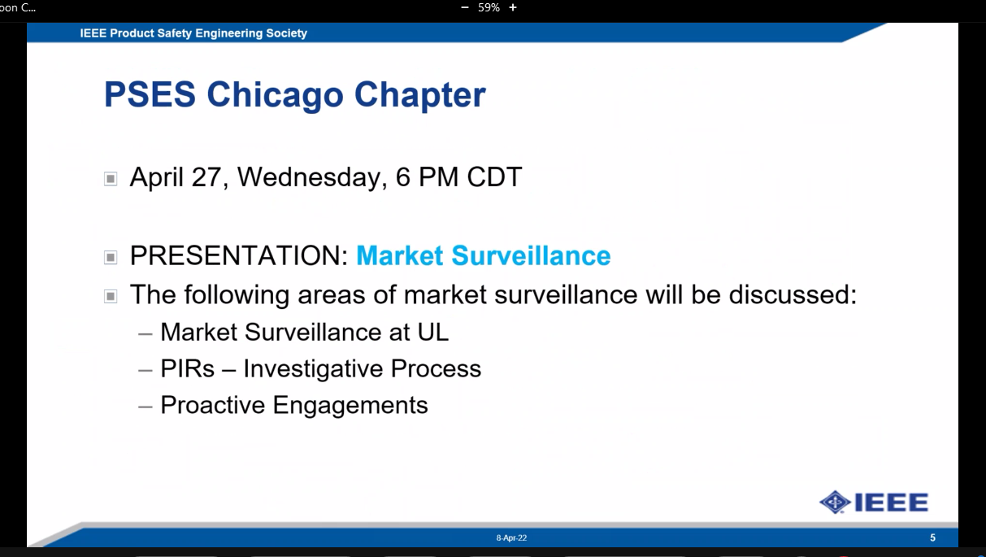

VP Technical Activities :
- Mentor program update
  - Mike Sherman has applied as a Mentor
- Technical Q&A Session report
  - Session held on the Safety Challenges on Electrical Automotive Products
- DL program report
  - Grant Schmidbauer, Pete Perkins, Prof. Dr. JM Chung will hold virtual lectures
- Volunteer position open
- April Technical Q&A
  - Date, time and topic is TBD
- Report: __________

VP Communications:
- PSES website refresh
  - A committee to review and update the website will be convened
VP Publications:
- Newsletter update
  - Newspaper advertisements policy has been implemented
  - Bill Bisenius wants to advertise
- Magazine
  - Collaborating with IAS
  - Meetings to discuss a collaboration is still in progress
- MIT
  - May be collaborating on a new standard

VP Education:
- Update on ILN Compliance course
  - All current items are available on the webiste

Old Business
- Corporate Sponsorship Program
  - The fund has been created with $18K current balance
  - Funds can be transferred to the conference account when required for each complimentary attendee

New Business
- No New Business

Concluding Remarks
BoG election is coming up, need nominations
Need volunteers for conference

Adjourn
Motion made and passed

Next meeting May 5 – 9:00 AM Central USA time

Face to Face Meetings
Extended Board Meetings – 2022
- 2022 Spring Meeting – TBD
- 2022 Fall Meeting – TBD
- ISPCE – September 20 - 22, 2022

Monthly BoG Conferences – WebEx
2022 - First Thursday of the month - 9:00 AM Central US time

2022 BoG Conferences – WebEx
- January 13
- February 3
- March 3
- April 7
- May 5
- June 2
- July 7
- August 4
- September 1
- October 6
- November 3
- December 1

Reminder – USA Daylight Saving Time BEGINS on March 13, 2022 and ENDS on November 6, 2022.

