 | IEEE Product Safety Engineering Society | 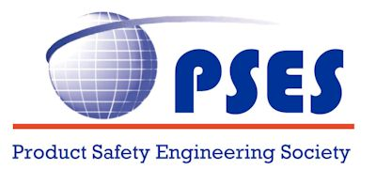

Meeting Report - BoG
July 07, 2022

.************************.
Board of Governors Members:
Mike Nicholls, Stefan Mozar, Daniece Carpenter, Wen-Chung Kao, Michael Anderson, JM (Jong Moon) Chung, Steli Loznen, Bansi Patel, Kim Fung (KF) Tsang, Supavadee Aramvith,
Leszek Langiewicz, Fabio Furlan, Silvia Diaz Monnier, Grant Schmidbauer, John Allen, Jeff Pasternak, Paul Robinson, Tom Lanzisero

Participants:
Mike Nicholls, Stefan Mozar, Daniece Carpenter, Wen-Chung Kao, JM (Jong Moon) Chung, Steli Loznen, Bansi Patel, Supavadee Aramvith

Guests:
Jim Bender

Call to order _9:11_ am Central USA time
Adjourn 11:06_ am Central USA time

Welcome:
- No items to add to the agenda
  - Motion to approve Agenda
  - Motion passed
- Dashboard
  - Dashboard needs to be updated
- PSES Society Review – IEEE
  - Review will be later this year
- Review cloud storage options
  - No report
- Discuss replacement of Treasurer
  - Dr. Supavadee Aramvith
  - Suggest Jim Bender to take VP Education; Jim will review the position description and reply later.
- Conference sponsorships
  - Discussion on the response when other organizations request conference sponsorships.
    - Level of participation should be considered on a case by case basis
    - Response – who should respond to the request
    - Reviewed past requests and found that we have not sponsored with financial support before
    - Decision to limit participation to sponsor in a technical sponsor with activities to distribute the call for paper, use of PSES logo, etc.
- Attended the TAB meeting
  - Spoke with representatives from the Robotics and Systems (RAS) Society;
  - Propose an association to support conferences
  - Discussed common issues with other Society presidents

Housekeeping and Secretary's Report:
- Approval of Meeting Report
  - Motion made and passed
- PSES website committee
  - Submitting changes on a as requested basis
  - Kickoff to be held shortly
- Committee to generate articles
  - Information on ghost writers
  - All ghost writer contacts are currently unavailable.
  - Need to generate new contacts
- Information on VP terms
  - Current VP terms end in December 2022
  - VP terms are 2 years with the option for a renewal twice

Past President Report:
- BoG Election
  - Will complete preparations over the weekend
  - Will ask IEEE for an extension and send an email to BoG
- Must do an email
  - Time to help find some strong candidates for nomination
- VP Election
  - End of 2022
  - Propose to do it at September meeting
- Co-operation with IAS
  - Will follow up with IAS on status of their internal discussions
- ByLaw changes
  - Will present at out next meeting for discussion
- MIT standard
  - Ask for volunteers to serve on the committee
  - Bansi, Steli, Prof Tsung, JM, Daniece
  - Note that volunteers must join the Standards committee
- Have received an invoice from IEEE Publications which seems to be a fraudulent invoice

Treasurer's Report:
- Financial Outlook
  - Member approximately $15K plus conference income;
  - Support for members to attend meetings may be very expensive and need to carefully consider;
  - Any member requesting support will need to submit a proposal with expected expense to be approved before the expenditure
  - Need to support President to attend TAB

VP Conferences:
- ISPCE 2022
  - Technical Program currently includes 66 submissions with 10 full papers
  - Great effort from the committee to spur interest and their efforts are appreciated
  - 57 attendees registered as of June 28 but it is still early
- Asia ISPCE 2022
- EMC + SIPI – Spokane, WA (Grant Schmidbauer)
  - Product Compliance Tutorial is registered
    - Compliance 101, 201, GMA
  - The PSES banner and booth materials have not been located. New material is order is in process .
  - A discussion was held on how to send out the EMC conference announcement to our members
  - One possibility is a IEEE eBlast, but how do we make sure that it has been sent
  - vTools can be used for local Section
- Report : _________

.

VP Member Services:
- Awards (Grant Schmidbauer)
  - Update on the awards
  - Closing date for nominations was June 30. Received few nominations for Service awards and will continue to work with IEEE for award materials
1) Sustained Service Award - IEEE PSES Plaque Award;
Will host a committee of 3 people to review and decide recipient
2) Service Acknowledgement Award - IEEE PSES Certificate of Appreciation
Award;
Received few nominations
3) Service Acknowledgement Award - IEEE PSES Certificate of Recognition
Award;
Received few nominations
4) IEEE PSES Chapter-of-the-Year Award.
No nominations received so will need input from VP Membership
Possible to honor Virtual Chapter or another Chapter with information from VP. If no choice, we will not have a Chapter of the Year award for 2022. Note that the award is for 2020-2021, awarded in 2022/
- Membership is increasing
  - Still -10 compared to Year over Year in 2021 and -53 compared to 2020
  - Reviewed statistics for each membership grade
- Volunteer positions yet to be filled
  - IEEE Region 7 Coordinator
  - Young Professionals (YP) committee chair
  - Women in Engineering (WIE) committee chair
- Report: _________________

VP Technical Activities:
- Mentor program update
  - See the report for a current list of Mentors. Several topics still need mentors
- DL program report
  - DL presentations will be delivered virtually
  - Need to advertise to Chapters and in our Newsletter
- Volunteer position open
  - Need TC chairs. See the Report for positions open
- Q&A Session report
  - The May Q&A was on “Internet of Things Maturity Index: Compliance and Safety” chaired by Assoc. Prof. Dr. Kim Fung Tsang
  - Japan chapter requested copies of the past Q&A ;
  - Held a discussion on whether to include on Japan website or PSES website or locate in ILN
  - Decision is to locate it in ILN at no charge
- July Technical Q&A
  - Date, time and topic
  - The presenter and the date for Q&A in July TBD.
- Website
  - Secretary will work with VP on the Technical activities webpage
- Report: _________

VP Communications:
- PSES website refresh
  - Plan is for 2 phases
  - Phase 1 will correct any errors, broken links, etc.
  - Phase 2 will develop a new format for the website

VP Publications:
- Newsletter update
  - 2 items still needed for the newsletter
  - Paid advertisement will do in the June newsletter
  - Need permission from InCompliance Magazine to reprint Stelli’s article
- Magazine
  - Collaborating with IAS
  - Still pending information from IAS; will need follow up
- ISPCE 2022
  - Planning meetings are being held
  - Will be a hybrid conference; Hong Kong presenters will not go to China
  - Planning a virtual appearance by Mike Nicholls, Bansi Patel, Stefan Mozar
- Standard with MIT
  - Plan to submit probably in August
    - Invite members to join effort
- Newsletter: _________

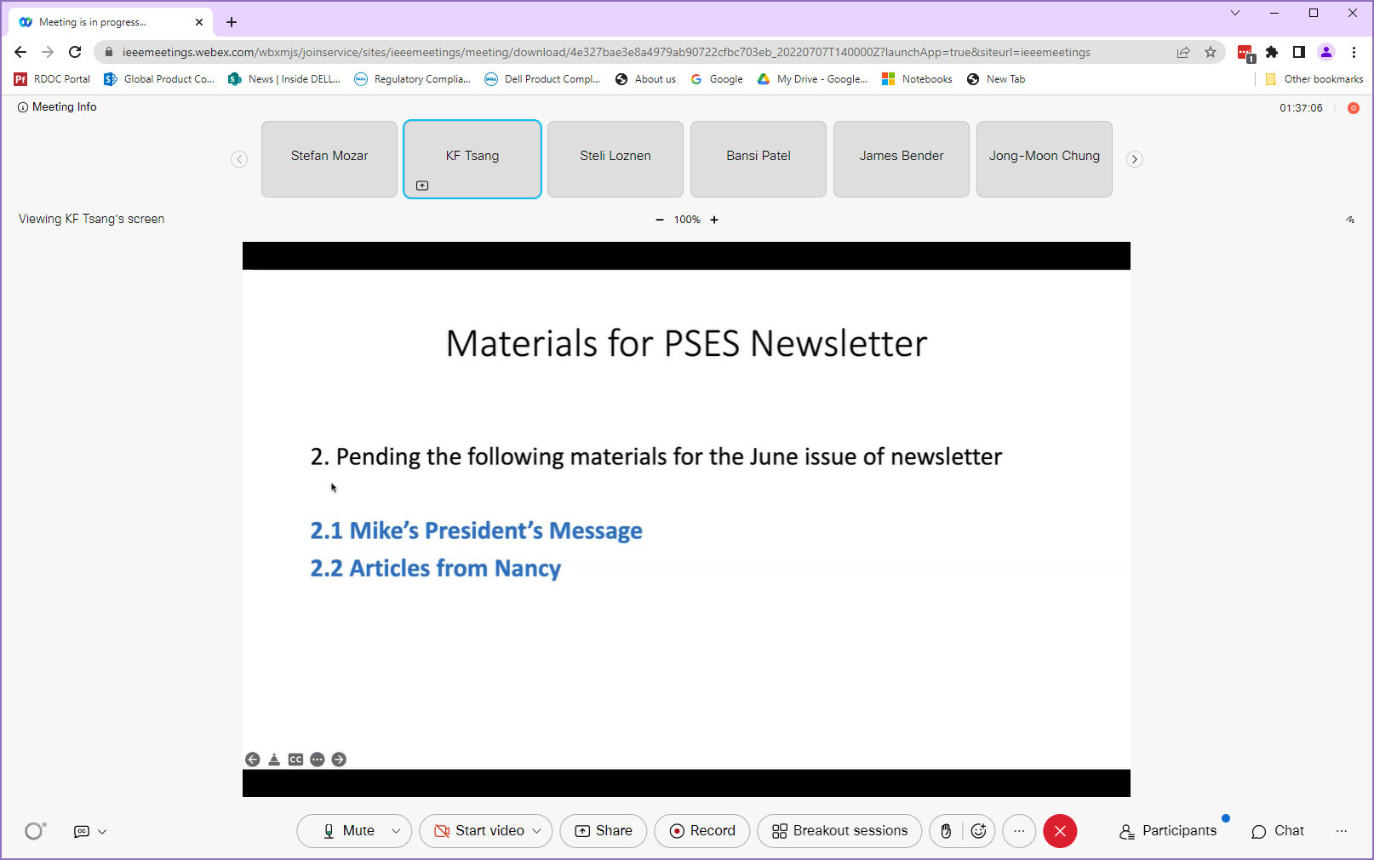

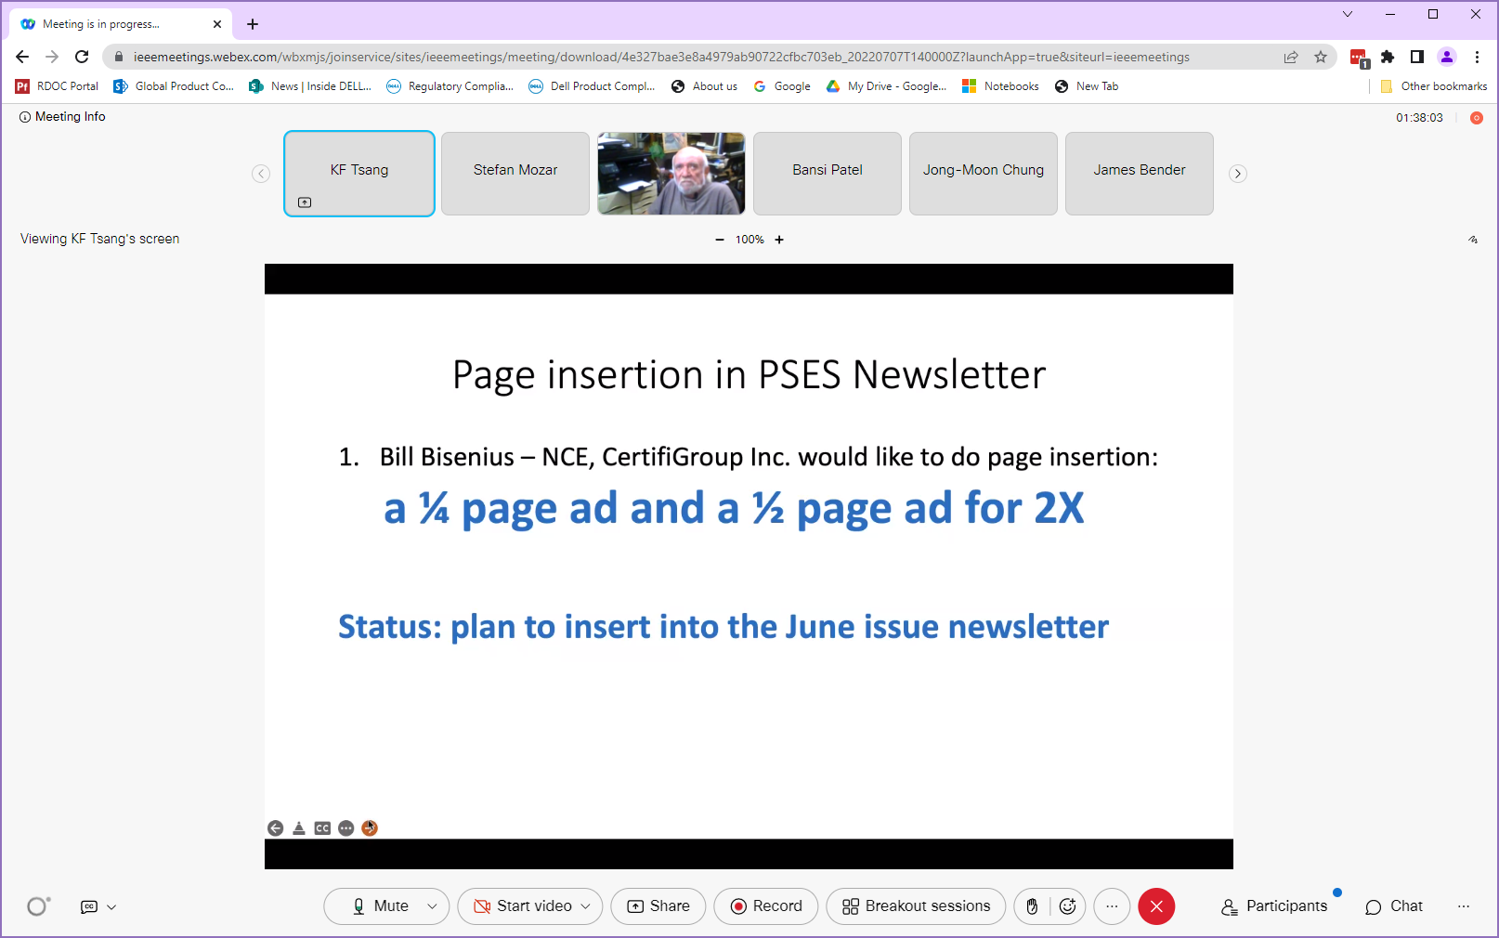

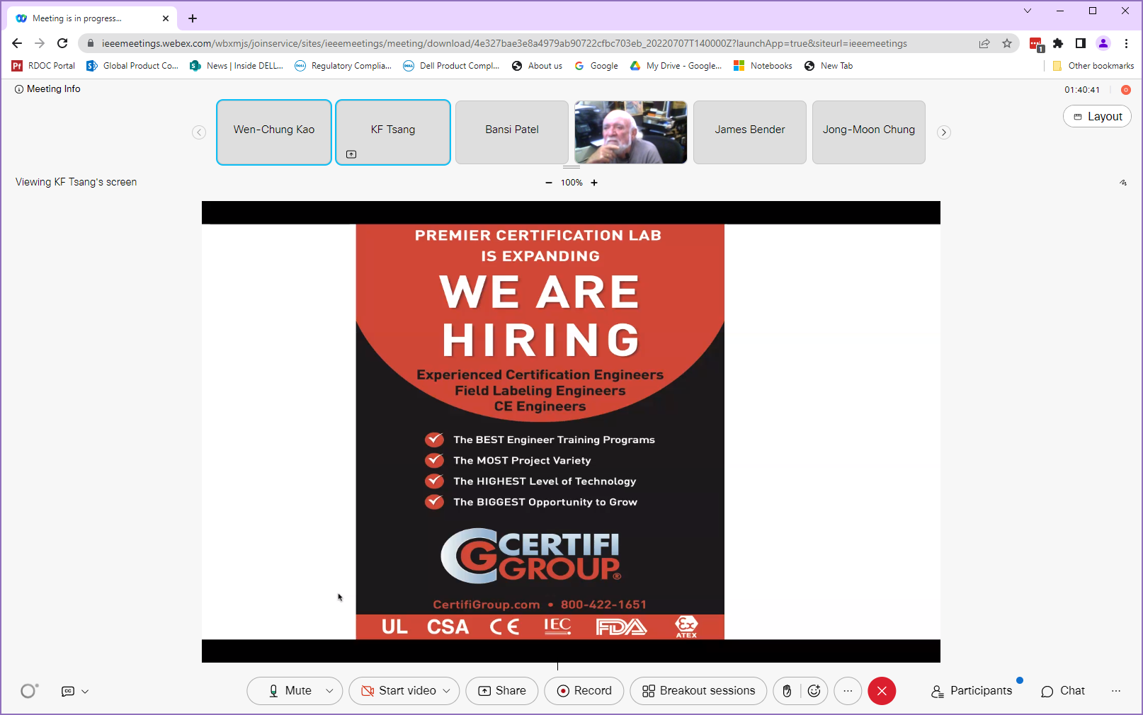

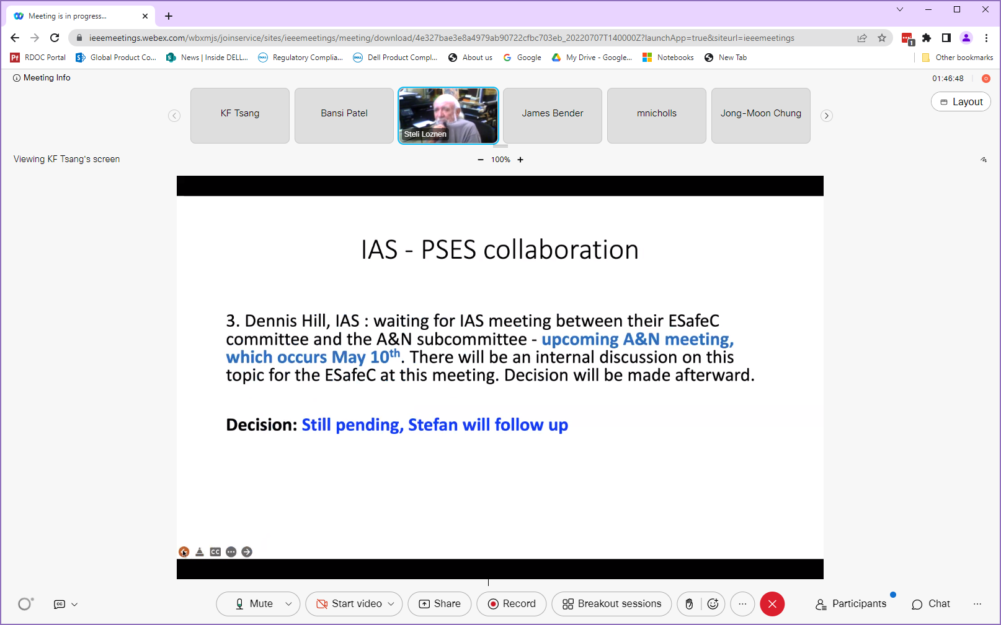

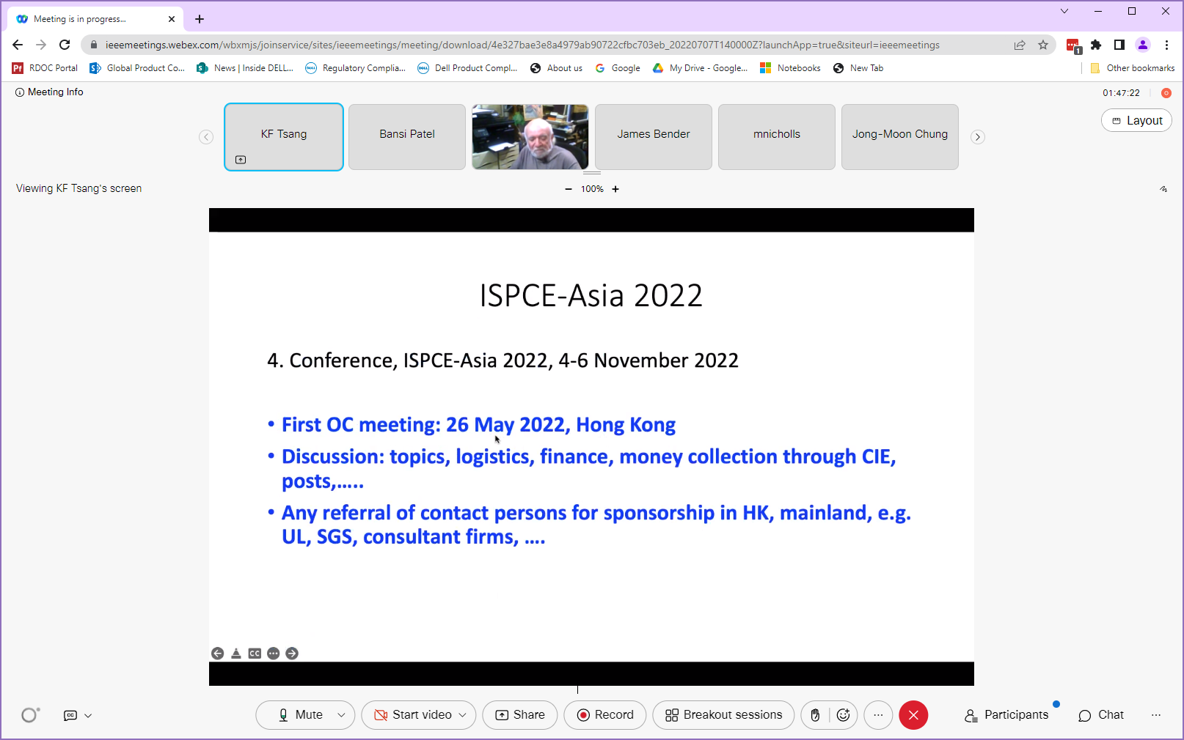

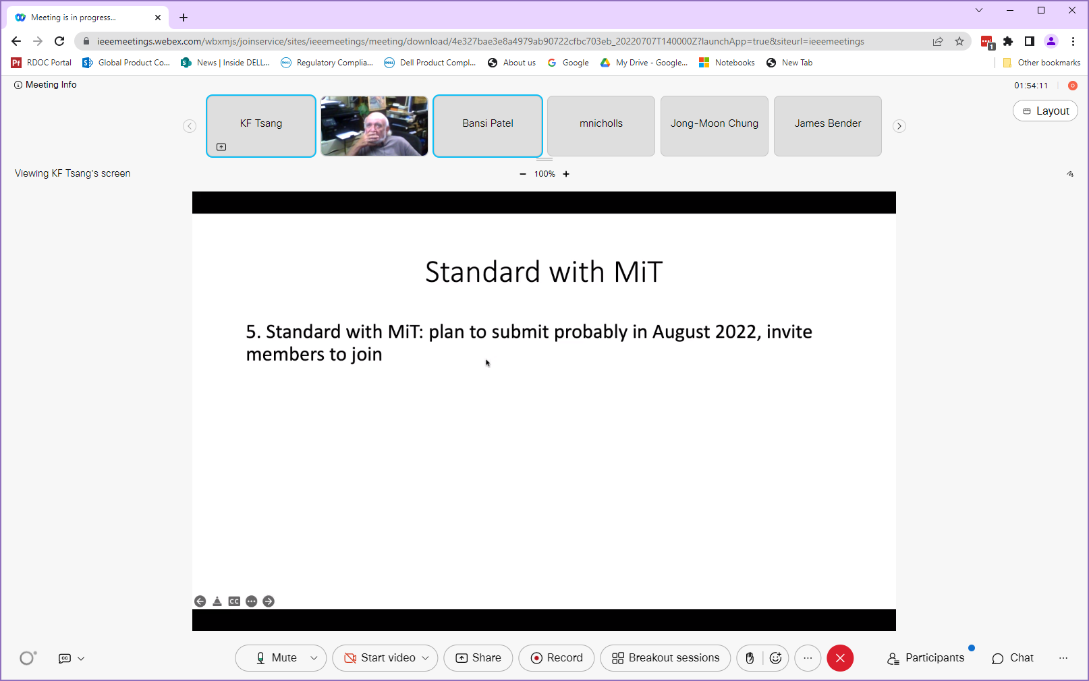

VP Education:
- Update on ILN Compliance course
  - Promotion is ongoing
  - Issue with receiving updates from educational activities for attendee statistics. Working to resolve the issue.
- TryEngineering Tuesday
  - Need speaker from PSES – 30-40 minutes with Q&A
- Webpage for education
  - Web page content
    - Mission/vision/activities
    - Collection of archived PSES educational content (video/past webinars)
- PSES collaborated educational webinar with chapters/universities
  - A broader knowledge of product safety
- Report: ____________

Old Business
- No old business

New Business
- No old business
- pen Floor for comments from attendees (any telecom attendee)
- Any new changes coming?

Concluding Remarks

Adjourn
11:06 AM

Next meeting August 4 – 9:00 AM Central USA time

Face to Face Meetings
Extended Board Meetings – 2022
- 2022 Spring Meeting – TBD
- 2022 Fall Meeting – September 19, 2022
- ISPCE – September 20 - 22, 2022

Monthly BoG Conferences – WebEx
2022 - First Thursday of the month - 9:00 AM Central US time

2022 BoG Conferences – WebEx
- January 13
- February 3
- March 3
- April 7
- May 5
- June 2
- July 7
- August 4
- September 1 - cancelled
- October 6
- November 3
- December 1

Reminder – USA Daylight Saving Time BEGINS on March 13, 2022 and ENDS on November 6, 2022.

