Guidelines for EDTM Paper
with 14-pt Title even for 2 Rows
Kazunari Ishimaru¹, Naoto Horiguchi², Paul Berger³, Lining Zhang⁴,
Kazuo Nojiri⁵, Yoichiro Kurita⁶, and William Nehrer⁷
¹Toshiba Corp., Tokyo, Japan, edtm@jtbcom.co.jp
²Imec, ³Ohio State Univ., ⁴Hong Kong Univ. of Sci. and Tech., ⁵Lam Research, ⁶Toshiba Corp., ⁷PDF Solutions

Abstract
This abstract is a brief (75 words) synopsis of your 3-page paper.
(Keywords: Manufacturing, CMOS and SOI)
Introduction
This template has been tailored for output on A4- or letter-sized paper. Margins, column widths, line spacing, and type styles are built-in; examples of the type styles are provided throughout this document and are identified in italic type, within parentheses, following the example, for the Electron Devices Technology and Manufacturing conference (EDTM) [1]. Final camera ready 3-page paper of text with 2 columns, figures and tables should be submitted by October 16. The paper should explain why/how it was done, principal results, and their significances.
Formats and Fonts
14, 12 and 11 pt of Times New Roman are used for the title, author/affiliation and text, respectively. In particular, the use of the International System of Units (SI Units) is advocated. And use a zero before decimal points: “0.25”, not “.25”.
A. Equations
11-pt Italic of Times New Roman is used for the equation, as shown in Eq. (1). The number of equation within parentheses are to position flush right.
y = f(x) (1)
B. References
When referring to them in the text, type the corresponding reference number in square brackets as shown at the end of this sentence [1].
C. Table
10.5 pt of Times New Roman is used for the caption, as shown in Table 1.
D. Figure
Note that the digest of EDTM will be provided as an electronic information through the USB. However, maximum 10 figures are recommended to find the achievements of your work. 10.5 pt of Times New Roman is also used for the caption.
Conclusion
Summarize the contents of paper. And finally, don't forget to check the spelling.
Acknowledgments
The authors gratefully acknowledge the contributions of T. Edison, G. Westinghouse, N. Tesla, A. Volta and A. Ampere to the electric power industry.
References
- http://ewh.ieee.org/conf/edtm/2018/
- T. Ohashi, K. Suda, S. Ishihara, N. Sawamoto, S. Yamaguchi, K. Matsuura, K. Kakushima, N. Sugii, A. Nishiyama, Y. Kataoka, K. Natori, K. Tsutsui, H. Iwai, A. Ogura and H. Wakabayashi, “Multi-layered MoS₂ film formed by high-temperature sputtering for enhancement-mode nMOSFETs,” Japanese Journal of Applied Physics, Vol. 54, No. 4S, 2015, doi:10.7567/JJAP.54.04DN08.
- T. Tanaka, Y. Kurosawa, N. Kadotani, T. Takahashi, S. Oda, and K. Uchida, “Deionization of dopants in silicon nanofilms even with donor concentration of greater than 10¹⁹ cm⁻³,” Nano Lett., vol. 16, 1143, January 2016, doi: 10.1021/acs.nanolett.5b04406.
- http://researcher.watson.ibm.com/researcher/view.php?person=jp-SHINTYM
- Tatsuro Maeda, Eiko Mieda, Hiroyuki Ishii, Taro Itatani, H Hattori, Tetsuji Yasuda, Atsuhiko Maeda, Yuichi Kurashima, Hideki Takagib, T Aoki, T Yamamoto, Osamu Ichikawa, T Osada, T Takada, Masahiko Hata, J. Yugami, A. Ogawa, T. Kikuchi and Y. Kunii, “Thin Epitaxial Film of Ge and III-V Directly Bonded onto Si Substrate,” ECS Trans. 2014 Vol. 64, issue 6, 491-498, doi: 10.1149/06406.0491ecst.
- W. Grabinski and T. Gneiting, “Power/HVMOS Devices Compact Modeling,” Springer, ISBN: 978-90-481-3045-0 (2010).
- Shuji Ikeda, Yasuko Yoshida, Koichiro Ishibashi, Yasuhiro Mitsui, “Failure analysis of 6T SRAM on low-voltage and high-frequency operation,” IEEE Trans. Electron Devices, Vol. 50, p. 1270, May 2003.

Table 1: List of font sizes.
Text | Type | Font [pt]
Title | Bold | 14
Authors |  | 12
Affiliation |  | 12
Headings | Bold | 11
Sub-headings | Italic | 11
Main text |  | 11
Equation | Italic | 11
References |  | 10.5
Footnotes |  | 10.5
Table caption |  | 10.5
Figure caption |  | 10.5

Fig. 1: Logos of the IEEE, EDS, and EDTM.

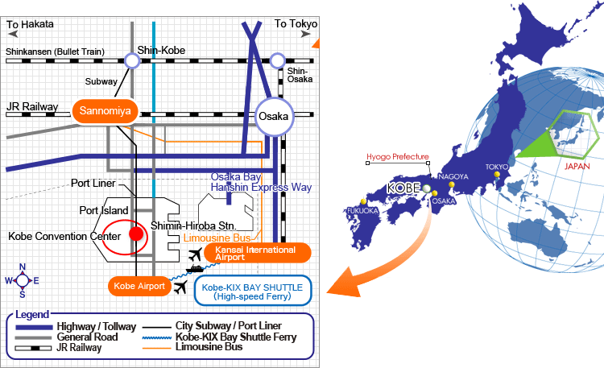

Fig. 2: The place of Kobe in Japan and direction to the conference venue from the Kansai International Airport, the Kobe Airport and the Sannomiya Station.

