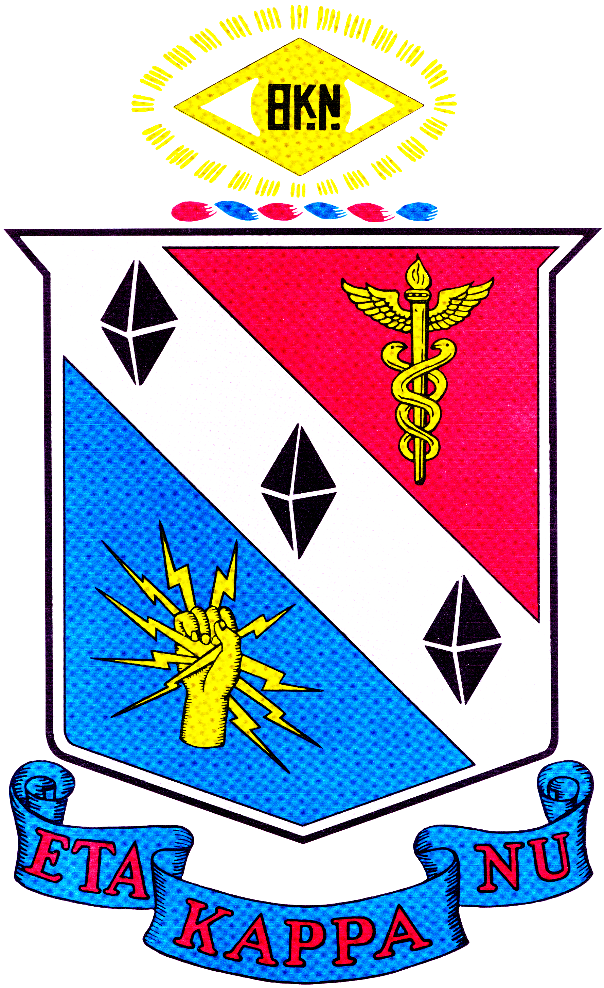

Sigma Chapter
Carnegie Mellon University
2009-2010 Annual Report
Officers for the 2009-2010 Academic Year:
Jessica Liao, President
Yush Gupta, Vice-President
Gregory Pitts, Treasurer
Devon Yang, Webmaster
Steven Das, Mentoring Chair
David Lewis, Tours Chair
Samarth Bhagava, Secretary

Faculty Advisor: Prof. David Casasent (Fall); Prof. William Nace (Spring)
Professional Advisor: Susan Farrington

Previously Initiated Members Currently in the Chapter: 59

New Members: 25

Membership Summary:
Sigma Chapter began the 2009 – 2010 academic year with 59 members. In the fall 65 students were invited to join Sigma Chapter; 25 of which accepted and participated in initiation rituals. Therefore, Sigma Chapter had a total of 84 members.

Table of Eta Kappa Nu Sigma Chapter Programs and Activities
Program/Activity | Fall Semester | Spring Semester | Person Hours
Fall Initiation | X |  | 97
Mentoring Program | X | X | 34
Snack Night Socials | X | X | 374
Department Tours | X | X | 374
Eta Kappa Nu Conference/Detroit | X |  | 6
Carnegie Science Center Outreach |  | X | 24
ECE Day – Project Demos |  | X | 78
Capstone Design Showcase |  | X | 40
ECE Jeopardy |  | X | 24
Spring Initiation |  | X | 38
Build_18 | X | X | 100
Excellence in Teaching Award |  | X | 55
Meeting of the Minds |  | X | 19
Total |  |  | 1263

Fall Initiation
Continuing a tradition started last year, our Fall Initiation was combined with a general body meeting in order to provide a direct welcome from the rest of the chapter and immediately involve new members in the functioning of the chapter. In total, the event lasted 2 hours. The first hour was used to initiate new members, the second hour was a celebratory meal. Current members were invited to all portions of the ceremony and meeting. During the meal, current members greeted new members and informally introduced them to the life and character of Sigma chapter.

Planning hours: 1 person x 7 hours + 5 persons x 2 hours = 17 person-hours
Execution hours: 40 persons x 2 hours = 80 person-hours
Total hours: 97 person-hours

Mentoring Program
The 09-10 mentoring program focused on two areas:

1) Steven Das, the mentoring chair worked on the creation of a professional development event aimed at exploring non-traditional career options possible with an ECE degree. With the thought that intelligent, problem solving individuals can do many different types of things and contribute in many different ways, he sought to create a forum whereby members and ECE students in the Dept. could hear from doctors, lawyers, artists, consultants, politicians/government agency leaders, etc. who had engineering degrees. After discussions with officers, members and advisors he started to identify the professionals who could be involved in either one panel discussion or separate career talks. Numerous individuals were identified, however, scheduling for the current academic year became an issue. Therefore, it was decided that the concept, planning and work done would be passed on to next year’s officers to implement and that the focus this year would be a talent show on ECE Day, the last day of classes. Steven was able to find ECE students and faculty with extraordinary musical ability to perform on stage for the ECE community. It was one of the highlights of this annual event. From classical keyboard, to rock band and folk guitar, a wide variety of talent acts demonstrated the fact that engineers can and do have many developed talents.

2) HKN members were also available to support ECE Dept. information sessions for incoming sophomores and to act as peer mentors to help with course and curriculum questions.

Professional Development Event Planning: 1 person X 10 hours = 10 person hours
ECE Day Talent Show: 1 person X 15 hours = 15 person hours
Class presentation hours: 6 persons x .5 hours = 3 person-hours
One-on-one mentoring hours: 3 persons x 2 hours = 6 person-hours
Total hours: 34 person-hours

Snack Night Socials
As a long-standing tradition, Sigma Chapter (in cooperation with our sponsors) has provided snack food on Wednesday nights that any student in the department is welcome to enjoy. The food is typically served around 9 pm, as planned evening labs are winding down and students are starting to come in for late night work sessions in 24hour labs or the computer cluster. The officers and members took turns purchasing the snacks and providing the forum of interaction for that evening. In other words, not only is it a snack break, but also a time to interact and get to know one’s peers and the HKN members.

Planning hours: 1 person x 1 hour x 34 weeks = 34 person-hours
Execution hours: 20 persons x .5 hours x 34 weeks = 340 person-hours
Total hours: 374 person-hours

Department Tours
In an effort to support the department in recruiting exceptional new students, current HKN members volunteer their time to give prospective students informal tours of the department. As we would like visitors to have a genuine and authentic impression of the department, tour guides have no script and receive only moderate guidance on how to approach the tour and present the department. We have found that visitors are overwhelmingly left with a positive impression of the department and appreciate the chance to have an informal conversation with a friendly, untrained student. Often the impression of the department made during the tour is significant and lasting enough that enrolled students can recall whom their tour guide was when they first visited. This year was exceptional in that improvements were made to the schedule, tour route and tours website. HKN took over tours during “April Yield” which is normally handled by the Dean’s Office. For the month of April, the number of tours dramatically increased, but was handled with dedication and extraordinary enthusiasm by HKN members.

Planning hours: 1 person x 1 hours x 34 weeks = 34 person-hours
Execution hours: 5 persons x 2hour x 34 weeks = 340 person-hours
Total hours: 374 person-hours

Eta Kappa Nu National Conference in Detroit

Three Sigma Chapter officers attended and participated in the National Conference. Upon returning, we shared what we had experienced and learned with the members and our advisors. We were interested to see that some chapters had more graduate student members than undergrads because Sigma chapter has traditionally been mostly undergraduates. This inspired us to consider outreach activities that would encourage more MS and PhD students to join and affiliate. While this was not quantitatively achieved last year, the discussion and resulting plans were passed on to the next set of officers to implement.

Report and discussion hours: 3 people X 2 hours = 6 person-hours
Total hours: 6 person-hours

Carnegie Science Center Outreach
In an effort to increase public awareness and appreciation of engineering and connect students with the surrounding community, Sigma Chapter joined efforts with Professor Tom Sullivan to offer a learning opportunity to the public. Students assisted Professor Sullivan in leading a simple building exercise demonstrating some basic principles and the excitement intrinsic to ECE. The event took place over the morning and afternoon of two days.

Total hours: 2 persons x 6 hours x 2 days = 24 person-hours

Fifth Annual ECE Day
Since 2006, the last day of classes of the spring semester has also marked ECE day. This day celebrates all aspects of the ECE experience and engages the entire ECE community, including undergraduate and graduate students, faculty and staff. The day is marked by a number of planned activities both inside and outside. Sigma Chapter has provided the Capstone Design Showcase and ECE Jeopardy games for each ECE Day and this year added a focus on projects demonstrations from classes (both undergraduate and graduate) and independent project activity like Build 18. By promoting this idea and activity, HKN was able to integrate ECE academic activity with ECE community activity for purposes of enjoyment and education. This year Yush invited an embedded systems class and a pattern recognition class to present to the community on ECE Day, with Build 18 independent projects following.

Project Demo Planning hours: 1 person x 8 hours = 8 person-hours
Execution hours: 10 persons x 7 hours = 70 person-hours
Total hours: 78 person-hours

Capstone Design Showcase
In the capstone design showcase, upper-class and graduate students presented projects completed in Capstone Design Courses. These are 500 level courses where students work in teams to complete a large project over the course of an entire semester. Each undergraduate student must complete a capstone design course to graduate. Presenters prepared Power Point presentations describing the basic requirements of their capstone design course, how students should prepare for the course, and why they should be excited for that particular course. Presenters also often included a demonstration of their actual project in the presentation to give students a more concrete idea of the outcome. Presenters were also available for questions from students considering the various capstones.

Planning hours: 1 person x 5 hours + 5 persons x 1 hour = 10 person-hours
Execution hours: 15 persons x 2 hours = 30 person-hours
Total hours: 40 person-hours

ECE Jeopardy
Approximately seven years ago, an HKN member, Kermin Fleming, won the national college Jeopardy competition on TV. In honor of Kermin’s win, Sigma Chapter developed its own ECE Jeopardy game after purchasing the official software and buzzer systems. Each year, a subset of Sigma chapter members recreates the game with a new set of categories and questions relevant to the ECE discipline and life in the ECE Department. On ECE Day, everyone gets to play round after round and challenge themselves and their teams to victory. This popular past time in ECE is both fun and educational.

Planning hours: 1 person x 6 hours + 5 persons x 2 hours = 16 person-hours
Execution hours: 2 persons x 4 hours = 8 person-hours
Total hours: 24 person-hours

Spring Initiation
The spring initiation of Sigma Chapter was successful by the standard of our previous spring initiations. Generally, the fall initiation is larger as this is when a new class of students will have advanced to eligibility. However, this year we still initiated 7 new members during the spring ceremony. As usual the ceremony was concluded with a meal for the new members and initiating officers. Unlike our fall initiation, the spring initiation was not coupled with a general body meeting simply due to the timing of events and workflow during the semester. Spring initiates were not counted in the number of inductees because, due to a facilities emergency in our advisor’s office, the Spring paperwork was destroyed. Our advisor is in the process of working with those initiates (most of whom have graduated and left campus) to regenerate that paperwork and then file it with National.

Planning hours: 1 person x 5 hours + 5 persons x 1 hours = 12 person-hours
Execution hours: 13 persons x 2 hours = 26 person-hours
Total hours: 38 person-hours

Build_18
Since the “Build 18” tinkering/gadgeting festival for ECE students was previously created and piloted by Sigma Chapter member, Boris Lipchin, HKN decided to remain involved at a high level and insure that this creative project activity that uses ECE discipline ideas and skills, would be successfully launched in its first full year of delivery. Vice President, Yush Gupta, joined the Build 18 leadership team and initiated the idea of corporate sponsorships to fund the activity. He wrote a formal proposal, contacted many companies and eventually secured over $5,000 in funding from Qualcomm, Google and SparkFun. He encouraged all sponsors to send representatives to campus to support the event, interact with the students building the projects and even provide a talk or two for educational value, and they did so. Yush also worked with the platinum sponsor (Qualcomm) to create the Innovation Award that would be given on ECE Day. The funding that Yush raised provided parts and components for the projects, t-shirts for participants, snacks during the festival and awards at the end of the competition. In 2009-10, sixteen teams signed up for Build 18, all presented exciting work at the end of one week and six teams continued to work on their projects in their spare time and competed for the Innovation Award on ECE Day. Build 18 is now thought to be one of the finest and most fun and productive student run activities in the Department. It has the enthusiastic approval of the faculty and Dept. Head, who consider it a healthy, creative activity that supports the academic mission. ECE students are excited to work on project ideas with their peers outside of class, some of which may eventually go to market.
.

Proposal and fund raising hours: 1 person x 20 hours = 20 person-hours
Project Planning hours: 2 persons x 5 hours = 10 person-hours
Execution hours: 2 persons x 5 hours x 7 days = 70 person-hours
Total hours: 100 person-hours

Eta Kappa Nu Sigma Chapter Excellence in Teaching Award
In a long standing tradition, the members of Sigma Chapter selected a single faculty member whom they feel has made an exceptional contribution to the teaching efforts of the department. Through careful debate and passionate conversation, students eventually narrowed their initial field of 10 nominated professors to 3 finalists and ultimately to 1 designated outstanding teacher. Traditionally, the award is presented at the graduation departmental diploma ceremony. Unfortunately, the professor selected was already engaged to speak at a conference in Europe at the time of graduation, and was unable to attend the ceremony. He sent the deepest regrets and arranged for the associate department head to accept the award and read a response statement on his behalf.

Planning hours: 1 person x 5 hours = 5 person-hours
Execution hours: 50 persons x 1 hour = 50 person-hours
Total hours: 55 person-hours

Meeting of the Minds
In collaboration with Lockheed Martin Corporation and Carnegie Mellon’s Office of Undergraduate Research, Sigma Chapter was able to offer an opportunity to recognize outstanding undergraduate research in the area of Electrical and Computer Engineering. The Meeting of the Minds event is organized annually during spring semester finals by the Office of Undergraduate Research as an opportunity for undergraduates from all disciplines to share their research in a broader setting. Sigma Chapter augmented the event by organizing opportunities for the student researchers to present their work to panel of judges drawn from Carnegie Mellon’s faculty as well as Lockheed Martin. Lockheed Martin generously supplied prize monies to recognize the outstanding work done on six separate research projects.

Planning hours: 1 person x 7 hours = 7 person-hours
Execution hours: 12 persons x 1 hour = 12 person-hours
Total hours: 19 person-hours

Summary
The year following Sigma Chapter’s delivery of the 2008 National Leadership and Innovation Conference for HKN National, the members continued to strive to offer not only their traditional activities but some new and innovative ones as well. We did not rest on our laurels but looked thoughtfully and deeply at what we could do and what the Department and our peers needed. We continued to improve Sigma Chapter and take it to a new level in terms of professional development, creativity and contribution.

It should be noted that Sigma Chapter had less than $25,000 in gross receipts and filed the IRS 990N form on October 15, 2010.

Eta Kappa Nu Sigma Chapter
Carnegie Mellon University
Hamerschlag Hall 1110
5000 Forbes Avenue
Pittsburgh, PA 15213

