**Zeta Sigma Polytechnic Institute of NYU**

Chapter Name  Institution Name

**6 Metrotech Center, Brookyln, NY 11201**

Chapter Address

**David Gutierrez 10/9/2010**

Submitted by Date

**OFFICERS AND DATA**

|  |  |  |  |  |
| --- | --- | --- | --- | --- |
| **Officers** | **FALL SEMESTER 2009** | | **SPRING SEMESTER 2010** | |
| President | **Srinivas Chemdupati** | | **David Gutierrez** | |
| Vice President | **Valentin Siderskiy** | | **Sharon Gershi** | |
| Treasurer | **Victoria Chen** | | **Chaorong Chen** | |
| Recording Secretary | **Vinnay Murthy** | | **Artem Durytskyy** | |
| Corresponding Secretary | **Vinnay Murthy** | | **Ed Bear** | |
| HKN Web Correspondent |  | | **Marco Rokvic** | |
| Faculty Advisor | **Nirod Das** | | **Nirod Das** | |
| **Chapter Statistics** |  | | | |
| **IMPORTANT – Chapter Size:**  No. of members currently at school at  *beginning* of the semester | **4** | | **13** | |
| No. of ECE students invited to join HKN | Undergrad: 30 | Grad:0 | Undergrad: 30 | Grad: 0 |
| No. of students inducted | Undergrad: 0 | Grad:0 | Undergrad:13 | Grad: 0 |
| No. of ECE faculty *not* already in HKN  No. of faculty Inducted | **0** | | **0** | |
| **IRS Reporting** for Chapters who are part of the HKN Group Exemption:  Fiscal year July 1, 2009 – June 30, 2010 | Chapter had more than $25,000 in gross receipts and filed IRS form 990 | Date Submitted: | Chapter had less than $25,000 in gross receipts and filed IRS form 990N | Date Submitted: |

**PROGRAM OF ACTIVITIES and PERSON-HOURS** … *continue on additional sheets…*

| **ACTIVITY NAME** | **PERSON-HOURS**  **FOR SCHOOL YEAR** | **FALL, SPRING, or**  **both** | **DESCRIPTION and goal OF ACTIVITY** |
| --- | --- | --- | --- |
| Soldering Workshop | 50 | BOTH | To expose students, and all others interested, to fundamental practices of Electrical Engineers by teaching the purpose and method of soldering.  *Pictures attached* |
| **Teardown!** | 35 | Spring | Teardown presents a unique opportunity to gain hands on experience by reverse engineering a real consumer product.  Learn basic physical concepts, identify reusable and valuable components, tackle common engineering problems, familiarize yourself with modern manufacturing practices, and realize the power of what you already know. |
| **Free FM Radio Transmitters!** | 30 | Spring | Turn 50 cents of outdated electronics into a digitally controlled, micropower radio transmitter in a guided workshop.  Experiment with antennas, microcontrollers, and digital and analog electronics in the process. |
| Induction | 13 | Spring | Spring 2010 Induction Ceremony  *Pictures attached* |
|  |  |  |  |
|  |  |  |  |
|  |  |  |  |
|  |  |  |  |
|  |  |  |  |
|  |  |  |  |
|  |  |  |  |
|  |  |  |  |
|  |  |  |  |
|  |  |  |  |

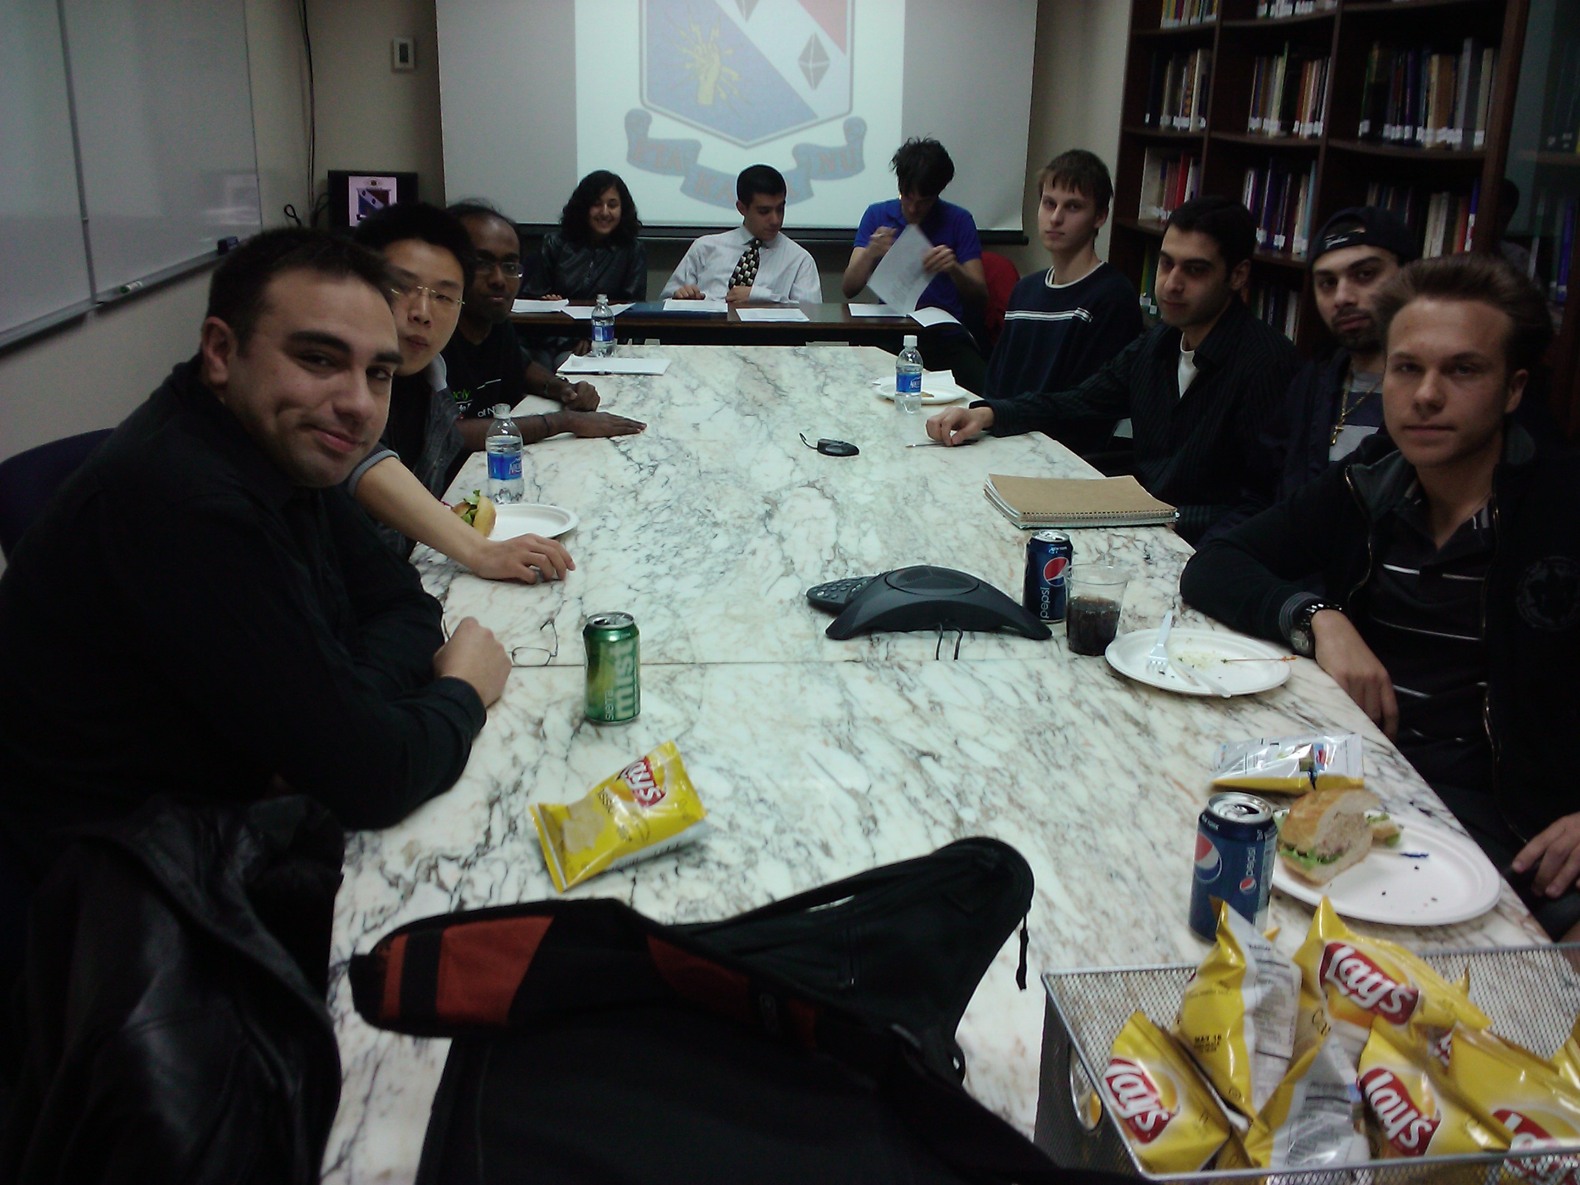

Spring 2010 Induction

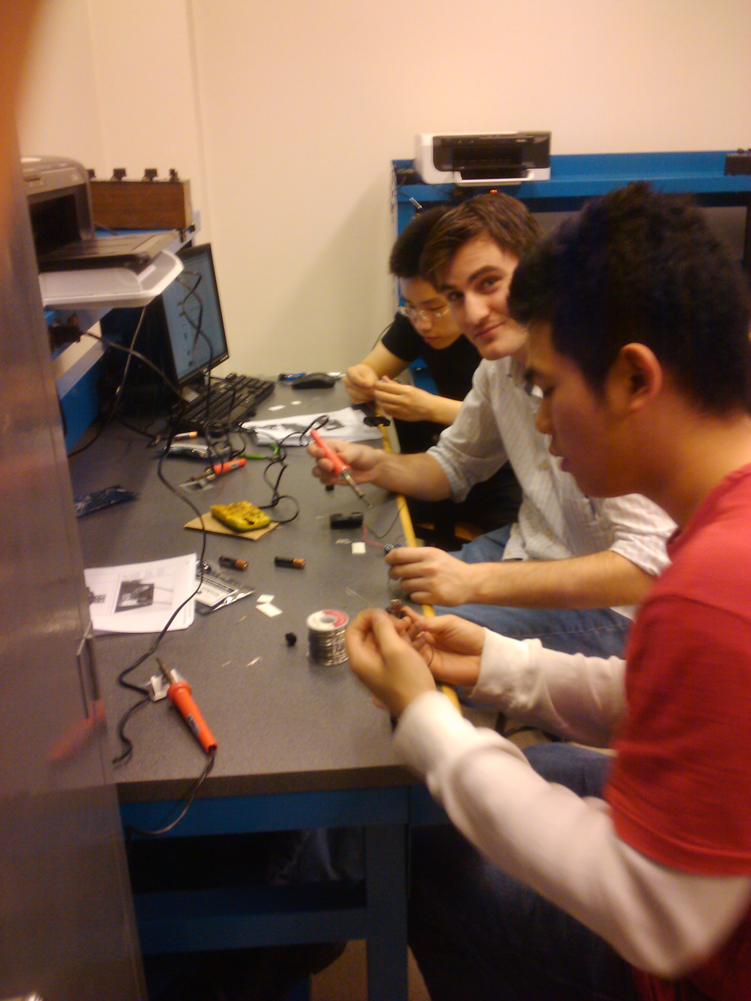

Spring 2010 – Soldering Workshop