IEEE CES - 2020

Webinar - Introduction and Application of IoT

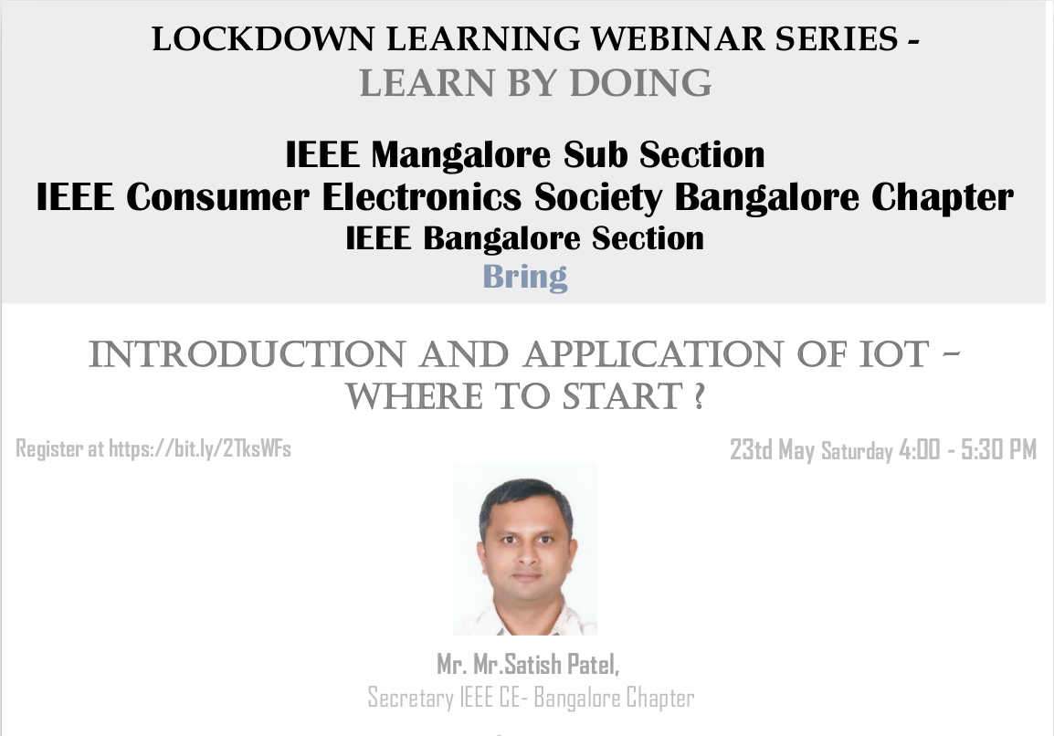

Flyer

Venue:
Online - Webinar using webex
Date - 23/05/2020, 4:00 p.m. To 5:30 p.m.

Attendees:
~153 Students, Professors and other Professionals
(~35 IEEE members)

Description:
Covid-19 situation has created a major gap to reach out and conduct physical seminars/workshops for the learning community.IEEE CES has explored the opportunity to reach out to the learning community via an online platform. With the collaboration with IEEE Mangalore sub section, IEEE Consumer Electronics Society Bangalore Chapter conducted a webinar to engineers interested in the IoT technology, whether novice or professional.
More and More devices are now getting connected over the Internet and the pace of "getting connected" will continue over the next decades. In this exploding Internet of Things (IoT), cloud services and entities connect using the Internet to enable new use cases and new business models across multiple markets and applications. The whole intention of this talk is to unveil the "IoT Fundamentals and How can I engage myself to it"

Talk is well received by over 150 participants over webex. Also feedback has been received to conduct more such webinars.

