Simplified IEMT 2016 Abstract and Paper Submission for Dummies
- Go to Easy Chair Web site:
http://ewh.ieee.org/r10/malaysia/cpmt/Home/iemt/2016/iemt2016_registration.html
- This screen will appear. If this is the first time you are seeing this and you did not posses an EasyChair account, select “create an account” else fill in your user name and password.
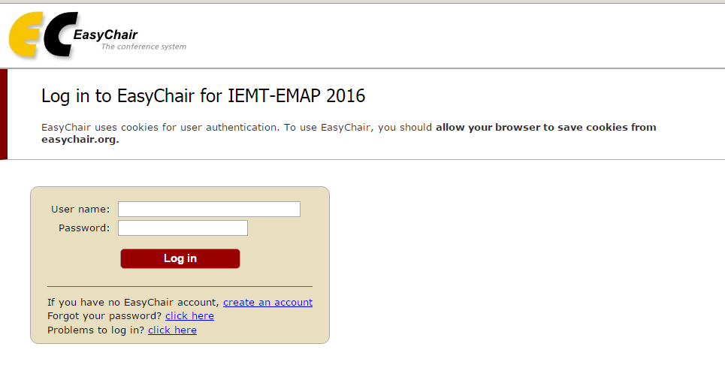
- Assuming you don’t have an EasyChair account and selected “Create an account”, you will be directed to this page:
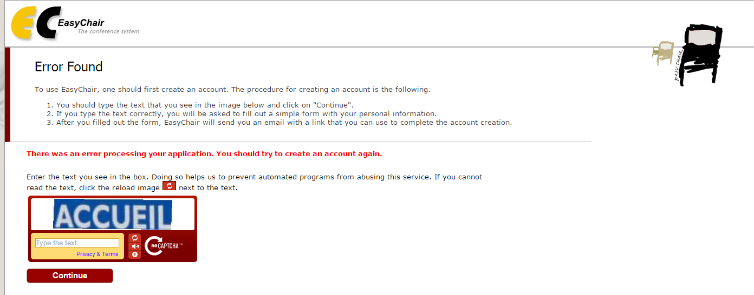

- Just submit the word you see – this is to ensure you are not a software BOT. This will get you to the next screen.
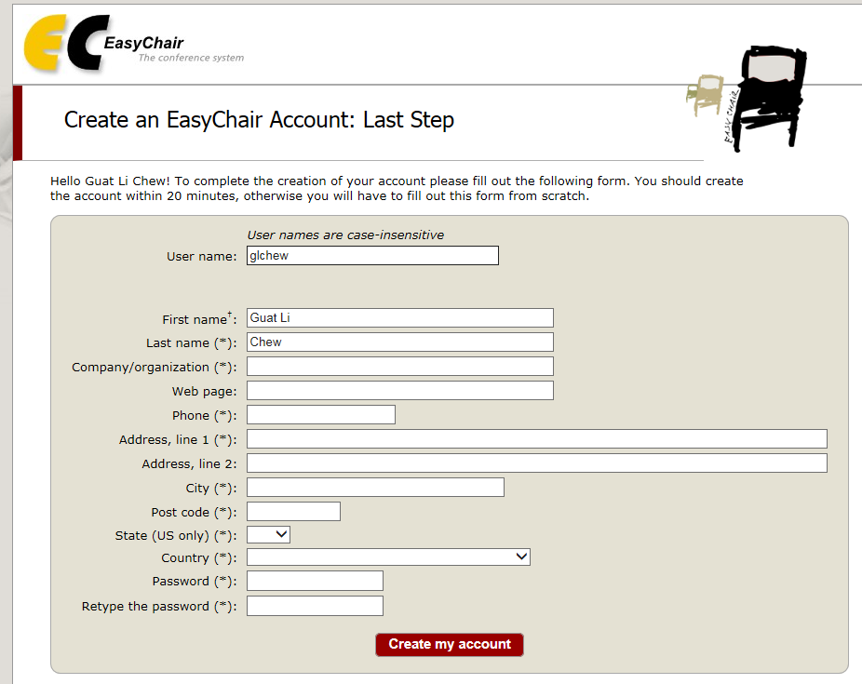
- Fill in your details and press “Create my account”. After that, you should receive the following screen.

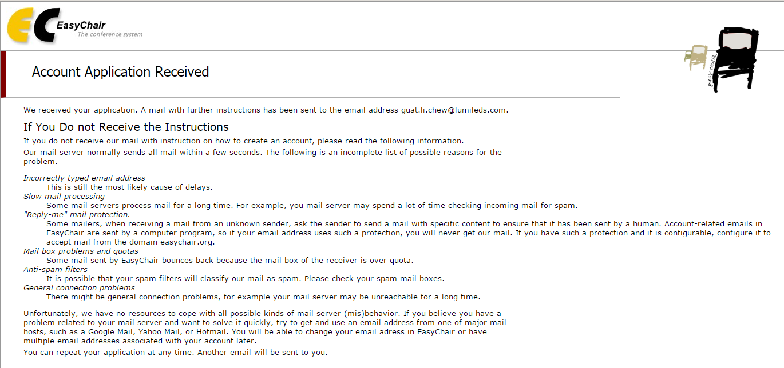
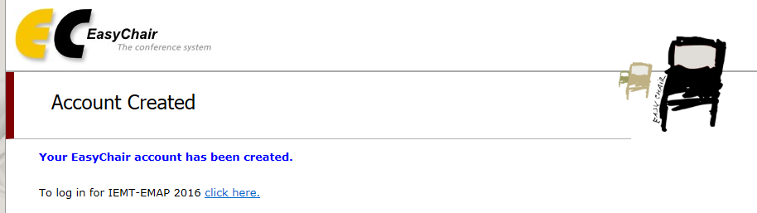
- Click to login to site.
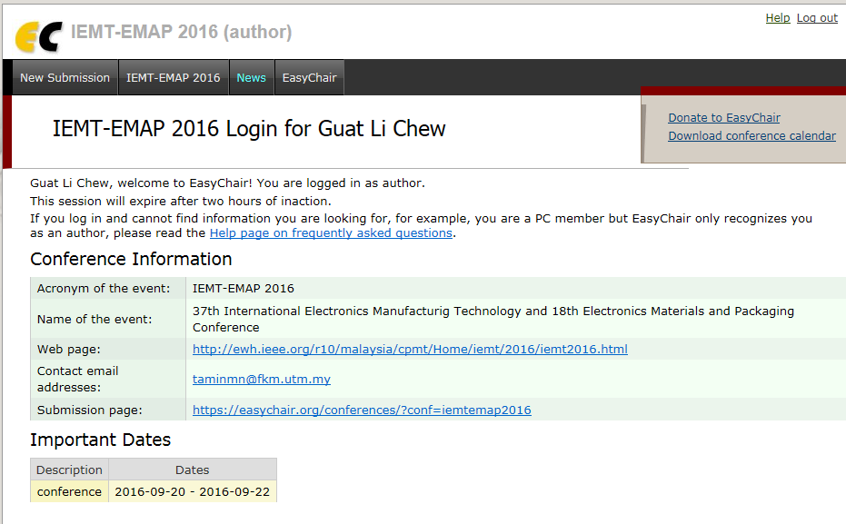
- On selecting the web page link (1st time only):
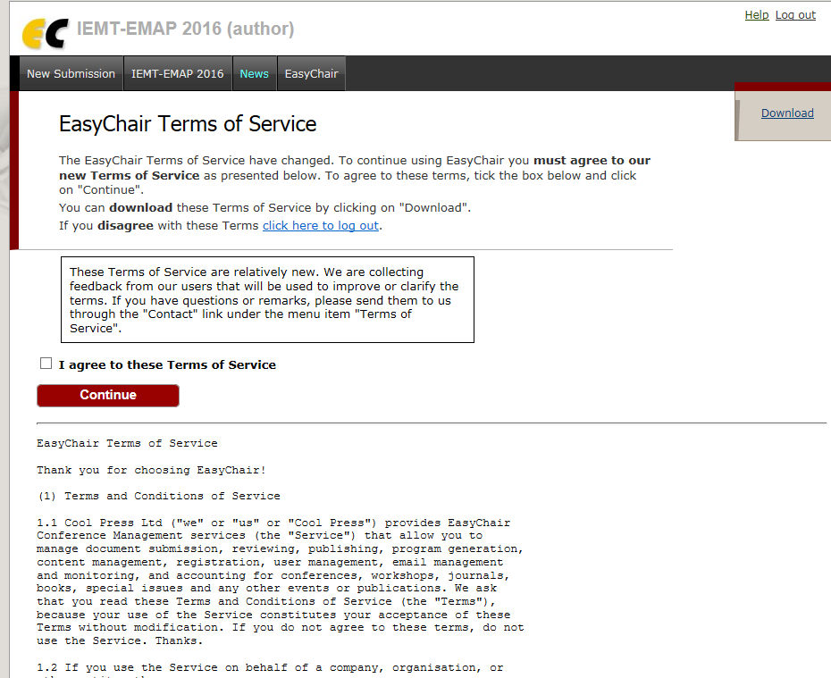
- If agree to the terms and condition, you will get this next screen shot.
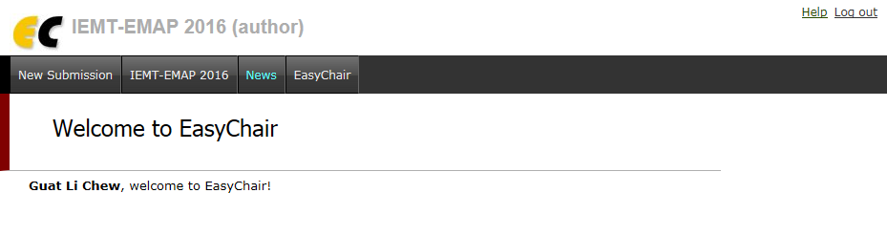
- Select “New Submission” on the top left corner as shown in screen below:
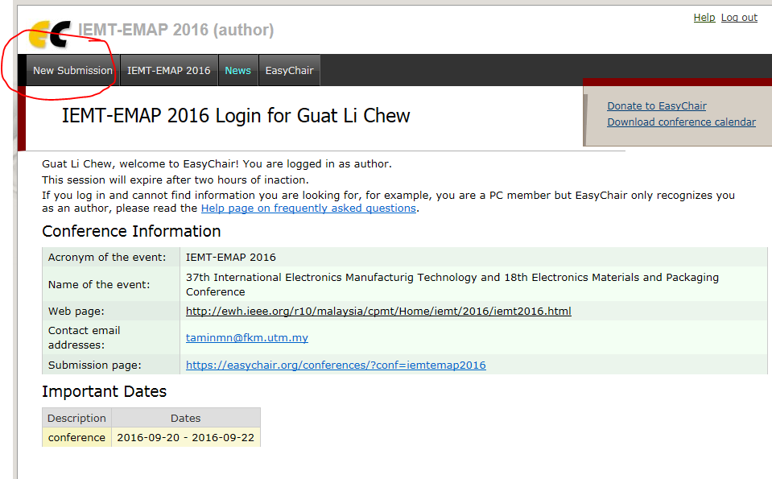
- Fill in the details
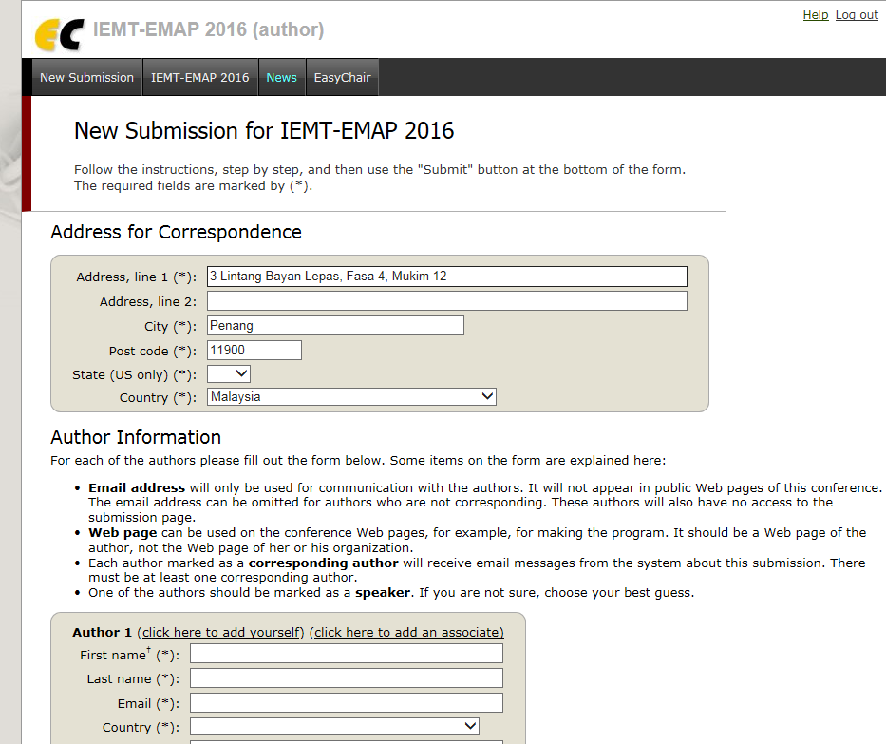
- IMPORTANT: Make sure you list Key words with <Enter> as the delimiter between each Key Word. Min Key Word required is 3 words. Also, abstract needs to be a pdf for loading. Once submission is successful, you should get the following screen.
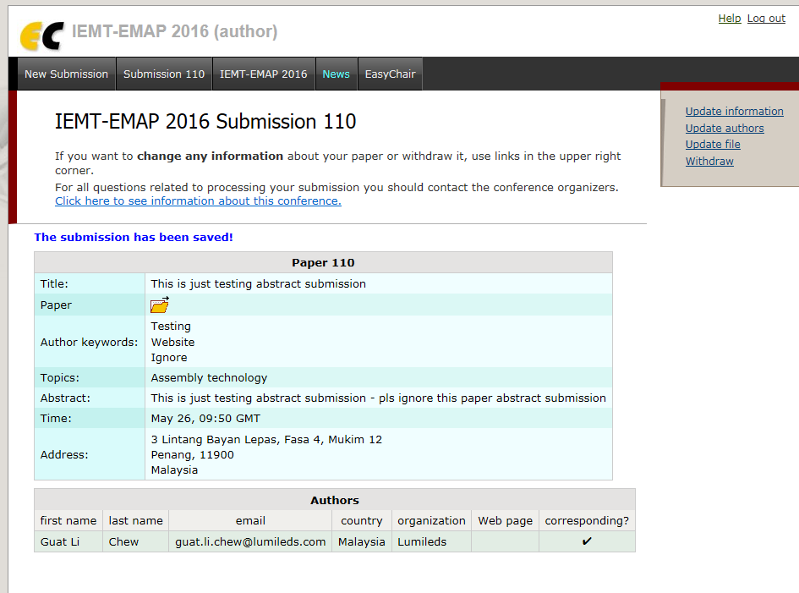

- You will also receive 2 emails in the email address you inserted into the information requested.
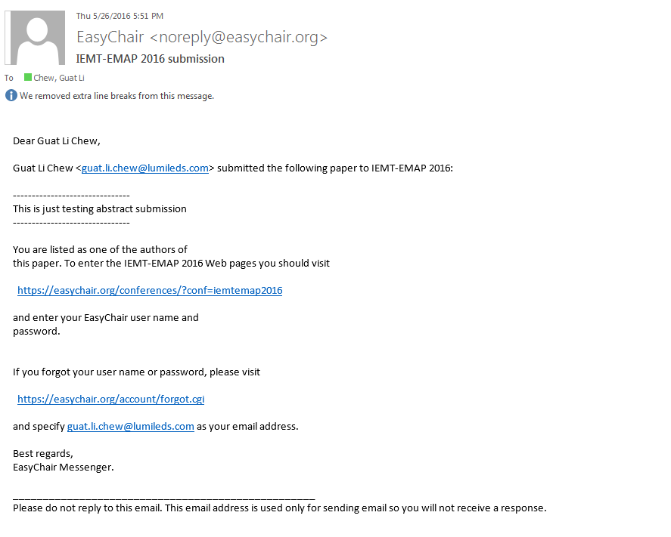
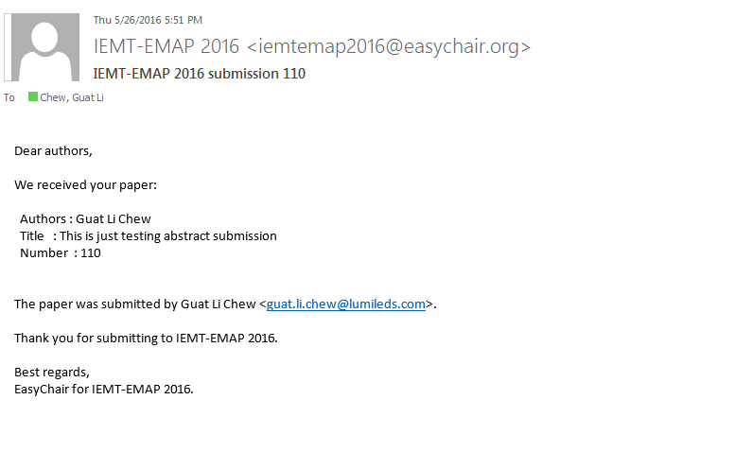
- To update your paper/abstract into a full blown paper, save your final paper copy in pdf format and select “Update File” in the following screen. If you didn’t get the screen below, press the 2nd tab “Submission XXX” circled in red.
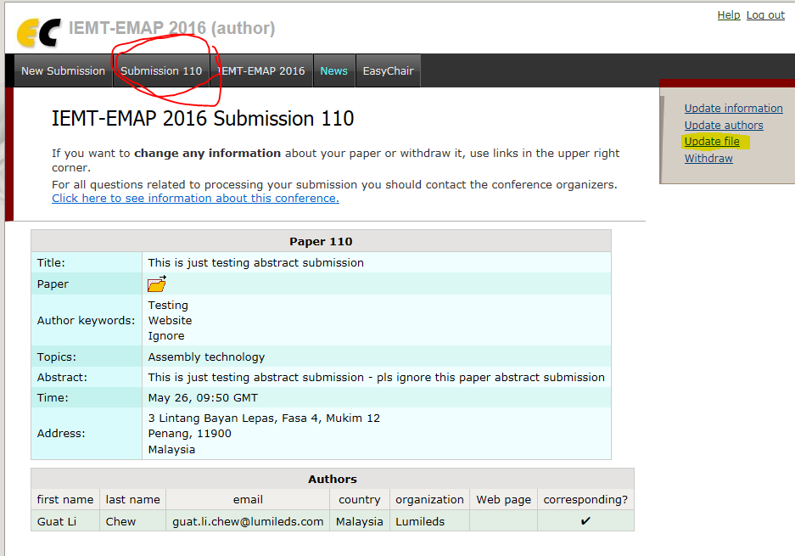
- You will get the following screen if you press “Update File”
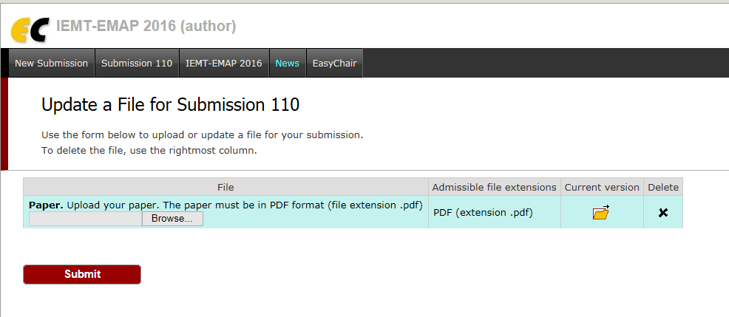
- Press the “Browse” button and select your final paper in pdf format.
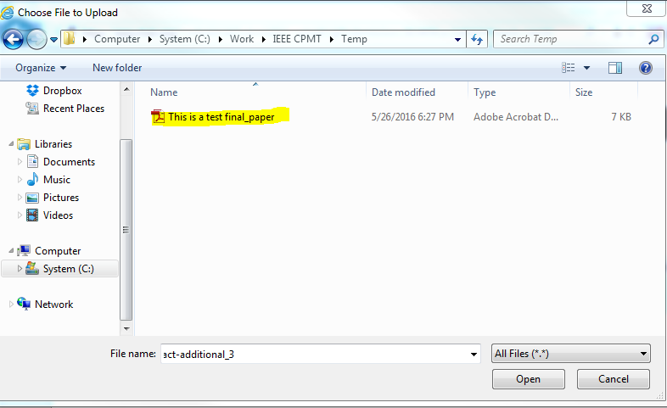
- Press “Open” and you will get the next screen. Press “Submit” as circled in red
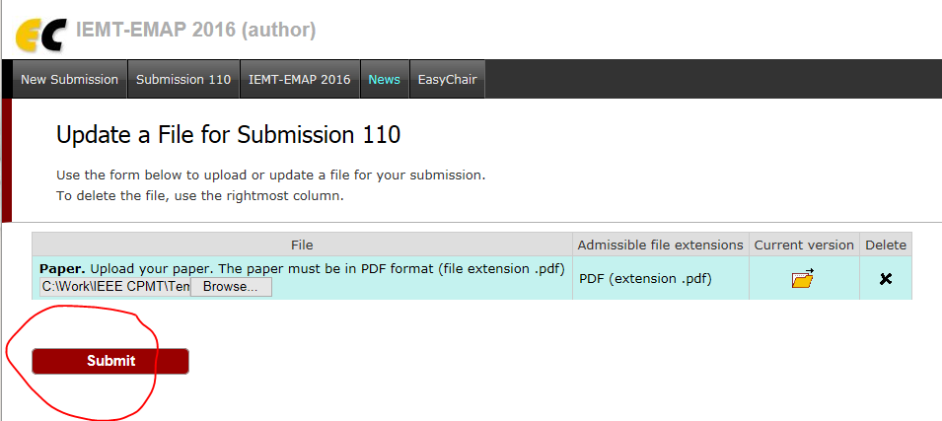
- You will now see that your final paper has been uploaded; see yellow item “The file has been uploaded!” You can press on “Current version” circled in red below
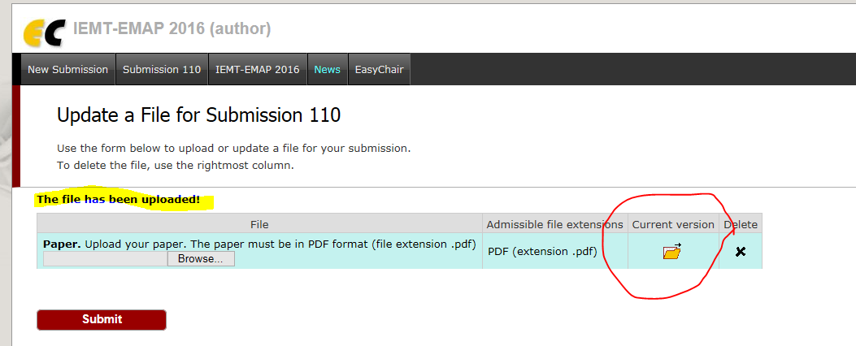
- This will bring you to your latest copy and you can validate it is the correct version. The system will NOT save multiple versions. All new versions will overwrite the old versions so please be very careful when uploading your papers. If you confirm that the current version is now correct, just close the document post viewing and press “Log out” as indicated below.
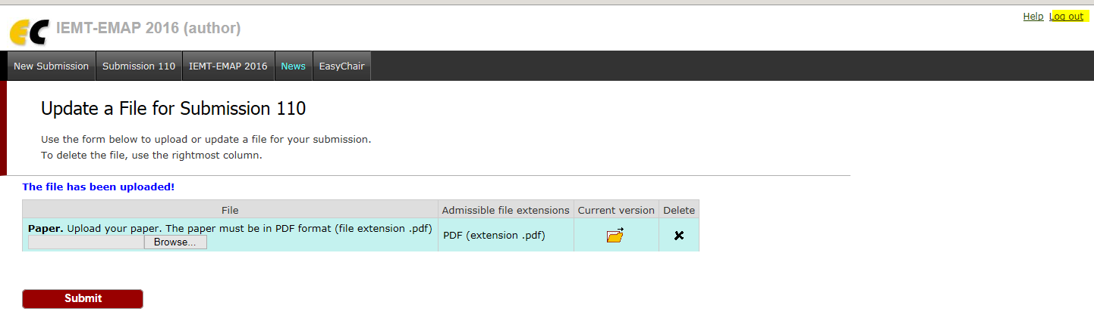
- You should receive email in your designated email that you have submitted a newer version.
- You are done submitting your FINAL PAPER into the conference. You can still delete it, update a newer copy until closing date in which case, uploads will not be entertained.

