IEEE Industrial Electronics Society (IES) Western Australia Chapter Establishment and Activities
Prepared by: Dr. Amit Kunwar, Newsletter Editor, IEEE Western Australia Section
The most recently established chapter by the IEEE Western Australia (WA) Section is the WA’s Industrial Electronics Society (IES) Chapter which was formed in May 2019. Assoc. Prof. Farhad Shahnia, Chair for IEEE WA Section and Dr. Hai Wang from Murdoch University are the founding chairs of this chapter. Since the formation, this Chapter has been very active in arranging various technical and social activities, attracting members and supporting them.
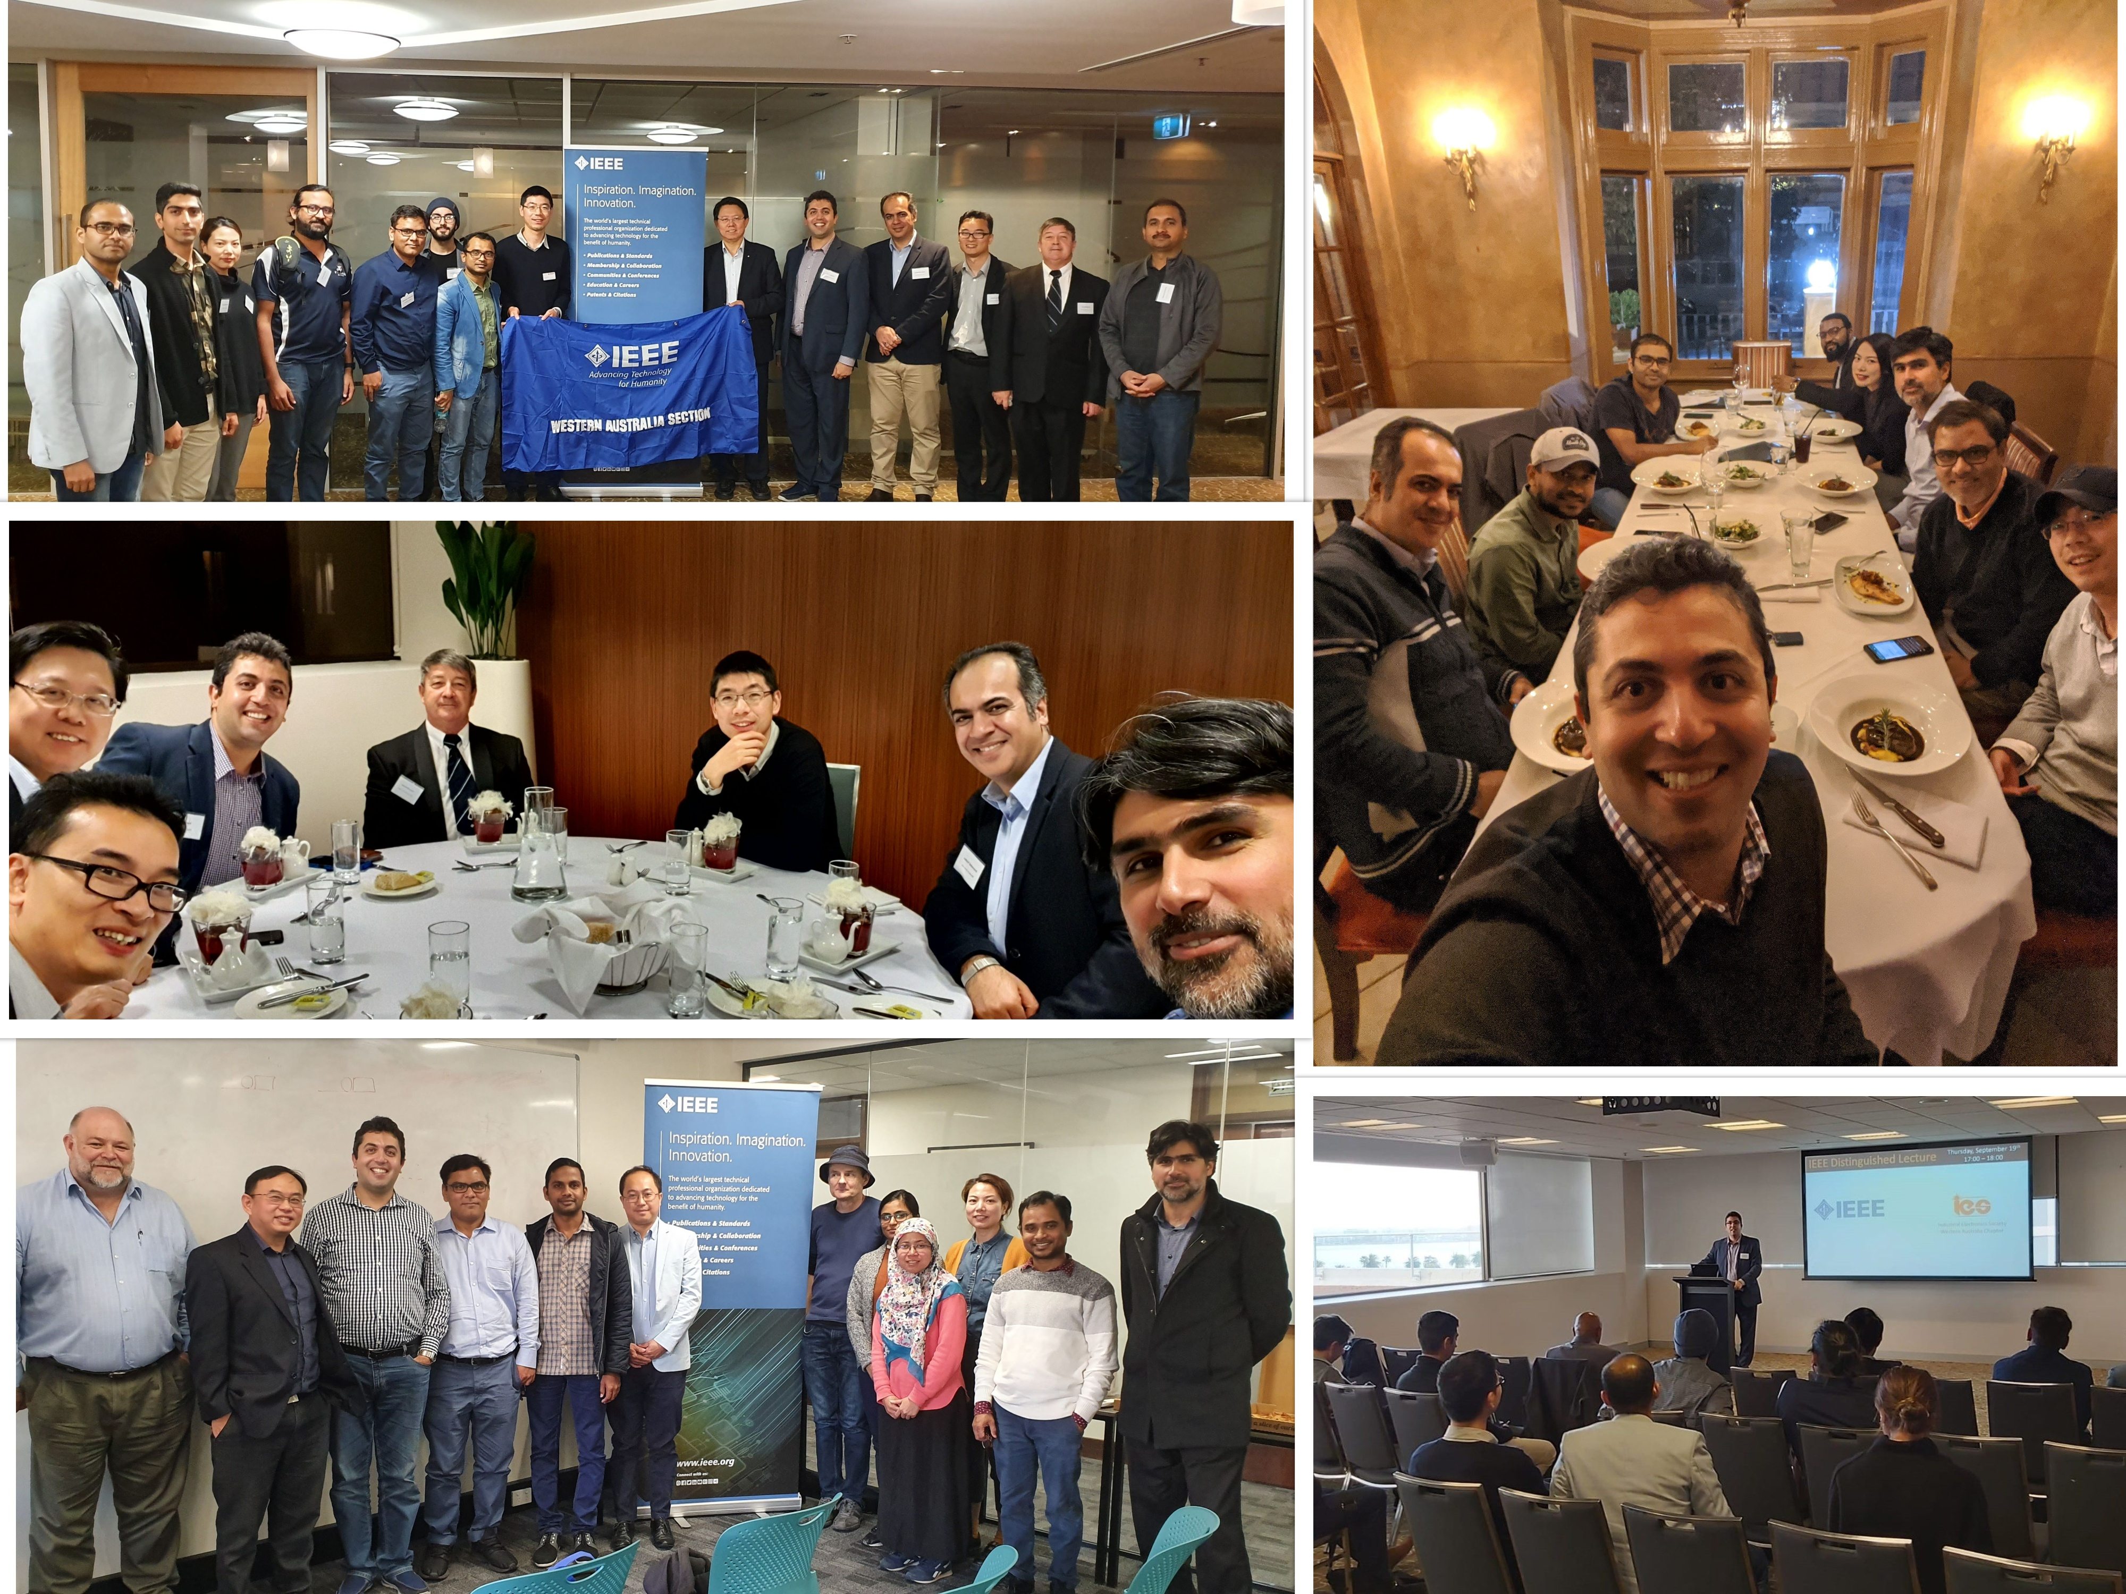In 2019, the Chapter arranged 3 technical seminars, one distinguished talk by the IES President Prof. Xinghuo Yu, and one workshop by the IES Vice-president Membership Prof. Yousef Ibrahim. In the first 8 months of 2020, the Chapter has arranged 5 technical seminars while 3 additional seminars and one distinguished talk are planned for the remainder of this year. Usually, 20-40 people attended the arranged seminars, which are focused on various aspects of the IES such as industrial systems, power and energy, power electronics and drives, control systems, and mechatronics. The Q&A session in some of the seminars has been well attended by the delegates. From 2020, the Chapter has also created its YouTube channel (https://www.youtube.com/channel/UC4IzbWYYfIRkPDE4gueCDlg) and is sharing the videos of the technical seminars with the interested members and non-members globally. The Chapter has also arranged two social (dinner) networking events in 2019 and 2020.
The WA IES Chapter is one of the technical co-sponsors of the 2020 International Conference on Smart Grids and Energy Systems (SGES 2020) which will be held in November 2020 online (virtually) from Perth, Australia; and the Chapter members are active volunteers in the Conference Executive, Organizing and Technical Committees. The Chapter has also won the bid to host the IEEE 20th International Conference on Industrial Informatics (INDIN), which is one of the IES’s key and flagship conferences in Perth, Australia in 2022. The chapter members have key roles in the organizing committee of this conference.
The Chapter has also received a start-up grant from the IES in 2019 and has also won one of the IES’s Support to Chapter Local Activities (SCLA) grants in 2020, and these funds are being used by the Chapter to enhance its technical and social activities and for the benefit of its local members in WA.
Since formation, the WA IES Chapter has increased its membership number twice and is the most successful chapter of the WA in terms of membership growth. In 2020, the Chapter has also initiated the three awards of Outstanding Engineer, Best Undergraduate Student, and Outstanding Young Researcher to further encourage and praise its volunteers, student members and Young professionals as well as to promote IEEE and IES membership locally.

