Canaveral Section Hosts Milestone Celebration

IEEE President, Other Dignitaries Honor Electrical/Electronics Space Pioneers

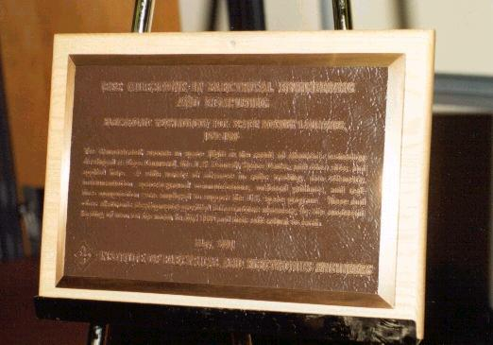

IEEE Milestone Plaque

On May 25 approximately 200 guests celebrated an IEEE Milestone unveiling at the Dr. Kurt H. Debus Conference Center, Kennedy Space Center Visitor’s Complex. IEEE President Joel Snyder unveiled the Milestone, assisted by section Life Senior Member Art Greene, who represented the thousands of space pioneers without whom these achievements would not have occurred. This ceremony took place on the 40th anniversary of President Kennedy’s “Special Message to the Congress on Urgent National Needs” speech, in which the national goal to go to the moon and return the astronaut safely to earth was first publicly identified.

This Milestone, the 37th in the world, recognizes the advancements in electronics technology for space launches between 1950 and 1969. It is only the second Milestone in the Southeast, and is the first to recognize accomplishments in the American space effort. More information, including the citation and ceremony photographs, can be found on the Canaveral Section website. (Photos courtesy of Charles Downen Photography.)

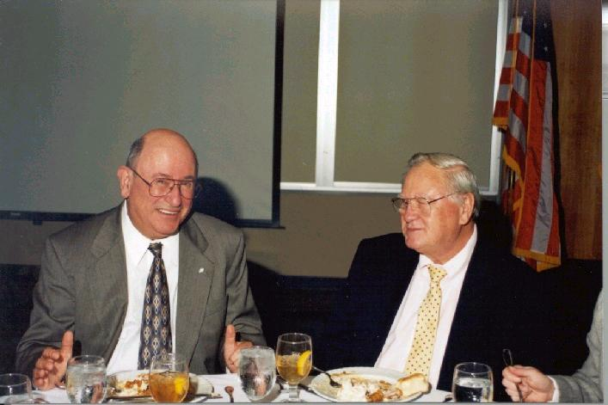

Joel Snyder and IEEE Region 3 Director Richard Riddle

In addition to Mr. Snyder, IEEE dignitaries attending included the IEEE History Committee Chair Dr. Martha Sloan of Michigan, the IEEE Region 3 Director Mr. Richard Riddle of North Carolina, the Region 3 Director-Elect Mr. James Howard of Tampa, the Florida Council Chair Dr. Kalpathy Sundaram and Vice-Chair Dr. Eric Ackerman, as well as representatives from the Jacksonville, Orlando, Florida West Coast, Daytona Beach,Palm
(Continued on next page)
What’s Inside…..
Canaveral Section Hosts Milestone Celebration | 1
Has IEEE Shortchanged You? | 3
Nominations for IEEE/ABET | 3
Chuck, Adam, Garry Become Latest Seniors! | 4
Help Us Get Your Money Back to You! | 4
Life Member Chapter Chartered Recently | 5
URGENT! Nominations for Diamond Award needed for 1 August Deadline | 5
Want Programs More Geared To Antennas and Propagation, Signal Processing, or Communications? | 5
Call for Section Officer Nominations for 2002 | 6

Beach, and Broward sections. Local dignitaries included State Senator Bill Posey, State Representatives Randy Ball, Mitch Needelman, and Bob Allen, as well as Spaceport Florida Authority Director Mr. Ed Gormel, and others. Just as important were the nearly 100 space pioneers who attended and were recognized as a group during the presentation.

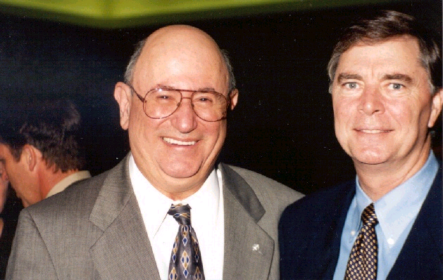

Joel Snyder and Florida State Senator Bill Posey

The program began with an invocation by Chaplain Captain Marshall McClellan, USAF, which was delivered during the luncheon portion of the event. The ceremony commenced with a posting of the colors by the Patrick AFB Honor Guard, followed by a videotape of President Kennedy delivering the “Space” portion of his historic message. Welcoming comments were delivered by your section chair, followed by a videotape presentation by Senator Bill Nelson. Mr. Brian Chase, District Director of the Office of Congressman Dave Weldon, relayed some comments and presented the section with a framed copy of a statement entered into the Congressional Record by Representative Weldon recognizing the ceremony. A videotaped presentation from Lieutenant Governor Frank Brogan was next, followed by speeches by Colonel Samuel W. Fancher of Patrick AFB, Mrs. JoAnn Morgan, the Director of External Relations and Business Development at NASA-KSC, and IEEE President Joel Snyder. Mr. Art Greene served as the Master of Ceremonies.

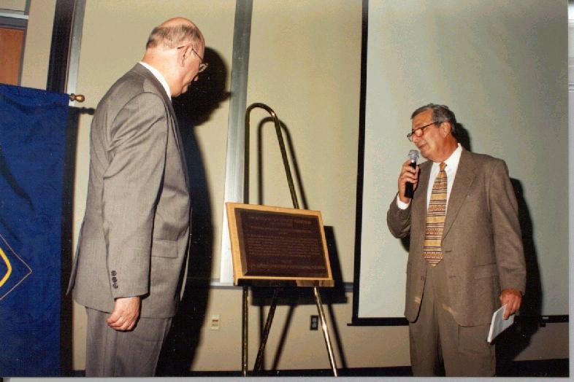

Joel Snyder and Art Greene unveiling the Milestone Plaque

“Space Coast Press” provided the section with several articles about the ceremony over a period of weeks, and “Florida Today” mentioned the ceremony as well. WESH Channel 2’s Dan Billows attended the event and provided film footage for airing on at least two broadcasts. While not part of the official ceremony, Mr. Art Greene participated in a National Public Radio “Talk of the Town—Science Friday” panel discussion broadcasted throughout the country and on the internet, where archives are available at the time of this writing. An article about the ceremony may also appear in the “Institute” newspaper.

Without the assistance of many individuals from New York, New Jersey and North Carolina to Colorado and Hawaii, the remarkable success of this ceremony would not have occurred. (Special thanks are due to IEEE-USA and Mr. Ned Sauthoff.) Local members who contributed greatly to the outstanding event are Art Greene, Leon Migdalski, Wayne Rendla, Chuck Chapman, Robert Morrison, Bahman Motlagh, Dave Bryant, Karen Beauchamp, Adam Kissiah, Bill Zelinsky, John P. “Andy” Anderson, Joe Dunn, and countless others of whom your section chair is unaware. The spouses of the aforementioned should also be considered as contributors, as the volunteer efforts the members made were not without a tradeoff somewhere. Your section chair wishes to thank all who made this program possible.

Has IEEE Shortchanged You?

Twice in the last two years, including once recently, Kathy Rinehart has discovered that IEEE Headquarters erroneously categorized members who merited full membership as associate members. If you have an electrical engineering bachelor’s degree or higher and have been categorized as an associate member, please call IEEE Headquarters at 1-800-678-4333 and let them know that your membership category should be that of full membership. Alternately, you may send your request to Ms. Denise Howard at d.howard@ieee.org. If you have other membership questions, feel free to e-mail them to Kathy Rinehart at k.rinehart@ieee.org.

Nominations for IEEE/ABET Evaluators Now Open
PISCATAWAY, NJ, 18 June 2001
Lynn Murison
Outreach Administrator, IEEE Educational Activities
ph: 1.732.562.6526
www.ieee.org/organizations/eab/

Contribute to the engineering professional and public good. The IEEE Educational Activities Board seeks engineering professionals from industry, government, and academe to serve as program evaluators for accrediting engineering and engineering technology programs at U.S. universities. Nominations will be accepted through 31 October 2001.
The Accreditation Board for Engineering and Technology, Inc (ABET) provides a peer review of university programs that is vital to the continuing quality of the engineering and engineering technology professions. Aside from supporting the health of the profession, there are more tangible rewards for evaluators and their employers. The evaluators are trained in the Quality Process and are able to hone their decision-making skills. By virtue of being on campus, evaluators come in contact with the next wave of future innovators and industry leaders.
“The training helps to keep you up to date with all the changes being made every year in the criteria,” said William Boley, Litton Guidance & Control
Systems. “The campus visits are a great opportunity, to see first hand, the different approaches being taken in engineering education.”
The IEEE members selected will attend a one-day training seminar on the IEEE/ABET accreditation process. After training, these program evaluators are dispatched in teams, one evaluator to a program, to visit engineering and engineering technology departments across the country on behalf of the IEEE and ABET. Evaluation sessions take place each fall and generally run for two to three days.
Read comments from a first-time evaluator at:
www.ieee.org/organizations/eab/apc/news5.htm.

Information packages, including the application and nomination forms, are available on the web at:
www.ieee.org/organizations/eab/apc/ceaa/engapplication.htm (engineering programs).
And:
www.ieee.org/organizations/eab/apc/ctaa/techapplication.htm (engineering technology programs).

For more program information, contact:
eab-accred@ieee.org.

Chuck, Adam, Garry Become Latest Seniors!

Wide Range of Experience and Specialties Reflected in Upgrades

Charles H. “Chuck” Chapman, Adam “Buddy” Kissiah, Jr., and Garry Haase were elevated to Senior Member status at the March 31 IEEE Admission and Advancement Committee meeting. Word of these upgrades reached the section too late for inclusion in the April newsletter.

Chuck Chapman, the section’s webmaster and the Computer Society Chapter’s Vice-Chair, is employed by NASA and is a former employee of Dynacs at Kennedy Space Center. Prior to relocating to the Brevard area three years ago, Chuck worked for several years at the Georgia Tech Research Institute and was involved in software efforts supporting the Atlanta Olympics.. His references for membership upgrade included Stan Starr, who was upgraded at the February A&A meeting. The remaining two references came from former coworkers who remain at GTRI.

Adam Kissiah, Jr., known to many in the section as “Buddy”, is a retired NASA employee who is a licensed private investigator. Adam’s employment at NASA occurred during the 1950s through the 1980s, encompassing many of the efforts celebrated by the recently dedicated IEEE Milestone. Adam’s references included Art Greene, F. W. “Skip” Blum, and Jim Yontz.

Garry Haase, a captain in the United States Air Force, is by comparison a relative newcomer to the engineering world with less than ten years of post-college experience. Garry’s efforts here have been in the 3rd Space Launch Squadron at Cape Canaveral Air Force Station. As with many Air Force officers, Garry has not been able to stay in one area for many years, and since his upgrade has been reassigned to the Seattle, Washington area. Garry’s references were provided by professors at his undergraduate alma mater, University of Missouri-Rolla, and by his Master’s degree professor at Wright State University.

Congratulations to our newest Senior Members, and congratulations as well to those who wrote such excellent reference letters.

Help Us Get Your Money Back to You!

Usually the yearly rebate to the Canaveral Section is between $2700 and $3000. One-third to one-half of the budget is spent on printing and mailing costs, and with the January and July postage increases this percentage will likely be even higher. The section leadership has made efforts to return the rebate to members. These have been in the form of meal discounts at meetings, and in efforts to obtain more varied speakers that will benefit the professional and networking interests of members and the broader technical community. We would prefer to not give your money to the printers or to the United States Postal Service.

Your section chair requests that you consider signing up on the section’s e-mail list, which will enable you to receive newsletters and meeting announcements quicker and cheaper as well. Once you are satisfied that the delivery is sufficient, please notify the Newsletter Editor via sec.Canaveral@ieee.org that you will accept e-mailed information rather than the expensive paper mailings. This way, we can have more of your resources to bring in high-caliber speakers in technical areas currently not available locally, and give you a meal discount as well.

URGENT! Nominations for Diamond Award needed for 1 August Deadline

Many times it may seem that the IEEE awards are written for those in non-government areas, but the Harry Diamond Memorial Award and the Electrotechnology Transfer Award are designed just for U. S. Government employees and government contractors. We have the expertise to qualify and win one or both of these awards! However, while your section chair has endeavored to speak with each of you and become better acquainted, she does not know each of you well enough to know and evaluate your professional accomplishments. The deadline is fast approaching, but with the assistance of other section members nominating those who qualify the Canaveral Section can still submit viable contenders for these awards by the 1 August cutoff. Please assist us by reviewing the award criteria at http://www.ieeeusa.org/AWARDS/award6.html for the Harry Diamond Memorial Award and at http://www.ieeeusa.org/AWARDS/award7.html for the Electrotechnology Transfer Award, and by submitting your nomination for these awards to sec.Canaveral@ieee.org.

Life Member Chapter Chartered Recently

First Organizational Meeting to Take Place on July 19

During May the joint Canaveral-Melbourne Life Member Chapter was officially chartered. This affinity group consisting of Life Members and Life Senior Members is only the second in the state, the first being in the Florida West Coast (Tampa) section. The purpose of this Chapter is to focus on the needs of the Life and Life Senior Members of both sections, which could include more luncheon meetings or technical topics which appeal to the retired and semi-retired. To remain a viable chapter, only two meetings per year are required, but there is certainly no upper limit on the number of meetings the chapter may have.

Please make plans to attend the July 19 meeting at the Canaveral Council of Technical Societies (CCTS) office, located on the fourth floor of the Cape Royale Building, Cocoa Beach. The meeting will start at 5 pm, and the purpose is to identify member meeting locations for the next meeting and proposed topics for subsequent investigation.

Want Programs More Geared To Antennas and Propagation, Signal Processing, or Communications?

A fair percentage of the section membership is a member of one or more of the above technical societies. Each of these societies offers a Distinguished Lecturer/Visitor Program, but the speakers in those programs are available only to chapters of those societies. (The method that the individual societies cover the expenses of their speakers varies, but each society assists the chapter in some way.) Currently, the Canaveral section does not have a chapter of any of these societies, and the Melbourne section does not have a chapter of these three either. It only takes twelve members to sign a petition for a technical chapter formation, and there is a minimum of two meetings per year required to keep a chapter active.

Please examine the listings of the Distinguished Lecturer/Visitor Program of the societies, which are on the section’s website. If you find any of these topics of interest, please be willing to sign a petition for chapter formation when you are contacted. If you would like to volunteer to get the chapter off the ground, please contact the section at sec.Canaveral@ieee.org.
2001 EXCOM Officers:
Kathryn Rinehart - Chairman
Leon Migdalski - Vice Chair
Robert Morrison - Secretary
Wayne Rendla - Treasurer
Dr. Bahman Motlagh - Comp. Soc. Chapter Chair
Charles Chapman – Computer Society Vice Chair

Important websites:
www.ieee.org
http://www.ewh.ieee.org/r3/canaveral/
http://www.ieee.org/membership/
http://www.ieee.org/compliance
http://www.ieee.org/tag/tag.html
http://www.ewh.ieee.org/reg/1/gold/



IEEE Canaveral Section
PO Box 236391
Cocoa, FL 32923

Call for Section Officer Nominations for 2002

December, 2001 may seem a long way off, but it is not too early to consider either becoming a candidate for a section position, or to nominate those you would like to see as the next year’s officers. The positions are the Chair, Vice-Chair, Secretary, and Treasurer. Elections will be held at the December social meeting, but a slate of potential candidates needs to be published in the October newsletter. If you are considering serving as an officer, or if you know someone who is or who would be a good one, please submit these names to the section at sec.Canaveral@ieee.org.

Non-Profit Org.
U.S. Postage Paid
Permit No. 152
Cocoa, FL 32922

