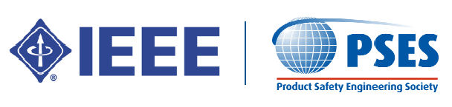
Orange County
Product Safety Engineering Society
Meeting
(Open to all – you do not need to be a member of IEEE)
+ FREE FOOD!!!!!
(Provided by Northwest EMC)

Tuesday, June 28, 2016 – 6 PM
Northwest EMC
41 Tesla
Irvine, CA 92618

- INTRODUCTIONS

- COMMITTEE REPORTS
- Program Committee – J.R. Long, Chairperson
- Treasurer Report – Paul Herrick
- 2016 IEEE PSES Annual Symposium – Bansi Patel

- PRESENTER –
Raghu Nathan / CSA Irvine Manager of Field Services / Inspections.
- Basic 3 year degree in Mathematics followed by 3 year Engineering Degree in Electronics and a Masters in Instrumentation (Process Control) from India.
- Started with a few years as R & D Engineer developing Electronic Process Control Instruments (Temperature, Pressure, Flow Controls)
- Worked in the largest Steel Plant in India as Electronics Maintenance Engineer
- Moved to Kuwait to work for a Houston based Oil & Gas Engineering, Construction Company (M.W.Kellogg) and continued with M.W.Kellogg in Texas as Cost Engineer for Project Construction
- Spent 3 years in Malaysia (Offshore Oil & Gas) as Instruments Material Consultant
- Managed a Commercial Cooking Appliance (Gas) business in California for 6 years and finally with CSA for the last 9 years managing Irvine Field Services
- PRESENTATION –
- I will talk about Factory Inspections – what we do
- Initial Factory Evaluations
- Touch on Special Inspections and U.S. Field Evaluations (though I do not manage these now) – as they also fall under Inspections.
- Answer any questions- if I don’t have immediate answer, I shall check and get back later.
DISCUSSION ITEMS
- Discussion of other Product Safety/Certification issues
