IEEE Power Engineering Society and Industry Applications Society Northern Canada Chapter Seminar

Electric Deregulation in Alberta – Progress, Problems, and Misconceptions
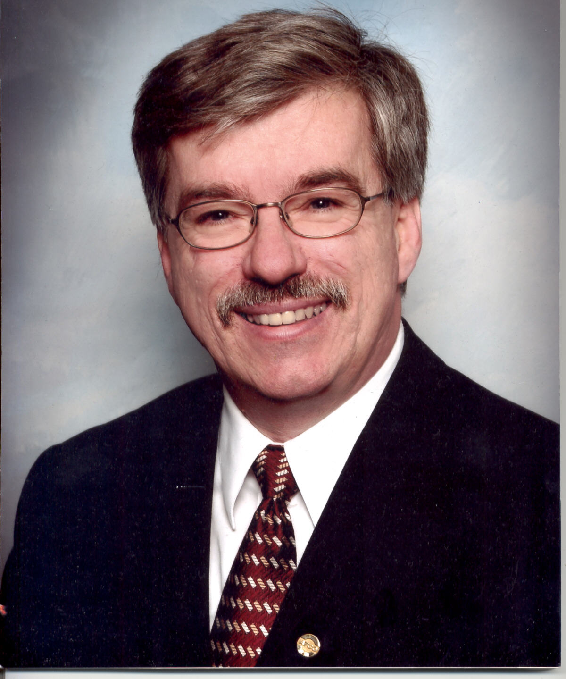

W. James Beckett, P. Eng.
Executive Vice President
ATCO Gas and ATCO Electric

Abstract

In this seminar Mr. Beckett will summarize the history of electricity deregulation, outline some of the current challenges that continue to face the industry, and address many of the issues that are appearing in today’s newspaper headlines.

Biography

W. James (Jim) Beckett joined ATCO Electric (then known as Alberta Power) in 1973 after graduating from the University of Alberta with a B. Sc. in Electrical Engineering. He held positions in the engineering, planning, operations, and regulatory roles for ATCO Electric, becoming a vice-president in 1994. In 2000, he took on the regulatory responsibilities for ATCO Gas as well.

Since 1994, Mr. Beckett was involved as a representative of ATCO Electric in the discussions with the provincial government, which led to the legislation that began the deregulation of the electric industry in Alberta. Through that period, he was active in many areas assisting in the establishment of the current infrastructure of the deregulated electric industry that exists today in Alberta. Mr. Beckett played significant roles in the Electric Transmission Committee, the Power Pool, and the establishment of the Transmission Administrator. At the same time, he was involved in the many regulatory applications required of ATCO Electric during the period of deregulation.
IEEE Canada

Electric Deregulation in Alberta – Progress, Problems, and Misconceptions

IEEE NCS PES/IAS Chapter Seminar

Presentation by Jim Beckett, Vice President of ATCO

Location: Derrick Golf and Winter Club, 3500-119 Street, Edmonton, Alberta.

Date: Thursday, 19 June 2003.

Time: 6:00 – 6:45PM Registration and Cash Bar in Banff Hall
6:45 – 8:00PM Supper (cost included in the registration fee)
8:00 – 9:00PM Seminar Presentation
9:00 – 9:30PM Coffee

Fee: IEEE Non-Members: $30
IEEE Members: $25
IEEE Student Members: $20
Payable by cash or check. Income tax receipts provided for members, IEEE ID required.

Supper Menu: 1) Salmon, 2) Chicken, 3) Stir-fry (Chicken/Vegetarian).

RSVP: by Monday 16 June by either
E-mail: mickwalton@bjelectricsupplies.com
Phone: Mick Walton at (780) 461-2334
use the PES/IAS Chapter executive committee member contacts at
http://www.ewh.ieee.org/r7/northern-canada/ias-pes/
Please RSVP early indicating your menu choice (details provided at request).

