 IEEE Tutorial: Power System Fundamentals
for Distributed Generation and Power Quality Assessment
Saturday, June 12, 2004, 8:30AM to 2:00PM

University of Alberta, ETLC E1018

Lecturer: Dr. Wilsun Xu

Professor, University of Alberta

IEEE PES Power Quality Subcommittee

IEEE PES Power System Stability Control Subcommittee

Abstract:
Distributed generation (DG) and power quality (PQ) have become an important concern for the design and operation of power distribution systems. Although many tools are available to conduct distribution system analysis, it is still very important to understand the fundamentals behind those tools. Such knowledge will help power engineers to use the tools more effectively and to build intuitive understandings on the problems involved.

The objective of this tutorial is to review some of the basic theories involved in distribution system analysis, with a special focus on DG and PQ applications. The tutorial is designed according to the feedback received for a DG seminar organized by the University of Alberta in February 2004. It is an expanded version of the presentation made by Dr. Xu during that seminar. The tutorial will cover the following subjects:

- Technical constraints for DG interconnections
- Power quality issues brought by distributed generators
- Tutorial Case 1: Sizing shunt capacitor to avoid harmonic resonance problem
- Tutorial Case 2: Voltage drop analysis for variable frequency drive motor starting
- Tutorial Case 3: Mechanism of ferror-resonance
- Tutorial Case 4: Performance characteristics of frequency-based anti-islanding relays

The tutorial will be conducted in the form of step-by-step teaching instead of presentation. It is therefore quite different from traditional industry organized seminars. We expect that the attendees will gain from this tutorial a solid understanding on the basic principles behind the apparently complex power distribution problems.
Biography:

The tutorial speaker, Dr. Wilsun Xu, is presently a professor at the University of Alberta. Before joining the University, he was with BC Hydro and worked in its System Planning, Distribution Technical Services, and System Operation Divisions. Dr. Xu has extensive research and engineering experiences in the areas of power quality, distribution system analysis and power system stability. He is a member of the IEEE Harmonic Standard 519 Committee and IEEE Power System Stability Control Subcommittee. In recent years, Dr. Xu has been conducting active research in the distributed generation area. Some of his research results, which will be presented in this tutorial, are being included into the Application Guide for IEEE Std. 1547 Standard for Interconnecting Distributed Resources.

Location: Electrical and Computer Engineering Department, University of Alberta, Edmonton, Alberta. Class Room: ETLC E1018
Date: Saturday, June 12th, 2004.

Registration: 8:30 AM
Tutorial: 9:00 AM to 2:00 PM (Lunch provided)
- minimal handouts provided - be prepared to take notes
Fee: IEEE Non-Members: $150
IEEE Members: $100
Payable by cash or check

Please have your IEEE membership card ready to obtain the discount or
Sign up for the IEEE at the registration booth and receive member's price

RSVP: by Wednesday, June 9 2004

Email: nsarker@shaw.ca (preferred)
Phone: Narayan Sarker at (780) 490-5564

This event is partly sponsored by the Department of Electrical and Computer Engineering:
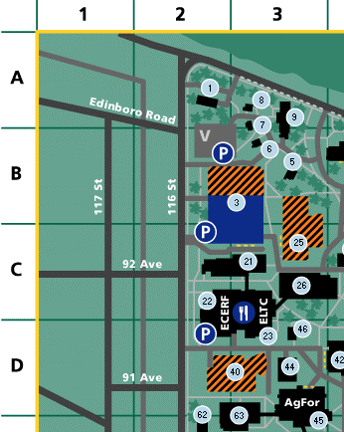

The Engineering Teaching and Learning Complex (ETLC) (Building 23) is located directly east of the new ECERF building on the western edge of campus.

