Hilton site indicting area things to do
Name | Distance | Heading
Al Lang Field | 1.0 BLK | E
Antique shopping | 4.0 BLK | N
Art galleries | 4.0 BLK | N
Baywalk Entertainment Complex | 6.0 BLK | N
City Center | 0.0 MI | N
Dali Museum | 7.0 BLK | S
FL Holocaust Museum | 8.0 BLK | NW
Fort DeSoto Park | 5.0 MI | SE
Great Exploration Museum | 8.0 BLK | S
International Museum | 5.0 BLK | N
Jannus Landing | 3.0 BLK | N
Mahaffey Theater | 1.0 BLK | E
Museum of the Fine Arts | 5.0 BLK | N
St Pete Yacht Club | 5.0 BLK | N
St. Petersburg Museum of History | 10.0 BLK | N
Straub Park | 8.0 BLK | N
Tropicana Field | 2.0 MI | W
Vinoy Park | 1.0 MI | N
MI=Miles BLK=Block KM=Kilometers MT=Meters YD=Yards

Hilton site indicates these transportation cost/information

Tampa International Airport
DIRECTIONS
Take I-275 South to Exit 22: Interstate 175. The exit will turn into 5th Avenue south. Follow 5th Avenue south to First Street south, turn left, Hilton is 2 blocks down on the Left.
Distance from Hotel:22 mi.
Drive Time:30 min.
Type | Typical Minimum Charge
Super Shuttle | 50.00 USD
Taxi | 55.00 USD
GET TURN-BY-TURN DIRECTIONS
St. Petersburg-Clearwater International
DIRECTIONS
Take Ulmerton Road East to I-275 South, Exit 22: Interstate 175. The exit will turn into 5th Avenue South. Follow 5th Avenue South to First Street South, turn left, Hilton is 2 blocks down on the Left.
Distance from Hotel:15 mi.
Drive Time:20 min.
Type | Typical Minimum Charge
Super Shuttle | 35.00 USD
Taxi | 30.00 USD
GET TURN-BY-TURN DIRECTIONS

In checking Super Shuttle site it indicates that the typical fare from TIA to Hilton Bayfront is $25.00 However, I went online and ‘booked’ a ride tonight

1 way was $23.00

Round trip was $19.50 (ea way) or about 15% off.

So it might be worth inquiring if they would provide a special rate?? Maybe to include tip $40 or $45 round trip?
Hilton DINING
At the Hilton St. Petersburg Bayfront hotel, dining options are designed with you in mind. Start the day with a hearty breakfast or nutritious light bite; savor innovative dishes prepared with only the freshest ingredients in the Tangerine restaurant or simply relax with a drink in the Dali hotel bar. From business brunches to pre-dinner drinks and everything in between, our St. Petersburg, FL restaurants are catered especially for you.

CP EXPRESS
Enjoy our CP Express menu with items delivered directly to your door or browse our selection prepared foods, snack and drinks in the Corner Pantry.
CP Express Menu (PDF)

MONDAY | 6:00 am - 11:00 pm
TUESDAY | 6:00 am - 11:00 pm
WEDNESDAY | 6:00 am - 11:00 pm
THURSDAY | 6:00 am - 11:00 pm
FRIDAY | 6:00 am - 11:00 pm
SATURDAY | 6:00 am - 11:00 pm
SUNDAY | 6:00 am - 11:00 pm

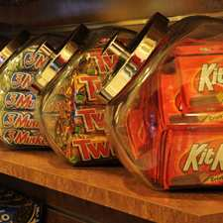
- CORNER PANTRY
Looking for a quick snack, something to take back to your room or on your way to t he airport – our Corner Pantry is located next to the Front Desk and is open 24-hours.
- Sundries
- Newspaper
- Ice Cream
- Clothing
- Beverages
- Salads
- Magazines
- Snacks
- Sandwiches

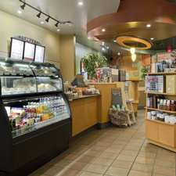
STARBUCKS
On-site Starbucks® facility serving your favorite throughout the day, during your stay or meeting. Come enjoy a snack or just coffee, while sitting on our outdoor patio, or relaxing indoors.

HOURS
MONDAY | 6:00 am - 5:00 pm
TUESDAY | 6:00 am - 5:00 pm
WEDNESDAY | 6:00 am - 5:00 pm
THURSDAY | 6:00 am - 5:00 pm
FRIDAY | 6:00 am - 5:00 pm
SATURDAY | 6:00 am - 5:00 pm
SUNDAY | 6:00 am - 4:00 pm

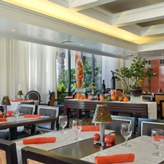
TANGERINE
Our modern restaurant, Tangerine, serves breakfast, lunch and dinner.
Breakfast Menu (PDF)
Lunch Menu (PDF)
Dinner Menu (PDF)

HOURS
MONDAY | 6:30 am - 10:00 pm
TUESDAY | 6:30 am - 10:00 pm
WEDNESDAY | 6:30 am - 10:00 pm
THURSDAY | 6:30 am - 10:00 pm
FRIDAY | 6:30 am - 10:00 pm
SATURDAY | 6:30 am - 10:00 pm
SUNDAY | 6:30 am - 10:00 pm

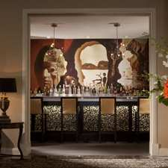
THE DALI BAR
One of the best bars in Downtown St Petersburg, the Dalí Bar is the only bar in St. Petersburg inspired by, and named after an artist. For a drink in an intimate setting, have a cocktail at our newest addition to the hotel, the Dalí Bar. Our expert mixologist will be glad create a unique concoction sure to tantalize your taste buds and titillate your senses.

HOURS
MONDAY | 3:00 pm - 11:00 pm
TUESDAY | 3:00 pm - 11:00 pm
WEDNESDAY | 3:00 pm - 11:00 pm
THURSDAY | 3:00 pm - 11:00 pm
FRIDAY | 3:00 pm - 11:00 pm
SATURDAY | 3:00 pm - 11:00 pm
SUNDAY | 3:00 pm - 11:00 pm

Other Restaurants around downtown area: (also please see ‘DiningMap-Florida3.ppt)
- Five Guys / Nature’s Table
- Sushi Inc.
- Joey Brooklyn’s
- McDintons
- Lucky Dill Deli
- Crowley’s
- Fortunado’s Italian
- Central Ave Oyster Bar
- Five Bucks Brewery
- Caddy’s on Central
- Burrito Boarder
- Dooner’s
- The Mill
- Subway
- Rowdies Den
- Z Grille
- Acropolis
- Red Mesa Cantina
- Sab Cafe
- Bombay Grill
- Avenue Burger
- La V
- MEZE 119
- Players Tap & Tavern
- Hofbräuhaus
- Starbucks
- Ceviche
- Cassis American Brasserie
- Bella Brava
- Stillwater Tavern
- Ruth Chris, Sea Salt, Local Market

