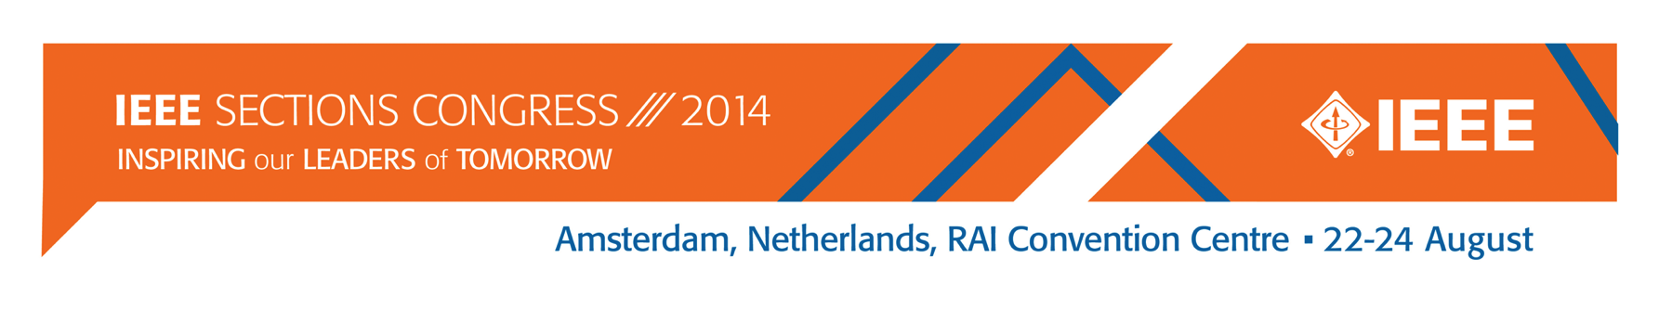

13 December 2013
To: Region Directors, Director-Elects, and Region Sections Congress Coordinators
From: Murty Polavarapu, SC2014 Program Committee Chair
Sub: IEEE Sections Congress 2014 (SC2014) Recommendation Process
The upcoming Sections Congress (SC2014) provides a unique forum to collect input from our grassroots leadership to help shape our organization for the future. The recommendations process for SC2014 builds on the experiences from previous events with some refinements. This process was reviewed by the MGA Board in November 2013.
- Each Region is requested to submit up to four prioritized recommendations using the SC2014 Recommendation template (attached).
- Recommendations are to be submitted no later than 16 May 2014.
- As you generate the recommendations at your Region meetings, please encourage consideration of the long term vision of IEEE and alignment with MGA five year strategies. Recommendations related to MGA goals and strategies will have greater probability of implementation. Those that are outside of the MGA domain will be evaluated by the impacted Organizational Unit.
- The MGA Operations Committee and SC2014 Program Committee will take ownership of the recommendations to review and modify, if necessary, to remove duplicates and ensure clarity.
- Back up material concerning the issue addressed in the recommendation will be coordinated prior to SC2014. All recommendations and back up information will be distributed to attendees by 7 July 2014.
- We will promote the discussion on the recommendations using social media channels prior to, during, and after the Congress.
- The voting by primary delegates can be completed anytime during the Congress, up to 12:00 noon, on Sunday, 24 August 2014, using the SC2014 mobile app and web.
- The top five recommendations will be presented on 24 August 2014 at the Closing Ceremony.
An update on responses and status of SC2011 Recommendations can be found on the IEEE Sections Congress web page. If you have any questions regarding the SC2014 Recommendation process, please contact sc-coordinator@ieee.org.
I look forward to input from your Regions in generating innovative ideas to drive our organization forward.
Murty Polavarapu
Chair, Program Committee SC2014

SC2014 Proposed Recommendation
Region:
Recommendation (no more than 50 words):
Why is this recommendation being submitted? (no more than 150 words):
MGA Goal/Strategy/Other goal Supported:
Identified measures of success (i.e. What does it take to consider this recommendation achieved?):
Financial Implications (Does this need money?)
Has this been included as a recommendation at a previous Sections Congress?

Contact for additional information (name and email address)
Proposed Champion for this recommendation (i.e. , person who will follow up, agree to work with MGA Board in achieving this recommendation)
Submission Date
Indicate Recommendation Category below:
 | Business Financial/ Operations |  | Membership
 | IT Operations |  | Public Awareness & New Technology
 | Member Benefits |  | Recruitment/ Retention (Membership)
 | Member Growth and Development |  | Other:

