Set - I
======
- Design basic gates (AND,OR, NOT, XOR, XNOR, NAND, NOR) using VHDL.

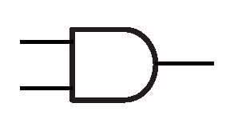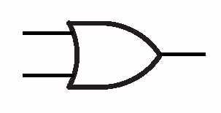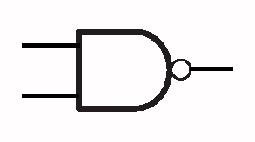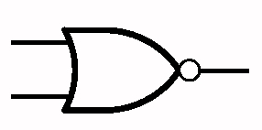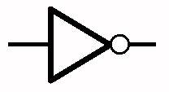
X

Y

Z

0

0

0

0

1

0

1

0

0

1

1

1

X

Y

Z

0

0

0

0

1

1

1

0

1

1

1

1

X

Z

0

1

1

0

X

Y

Z

0

0

1

0

1

1

1

0

1

1

1

0

X

Y

Z

0

0

1

0

1

0

1

0

0

1

1

0

AND
OR
NOT
NAND
NOR

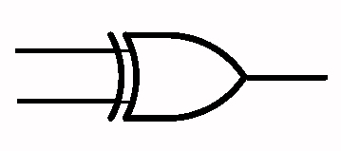
X

Y

Z

0

0

0

0

1

1

1

0

1

1

1

0

X

Y

Z

0

0

1

0

1

0

1

0

0

1

1

1

XOR
XNOR

library IEEE;
use IEEE.STD_LOGIC_1164.ALL;
use IEEE.STD_LOGIC_ARITH.ALL;
use IEEE.STD_LOGIC_UNSIGNED.ALL;

entity GATES is
Port ( G1 : in std_logic;
G2 : in std_logic;
N1 : out std_logic;
A1 : out std_logic;
O1 : out std_logic;
X1 : out std_logic;
NA1 : out std_logic;
NO1 : out std_logic;
XN1 : out std_logic);
end GATES;

architecture Behavioral of GATES is
begin
N1 <= NOT G1;
A1 <= G1 AND G2;
O1 <= G1 OR G2;
X1 <= G1 XOR G2;
NA1 <= G1 NAND G2;
NO1 <= G1 NOR G2;
XN1 <= G1 XNOR G2;
end Behavioral;

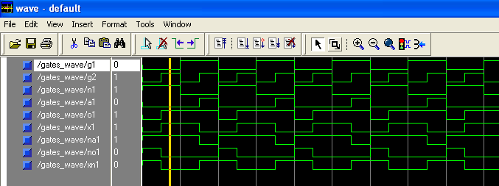

- (a) Design a Half Adder using dataflow modeling with VHDL.

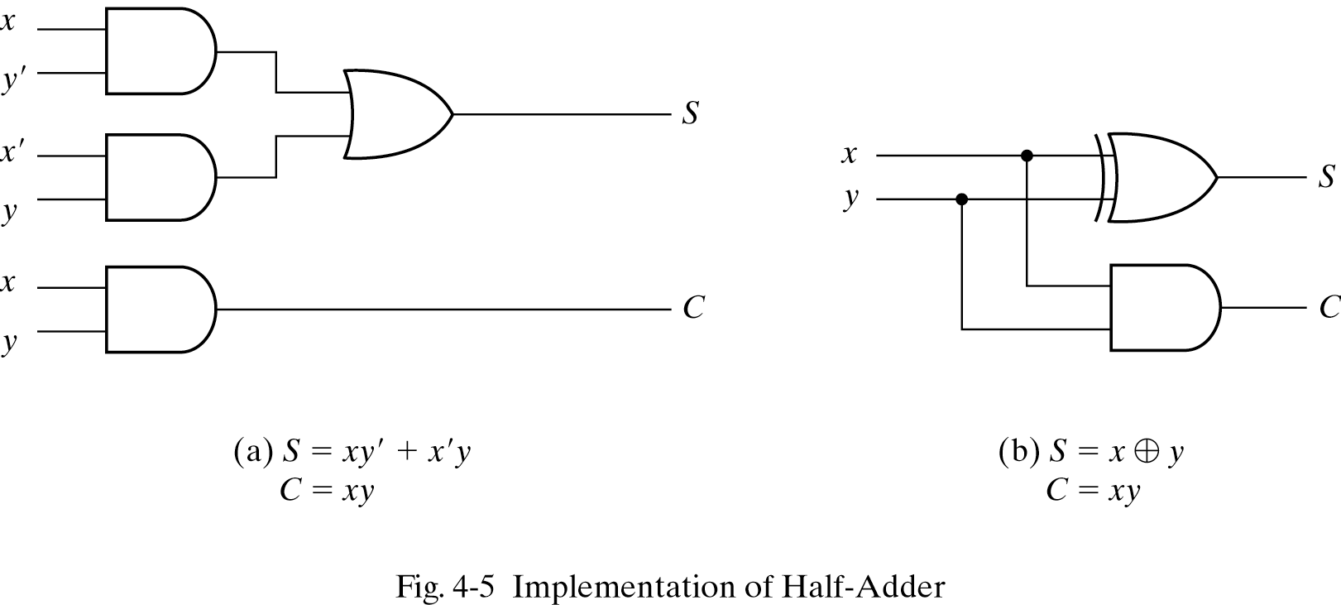
S= X Y
C= X.Y
library IEEE;
use IEEE.STD_LOGIC_1164.ALL;
use IEEE.STD_LOGIC_ARITH.ALL;
use IEEE.STD_LOGIC_UNSIGNED.ALL;

entity HALF_ADDER is
Port ( HA1 : in std_logic;
HA2 : in std_logic;
HA_SUM : out std_logic;
HA_CAR : out std_logic);
end HALF_ADDER;

architecture Behavioral of HALF_ADDER is
begin
HA_SUM <= HA1 XOR HA2;
HA_CAR <= HA1 AND HA2;
end Behavioral;

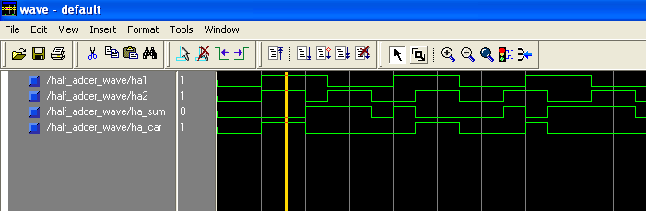

2. (b) Design a Half Adder using structural modeling

library IEEE;
use IEEE.STD_LOGIC_1164.ALL;
use IEEE.STD_LOGIC_ARITH.ALL;
use IEEE.STD_LOGIC_UNSIGNED.ALL;

entity HALF_ADDER_COMP is
Port(HA1 : in std_logic;
HA2 : in std_logic;
HA_SUM : out std_logic;
HA_CRY : out std_logic);
end HALF_ADDER_COMP;

architecture Behavioral of HALF_ADDER_COMP is
component XOR_TWO is
Port ( X : in std_logic;
Y : in std_logic;
Z : out std_logic);
end component XOR_TWO;

component AND_TWO is
Port( A : in std_logic;
B : in std_logic;
C : out std_logic);
end component AND_TWO;
begin
LB1 : XOR_TWO PORT MAP(HA1,HA2,HA_SUM);
LB2 : AND_TWO PORT MAP(HA1,HA2,HA_CRY);
end Behavioral;

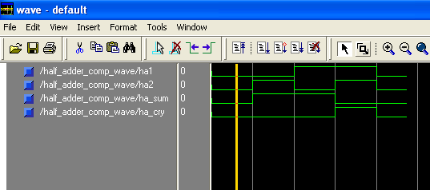

3. (a) Design a Full adder using dataflow modeling.

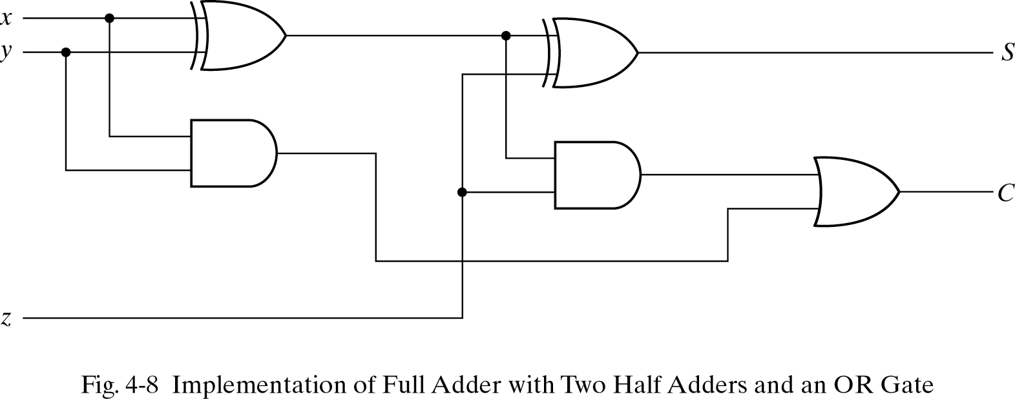
D= X Y  Z
C= X.Y+Z(X Y)
library IEEE;
use IEEE.STD_LOGIC_1164.ALL;
use IEEE.STD_LOGIC_ARITH.ALL;
use IEEE.STD_LOGIC_UNSIGNED.ALL;

entity FULL_ADDER_DATA is
Port ( FA1 : in std_logic;
FA2 : in std_logic;
FA3 : in std_logic;
FA_SUM : out std_logic;
FA_CAR : out std_logic);
end FULL_ADDER_DATA;

architecture Behavioral of FULL_ADDER_DATA is
begin
FA_SUM <= FA1 XOR FA2 XOR FA3;
FA_CAR <= (FA1 AND FA2) OR (FA2 AND FA3) OR(FA1 AND FA3);
end Behavioral;

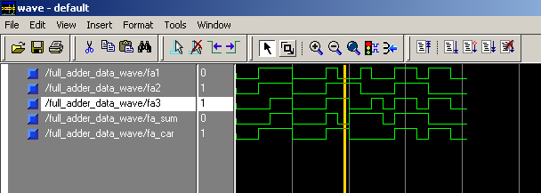
3. (b) Design a Full adder using the macro of Half adder.

HA
HA
X
Y
Z
C
S
D= X Y  Z
C= X.Y+Z(X Y)
library IEEE;
use IEEE.STD_LOGIC_1164.ALL;
use IEEE.STD_LOGIC_ARITH.ALL;
use IEEE.STD_LOGIC_UNSIGNED.ALL;

entity FULL_ADDER_COMP is
Port ( FA1 : in std_logic;
FA2 : in std_logic;
FA3 : in std_logic;
FA_SUM : out std_logic;
FA_CAR : out std_logic);
end FULL_ADDER_COMP;

architecture Behavioral of FULL_ADDER_COMP is
component HALF_ADDER is
Port ( HA1 : in std_logic;
HA2 : in std_logic;
HA_SUM : out std_logic;
HA_CAR : out std_logic);
end component HALF_ADDER;
signal T1,T2,T3,SUM : std_logic;
begin
F1: HALF_ADDER port map(FA1,FA2,T1,T2);
F2: HALF_ADDER port map(T1,FA3,SUM,T3);
FA_CAR <= (T2 OR T3);
FA_SUM <= SUM;
end Behavioral;

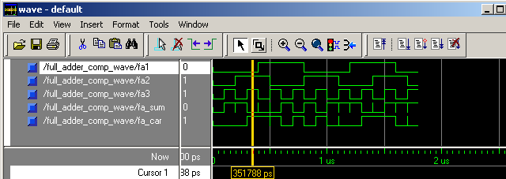
4. (a) Design a 4-bit adder circuit using the macro of Full adder.

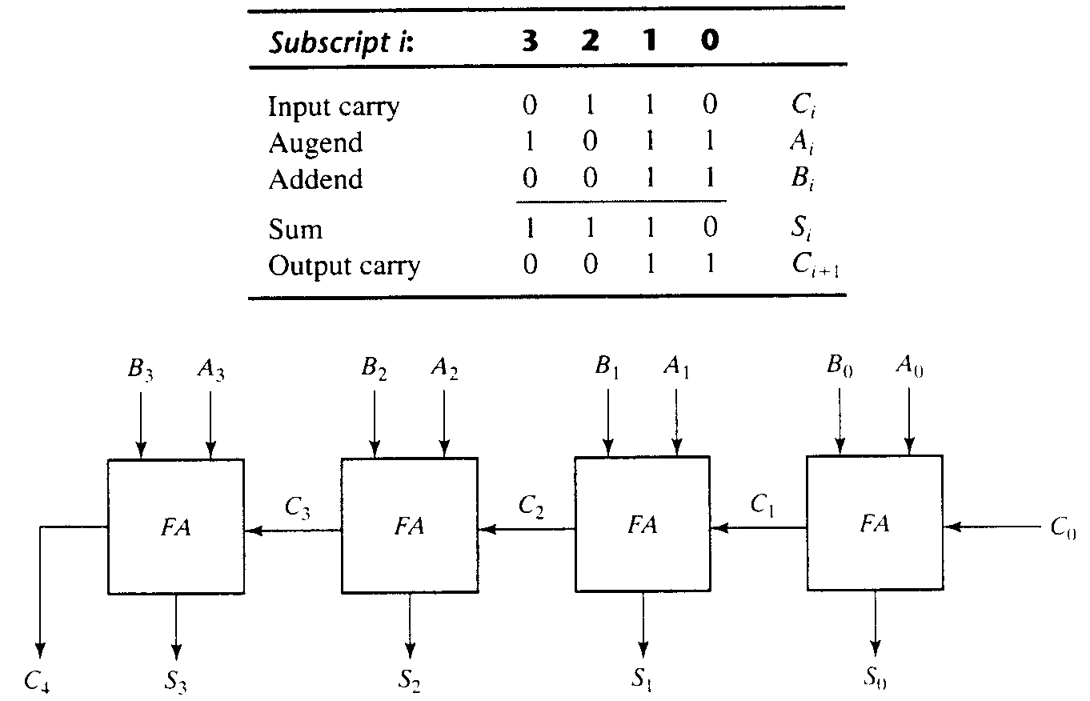
C_{out} C₃ C₂ C₁ C_{in}
A₃ A₂ A₁ A₀
B₃ B₂ B₁ B₀

S₃ S₂ S₁ S₀
library IEEE;
use IEEE.STD_LOGIC_1164.ALL;
use IEEE.STD_LOGIC_ARITH.ALL;
use IEEE.STD_LOGIC_UNSIGNED.ALL;

entity FULL_ADDER_4BIT is
Port(Ain : in std_logic_vector(3 downto 0);
Bin : in std_logic_vector(3 downto 0);
Cary_in : in std_logic;
Cout : out std_logic_vector(3 downto 0);
Cary_out : out std_logic);
end FULL_ADDER_4BIT;

architecture Behavioral of FULL_ADDER_4BIT is
component FULL_ADDER_COMP is
Port( FA1 : in std_logic;
FA2 : in std_logic;
FA3 : in std_logic;
FA_SUM : out std_logic;
FA_CAR : out std_logic);
end component FULL_ADDER_COMP;
signal T : std_logic_vector(4 downto 0);
begin
T(0) <= Cary_in;
FA4B_1: FULL_ADDER_COMP PORT MAP(Ain(0),Bin(0),T(0),Cout(0),T(1));
FA4B_2: FULL_ADDER_COMP PORT MAP(Ain(1),Bin(1),T(1),Cout(1),T(2));
FA4B_3: FULL_ADDER_COMP PORT MAP(Ain(2),Bin(2),T(2),Cout(2),T(3));
FA4B_4: FULL_ADDER_COMP PORT MAP(Ain(3),Bin(3),T(3),Cout(3),T(4));
Cary_out <= T(4);
end Behavioral;

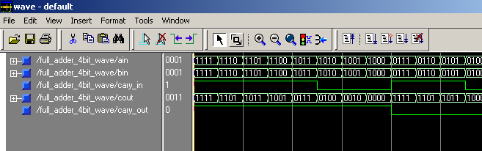

4. (b) Design a 4-bit adder circuit using carry look-ahead adder circuit.

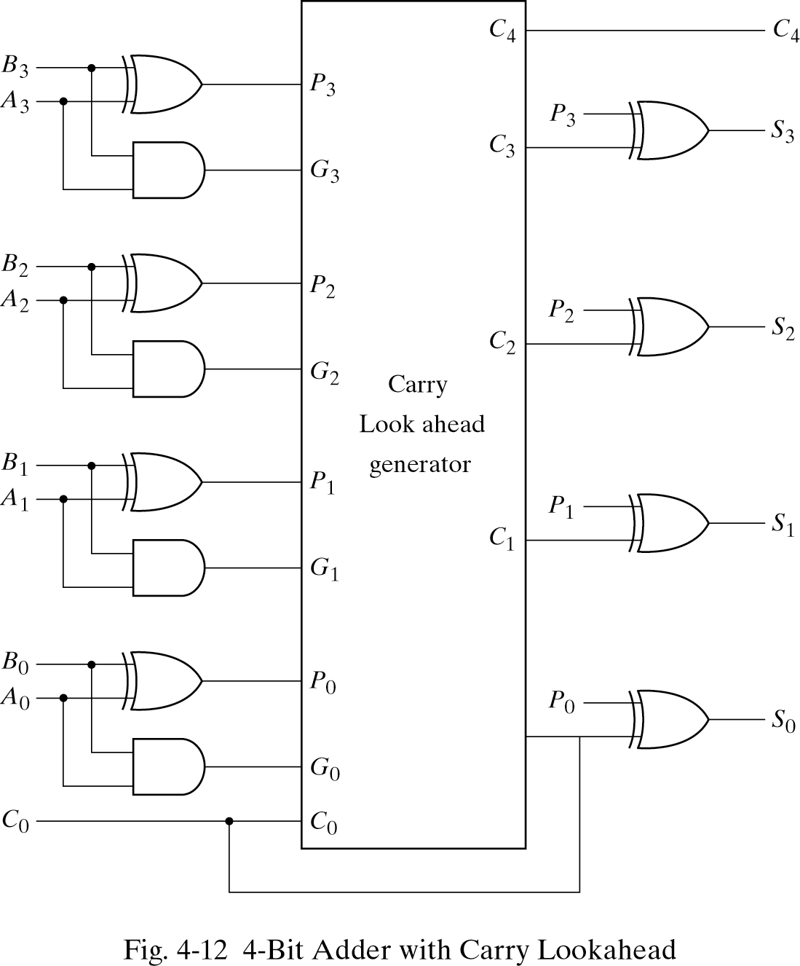

carry propagate: P_{i} = A_{i} XOR B_{i}
carry generate: G_{i} = A_{i}B_{i}
sum: S_{i} = P_{i} XOR C_{i}
carry: C_{i+1} = G_{i}+P_{i}C_{i}

library IEEE;
use IEEE.STD_LOGIC_1164.ALL;
use IEEE.STD_LOGIC_ARITH.ALL;
use IEEE.STD_LOGIC_UNSIGNED.ALL;

entity CARRY_LOOK_AHEAD_ADDER_4BIT is
port( CAin1 : in std_logic_vector(3 downto 0);
CAin2 : in std_logic_vector(3 downto 0);
CAcarryin : in std_logic;
CAsum : out std_logic_vector(3 downto 0);
CAcarry : out std_logic);
End entity CARRY_LOOK_AHEAD_ADDER_4BIT;

Architecture CLA_ADDER OF CARRY_LOOK_AHEAD_ADDER_4BIT is
Begin
process(CAin1,CAin2,CAcarryin)
variable P,G : std_logic_vector(4 downto 1);
variable C : std_logic_vector(4 downto 0);
begin
C(0) := CAcarryin;
for I in 1 to 4 loop
G(I) := (CAin1(I-1) AND CAin2(I-1));
P(I) := (CAin1(I-1) XOR CAin2(I-1));
C(I) := G(I) OR (P(I) AND C(I-1));
End loop;
for I in 0 to 3 loop
CAsum(I) <= P(I+1) xor C(I);
End loop;
CAcarry <= C(4);
end process;
End CLA_ADDER;

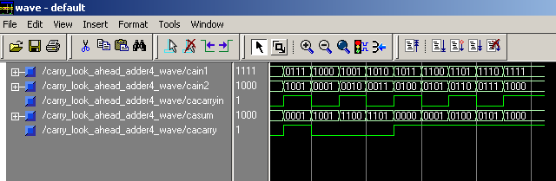
5. (a) Design a Half Subtractor using data flow modeling.

D= X Y
C= A.B
library IEEE;
use IEEE.STD_LOGIC_1164.ALL;
use IEEE.STD_LOGIC_ARITH.ALL;
use IEEE.STD_LOGIC_UNSIGNED.ALL;

entity half_subtractor is
Port(HS1 : in std_logic;
HS2 : in std_logic;
HS_SUB : out std_logic;
HS_BOR : out std_logic);
end half_subtractor;

architecture Behavioral of half_subtractor is
begin
HS_SUB <= HS1 XOR HS2;
HS_BOR <= (NOT HS1) AND HS2;
end Behavioral;

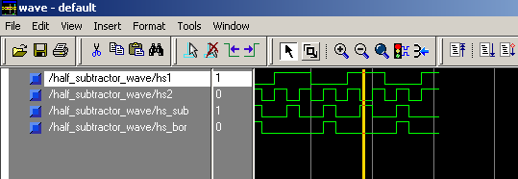
5. (b) Deisgn a full subtractor using a 3:8 Decoder circuit and OR gates.

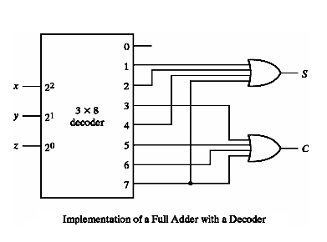

library IEEE;
use IEEE.STD_LOGIC_1164.ALL;
use IEEE.STD_LOGIC_ARITH.ALL;
use IEEE.STD_LOGIC_UNSIGNED.ALL;

entity FULL_SUBTRACTOR_38DECODER is
Port(FS1 : in std_logic;
FS2 : in std_logic;
FS3 : in std_logic;
FS_SUB : out std_logic;
FS_BOR : out std_logic);
end FULL_SUBTRACTOR_38DECODER;

architecture Behavioral of FULL_SUBTRACTOR_38DECODER is
component DECODER_38 is
Port( S : in std_logic_vector(2 downto 0);
D : out std_logic_vector(7 downto 0);
en : in std_logic );
end component DECODER_38;
signal T : std_logic_vector(7 downto 0);
signal Temp : std_logic_vector(2 downto 0);
begin
Temp <= FS1 & FS2 & FS3;
DE1 : DECODER_38 PORT MAP(Temp,T,'1');
FS_SUB <= T(1) or T(2) or T(4) or T(7);
FS_BOR <= T(1) or T(2) or T(3) or T(7);
end Behavioral;
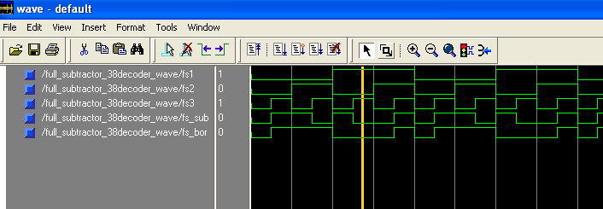

6. Design a BCD adder circuit using VHDL.

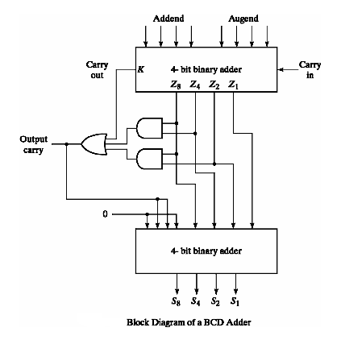
library IEEE;
use IEEE.STD_LOGIC_1164.ALL;
use IEEE.STD_LOGIC_ARITH.ALL;
use IEEE.STD_LOGIC_UNSIGNED.ALL;

entity BCD_ADDER is
Port( BCD1 : in std_logic_vector(3 downto 0);
BCD2 : in std_logic_vector(3 downto 0);
BCD_CIN : in std_logic;
BCD_SUM : out std_logic_vector(3 downto 0);
BCD_COUT : out std_logic);
end BCD_ADDER;

architecture Behavioral of BCD_ADDER is
component FULL_ADDER_COMP is
Port( FA1 : in std_logic;
FA2 : in std_logic;
FA3 : in std_logic;
FA_SUM : out std_logic;
FA_CAR : out std_logic);
end component FULL_ADDER_COMP;
signal TS : std_logic_vector(3 downto 1);
signal C : std_logic_vector(6 downto 0);
signal T : std_logic_vector(2 downto 0);
signal Cin : std_logic;
begin
C(0) <= BCD_CIN;
Cin <= '0';
B1: FULL_ADDER_COMP port map(BCD1(0), BCD2(0), C(0), BCD_SUM(0), C(1));
B2: FULL_ADDER_COMP port map(BCD1(1), BCD2(1),C(1),TS(1),C(2));
B3: FULL_ADDER_COMP port map(BCD1(2), BCD2(2),C(2),TS(2),C(3));
B4: FULL_ADDER_COMP port map(BCD1(3), BCD2(3),C(3),TS(3),C(4));
T(0) <= TS(3) and TS(2);
T(1) <= TS(3) and TS(1);
T(2) <= C(4) or T(0) or T(1);
B5: FULL_ADDER_COMP port map(TS(1),T(2),Cin,BCD_SUM(1),C(5));
B6: FULL_ADDER_COMP port map(TS(2),T(2),C(5),BCD_SUM(2),C(6));
BCD_SUM(3) <= TS(3) xor C(6);
BCD_COUT <= T(2);
end Behavioral;

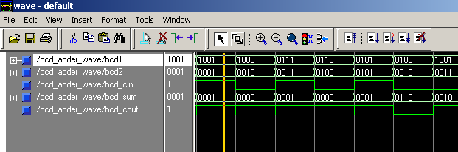
Set - II
=====
1. Design a 4-bit adder using generate statement.

C_{out} C₃ C₂ C₁ C_{in}
A₃ A₂ A₁ A₀
B₃ B₂ B₁ B₀

S₃ S₂ S₁ S₀

library IEEE;
use IEEE.STD_LOGIC_1164.ALL;
use IEEE.STD_LOGIC_ARITH.ALL;
use IEEE.STD_LOGIC_UNSIGNED.ALL;

entity FULLADDER_4BIT_GENERATE is
Port ( FAIN_A : in std_logic_vector(3 downto 0);
FAIN_B : in std_logic_vector(3 downto 0);
FAIN_C : in std_logic;
FA_SM : out std_logic_vector(3 downto 0);
FA_CY : out std_logic);
end FULLADDER_4BIT_GENERATE;

architecture Behavioral of FULLADDER_4BIT_GENERATE is
component FULL_ADDER_COMP is
Port ( FA1 : in std_logic;
FA2 : in std_logic;
FA3 : in std_logic;
FA_SUM : out std_logic;
FA_CAR : out std_logic);
end component FULL_ADDER_COMP;
signal C : std_logic_vector(4 downto 0);
begin
C(0) <= FAIN_C;
GK: for k in 3 downto 0 generate
U1: FULL_ADDER_COMP PORT MAP (FAIN_A(K), FAIN_B(K), C(K), FA_SM(K), C(K+1));
end generate gk;
FA_CY <= C(4);
end Behavioral;

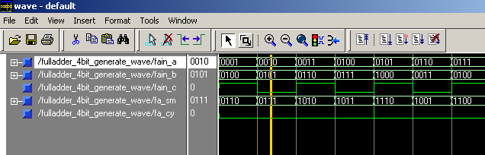
2. Design a mode-control 4-bit adder/subtractor circuit.

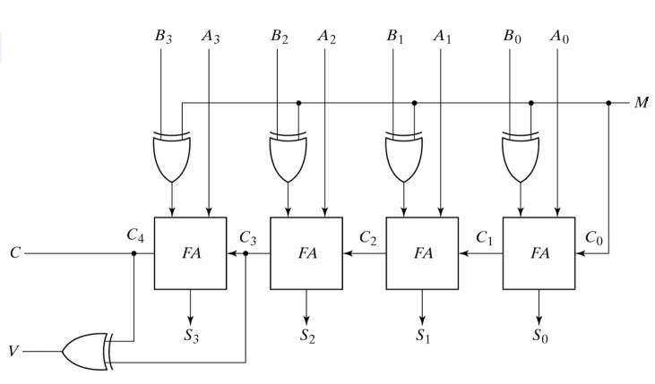
library IEEE;
use IEEE.STD_LOGIC_1164.ALL;
use IEEE.STD_LOGIC_ARITH.ALL;
use IEEE.STD_LOGIC_UNSIGNED.ALL;

entity FULL_ADDER_4_MODE is
Port ( FAIN_A : in std_logic_vector(3 downto 0);
FAIN_B : in std_logic_vector(3 downto 0);
FA_MODE : in std_logic;
FA_SUM : out std_logic_vector(3 downto 0);
FA_CAR : out std_logic;
FA_V : out std_logic);
end FULL_ADDER_4_MODE;

architecture Behavioral of FULL_ADDER_4_MODE is
component FULL_ADDER_COMP is
Port ( FA1 : in std_logic;
FA2 : in std_logic;
FA3 : in std_logic;
FA_SUM : out std_logic;
FA_CAR : out std_logic);
end component FULL_ADDER_COMP;
signal carry : std_logic_vector(4 downto 0);
signal ModeB : std_logic_vector(3 downto 0);
begin
ModeB(0) <= FAIN_B(0) xor FA_MODE;
ModeB(1) <= FAIN_B(1) xor FA_MODE;
ModeB(2) <= FAIN_B(2) xor FA_MODE;
ModeB(3) <= FAIN_B(3) xor FA_MODE;

carry(0) <= FA_MODE;
FA4M_1: FULL_ADDER_COMP PORT MAP(FAIN_A(0), ModeB(0), carry(0), FA_SUM(0), carry(1));

FA4M_2: FULL_ADDER_COMP PORT MAP(FAIN_A(1), ModeB(1), carry(1), FA_SUM(1), carry(2));

FA4M_3: FULL_ADDER_COMP PORT MAP(FAIN_A(2), ModeB(2), carry(2), FA_SUM(2), carry(3));

FA4M_4: FULL_ADDER_COMP PORT MAP(FAIN_A(3), ModeB(3), carry(3), FA_SUM(3),carry(4));

FA_V <= carry(4) xor carry(3);
FA_CAR <= carry(4);
end Behavioral;

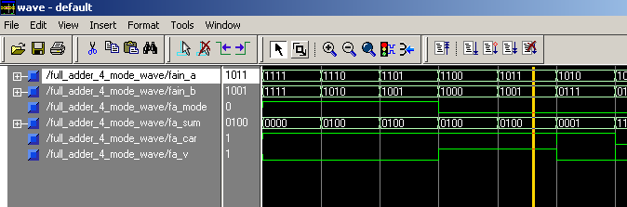
3. (a) Design a 4:1 Multiplexer using if_else statement.

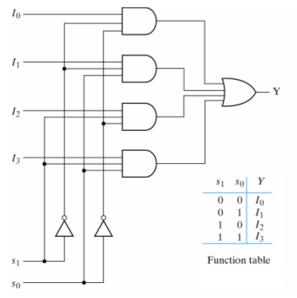
library IEEE;
use IEEE.STD_LOGIC_1164.ALL;
use IEEE.STD_LOGIC_ARITH.ALL;
use IEEE.STD_LOGIC_UNSIGNED.ALL;

entity MUX4_1_IF_ELSE is
Port( MUXIN_0,MUXIN_1,MUXIN_2,MUXIN_3 : in std_logic;
MUXSEL : in std_logic_vector(1 downto 0);
MUXOUT : out std_logic);
end MUX4_1_IF_ELSE;

architecture Behavioral of MUX4_1_IF_ELSE is
begin
PROCESS(MUXSEL)
BEGIN
IF MUXSEL = "00" THEN
MUXOUT <= MUXIN_0;
ELSIF MUXSEL = "01" THEN
MUXOUT <= MUXIN_1;
ELSIF MUXSEL = "10" THEN
MUXOUT <= MUXIN_2;
ELSE
MUXOUT <= MUXIN_3;
END IF;
END PROCESS;
end Behavioral;

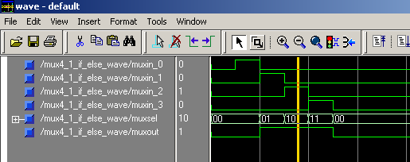
3. (b) Design a 4:1 Multiplexer using case statement.

library IEEE;
use IEEE.STD_LOGIC_1164.ALL;
use IEEE.STD_LOGIC_ARITH.ALL;
use IEEE.STD_LOGIC_UNSIGNED.ALL;

entity MUX4_1_CASE is
Port( MUXIN_0,MUXIN_1,MUXIN_2,MUXIN_3 : in std_logic;
MUXSEL : in std_logic_vector(1 downto 0);
MUXOUT : out std_logic);
end MUX4_1_CASE;

architecture Behavioral of MUX4_1_CASE is
begin
PROCESS(MUXSEL)
BEGIN
CASE MUXSEL IS
WHEN "00" => MUXOUT <= MUXIN_0;
WHEN "01" => MUXOUT <= MUXIN_1;
WHEN "10" => MUXOUT <= MUXIN_2;
WHEN OTHERS => MUXOUT <= MUXIN_3;
END CASE;
END PROCESS;
end Behavioral;

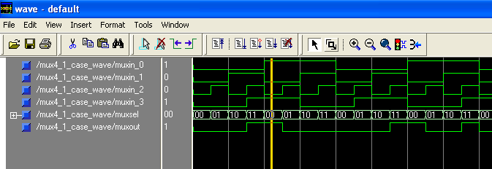
4. (a) Design a 2:4 Decoder using behavioral modeling.

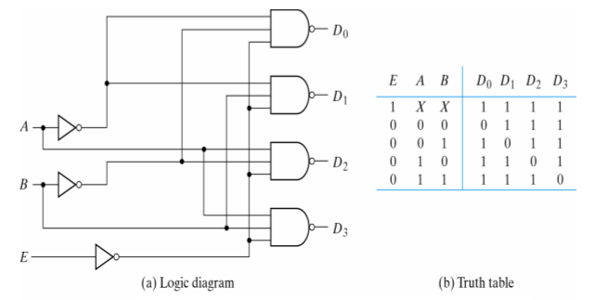

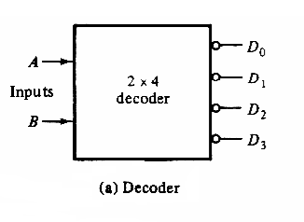

library IEEE;
use IEEE.STD_LOGIC_1164.ALL;
use IEEE.STD_LOGIC_ARITH.ALL;
use IEEE.STD_LOGIC_UNSIGNED.ALL;

entity DECODER2_4 is
Port ( SE : in std_logic_vector(1 downto 0);
DE : out std_logic_vector(3 downto 0));
end DECODER2_4;

architecture Behavioral of DECODER2_4 is
signal TE : std_logic_vector(3 downto 0);
begin
TE <= "0001" when SE = "00" else
"0010" when SE = "01" else
"0100" when SE = "10" else
"1000" when SE = "11";
DE <= TE;
end Behavioral;

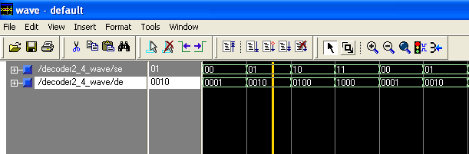
4. (b) Design a 3:8 Decoder using behavioral modeling.

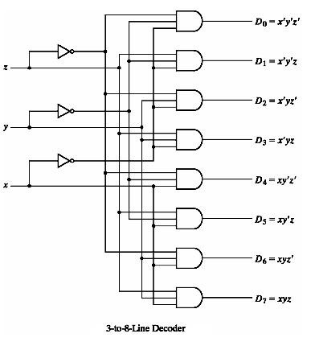

library IEEE;
use IEEE.STD_LOGIC_1164.ALL;
use IEEE.STD_LOGIC_ARITH.ALL;
use IEEE.STD_LOGIC_UNSIGNED.ALL;

entity DECODER_38 is
Port(S : in std_logic_vector(2 downto 0);
D : out std_logic_vector(7 downto 0);
en : in std_logic );
end DECODER_38;

architecture Behavioral of DECODER_38 is
begin
------------------process 1---------------
process(en,S)
begin
if en ='1' then
case s is
when "000" =>D<="00000001";
when "001" =>D<="00000010";
when "010" =>D<="00000100";
when "011" =>D<="00001000";
when "100" =>D<="00010000";
when "101" =>D<="00100000";
when "110" =>D<="01000000";
when "111" =>D<="10000000";
when others => null;
end case;
else
d<=(others =>'0');
end if;
end process;
---------------------------------------
end Behavioral;

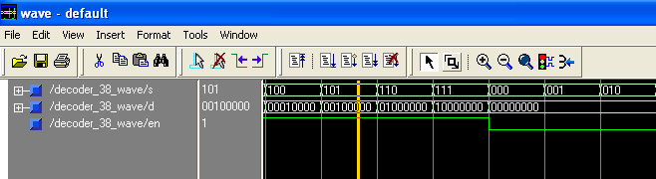
4. (c) Design a 5:32 decoder using the macro of above two design.

library IEEE;
use IEEE.STD_LOGIC_1164.ALL;
use IEEE.STD_LOGIC_ARITH.ALL;
use IEEE.STD_LOGIC_UNSIGNED.ALL;

entity DECODER5_32_COMP2_4_3_8 is
port( SEL : in std_logic_vector(4 downto 0);
DEC : out std_logic_vector(31 downto 0));
end DECODER5_32_COMP2_4_3_8;

architecture Behavioral of DECODER5_32_COMP2_4_3_8 is
component DECODER2_4 is
Port( SE : in std_logic_vector(1 downto 0);
DE : out std_logic_vector(3 downto 0));
end component DECODER2_4;

component DECODER_38 is
Port( S : in std_logic_vector(2 downto 0);
D : out std_logic_vector(7 downto 0);
en : in std_logic );
end component DECODER_38;
signal EN_DE : std_logic_vector(3 downto 0);
signal T : std_logic_vector(31 downto 0);
begin
D1 : DECODER2_4 PORT MAP(SEL(4 downto 3),EN_DE);

D2 : DECODER_38 PORT MAP(SEL(2 downto 0),T(7 downto 0), EN_DE(0));

D3 : DECODER_38 PORT MAP(SEL(2 downto 0),T(15 downto 8), EN_DE(1));

D4 : DECODER_38 PORT MAP(SEL(2 downto 0),T(23 downto 16), EN_DE(2));

D5 : DECODER_38 PORT MAP(SEL(2 downto 0),T(31 downto 24), EN_DE(3));

DEC <= T;
end Behavioral;

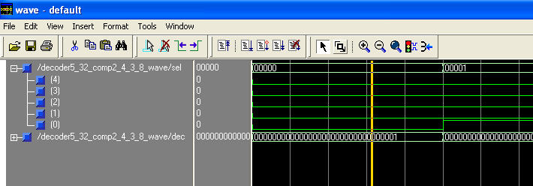
5. Design 4:2 binary encoder using VHDL.

library IEEE;
use IEEE.STD_LOGIC_1164.ALL;
use IEEE.STD_LOGIC_ARITH.ALL;
use IEEE.STD_LOGIC_UNSIGNED.ALL;

entity ENCODER4_2 is
Port( ENin : in std_logic_vector(3 downto 0);
ENout : out std_logic_vector(1 downto 0));
end ENCODER4_2;

architecture Behavioral of ENCODER4_2 is
begin
process(ENin)
begin
case ENin is
when "0001" => ENout <= "00";
when "0010" => ENout <= "01";
when "0100" => ENout <= "10";
when "1000" => ENout <= "11";
when others => NULL;
end case;
end process;
end Behavioral;

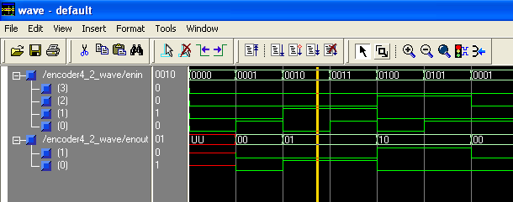

6. Design a Even-parity generator and cheker circuit.

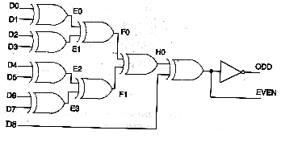
library IEEE;
use IEEE.STD_LOGIC_1164.ALL;
use IEEE.STD_LOGIC_ARITH.ALL;
use IEEE.STD_LOGIC_UNSIGNED.ALL;

entity PARITY_CHECKER_GENERATOR_8BIT is
Port( Pin : in std_logic_vector(7 downto 0);
Pcheck : out std_logic;
Pgenerate : out std_logic);
end PARITY_CHECKER_GENERATOR_8BIT;

architecture Behavioral of PARITY_CHECKER_GENERATOR_8BIT is
signal T : std_logic_vector(7 downto 0);
begin
T(0) <= Pin(0) XOR Pin(1);
T(1) <= Pin(2) XOR Pin(3);
T(2) <= Pin(4) XOR Pin(5);
T(3) <= Pin(6) XOR Pin(7);
T(4) <= T(0) XOR T(1);
T(5) <= T(2) XOR T(3);
T(6) <= T(4) XOR T(5);
T(7) <= NOT T(6);
Pcheck <= T(7);
Pgenerate <= T(6);
end Behavioral;

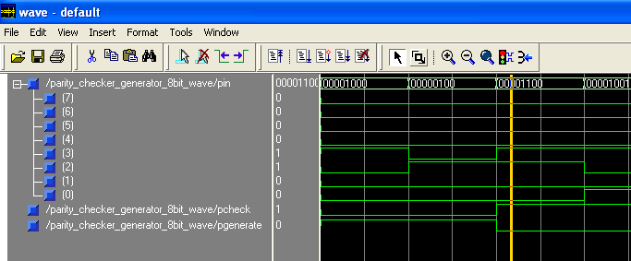
7. Design a 4-bit by 3-bit binary multiplier circuit using the macro of 4-bit adder and AND gates.

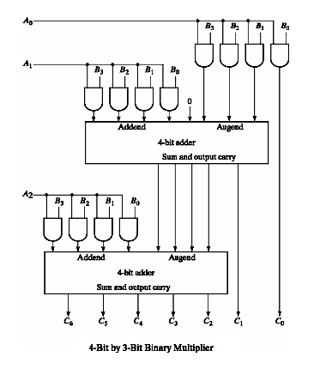
library IEEE;
use IEEE.STD_LOGIC_1164.ALL;
use IEEE.STD_LOGIC_ARITH.ALL;
use IEEE.STD_LOGIC_UNSIGNED.ALL;

entity Mutiplier4_3 is
port( B : in std_logic_vector(3 downto 0);
A : in std_logic_vector(2 downto 0);
O : out std_logic_vector(6 downto 0));
end Mutiplier4_3;

architecture Behavioral of Mutiplier4_3 is
component FULL_ADDER_4BIT is
Port( Ain : in std_logic_vector(3 downto 0);
Bin : in std_logic_vector(3 downto 0);
Cary_in : in std_logic;
Cout : out std_logic_vector(3 downto 0);
Cary_out : out std_logic);
end component FULL_ADDER_4BIT;
signal C : std_logic;
signal T : std_logic_vector(11 downto 0);
signal A1,B1,C1,D1,E1 : std_logic_vector(3 downto 0);
begin
T(0) <= A(0) and B(0);
T(1) <= A(0) and B(1);
T(2) <= A(0) and B(2);
T(3) <= A(0) and B(3);

T(4) <= A(1) and B(0);
T(5) <= A(1) and B(1);
T(6) <= A(1) and B(2);
T(7) <= A(1) and B(3);

T(8) <= A(2) and B(0);
T(9) <= A(2) and B(1);
T(10) <= A(2) and B(2);
T(11) <= A(2) and B(3);

A1 <= '0' & T(3) & T(2) & T(1);
B1 <= T(7) & T(6) & T(5) & T(4);
C1 <= T(11) & T(10) & T(9) & T(8);

O(0) <= T(0);
FA4_1 : FULL_ADDER_4BIT PORT MAP(A1,B1,'0',D1,C);
O(1) <= D1(0);
E1 <= C & D1(3 downto 1);
FA4_2 : FULL_ADDER_4BIT PORT MAP(E1,C1,'0',O(5 downto 2),O(6));
end Behavioral;

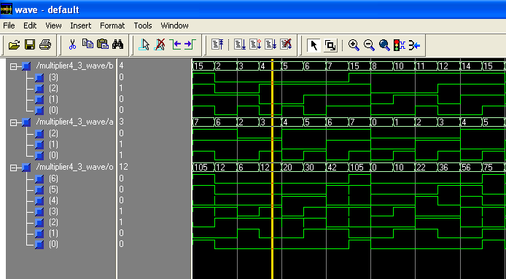
8. Design a single bit comparator cirucit using VHDL.

library IEEE;
use IEEE.STD_LOGIC_1164.ALL;
use IEEE.STD_LOGIC_ARITH.ALL;
use IEEE.STD_LOGIC_UNSIGNED.ALL;

entity COMPARATOR_1BIT is
Port ( A, B : in std_logic;
X : out std_logic; -- A > B
Y : out std_logic; -- A < B
Z : out std_logic; -- A = B
EN : in std_logic);
end COMPARATOR_1BIT;

architecture Behavioral of COMPARATOR_1BIT is
begin
PROCESS(A,B,EN)
BEGIN
If (EN = '1') then
If (A > B) then
X <= '1'; Y <= '0'; Z <= '0';
elsif(A < B) then
X <= '0'; Y <= '1'; Z <= '0';
else
X <= '0'; Y <= '0'; Z <= '1';
end if;
else
X <= '0'; Y <= '0'; Z <= '0';
end if;
END PROCESS;
end Behavioral;

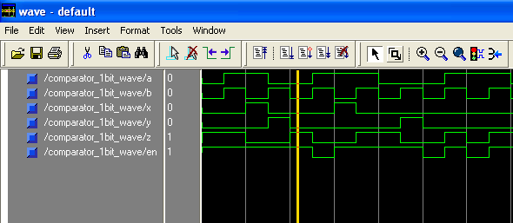
9. (a) Design a 4-bit comparator using the macro of single bit comparator.

library IEEE;
use IEEE.STD_LOGIC_1164.ALL;
use IEEE.STD_LOGIC_ARITH.ALL;
use IEEE.STD_LOGIC_UNSIGNED.ALL;

entity COMPARATOR_4BIT_COMP is
Port ( P, Q : in std_logic_vector(3 downto 0);
M : out std_logic; -- P > Q
N : out std_logic; -- P < Q
O : out std_logic; -- P = Q
EN : in std_logic);
end COMPARATOR_4BIT_COMP;

architecture Behavioral of COMPARATOR_4BIT_COMP is
component COMPARATOR_1BIT is
Port ( A, B : in std_logic;
X : out std_logic; -- A > B
Y : out std_logic; -- A < B
Z : out std_logic; -- A = B
EN : in std_logic);
end component COMPARATOR_1BIT;
signal T : std_logic_vector(11 downto 0);
constant enable : std_logic := '1';
begin
c1: COMPARATOR_1BIT port map(P(3),Q(3),T(0),T(1),T(2),enable);
c2: COMPARATOR_1BIT port map(P(2),Q(2),T(3),T(4),T(5),T(2));
c3: COMPARATOR_1BIT port map(P(1),Q(1),T(6),T(7),T(8),T(5));
c4: COMPARATOR_1BIT port map(P(0),Q(0),T(9),T(10),T(11),T(8));
M <= T(0) OR T(3) OR T(6) OR T(9);
N <= T(1) OR T(4) OR T(7) OR T(10);
O <= T(11);
end Behavioral;

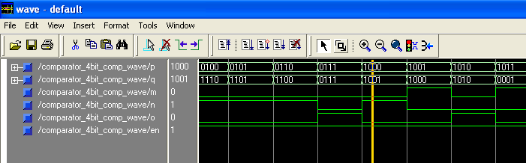
9. (b) Design a 4-bit comparator using the boolean function.

library IEEE;
use IEEE.STD_LOGIC_1164.ALL;
use IEEE.STD_LOGIC_ARITH.ALL;
use IEEE.STD_LOGIC_UNSIGNED.ALL;

entity COMPARATOR_4BIT_BOOLEAN is
Port ( P, Q : in std_logic_vector(3 downto 0);
M : out std_logic; -- P > Q
N : out std_logic; -- P < Q
O : out std_logic; -- P = Q
EN : in std_logic);
end COMPARATOR_4BIT_BOOLEAN;

architecture Behavioral of COMPARATOR_4BIT_BOOLEAN is
begin
process(P,Q,EN)
begin
if(EN = '1')then
if(P > Q) then
M <= '1';
N <= '0';
O <= '0';
elsif(P < Q) then
M <= '0';
N <= '1';
O <= '0';
else
M <= '0';
N <= '0';
O <= '1';
end if;
else
M <= '0';
N <= '0';
O <= '0';
end if;
end process;
end Behavioral;

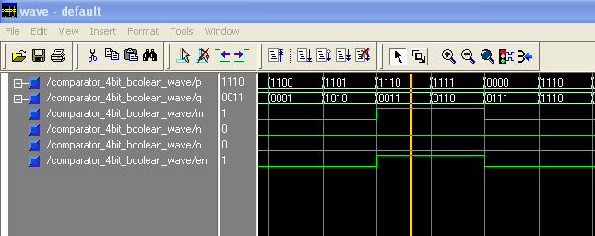
Set - III
======
1. Design a D-Flip flop with
a. Asynchronous preset and clear inputs.
b. Synchronous reset input.
c. Synchronous set input.

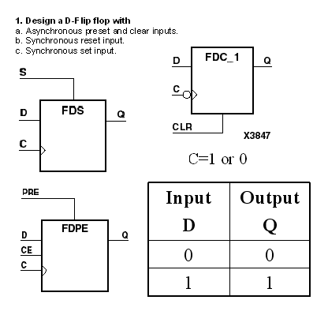
library IEEE;
use IEEE.STD_LOGIC_1164.ALL;
use IEEE.STD_LOGIC_ARITH.ALL;
use IEEE.STD_LOGIC_UNSIGNED.ALL;

entity D_F_F is
Port ( rst : in std_logic;
pr : in std_logic;
clr : in std_logic;
clk : in std_logic;
d : in std_logic;
q : out std_logic);
end D_F_F;

architecture Behavioral of D_F_F is
begin
process(rst,clk,pr,clr,d)
begin
if rst = '1' then
q <= '0';
elsif clr = '1'then
q <= '0';
elsif pr = '1'then
q <= '1';
elsif rising_edge(clk) then
q <= d;
end if;
end process;
end Behavioral;

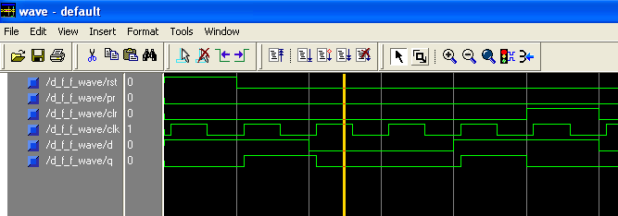
2. Design a negative edge triggered JK flip-flop with asynchronous reset and preset inputs.

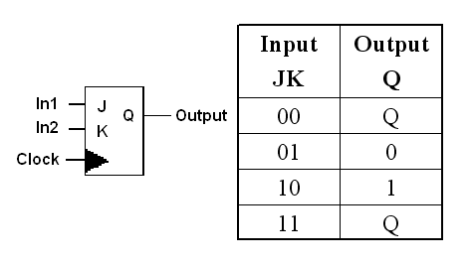
library IEEE;
use IEEE.STD_LOGIC_1164.ALL;
use IEEE.STD_LOGIC_ARITH.ALL;
use IEEE.STD_LOGIC_UNSIGNED.ALL;

entity JK_FF is
port( J : in std_logic;
K : in std_logic;
PRESET: in std_logic;
CLEAR: in std_logic;
CLK : in std_logic;
Q: inout std_logic;
QBAR : out std_logic := '1');
end JK_FF;

architecture Behavioral of JK_FF is
begin
process(PRESET,CLEAR,CLK)
variable JK : std_logic_vector(1 downto 0):= J&K;
begin
if PRESET = '0' then
Q <= '1';
elsif CLEAR = '0' then
Q <= '0';
elsif CLK = '0' and CLK'event then
Q <= (J and not Q) or (not K and Q);
end if;
end process;
QBAR <= not Q;
end Behavioral;

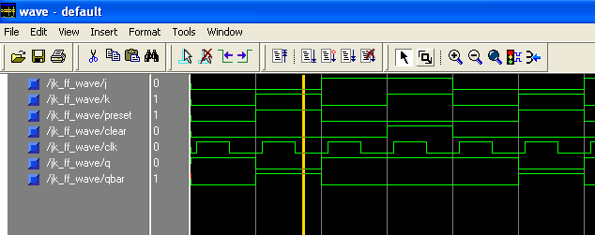
- Write a code to madel a 4-bit shift register with serial input and parallel output data. The circuit has an active high asynchronous reset, data input Din, a shift enable input shift_en and 4-bit output shift_out.

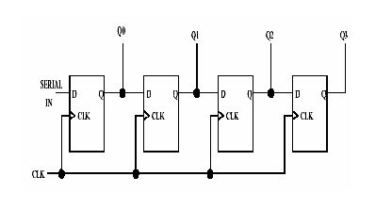
library IEEE;
use IEEE.STD_LOGIC_1164.ALL;
use IEEE.STD_LOGIC_ARITH.ALL;
use IEEE.STD_LOGIC_UNSIGNED.ALL;

entity ShiftR_4bit_Sin_Pout is
Port(clk : in std_logic;
rst : in std_logic;
d : in std_logic ;
q : out std_logic_vector (3 downto 0);
en : in std_logic);
end ShiftR_4bit_Sin_Pout;

architecture Behavioral of ShiftR_4bit_Sin_Pout is
signal q_s : std_logic_vector(3 downto 0);
begin
process(clk,rst,d,en)
begin
if rst = '1' then
q_s <= (others => '0') ;
elsif rising_edge(clk) then
if en = '1' then
q_s <= d & q_s ( 3 downto 1) ;
end if;
end if;
end process;
q <= q_s;
end Behavioral;

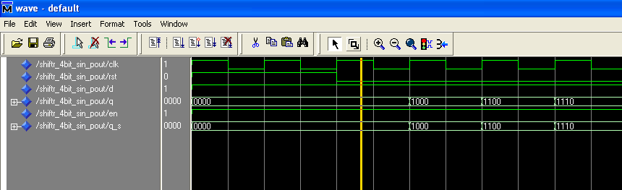
4.Write a code to model 3-bit counter. The counter has an asynchronous input reset and synchronous input count_en. The counter start counting when coount_en = 1 on the rising edge of clock.

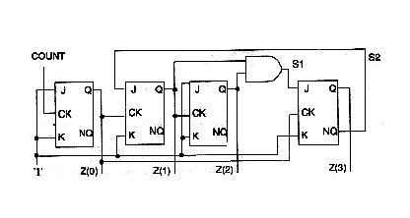

library IEEE;
use IEEE.STD_LOGIC_1164.ALL;
use IEEE.STD_LOGIC_ARITH.ALL;
use IEEE.STD_LOGIC_UNSIGNED.ALL;

entity COUNTER3_BIT is
Port(rst : in std_logic;
clk : in std_logic;
preset : in std_logic;
count_enable : in std_logic;
aload_enable : in std_logic;
aload : in std_logic_vector(2 downto 0);
op : out std_logic_vector(2 downto 0));
end COUNTER3_BIT;

architecture Behavioral of COUNTER3_BIT is
signal c: std_logic_vector(2 downto 0);
begin
process(clk,rst,preset,aload_enable,count_enable)
begin
if rst = '0' then
c <= (others => '0');
elsif preset = '1' then
c <= (others => '1');
elsif aload_enable = '1' then
c <= aload;
elsif rising_edge(clk) then
if count_enable = '1' then
c <= c + 1;
end if;
end if;
end process;
op <= c;
end Behavioral;

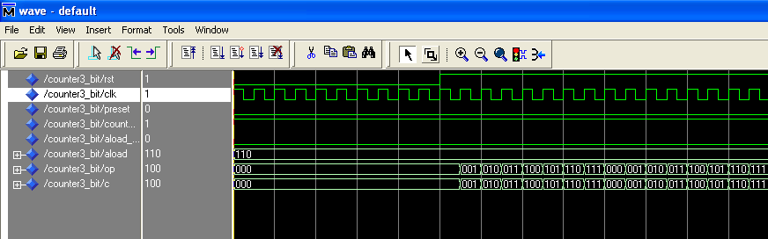
5.Develop a model of 4 bit up-down counter. It has asynchrounous reset input and synchronous inputs count_en and up. When synchronous input up is high, the counter counts up, when up is low it counts down.

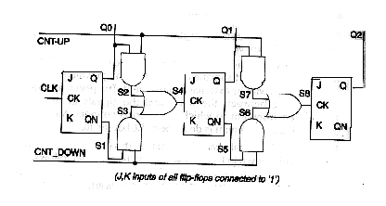

library IEEE;
use IEEE.STD_LOGIC_1164.ALL;
use IEEE.STD_LOGIC_ARITH.ALL;
use IEEE.STD_LOGIC_UNSIGNED.ALL;

entity COUNTER_UP_DOWN is
Port( rst : in std_logic;
clk : in std_logic;
count_en : in std_logic;
up_dwn : in std_logic;
op : out std_logic_vector(3 downto 0));
end COUNTER_UP_DOWN;

architecture Behavioral of COUNTER_UP_DOWN is
signal c: std_logic_vector(3 downto 0);
begin
process(rst,clk,up_dwn)
begin
if rst = '1'then
c <= (others => '0') ;
elsif rising_edge(clk) then
if count_en = '1'then
if up_dwn = '1'then
c <= c + 1;
elsif up_dwn = '0'then
c <= c - 1;
end if;
end if;
end if;
end process;
op <= c;
end Behavioral;

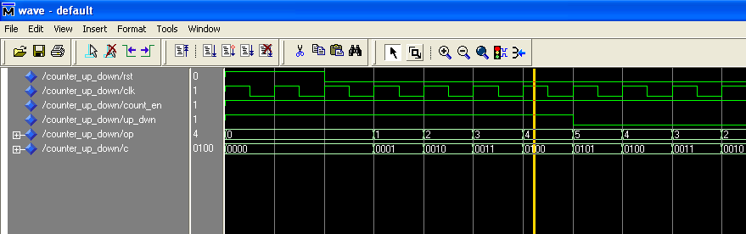
6. Write a code to model 4 bit decade counter.

library IEEE;
use IEEE.STD_LOGIC_1164.ALL;
use IEEE.STD_LOGIC_ARITH.ALL;
use IEEE.STD_LOGIC_UNSIGNED.ALL;

entity COUNTER_DACADE is
Port( rst : in std_logic;
clk : in std_logic;
count_en : in std_logic;
op : out std_logic_vector(3 downto 0));
end COUNTER_DACADE;

architecture Behavioral of COUNTER_DACADE is
signal c: std_logic_vector(3 downto 0);
begin
process(rst,clk,count_en)
begin
if rst = '1'then
c <= (others => '0') ;
elsif rising_edge(clk) then
if count_en = '1'then
c <= c + 1;
end if;
if c = "1001" then
c <= "0000";
end if;
end if;
end process;
op <= c;
end Behavioral;

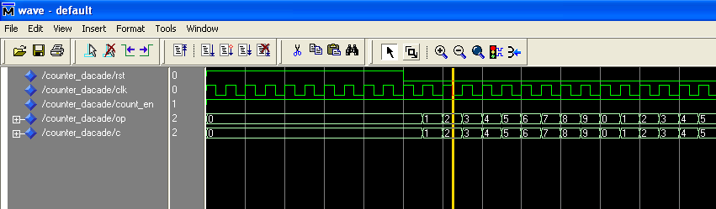
7. Design a counter, which has to count up by one and down by two.

library IEEE;
use IEEE.STD_LOGIC_1164.ALL;
use IEEE.STD_LOGIC_ARITH.ALL;
use IEEE.STD_LOGIC_UNSIGNED.ALL;

entity COUNTER_UP1_DOWN2 is
Port( rst : in std_logic;
clk : in std_logic;
count_en : in std_logic;
up_dwn : in std_logic;
op : out std_logic_vector(3 downto 0));
end COUNTER_UP1_DOWN2;

architecture Behavioral of COUNTER_UP1_DOWN2 is
signal c: std_logic_vector(3 downto 0);
begin
process(rst,clk,up_dwn)
begin
if rst = '1'then
c <= (others => '0') ;
elsif rising_edge(clk) then
if count_en = '1'then
if up_dwn = '1'then
c <= c + 1;
elsif up_dwn = '0'then
c <= c - 2;
end if;
end if;
end if;
end process;
op <= c;
end Behavioral;

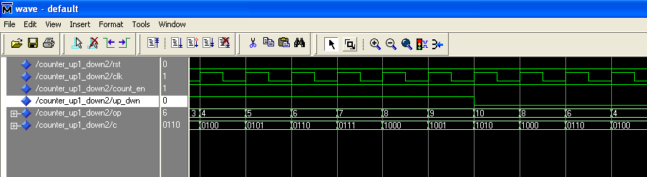
8. Write a code to model a parallel to serial converter. The circuit accepts a 4 bit paralle data (data_in) when the synchronous load input goes high.

library IEEE;
use IEEE.STD_LOGIC_1164.ALL;
use IEEE.STD_LOGIC_ARITH.ALL;
use IEEE.STD_LOGIC_UNSIGNED.ALL;

entity ShiftR_Pin_Sout is
Port(clk : in std_logic;
rst : in std_logic;
d : in std_logic_vector(3 downto 0) ;
q : out std_logic;
en : in std_logic);
end ShiftR_Pin_Sout;

architecture Behavioral of ShiftR_Pin_Sout is
signal st : std_logic_vector(1 downto 0);
begin
process(clk,rst,d,en)
begin
if rst = '1' then
q <= '0' ;
st <= "00";
elsif rising_edge(clk) then
if en = '1' then
case st is
when "00" =>
q <= d(3);
st <= "01";
when "01" =>
q <= d(2);
st <= "10";
when "10" =>
q <= d(1);
st <= "11";
when "11" =>
q <= d(3);
st <= "00";
when others => null;
end case;
end if;
end if;
end process;
end Behavioral;

