A Visit to GREEN BUILDING
A team of 10 Students and 9 faculty of the IEEE Student Branch of MVSR Engineering College had visited CII Sohrabji Godrej Green Business Centre, Hyderabad on 5th Feb 2016. The main objective of this visit is to create awareness among students in Engineering on how an Energy efficient building can be designed and constructed. The students of different Engineering domains visited and were educated on various technical areas involved in Green Building.

Student Branch Mentor: Student Branch Advisor:
Dr. Atul Negi, Mr. V. Ashwini Kumar,
Professor, School of CIS, Assoc.Professor , IT Dept.
University of Hyderabad. MVSR Engineering College.

Student Branch Counselor: WIE Student Branch Advisor:
Mrs. A.V.Vahini Mrs. Dr. G. Kanaka Durga,
Asst. Professor, IT Dept., Head, IT Department,
MVSR Engineering College. MVSR Engineering College.

PES Advisor:
Mr. B.Sarveshwar Reddy,
Asst. Professor, EEE Dept.,
MVSR Engineering College

Student Branch Executive Committee: WIE Affinity Group: E.Sanjana - Chairperson B. Jayasree - Chairperson
K.V.Sirisha- Vice Chairperson D.Sreeya reddy - Vice chair
G.K.Anirudh – Secretary Srinidhi Gattu - Secretary
T.Anirudh - Joint Secretary B.Makarand - Joint Secretary
G.Vinay– Treasurer P.Harshitha- Treasurer

Power Energy Society (PES):
V.B.Mounika- Chairman
Rahul Bhalla-Vice Chair
T.Sai Yashwanth- Secretary
B.Ujwala – Treasurer

Visit Details:
Date: 05-02-2016
Time: 10:00 am-01:30pm
Venue: CII Sohrabji Godrej Green Business Centre , Hyderabad.
Attendees: 20

About Green Building:
It is the First LEED Platinum Rated Building in India – CII Godrej GBC

It offers advisory services to the Industry in the areas of:
• Green buildings
• Energy Efficiency
• Water Management
• Environmental management
• Renewable energy
• Green business incubation
• Climate change activities

Green Architecture:
Using processes that are environmentally responsible and resource-efficient throughout a building's life-cycle: from cradle to grave
An attempt to make a positive change in design by Reducing the negative impact on the environment in terms of: Use of materials, Water Management, Energy Efficiency ,Sustainability Natural Ventilation, Reuse and Recycle, Renewable Energy, Effective Land Use ,Ecological footprint, Carbon Footprint ,Socio Cultural Response etc

A picture of Green Building in Hyderabad

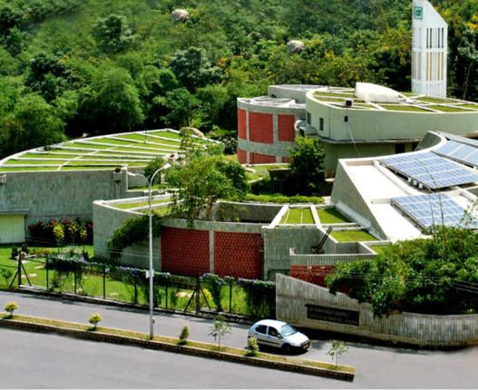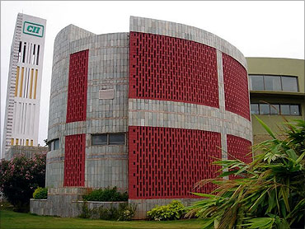
Top view of Green Building Wind Tower.

One of the officials working in Green building explained us about Energy Efficiency
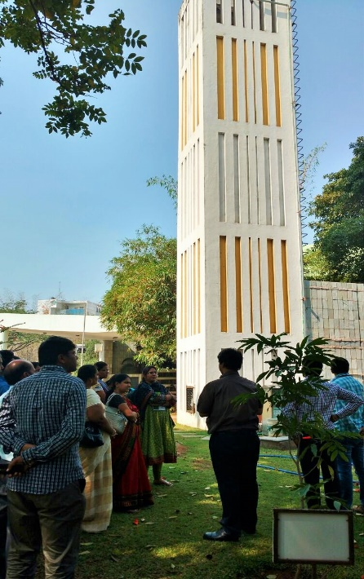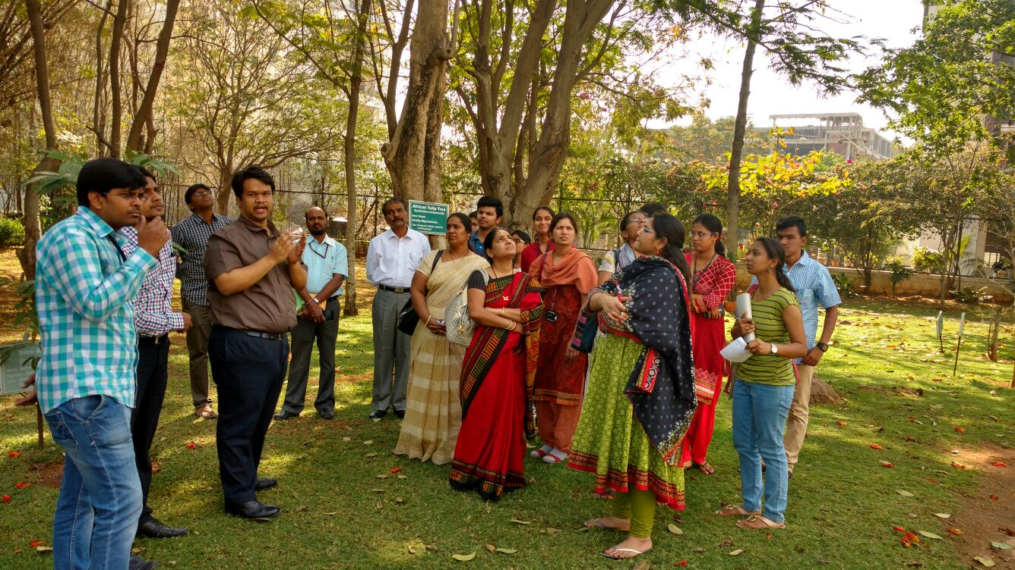
Explaining about Energy Efficient Ventilating System
About Energy Efficient Ventilating System:
- Energy savings are achieved by the GBCs two wind towers
- Air, cooled by upto 8 ^C, is supplied to the AHUs, substantially reducing the load on the air conditioning system.
- A heavily insulated roof further reduces the cooling load.
Energy Efficiency:
- Use of Solar photovoltaic cells on the rooftop grid provides about 24 kilowatts, or 16 % of the building's electricity needs.
- Placed appropriately on the roof facing South and West to capture maximum heat gain
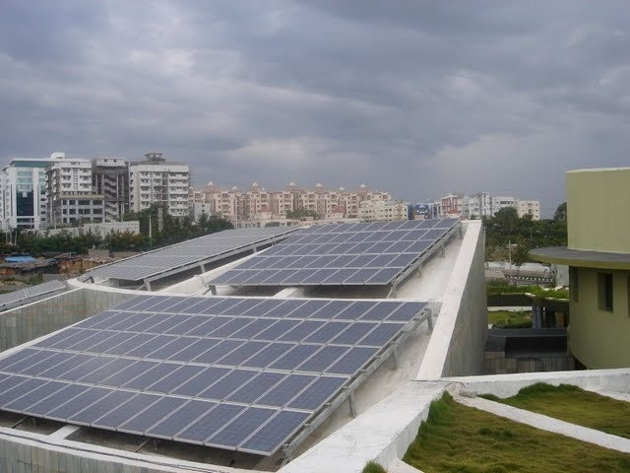
Solar Panels on the roof of the one of the block
The other interesting method practised in Green building is Water Management by Rain Water Harvest
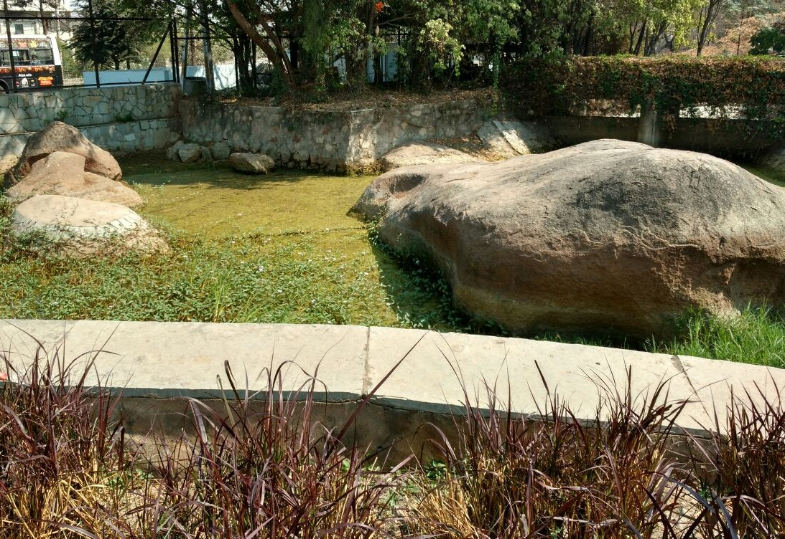
Storage area of Rain water with a capacity of storing of 8 lakh litres of water
About Rain Water Harvest:
- Some rainwater goes into the soil by the use of permeable grid pavers.
- The remaining rainwater follows existing flow patterns and is collected in a water pond -another traditional method of rain water harvesting, constructed at a lower end of the site.
- In addition, the building achieves a 35 % reduction of municipally supplied potable water, in part through the use of low-flush toilets and waterless urinals.
- All wastewater generated - recycled by "root zone treatment" - simultaneously irrigates the vegetation.
- Low operating cost , less energy requirement and ease of maintenance •Attractive alternative for wastewater management
- Enhances the Landscape
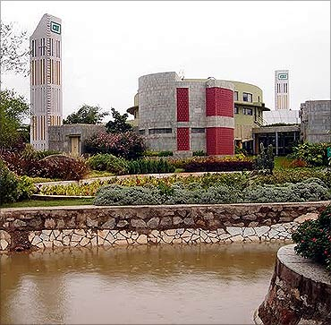

A View of CII Sohrabji Godrej Green Business Centre , Hyderabad
The officials showed us different species of plants with different sizes sequentially arranged for landscaping.
Few Snapshots of Plant species in Green Building
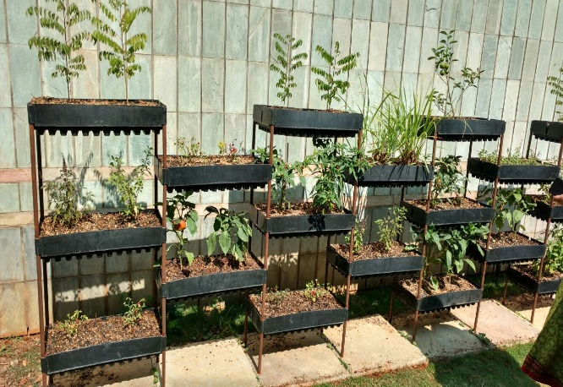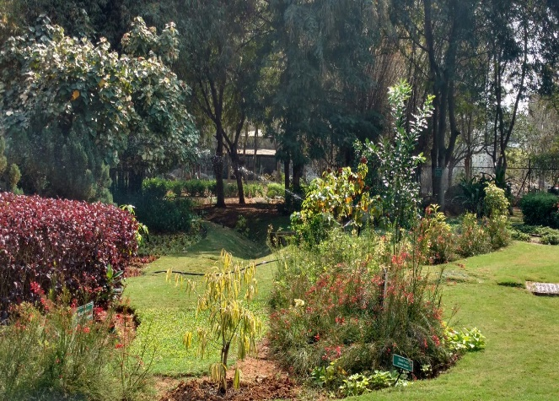
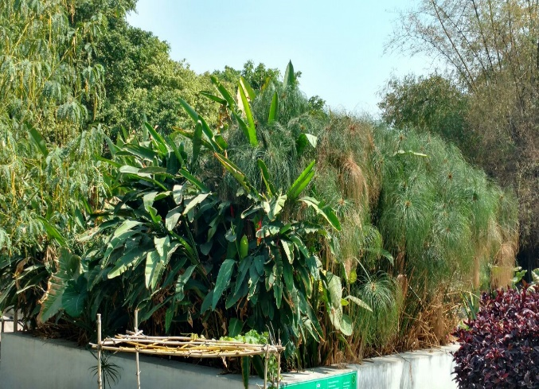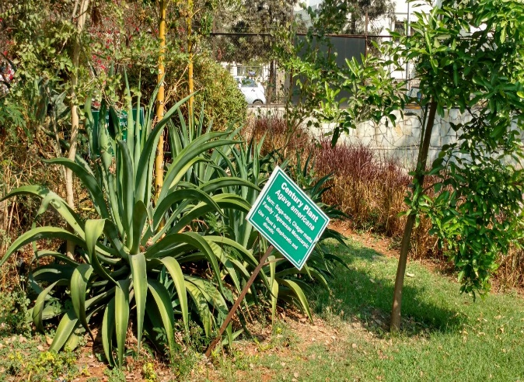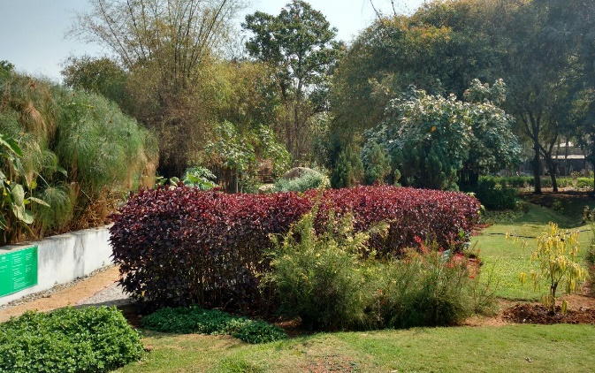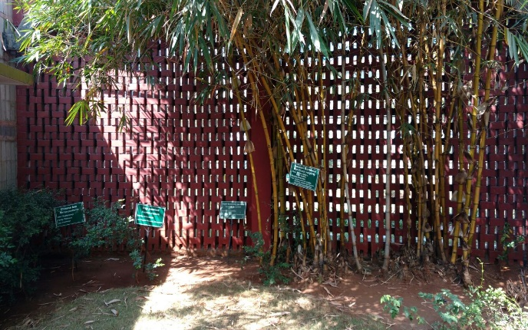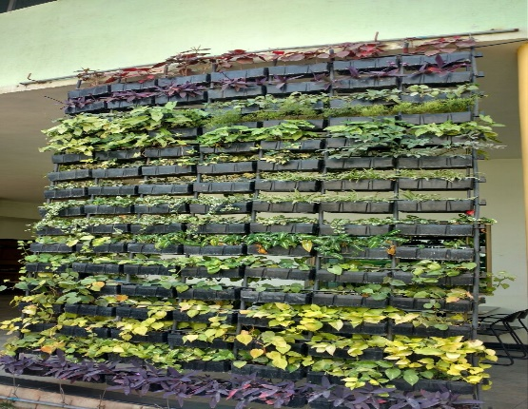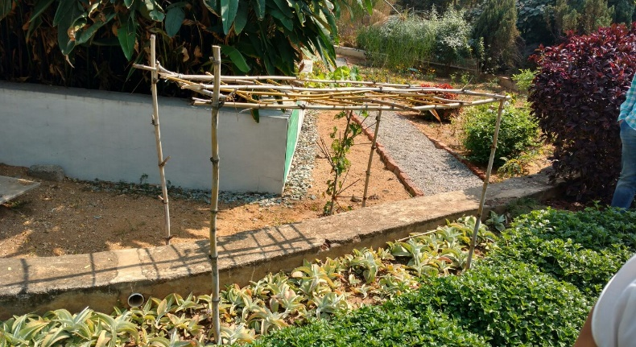

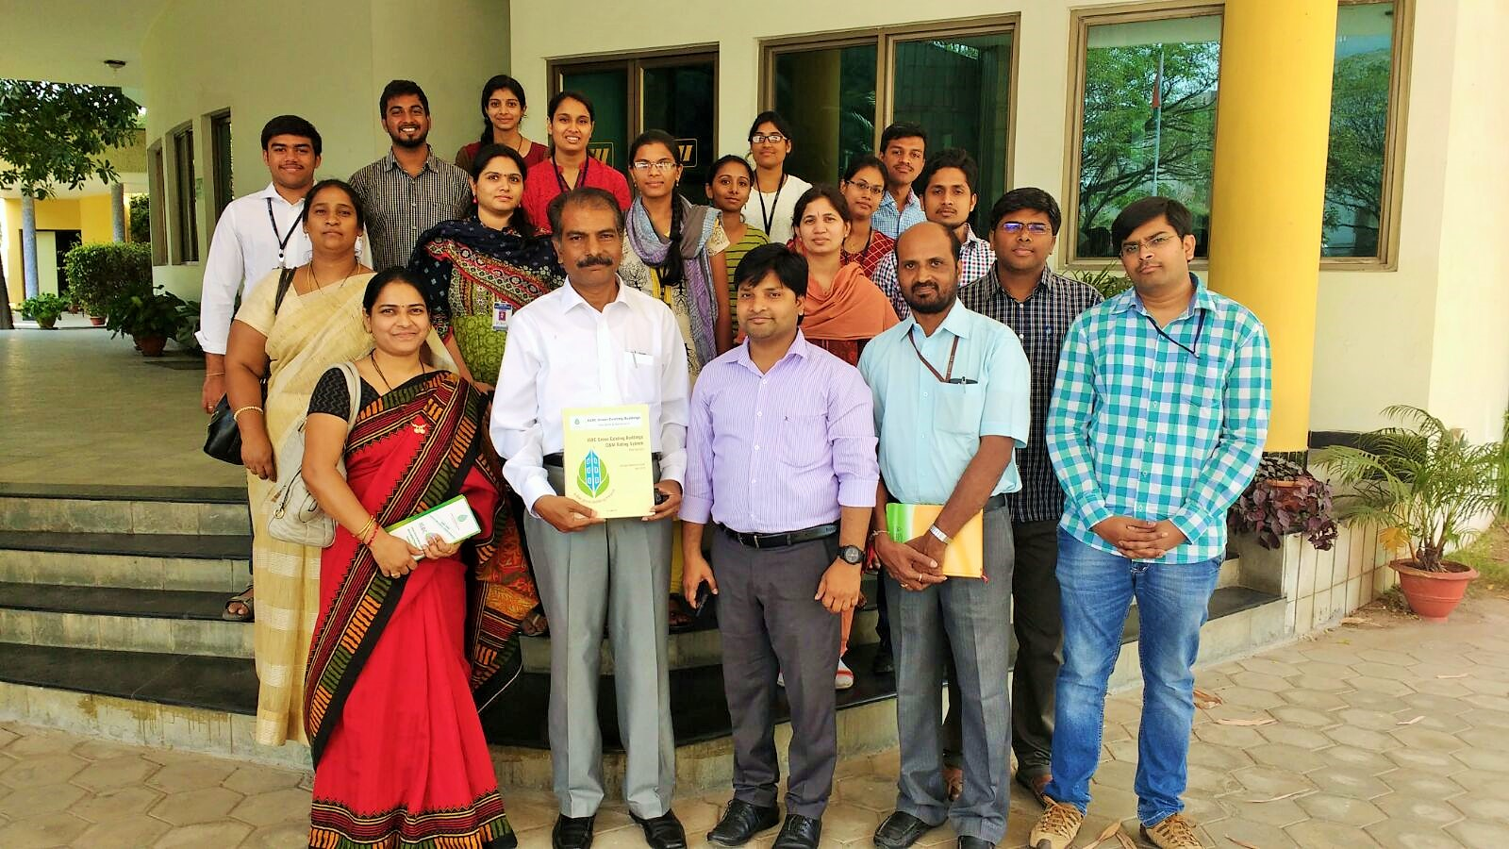
A picture of the team with the officials in Green Building along with Mrs.A.V.Vahini , Branch Counselor , Mr.V.Ashwini Kumar, Branch Advisor (Front row , left hand side)
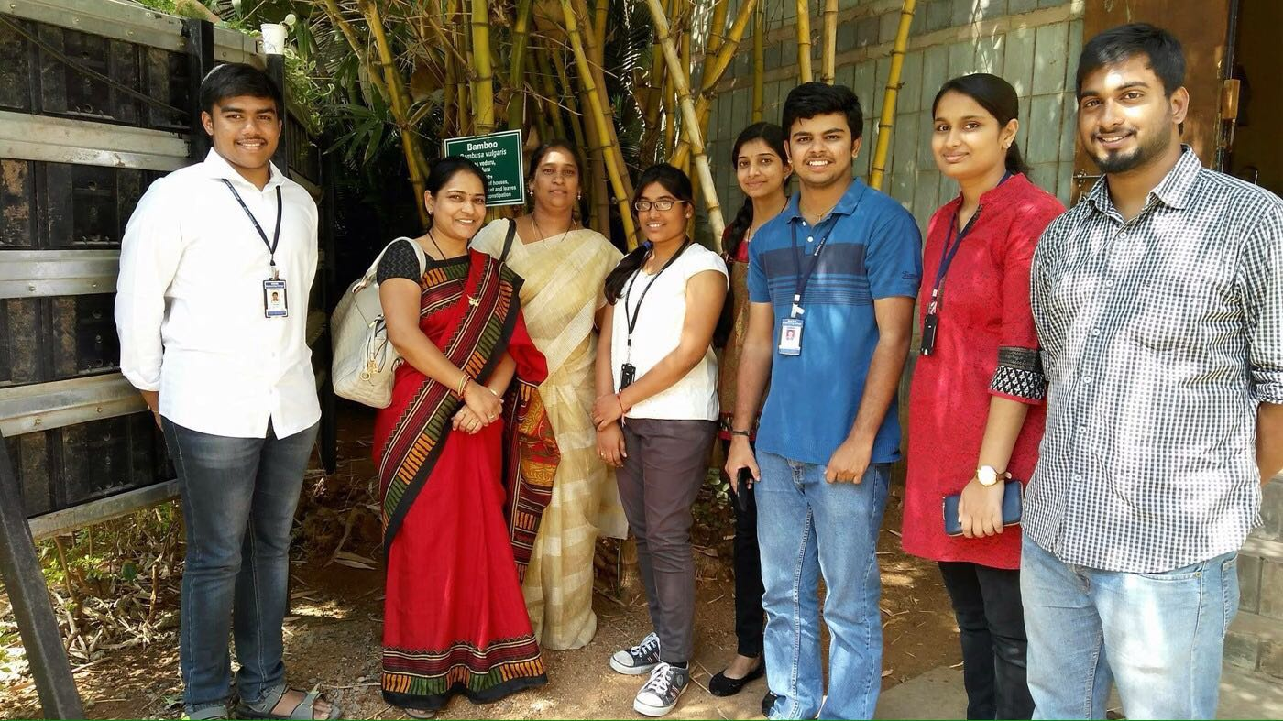
Some of the Student members who took active part in making the team along with Mrs.A.V.Vahini , Branch Counselor and Mrs.Saritha , Faculty ,CSE Dept.,MVSREC.

