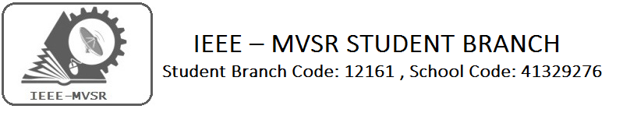
NATIONAL CONFERENCE
ON
ADVANCES IN INFORMATION TECHNOLOGY

The National Conference on Advances in Information Technology was aimed at providing academicians, engineers and researches with the state-of-the-art technology and knowledge. This also provided professionals with an opportunity to present their research works. It was hosted by department of Information Technology of MVSR Engineering College in collaboration with IEEE MVSR SB during January 22nd and 23rd 2016.
Student Branch Mentor: Student Branch Advisor:
Dr.Atul Negi, Mr. V. Ashwini Kumar,
Professor, School of CIS, Assoc.Professor , IT Dept.,
University of Hyderabad. MVSR Engineering College.

Student Branch Counsellor: WIE Student Branch Advisor:
Dr.Anil Kumar Dr. G. Kanaka Durga,
Professor, ECE Dept., Head, IT Department,
MVSR Engineering College. MVSR Engineering College.

PES Student Branch Advisor:
Mr. B.Sarveshwar Reddy,
Asst. Professor, EEE Dept.,
MVSR Engineering College

Student Branch Executive Committee: WIE Affinity Group: G.K.Anirudh - Chairperson B.Jayasree-Chairperson
T.Yashwanth- Vice Chairperson Achsah - Vice chair
T.Anirudh – Secretary G.Srinidhi - Secretary
Bhanu Teja - Joint Secretary Hari Priya - Joint Secretary
Jagadeesh– Treasurer B.Aparna- Treasurer Nikhil Varun Raj-Membership Drive Head

Power and Energy society:
Ujwala- Chairman
Divija-Vice Chair
Anusha- Secretary
Alok- Joint Secretary
Manoj– Treasurer

Workshop details:
Date: 22nd and 23rd January 2016
Time: 9:30am-4:30pm
Venue: MVSR Engineering College

The Conference invited papers on the following topics from the authors in the following areas:
- Big Data Analytics
- Data Visuualization&display Technologies
- Smart Sensors, Digitization & Automation
- Data Warehousing &mining
- Data& knowledge Engineering
- Social Media & Information Networks
- E-Commerce & E-Governance
- Cloud computing & Storage Technologies
- Distributed computing
- Wireless 4adhoc sensor networks
- Cognitive Radios
- Signal processing & digital signal processing
- Image processing
- Information security
- VLSI design
- Embedded systems
- Wireless,cellular&mobile communications
- Artificial Intelligence
- Machine learning
- Automata
- Operating systems –real time and mobile
- Real time systems
- Advanced computer architectures
- Soft computing
- Software engineering
- Data structures
- Algorithms
- Gaming and virtual reality
- Applications of Information technology

A few Snapshots of the Conference
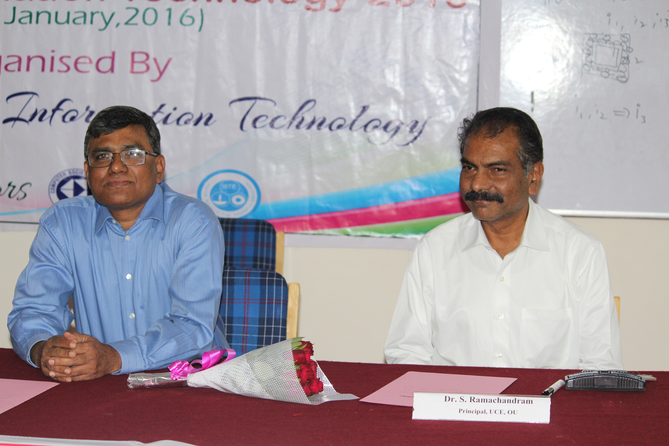
I

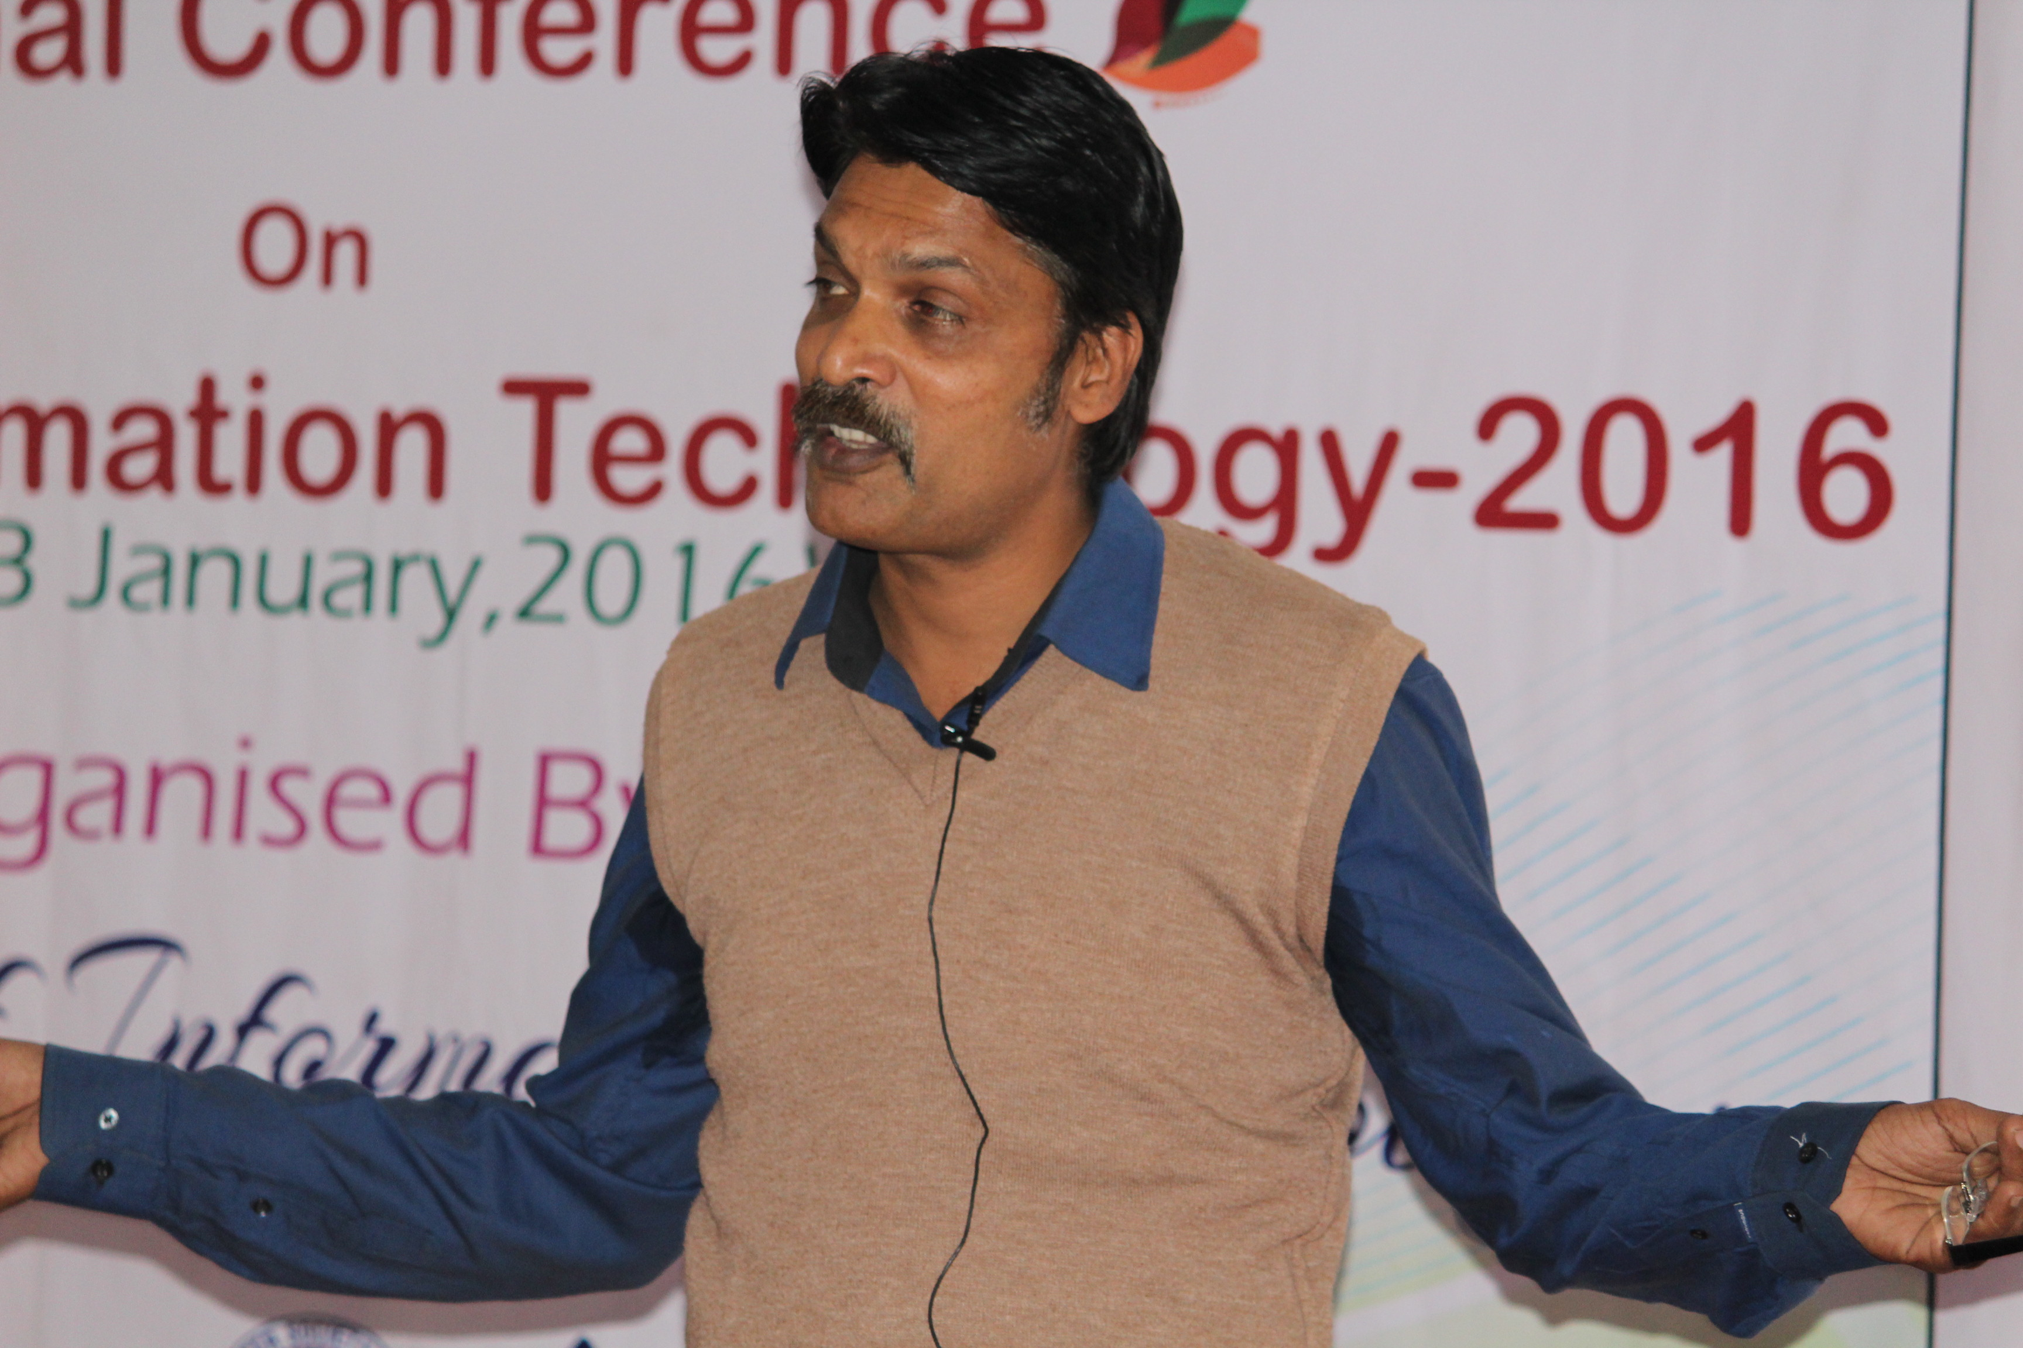
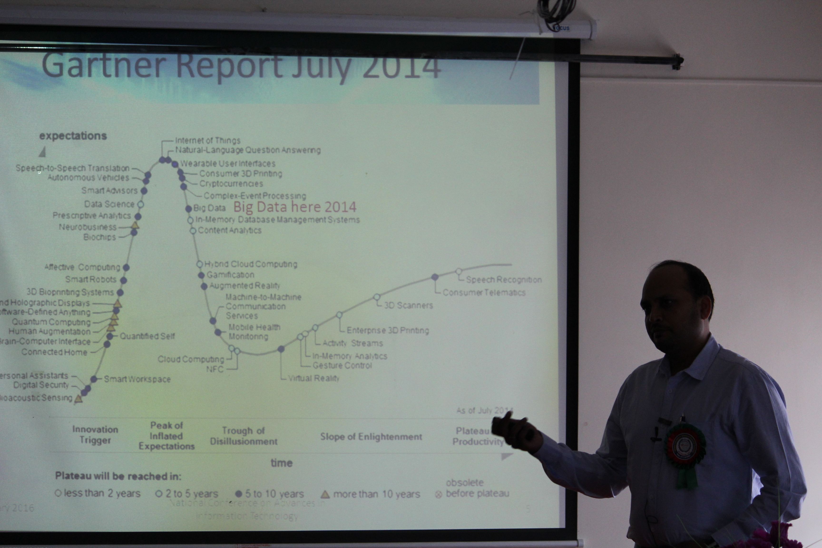

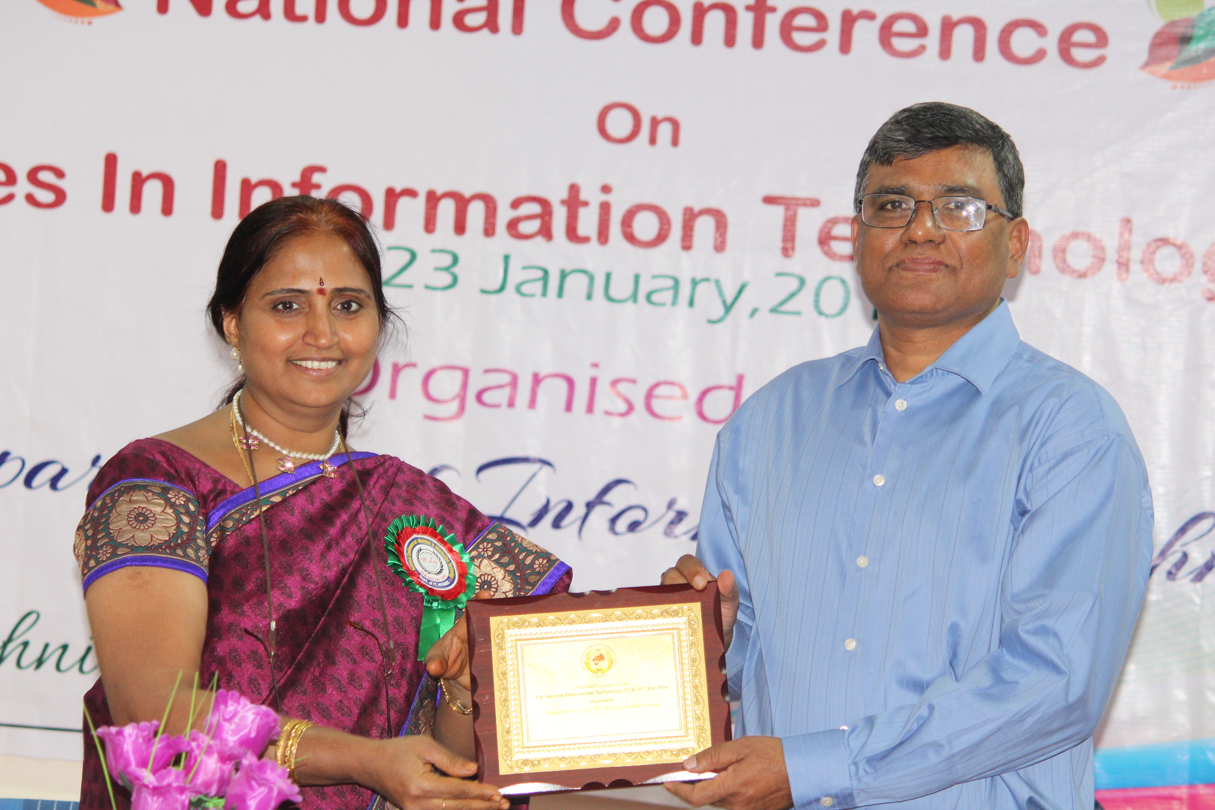
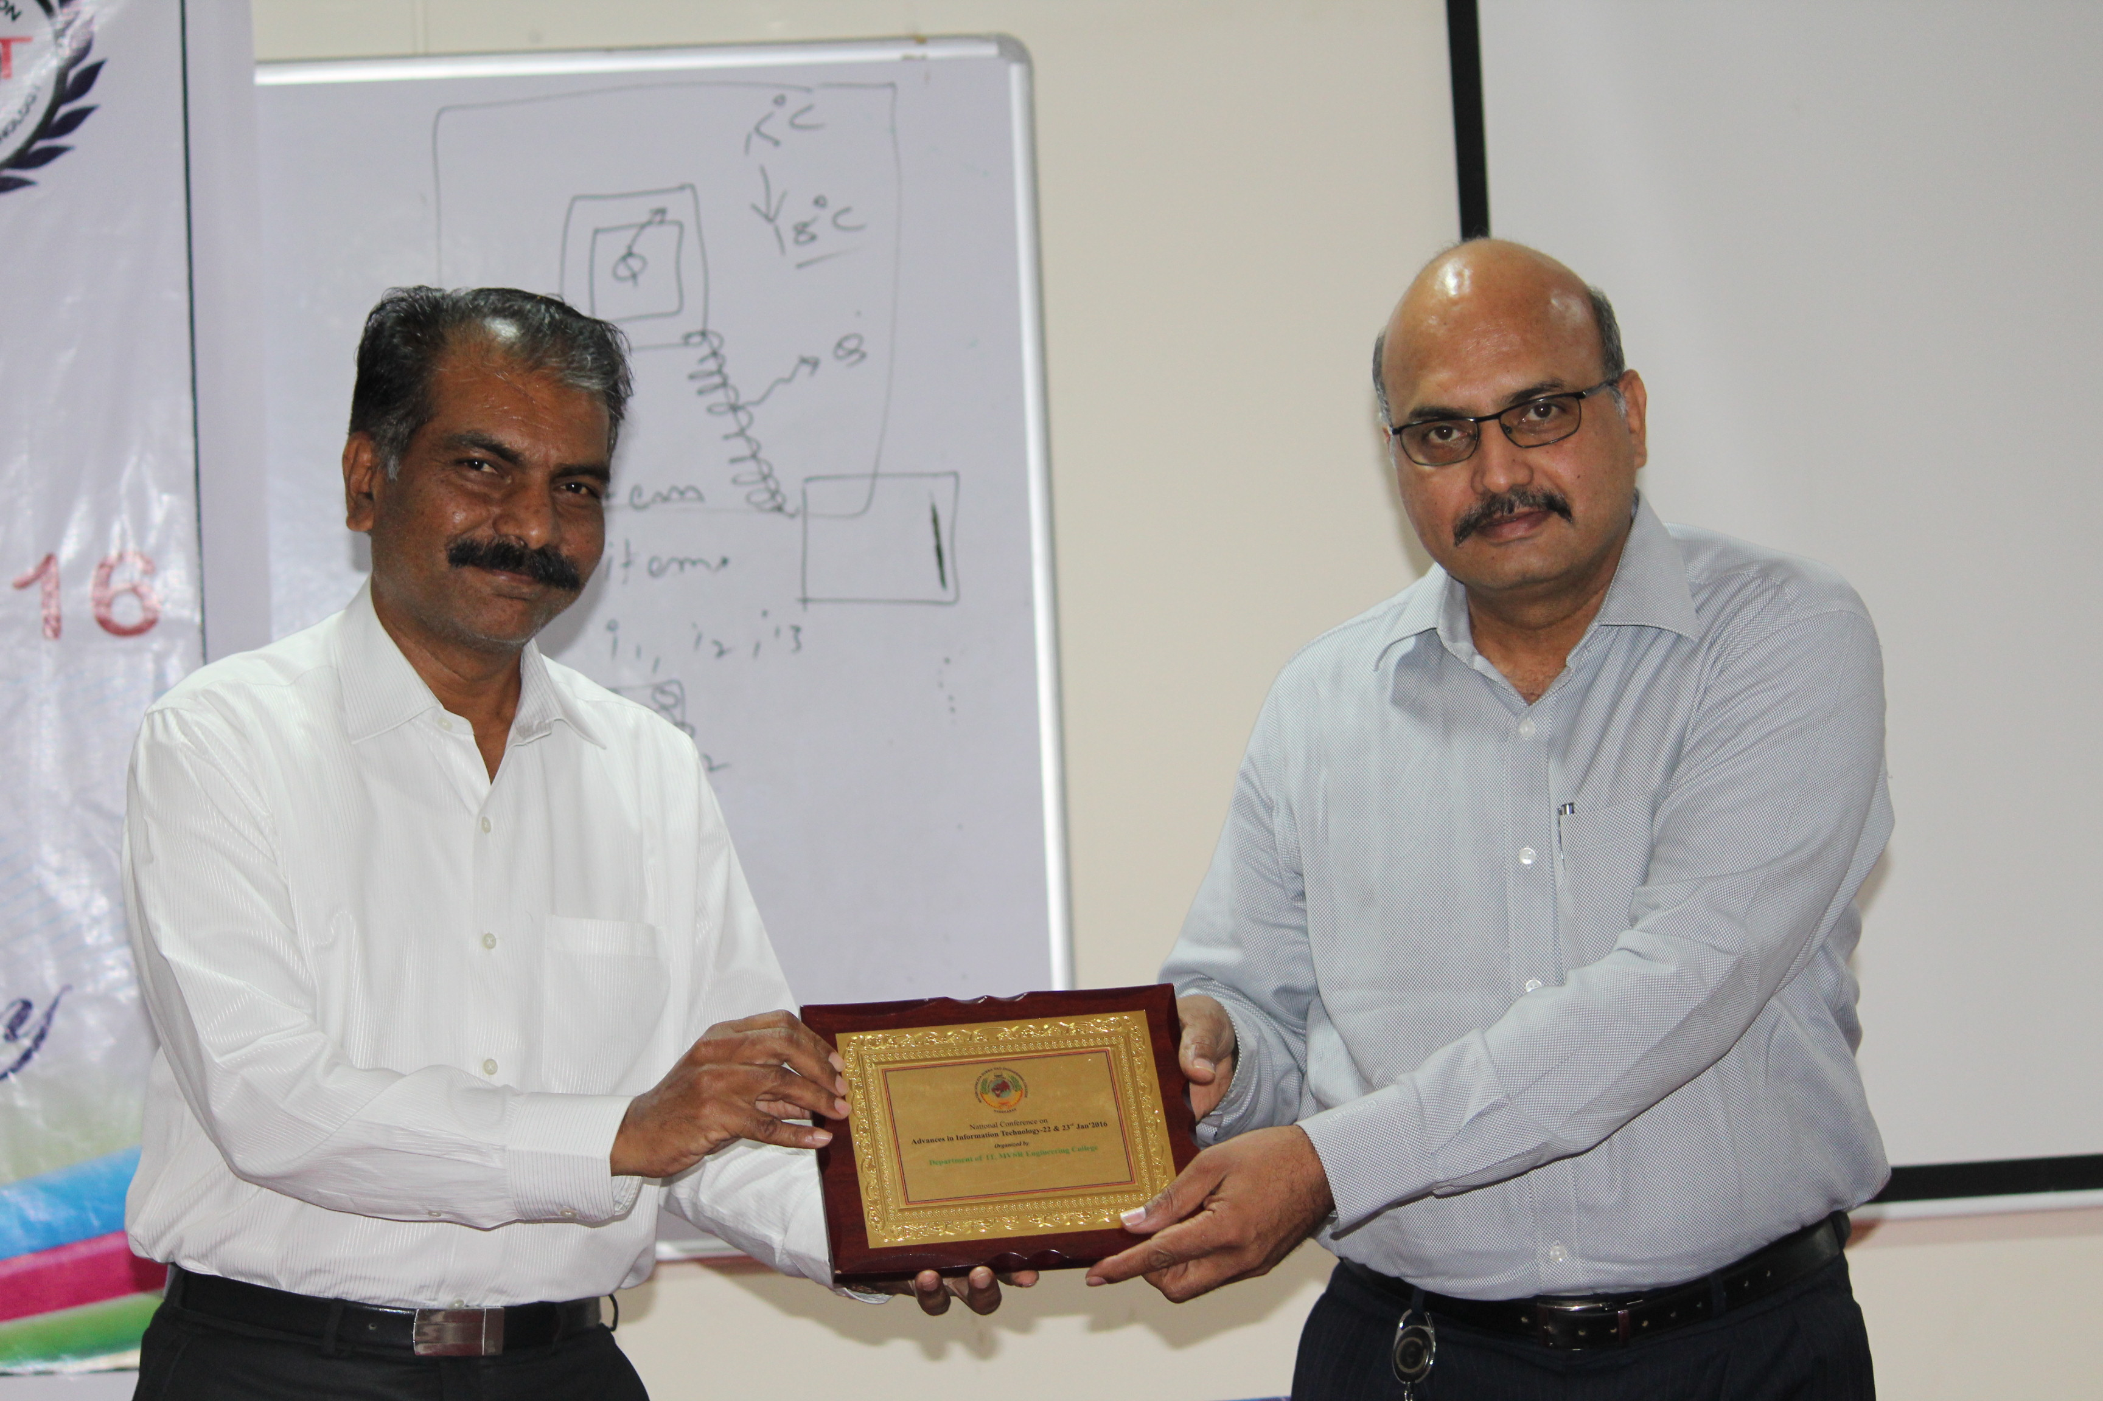

Resource Persons being honoured

