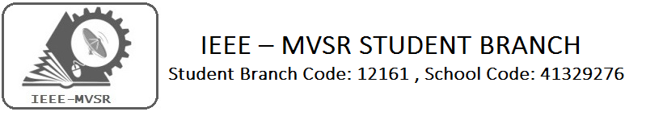
The IEEE Student Branch of MVSR Engineering college with an at most interest in knowing the developing technology, and to strengthen the student inherent talents. We have initiated IEEE Power and Energy Society (IEEE-PES) .The mission of launching Power & Energy Society is to provide a platform for sharing Scientific and Engineering Information on Electric Power and Energy for the betterment of society, and preferred professional development source to its members.
Student Branch Mentor: WIE Student Branch Advisor:

Dr. Atul Negi, Mrs. Dr. G. Kanaka Durga,
Professor, School of CIS, Head, IT Department,
University of Hyderabad. MVSR Engineering College.

Student Branch Advisor: Student Branch Counselor:
Mr. V. Ashwini Kumar, Mrs. A.V. Vahini
Assoc. Professor, IT Dept., Asst. Professor, IT Dept.,
MVSR Engineering College. MVSR Engineering College.

PES Student Branch Advisor:
Mr. B.Sarveshwar Reddy,
Asst. Professor, EEE Dept.,
MVSR Engineering College

Student Branch Executive Committee: WIE Affinity Group:
E.Sanjana - Chairman B. Jayasree - Chair
K.V. Sirisha – Vice Chairman D.Sreeya reddy - Vice Chair
G.K.Anirudh – Secretary Srinidhi Gattu - Secretary
T.Anirudh - Joint Secretary B.Makarand - Joint Secretary
G.vinay– Treasurer P.Harshitha- Treasurer

PES Affinity Group:
V.B.Mounika- Chairman
Rahul Bhalla-Vice Chair
T.Sai Yashwanth- Secretary
B.Ujwala - Treasurer

Event details:
- PES Inauguration Ceremony
- Project Expo
Date: 19th Jan 2016
Time: 10:30 am to 1:00pm (Inauguration Ceremony)
1:30 pm to 2:30 pm (Project Expo)
Venue: EEE/Mech Seminar Hall, MVSR Engineering College.
Number of attendees: 100

Guest Speakers :
Dr.Koduri Srinivas
( Chairperson, IEEE Hyderabad Section)

Dr.R.Balasubramanian
(IEEE Hyderabad Section PES Chairperson)

The Inaugural Ceremony of our PES chapter was held on 19th January 2016. Dr.Koduri Srinivas(Chairman, IEEE Hyderabad Section) was the Chief Guest and Dr. R. Balasubramanian,( Chairman for IEEE PES/IAS/PELS ) was Guest of Honour. Dr.V.ChandraShekhar (Principal of MVSR engineering college), Dr.P.A sastry (Professor-mechanical department), Mr.V.Ashwini kumar (MVSR – IEEE Student Branch Advisor), A.V. Vahini (MVSR-IEEE Student Branch Counsellor), Dr.D.Venu Madhava Chary(Head of EEE Department), Mr.B.Sarveshwar Reddy (MVSR – IEEE PES Advisor) were also invited for occasion.

The event commenced with a prayer song by Pranavi, Student of EEE department, followed by lighting of lamp by dignitaries.

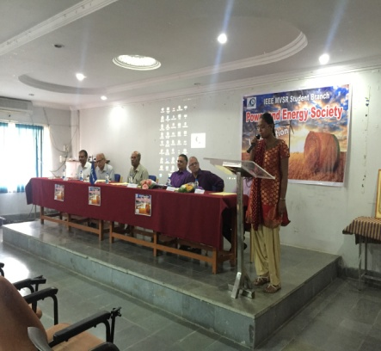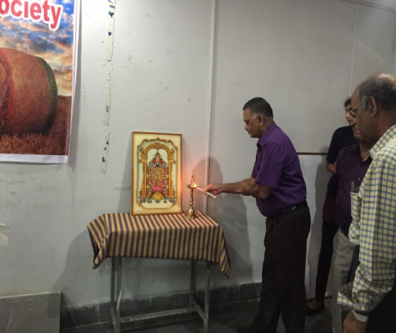
Prayer song by B.Pranavi Chief guest , Dr.Koduri Srinivas lighting the
lamp
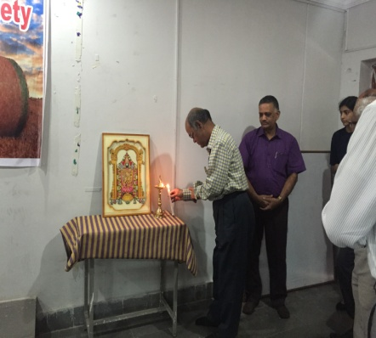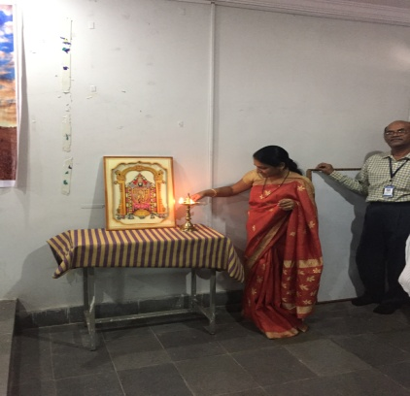
Pictures of Dr.V.Chandra Shekar ,Prinicipal, MVSREC and Mrs.A.V.Vahini ,Branch Counselor lighting the lamp after the Chief Guest.
Later,Mr. Ashwini Kumar, Professor, IT Dept(MVSR – IEEE Student Branch advisor) addressed
the gathering. He thanked Dr.Koduri Srinivas and Dr.R.Subramanian for accepting the invitation
and spending their precious time in making the members know the importance of
Power and Energy Society

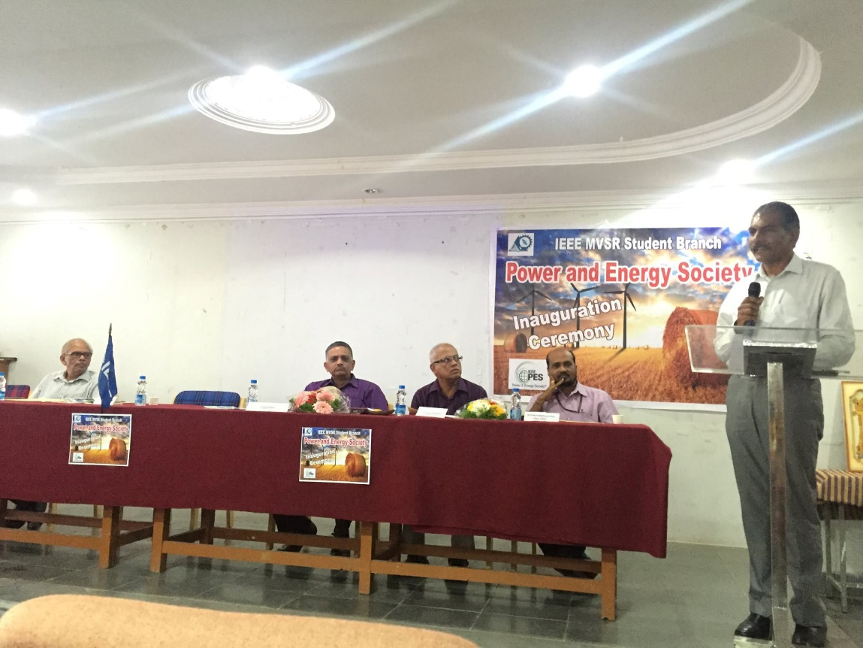
Mr. V. Ashwini Kumar ,Branch Counselor addressing the gathering

Dr.Chandrashekhar, Principal of MVSR Engineering College on this ocassion appreciated the students for actively conducting events and initiating a new society under IEEE.He extended his gratitude towards the guests and expressed his happiness for sharing their knowledge with the students.
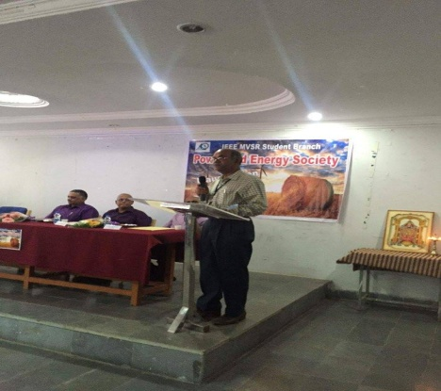

Dr.Chandra Shekhar (principal -MVSR Engineering college) addressing the gathering

After which,Dr.venumadhava chary(head,EEE dept) shared his views with the students. He was glad that his students, with their hardwork and dedication has initiated and formed a new society under IEEE. He promised to give all the support required and encouraged other students to join and work for IEEE .He explained the benefits and advantages of IEEE and PES to the students in developing their career
.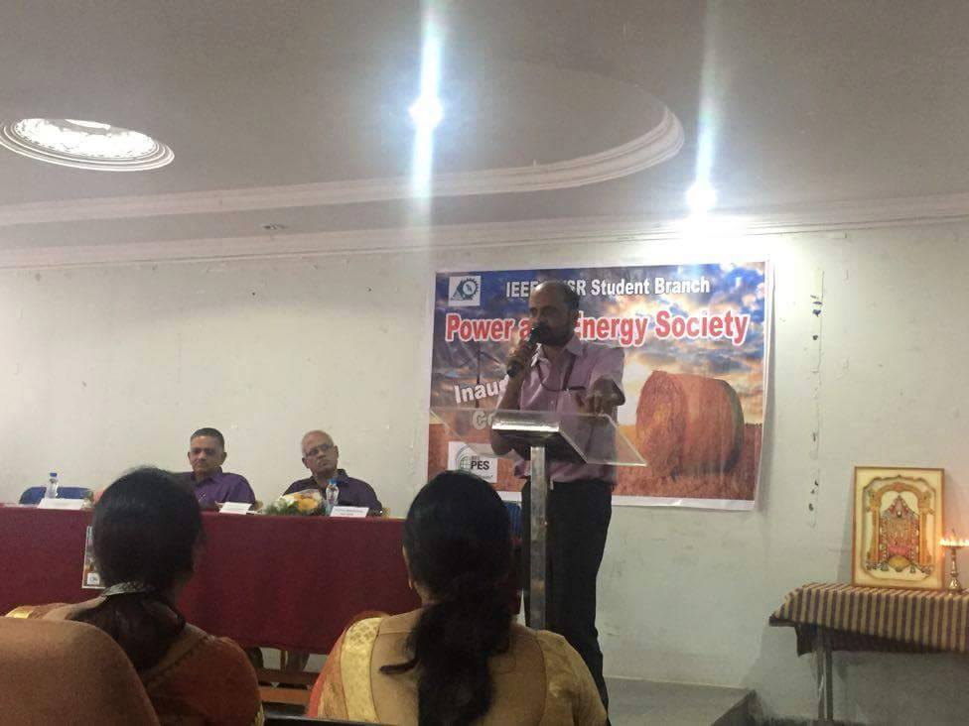

Dr.Venu Madhava Chary, Head,EEE dept.

Later on, Dr.Koduri srinivas was requested to address the students. He firstly congratulated all the Volunteers and Student Branch members for taking a step forward and initiating the new society in the Student Branch. He mentioned all the advantages we gain through Power and Energy society and also suggested to take up events which would encourage research in Power and Energy. He told the students to utilize their best potentials for the improvement of curricular and co-curricular activities. In this regard, IEEE-PES will provide a platform for improving the knowledge, skills and abilities of both students and professionals. He further mentioned the importance for being a part of this society. He motivated students to sharpen their skills by taking part actively in such events and learn new things. Also, He explained about all the resources available and that can be utilized at this platform. All the students got to know how IEEE and PES help them in future endearments.

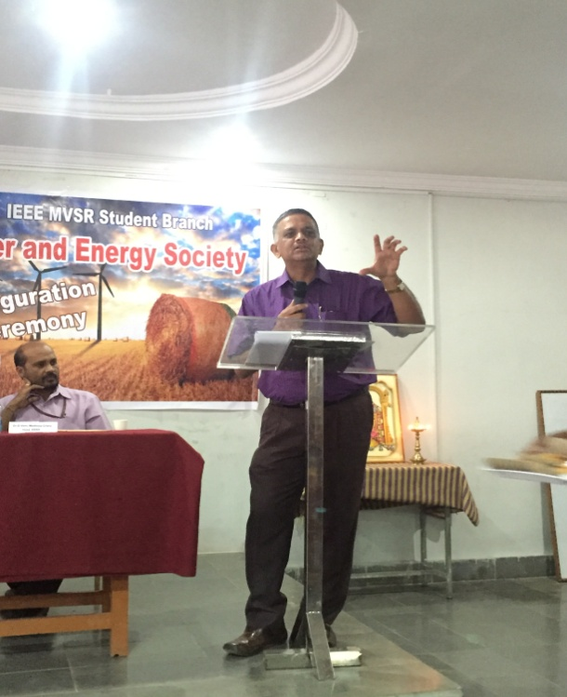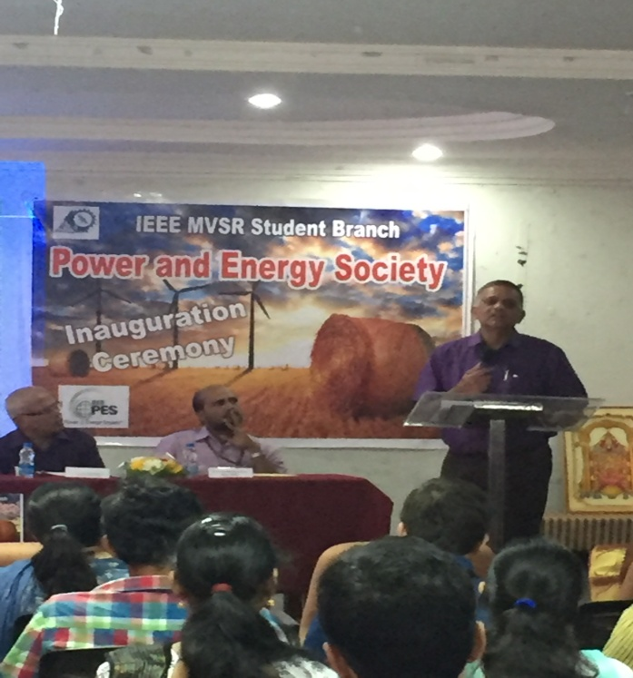
Dr.Koduri Srinivas (IEEE Hyderabad Section Chairperson) addressing the gathering on the occasion of Inauguration Ceremony of Power and Energy Society in IEEE MVSR Student Branch

Further,it was followed by the interaction of Dr. R. Balasubramanian,( Chairman for IEEE PES/IAS/PELS ).He congratulated students for forming a new society and talked about the objectives of IEEE- PES. He gave many ideas and techniques on how to conduct events in a quality manner. He discussed about latest trends in the field of Power and Energy and suggested few areas like Smart grids, SCADA etc. to work on. Students felt keen to know about advanced technologies in today’s world. He advised students to work on these areas under PES. He further said that IEEE PES chapter will benefit the students in their academic education. He also said that in the era of evolution, IEEE PES is the need of the hour. In this regard, every initiative will be taken for the betterment of the students and professionals of the Electrical Engineering. He assured his support in all means of possibility to the society.

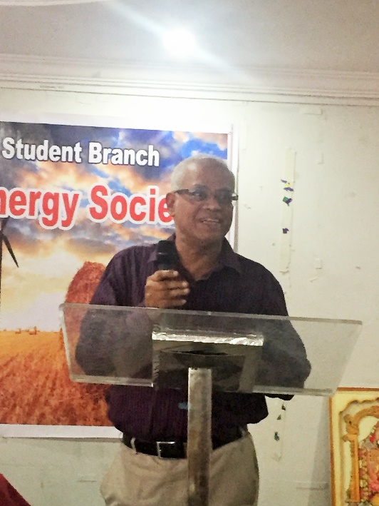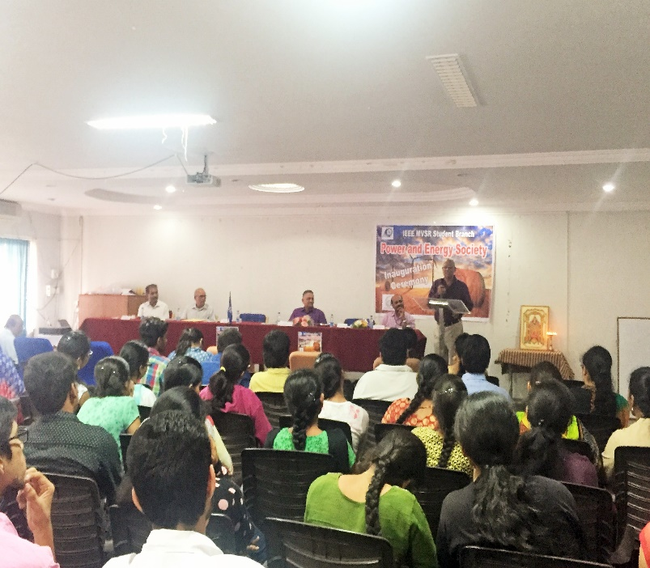
Dr. R. Balasubramanian, (Chairman for IEEE PES/IAS/PELS) guiding the students and members for successful working of IEEE-PES

Few other snapshots of attendees the IEEE-PES
Inauguration ceremony
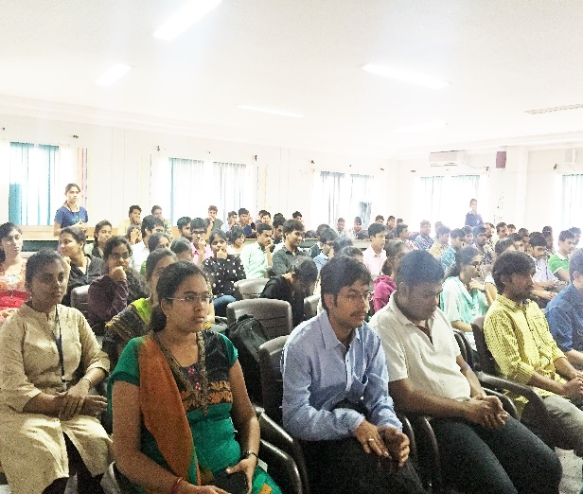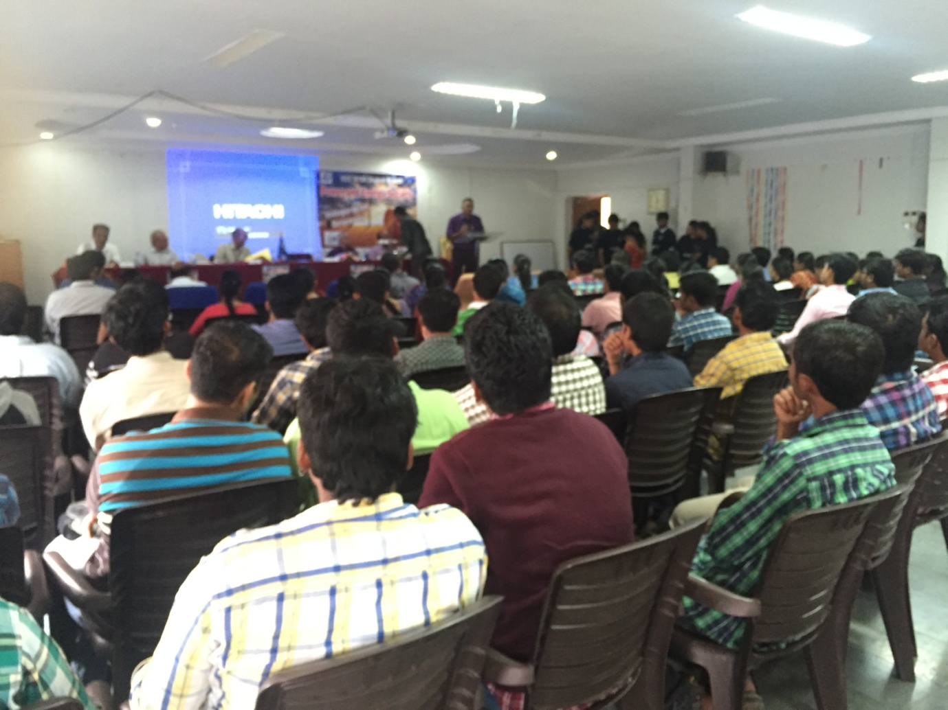
Attendees of the Ceremony

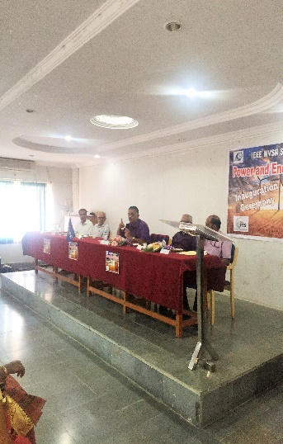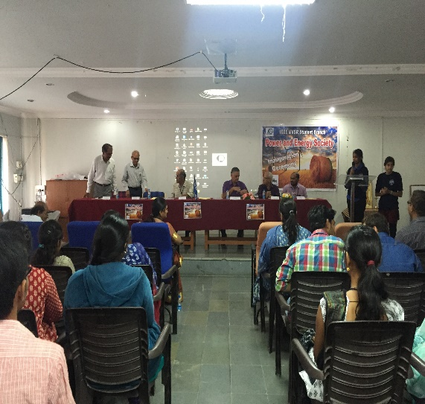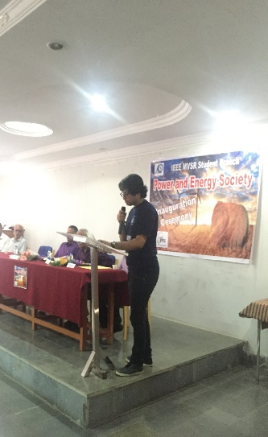

Honourable guests on the Dais.

All the students were very much enthusiastic and keen to learn the new things ,trends and technology from the guests.few of them turned up to work for power and Energy Society in the upcoming events .

After the talks by honourable Guests, Mrs A.V.Vahini , Counselor has thanked all the guests for spending their valuable time with the students and share their knowledge to make them understand what Power and Energy society is all about. She also thanked all the dignitaries on the dais, faculty and students for attending the inauguration and felicitated chief guest as a token of gratitude.

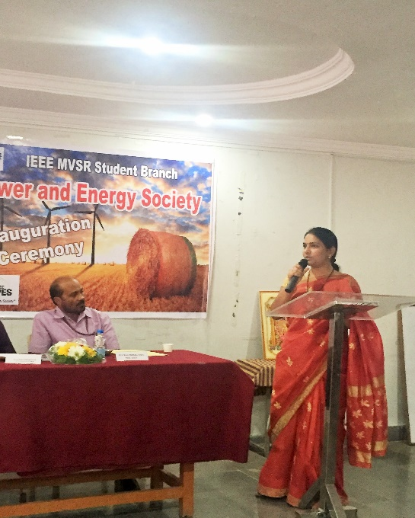
Mrs. A.V.Vahini , Branch Counselor

Later , The Welcome note for Power and Energy Society was released by Chief Guest, Dr.Koduri Srninivas

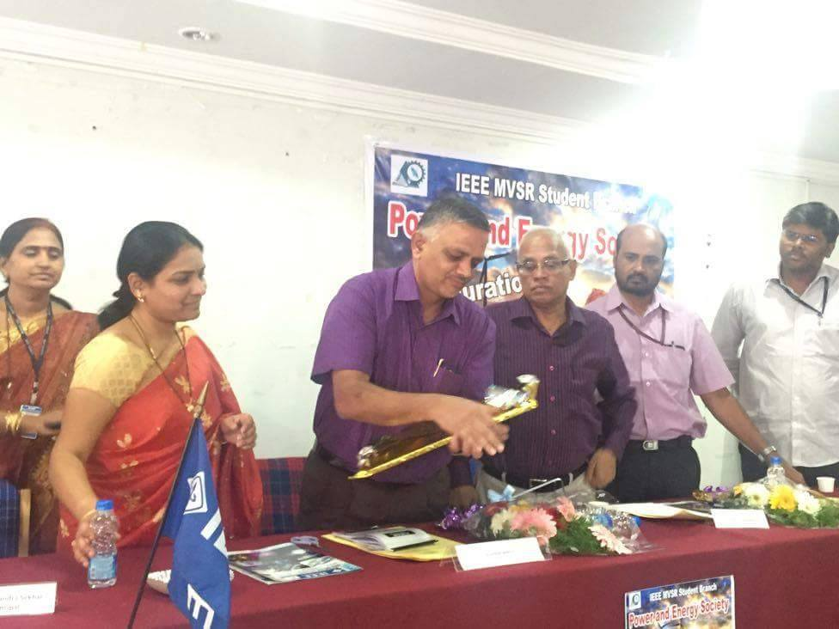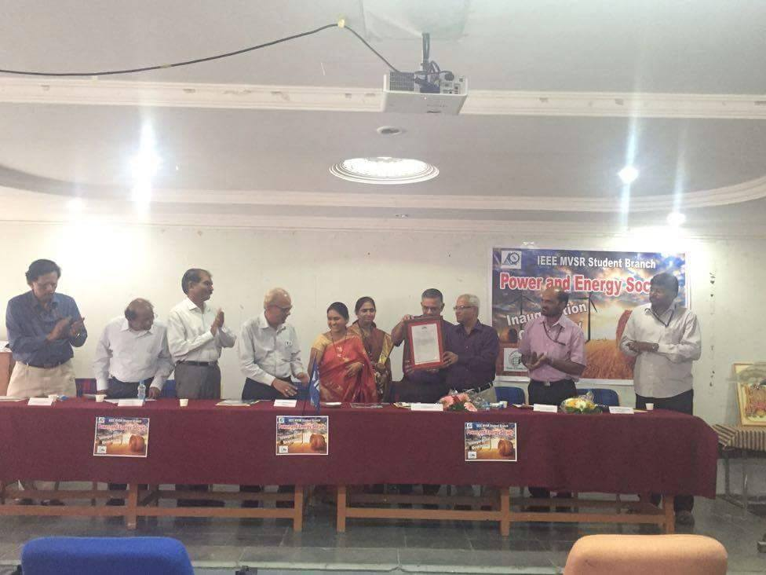
In the picture at right : From left to right:
Mr. Ashwini Kumar,Branch Advisor, Dr.P.A Sastry, Assoc. professor,Mech Dept.
Mrs. A.V.Vahini, Branch Counselor, Dr.G.Kanaka Durga, Advisor WIE AG,
Dr.Koduri Srinivas (Chairperson IEEE Hyderabad Section),
Dr. R. Balasubramanian( Chairman for IEEE PES/IAS/PELS ) Dr.D.V. M.Chary, Head of EEE Dept., Mr.B.Sarveshwar Reddy,Asst.professor,EEE Dept..,

The Inauguration Ceremony was ended with a vote of thanks, given by P.Ramya , Student member. She thanked all the guests who spent their valuable time and faculty who supported and helped us.

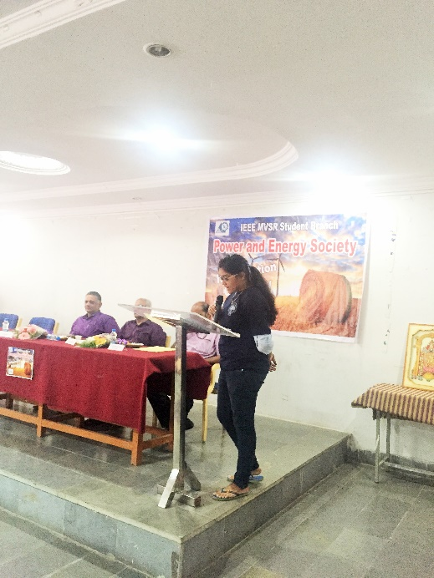
P.Ramya , Student member delivering Vote of thanks
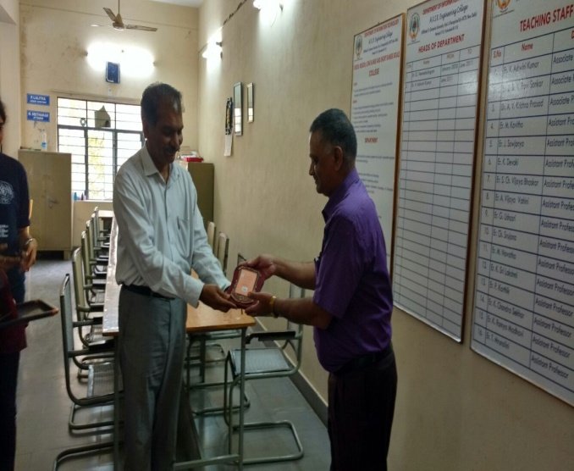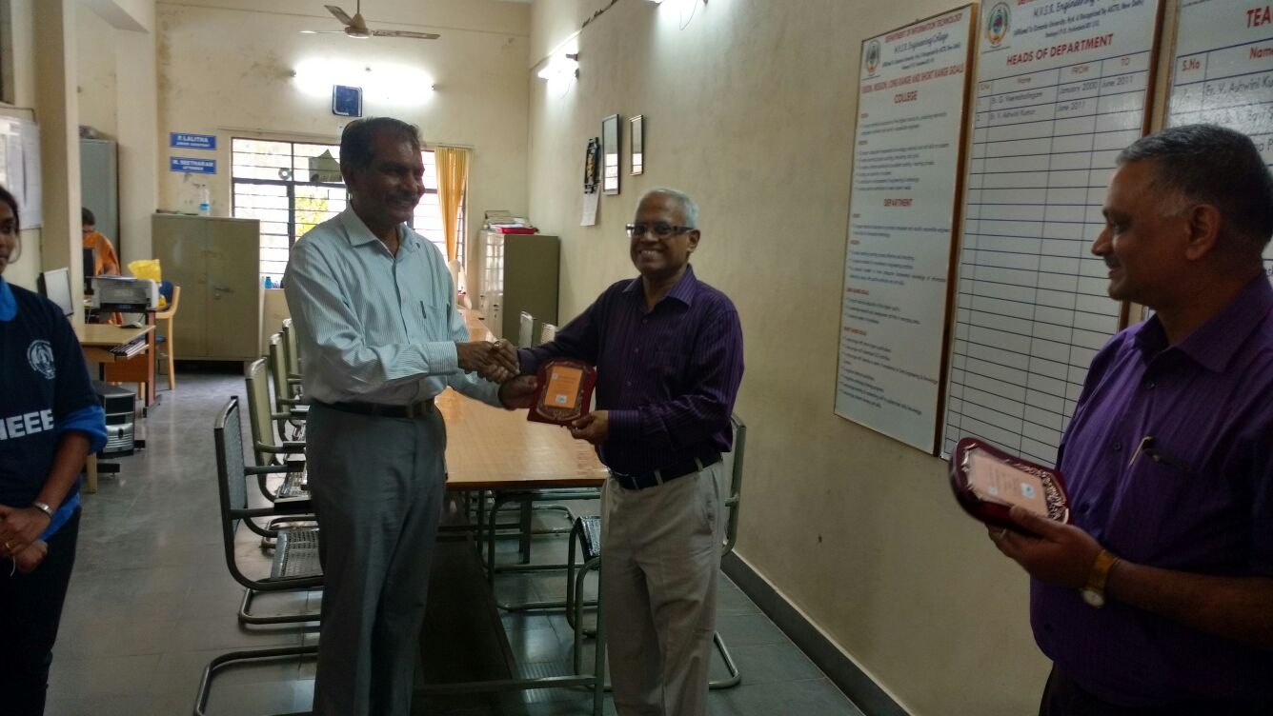
Mr. Ashwini Kumar,Branch Counselor, presenting Momento as a token of gratitude to the guests.

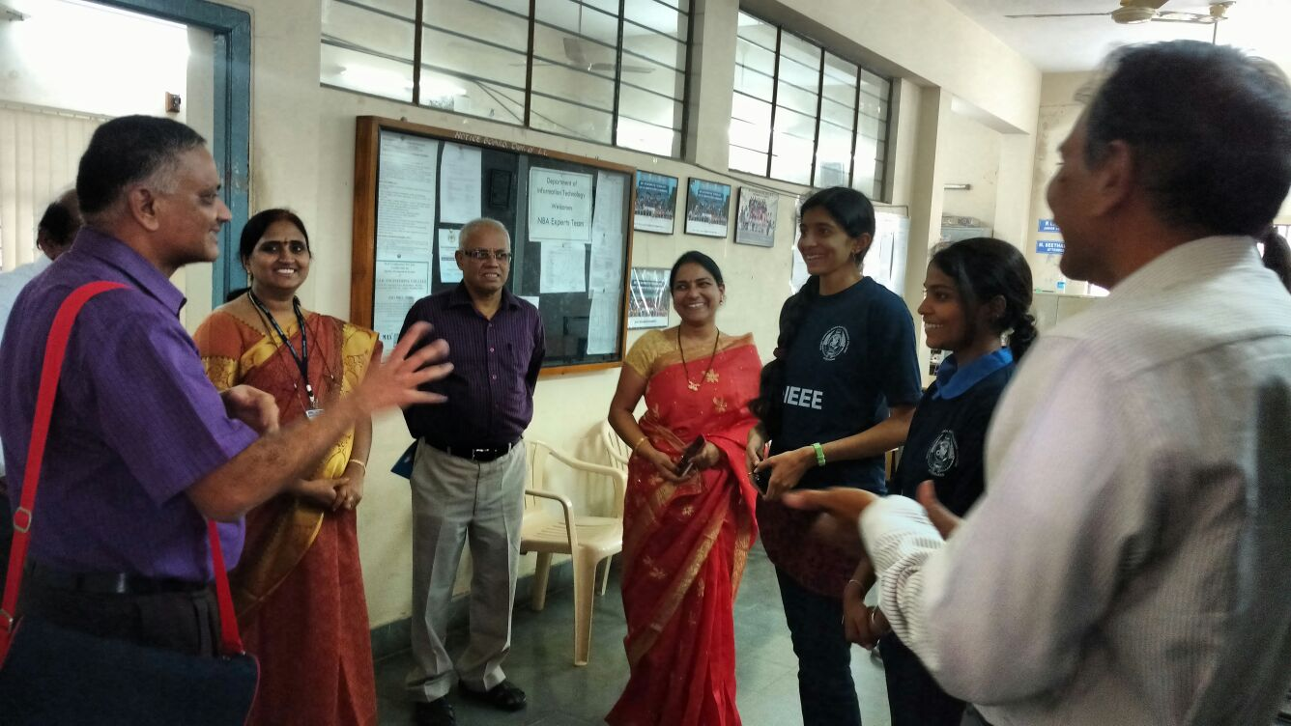

Guests and Faculty interacting with the Volunteers of IEEE, giving suggestions and good encouragement for upcoming events

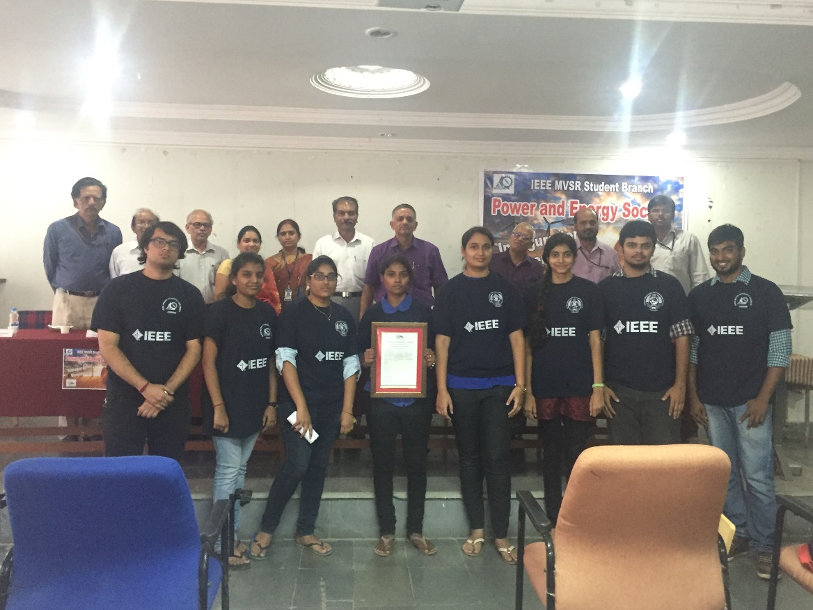

A picture of IEEE panel with the Chief guests and Members of Executive Committee of
IEEE MVSREC SB and PES

In the afternoon, we had Project Expo where student interacted with the Chief guests and exchange their thoughts. The main motto of this event is to encourage the talented students to explore their ideas for a better project output. The two projects were picked as best of all the projects exhibited.
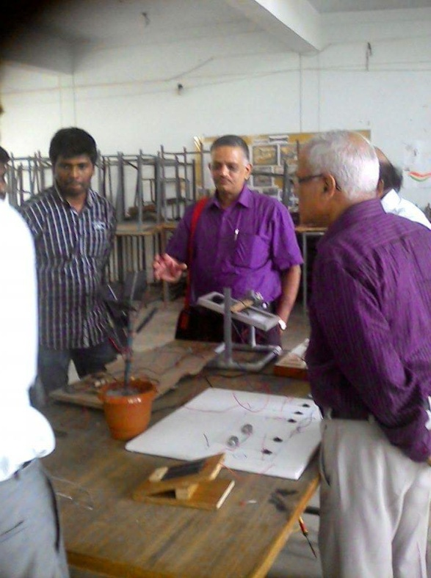
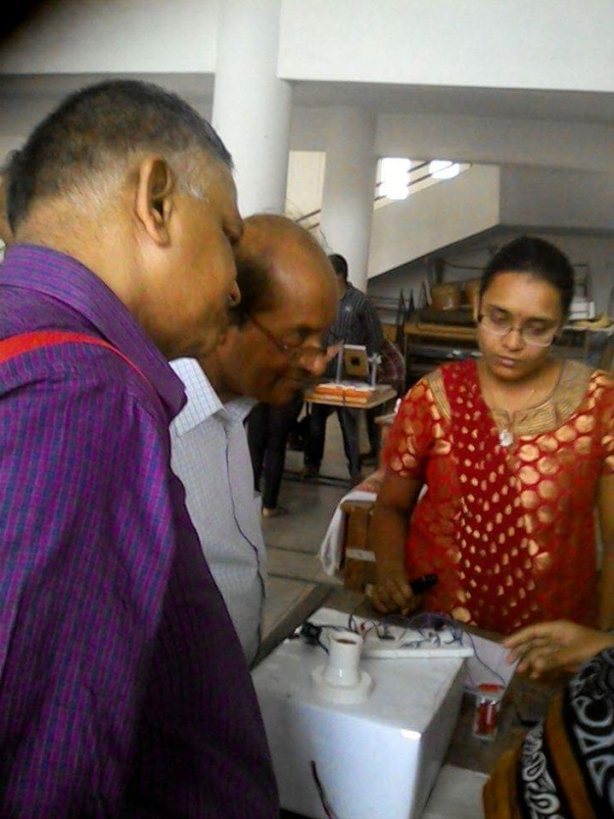
Project 1. Solar tree Project 2. Remote Contro of Electrical
Appliances

Reported by:
T. Sai Yashwanth ,
Secretary, Power and Energy Society.
IEEE – SB, MVSR.

