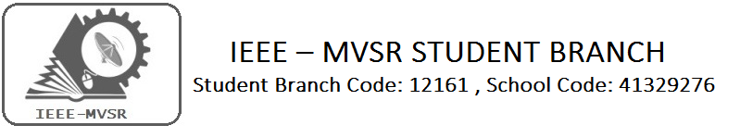

PARALLEL AND DISTRIBUTED COMPUTING
The workshop deals with the parallel (System in which multiple processor have direct access to shared memory) and distributed systems (system is a collection of independent computers, interconnected via a network, capable of collaborating on a task).the department of Information Technology of MVSR Engineering College has organized a three day workshop on PARALLEL AND DISTRIBUTED COMPUTING in association by the team of cloud wick technologies and in collaboration with IEEE.
Student Branch Mentor: PES Branch Advisor

Dr. Atul Negi, Mr.B.Sarveshwar Reddy
Professor, School of CIS, Assoc.professor,EEE Dept.,
University of Hyderabad. MVSR Engineering College.

Student Branch Advisor: Student Branch Counsellor:
Mr. V. Ashwini Kumar, Mrs. A.V.Vahini
Assoc. Professor, IT Dept., Asst. Professor, IT Dept.,
MVSR Engineering College. MVSR Engineering College.

Student Branch Executive Committee: Power and Energy Society:

E.Sanjana – Chairperson V.B Mounika-Chairperson
K.V Sirisha - Vice Chair Rahul Bhalla-Vice Chair
G.K Anirudh – Secretary T.Yashwanth-Secretary
T. Anirudh - Joint Secretary Bitla.Ujwala-Treasurer
G. Vinay – Treasurer
WIE Affinity Group
D.Sreeya reddy - Chairperson
B.Jayasree - Vice Chair
B.Makarand - Secretary
P.Harshitha- Treasurer
Workshop details:

Date: 18th, 19th and 20th January 2016
Time: 9:30am-4:30pm
Venue: MVSR Engineering College
Attendees: 120

The session started at 9:30am with an informal inauguration and a common address to all participants. They were given a brief idea about the IEEE student chapter, the objective of conducting this workshop.
The session started with a key note on “PARALLEL AND DISTRIBUTED COMPUTING” by Dr.Salman Abdul Moiz, (Assoc.Prof, SCIS, and UOH) and the next session were scheduled for cloud computing and related concepts which were presented by three different speakers. The topics covered during the first day included
- SOFTWARE AS A SERVICE
- PLATFORM AS A SERVICE
- INFRASTRACTURE AS A SERVICE
- CLOUD INSIGHT
- HIGH PERFORMANCE COMPUTING
- PRIVATE CLOUD WITH OPEN CLOUD

The second day session started by team of cloud wick technologies which is based on the setting up the cluster in cloud environment the main prerequisite for successful completion are
- Rackspace Cloud account
- SSH client
- A basic knowledge of Linux and Open MPI
They engaged the participants with the lab session of setting up the cluster in the cloud environment and related programming.

Last day of the workshop was engaged with the lecture of resource management and parallel computing theory, hands on session on C++AMP and related case studies. This is followed by valedictory, where Professor and Head of the Department Mr.J .Prassana Kumar have appreciated the participation of the many third year students.
Through this project the participants got a good knowledge on parallel and distributed computing systems.
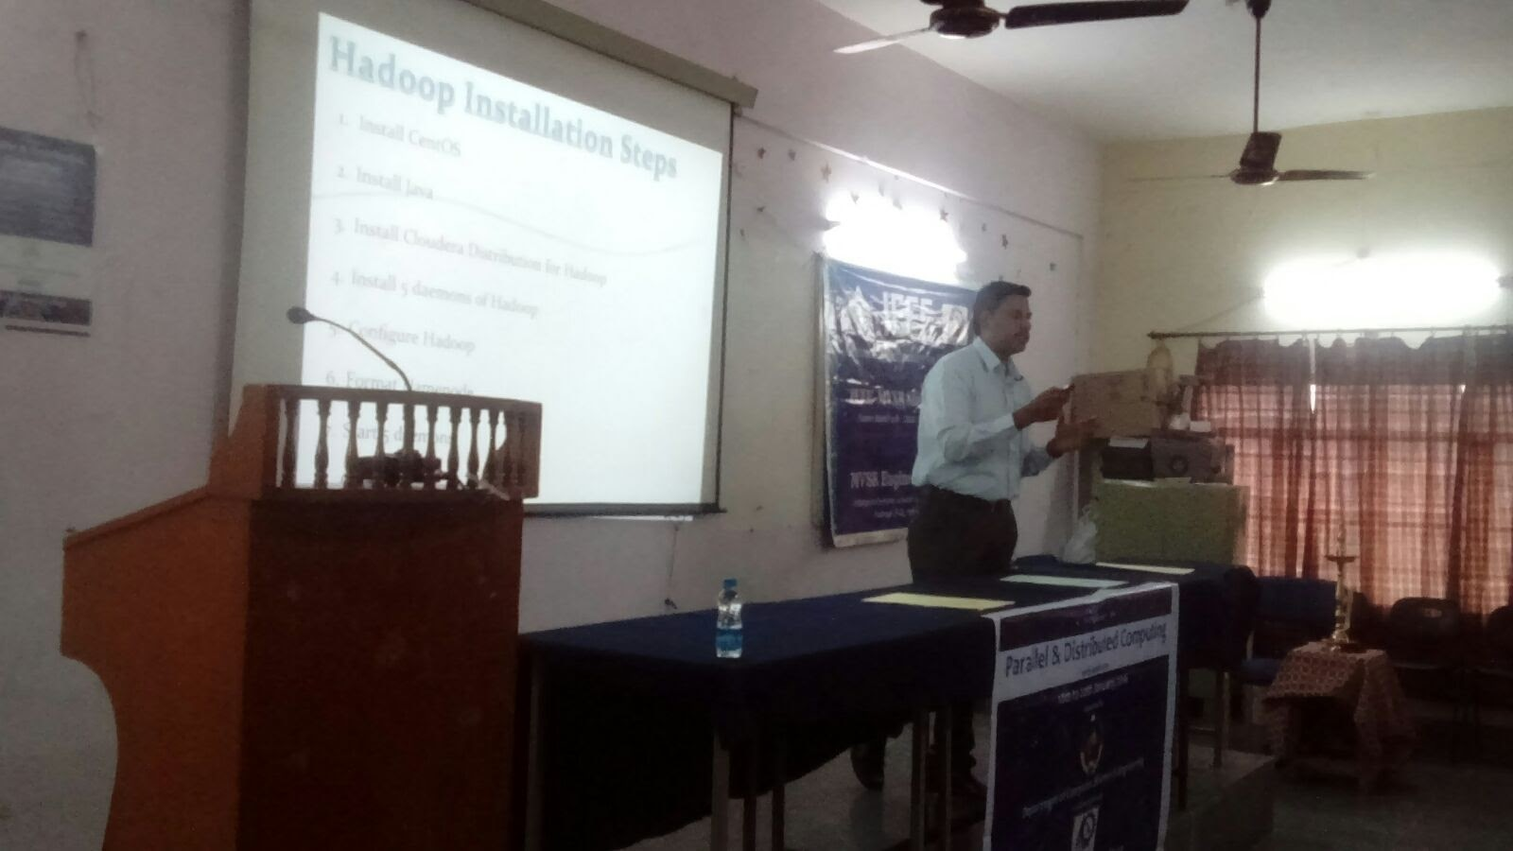
A few Snapshots of the workshop

