GENERAL AWARENESS ON HEALTH AND HYGIENE

Women In Engineering (WIE) of IEEE MVSREC SB had conducted an awareness program on 24th February 2016, at Sri Saraswathi Shishu Mandir School, Badangpet, Hyderabad. The agenda of the event was to educate the girls in respects to the measures that are to be taken to lead a healthy and a happy life ahead.

Student Branch Mentor: WIE Student Branch Advisor:

Dr. Atul Negi, Ms. Dr. G. Kanaka Durga,
Professor, School of CIS, Head, IT Department,
University of Hyderabad. MVSR Engineering College.

Student Branch Advisor: Student Branch Counselor:
Mr. V. Ashwini Kumar, Mrs. A.V.Vahini
Assoc. Professor, IT Dept., Asst. Professor, IT Dept.,
MVSR Engineering College. MVSR Engineering College.

Power and Energy Society Advisor
Mr. B.Sarveshwar Reddy
Asst.Professor , EEE Dept
MVSR Engineering College

Student Branch Executive Committee: WIE Affinity Group:

E.Sanjana – Chairperson V.B Mounika - Chairman
K.V Sirisha - Vice Chair D. Sreeya Reddy – Vice-chair
G.K Anirudh – Secretary Rahul Bhalla- Secretary
T. Anirudh - Joint Secretary B. Makarand– Joint Secretary
G. Vinay – Treasurer P. Harshitha- Treasurer

Power and Energy Society

V.B.Mounika-Chairman
RahulBhalla-ViceChair
T.SaiYashwanth-Secretary
B.Ujwala - Treasurer

Event Details:

Date: 24th February 2016
Time: 01:30PM-03:00PM
Venue: Sri Saraswathi Shishu Mandir School, Badangpet, Hyderabad

The event began at 01:30 PM at the school after gathering the girls in the classroom and exchanging pleasantries. The girls were from 6th standard to 10th standard. The Student members started the event by explaining our basic idea of health and personal hygiene.

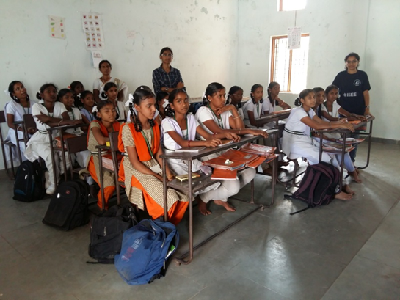

Attendees of the program

The children were very enthusiastic about everything we tried to explain, were listening very keenly and were very observant.

Student members talked about the way these girls need to improve their food habits by eating food rich in nutrients, not skipping their breakfast (as most of the girls do ) and exercise everyday which will help them build a strong immune system that can help them resist any kind of pain or exhaustion. Most of the girls there do not know that they were doing things in a wrong way.

The students clarified their doubts with us and Student members also explained their teachers what extra information they had. The students and the teachers there were very cooperative. The teachers also gave some more suggestions to the students and volunteers as well. Student members assured them that they would help them in whichever way they can and would also provide them with necessary needs.

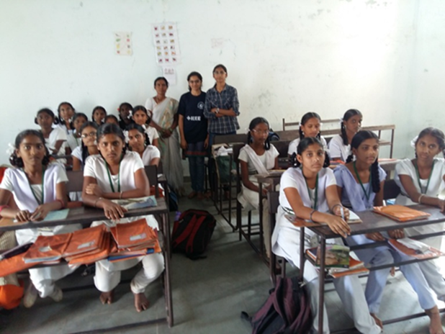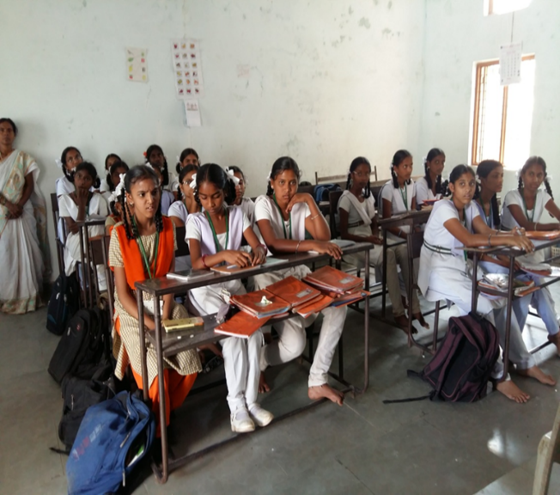

Students along with their teacher and Student members of WIE AG

The girls were happy to interact with the student members and by the end of the session, the girls could understand the mistakes they committed in their daily routine, in their food practices, until now and realized the need to overcome those mistakes.

Report by
B. L. Divija Sarupya
IEEE-SB, MVSREC

