

WOMEN’S DAY

The International Women’s Day is celebrated on March 8th every year throughout the world. The WIE Affinity group of IEEE SB, MVSREC celebrated Women’s day on March 5th ,2016 .The theme of the day was “Happy women are the prettiest..!!”

Student Branch Mentor: WIE Student Branch Advisor:

Dr. Atul Negi, Ms. Dr. G. Kanaka Durga,
Professor, School of CIS, Head, IT Department,
University of Hyderabad. MVSR Engineering College.

Student Branch Advisor: Student Branch Counselor:

Mr. V. Ashwini Kumar, Ms.A.V.Vahini
Assoc. Professor, IT Dept., Asst . Professor,IT Dept.,
MVSR Engineering College. MVSR Engineering College.

Student Branch Executive Committee: WIE Affinity Group:

E.Sanjana – Chairperson V.B Mounika - Chairman
K.V Sirisha - Vice Chair D. Sreeya Reddy – Vice-chair
G.K Anirudh – Secretary Rahul Bhalla- Secretary
T. Anirudh - Joint Secretary B. Makarand– Joint Secretary
G. Vinay – Treasurer P. Harshitha- Treasurer

Event Details:

Date: 05-03-2016
Time: 10:30 AM-04:30 PM
Venue: AV Room, IT Dept., MVSR Engineering College
Number of Participants: 60

The celebrations started with a welcome note by Mrs.A.V.Vahini, Student Branch Counselor followed by lighting of lamp by the Dr.G.Kanaka Durga, Student Branch Advisor,WIE AG.

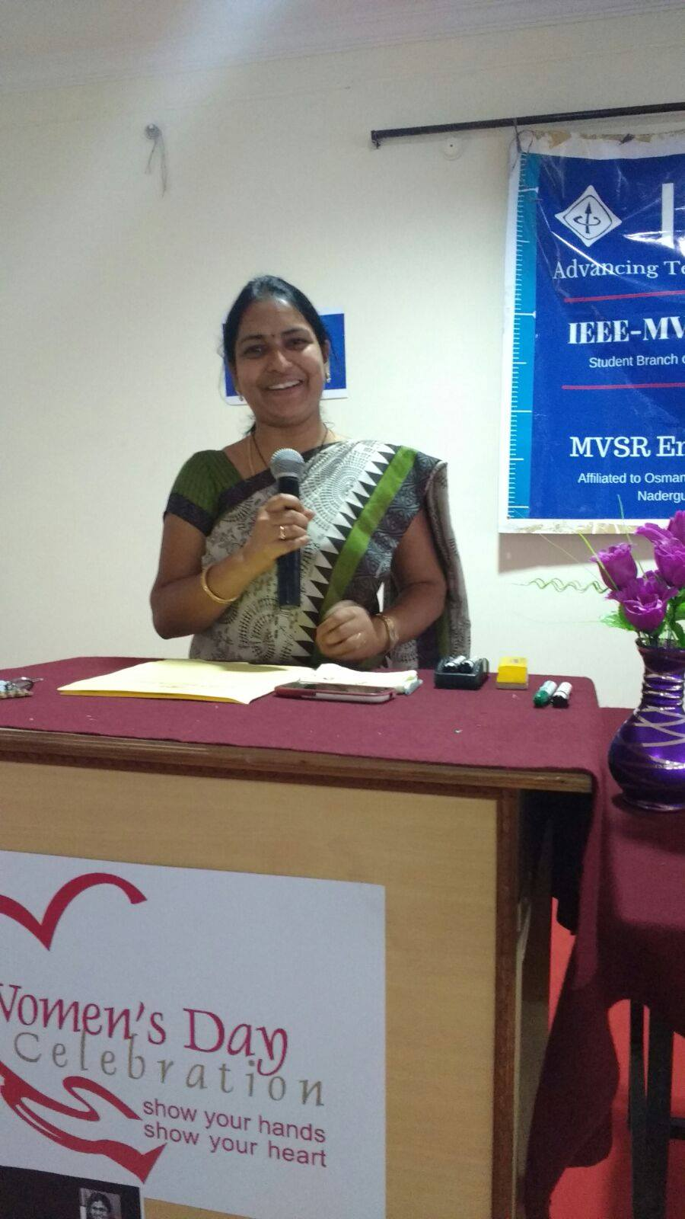

Mrs.A.V.Vahini, Student Branch Counselor,IEEE SB,MVSREC

We started our celebrations with a prayer song by Mrs.A.V.Vahini.

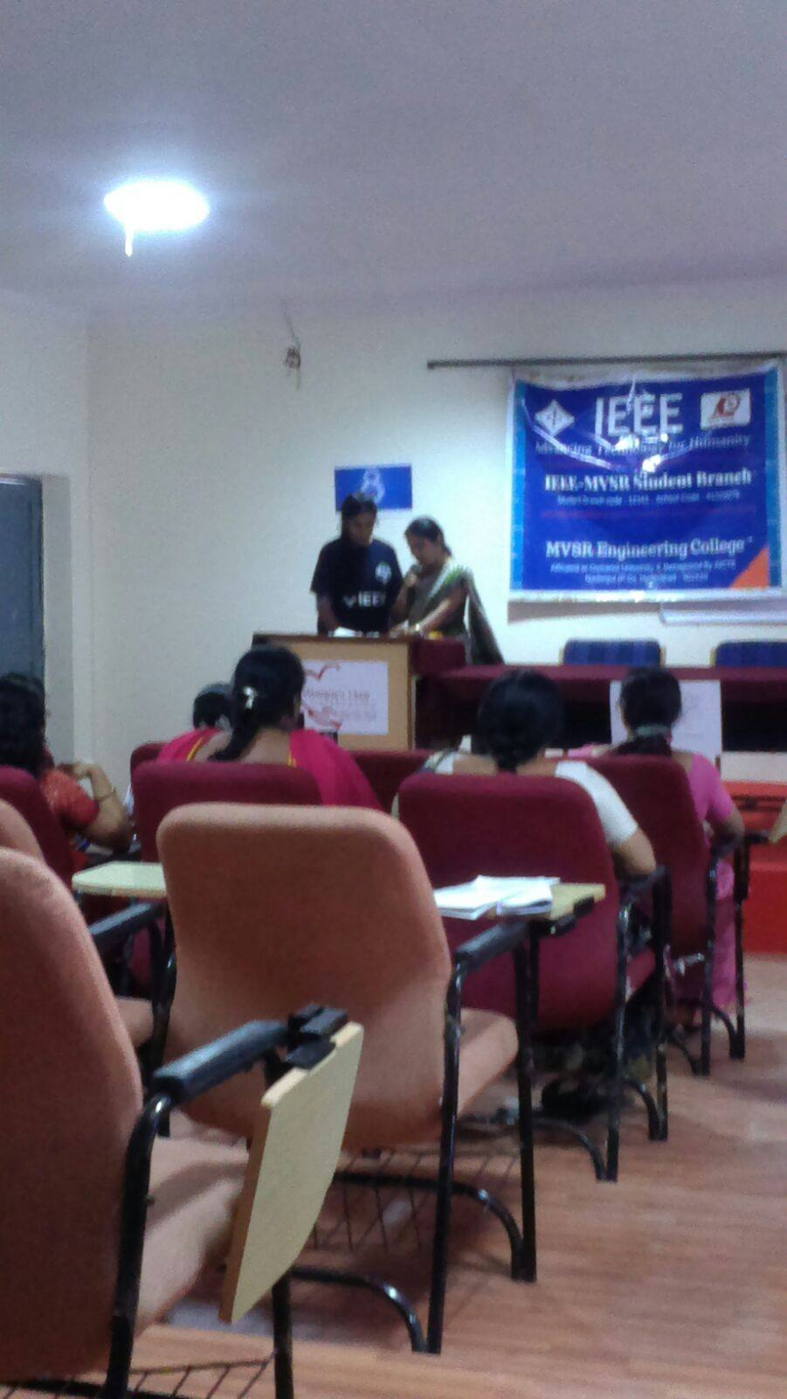

Song by Mrs.A.V.Vahini.

Since the UN theme for International Women's Day 2015 is "Happy women are the prettiest” , Dr.G.Kanaka Durga , Advisor WIE AG,MVSREC, addressed the gathering by her wishes for women’s day and she spoke about how the betterment of Women’s social status can lead to a better society and can give a happy life to a woman. She also spoke about how important it is for a girl/woman to get educated and how it can lead to the betterment of the society and the nation. She spoke about the various schemes the government started to help out women to be independent and lead a happy life.

Dr.G.Kanaka Durga, Advisor, WIE AG, IEEE SB,MVSREC

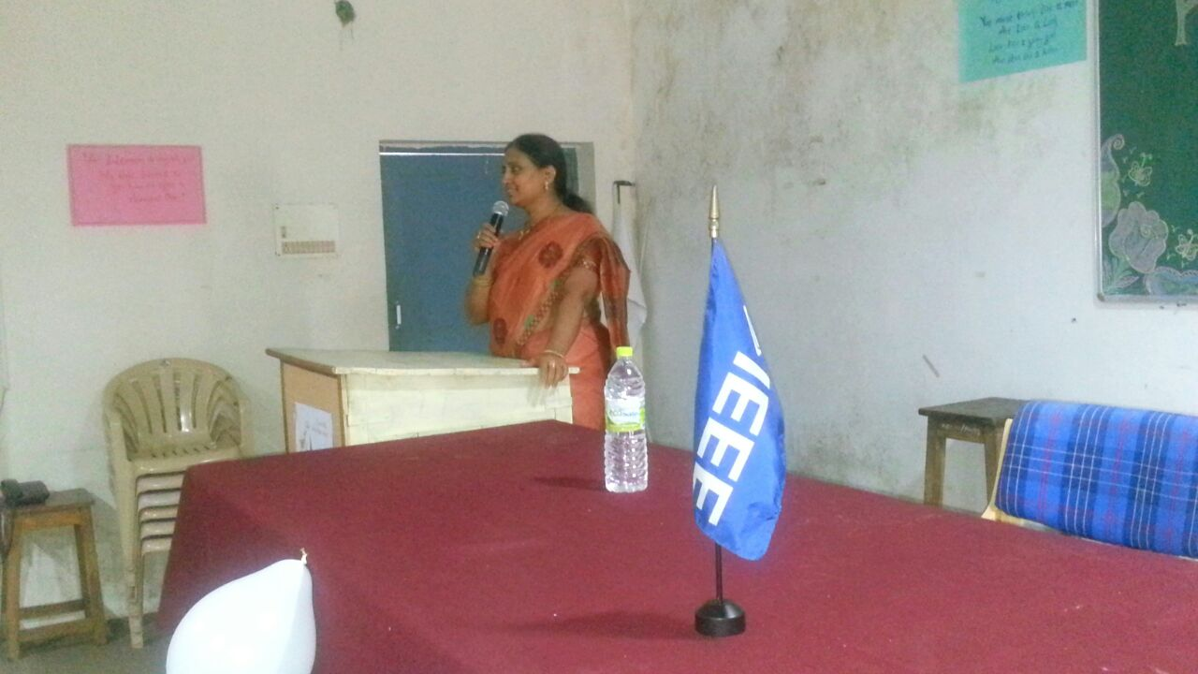

Later on ,Mrs.A.V.Vahini spoke on what are all the areas women have to be developed in and what kind of support they need.
It created awareness of why is it important for a woman to understand and enjoy her freedom, responsibilities.
The event continued with many fun events like rangoli competition, cooking competition.

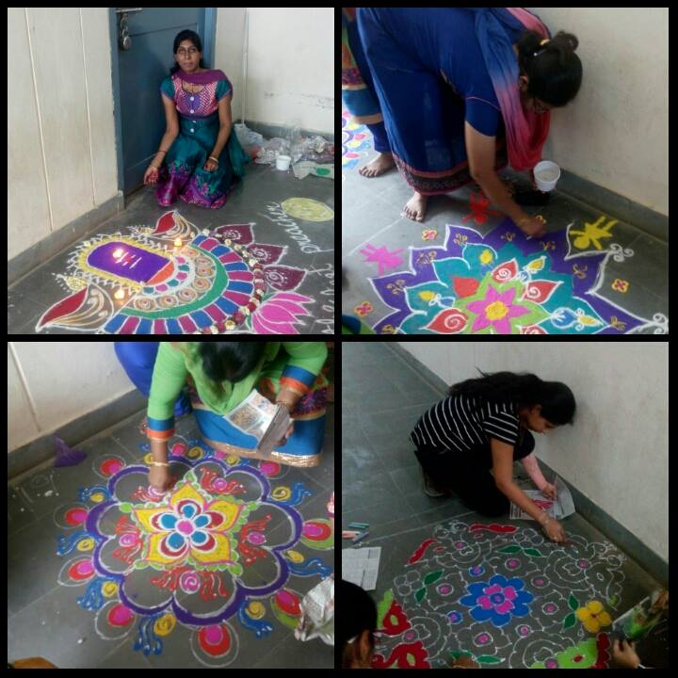

Teachers and students taking part in the rangoli competition.

The purpose of art is washing the dust of daily life off our souls.

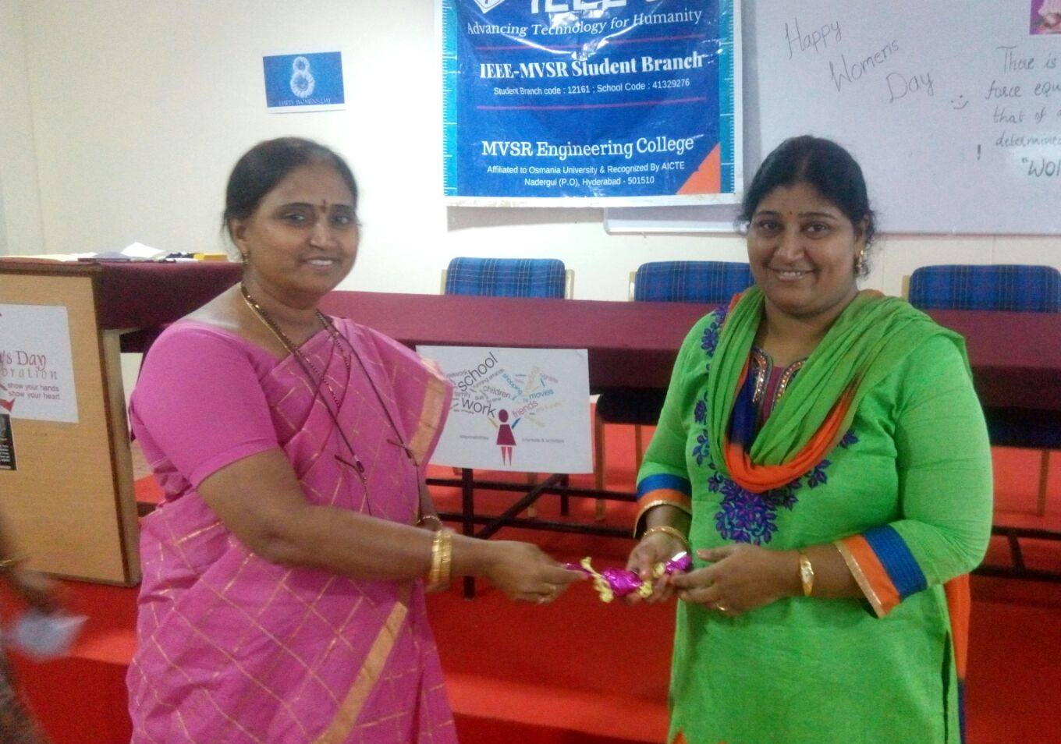

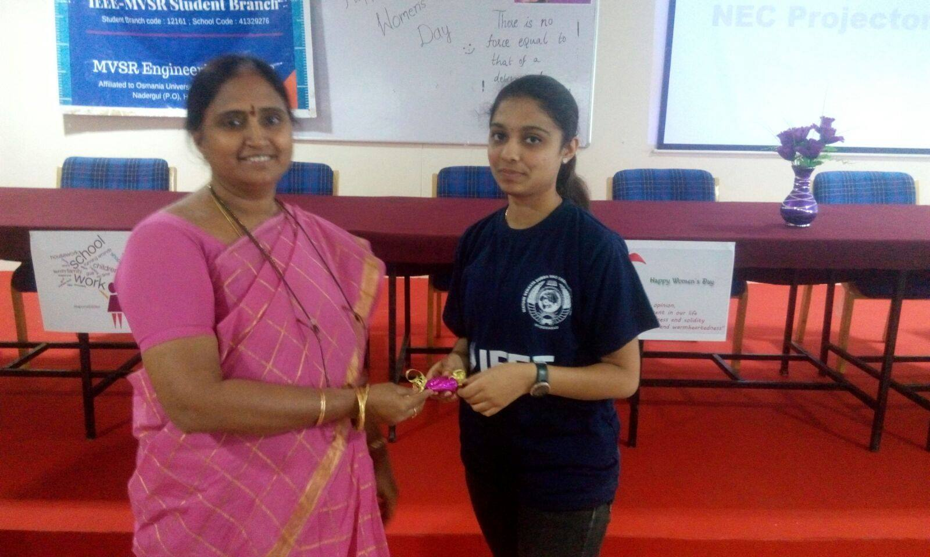

Dr.G.Kanaka Durga, Student Branch Advisor, W.I.E AG giving the prize to the winners of rangoli competition.

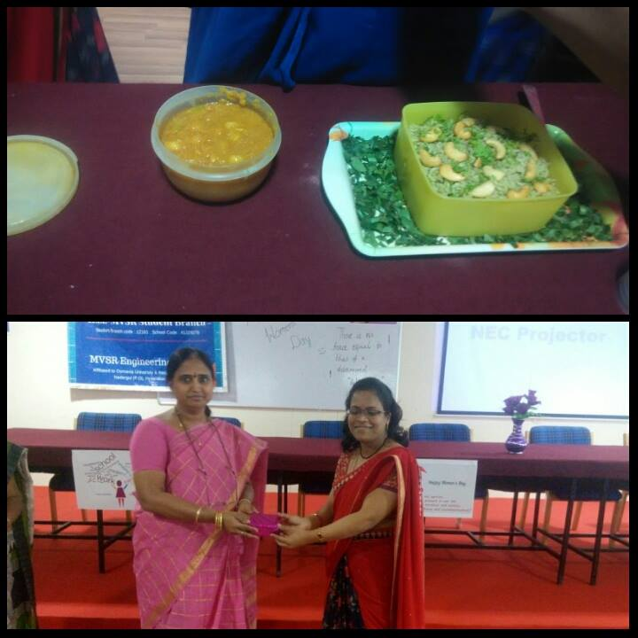
Dr.G.Kanaka Durga, Student Branch Advisor, W.I.E giving the prize to the winners of cooking competition.

Teachers were given an opportunity to enjoy, they were very enthusiastic. There were even many other fun things like dancing, singing, fun games like chits etc. It was a refreshing time for all the women there, out of their busy schedule who participated in the event.

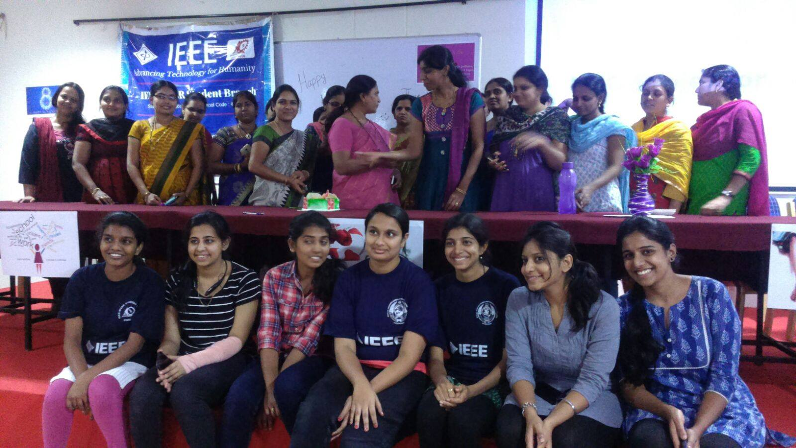

The programm ended up with the cake cutting celebration.

