Technical talk on Advances in VLSI Technology

IEEE MVSR Circuits and Systems Society (CASS) Student Chapter in association with the ECE Department, MVSREC has conducted a technical talk on “Advances in VLSI Technology” on 22nd December 2023. The main objective of organizing this technical talk was to enhance students’ knowledge of the latest developments in VLSI technology.

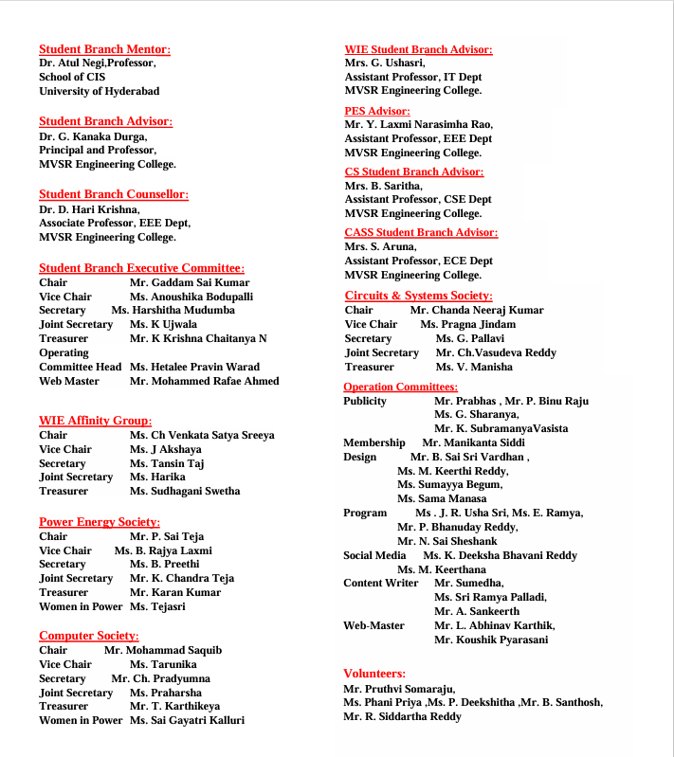

Session Details:

Date: 22nd December, 2023

Timings: 02:00 p.m. – 3:30 p.m.
Venue: ECE conference hall, MVSREC

No. of Attendees: 78
IEEE: 12 Non-IEEE:66

Speaker: Mr. Yesho Nagaraju

Mr. Yesho Nagaraju is the Joint Director of the Centre for Development of Advanced Computing(C-DAC), Hyderabad. He has more than 17 years of Design, Development, and Managerial experience in the fields of Electronic Product Design, Embedded System Design, and VLSI Design. Since March 2006, working with C-DAC Hyderabad in Embedded Systems, Electronic Product Design, and VLSI design at various levels. He has been instrumental in setting up various laboratories including VLSI Design, Embedded System Design, Test and Measurement, PCB Design and Industrial Design, and 3D printing Labs at C-DAC Hyderabad and responsible for the implementation of Capacity Building in Electronic Product Design and Production Technology project and u-Agri projects.
Currently working on the following projects of Govt. of India:
- Design and Development of Arm processor-based HPC SoC and Dual Socket Compute Node (As part of the National Supercomputing Mission of Govt. of India).

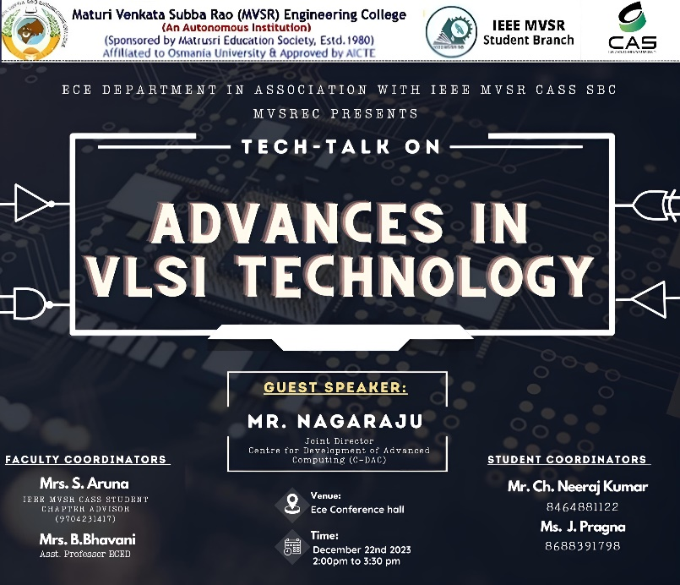
Technical talk Poster

Ms. G. Pallavi, IEEE MVSR CASS Student Branch Secretary commenced the session by extending a warm welcome on behalf of the CASS Student Chapter and MVSR Engineering College to the speaker Mr. Yesho Nagaraju, and all the participants.

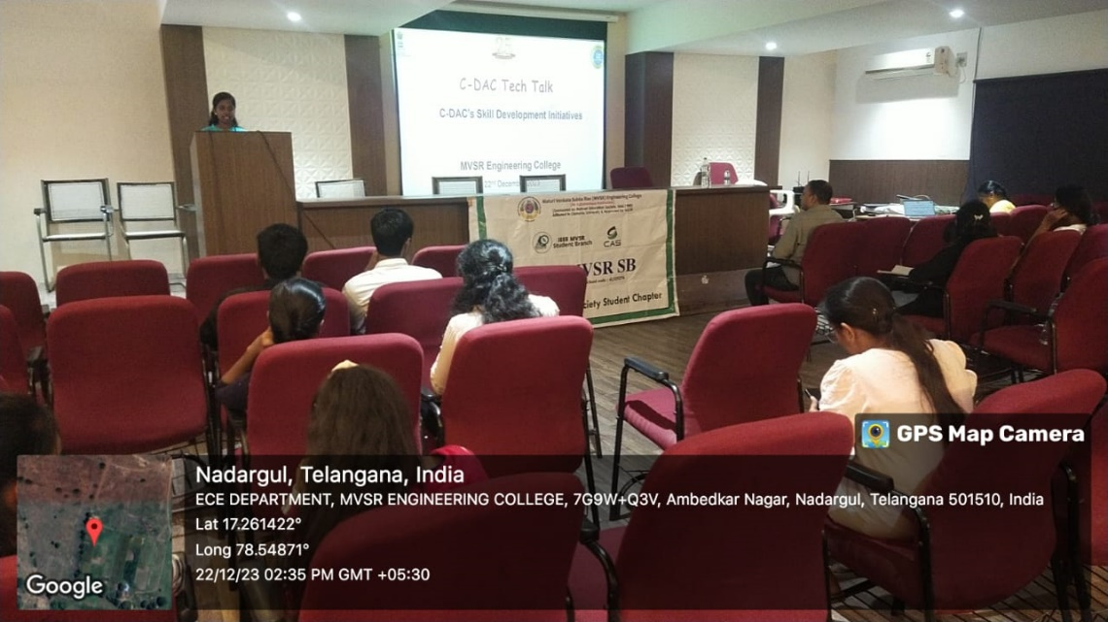
Welcome Address by Ms. G. Pallavi

Mr. Yesho Nagaraju addressed the gathering and provided an introduction to C-DAC and the successful projects it has taken up till now. Mostly it takes up the projects of the Government of India. The speaker introduced to the participants a mobile application M-Kavach-2 which was developed by C-DAC. The M-Kavach-2 application is a comprehensive mobile device security solution addressing emerging threats related to Android.

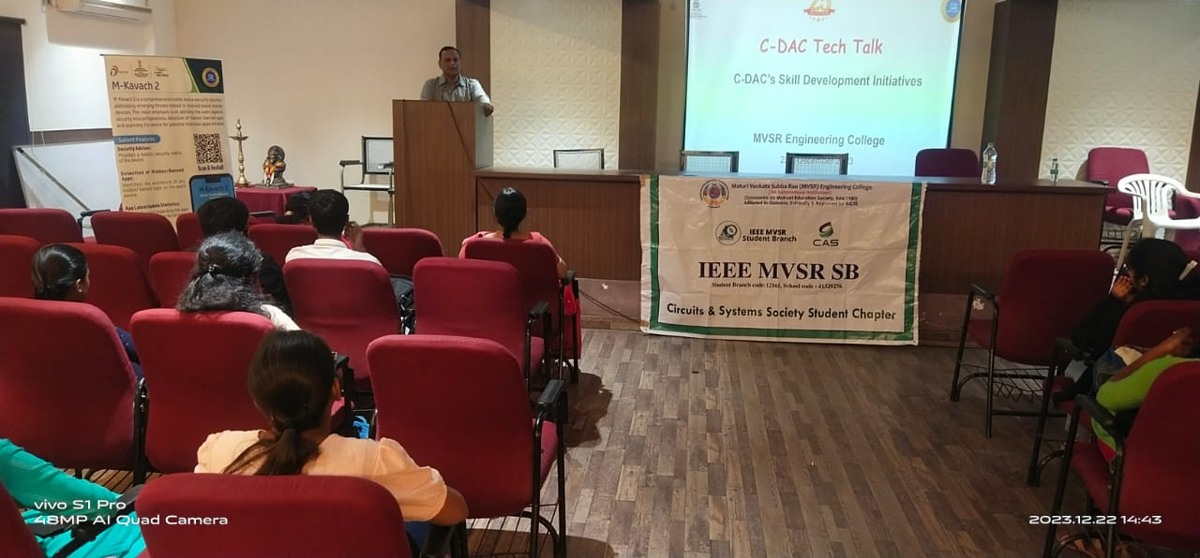
Speaker addressing the gathering

Further, he gave a brief explanation about VLSI, Moors law, and Dennard Scaling. He also explained different types of VLSI companies and how they work, are trending technologies of VLSI, and the level of usage of these technologies by India and other countries. The speaker gave information about the developments in data storage memory working technologies such as HBM-3(High Bandwidth Memory) and their speeds in TFLOPS (Trillion Floating Point Operations Per Second). He also went on to explain the evolution of chip designing techniques, fabrication methods using transistors, CMOS, and the latest finfets, and the development of supercomputers by technologically advanced countries such USA, Japan, and Germany and how India developed its Indigenous supercomputer. He told C-DAC played a major role in developing India’s first indigenous supercomputer PARAM 8000. The technical talk was concluded by Ms. Pragna Jindam, IEEE MVSR CASS SB Vice-Chairperson, by proposing a vote of thanks.

List of Attendees:
SNO | Name of the Student | Roll No
1 | M.SwethaMadhavi | 2451-21-735-044
2 | V.PoojaSri | 2451-21-735-090
3 | B.Saanvika | 2451-21-735-009
4 | CH. Akshitha | 2451-21-735-042
5 | Rithesha. N | 2451-21-735-049
6 | G. AbhinayaMudhiraj | 2451-21-735-031
7 | ChSatvika | 2451-21-735-005
8 | M Nava Prasad | 2451-21-735-008
9 | N. Swathi | 2451-21-735-041
10 | P. Usha | 2451-21-735-316
11 | G. Likitha | 2451-21-735-167
12 | D.SriVarsha | 2451-21-735-172
13 | S. Jahnavi | 2451-21-735-188
14 | Lohitha | 2451-21-735-135
15 | S. Vasundhara | 2451-21-735-164
16 | Sanjana | 2451-21-735-374
17 | Srinidhi | 2421-21-735-116
18 | Harshitha | 2451-21-735-114
19 | L.Anusha | 2451-21-735-313
20 | B. Shruthi | 2451-21-735-092
21 | P. Susmitha | 2451-21-735-109
22 | G. Bhavana | 2451-21-735-124
23 | Rasagna | 2451-21-735-310
24 | Koushik | 2451-21-735-301
25 | Sriharshan | 2451-21-735-303
26 | Sahan | 2451-21-735-307
27 | N. saisrija | 2451-21-735-311
28 | T. Bhavana | 2451-21-735-185
29 | Vinay Bijji | 2451-21-735-020
30 | M.Shashank | 2451-21-735-050
31 | M.Pooja | 2451-21-735-056
32 | Sravanthi | 2451-21-731-014
33 | RajKumar | 2451-21-735-057
34 | Sripooja | 2451-21-735-018
35 | P. Srujana | 2451-21-735-006
36 | Sahithi | 2451-21-735-039
37 | k Lokesh | 2451-21-735-004
38 | S. Aishwarya | 2451-21-735-001
39 | M.Pavani | 2451-21-135-069
40 | A. Yeshwanth | 2451-21-735-067
41 | K Sai vishveshwar | 2451-21-735-074
42 | Ashwath | 2451-21-735-073
43 | Mahesh | 2451-21-735-087
44 | Manikiran.V. Goud | 2451-21-735-127
45 | Teja B. | 2451-21-735-089
46 | PVarshithaReddy | 2451-21-735-078
47 | Anil Kumar | 2451-21-735-174
48 | Vikyath P. | 2451-21-735-185
49 | Sahithi | 2451-21-735-161
50 | Srinidhi | 2451-21-235-317
51 | Waseem baba | 2451-21-735-312
52 | Sameena | 2451-21-735-157
53 | Saha Taskeen | 2451-21-735-123
54 | Poojitha | 2451-21-735-182
55 | Renu Priya | 2451-21-731-138
56 | Sreevani | 2451-21-735-160
57 | Ritika | 2451-21-735-141
58 | Uday Naidu | 2451-21-735-133
59 | Sai Nitish | 2451-21-735-144
60 | Sandeep | 2451-21-735-139
61 | Santhosh | 2451-21-735-079
62 | Sharath | 2451-21-735-126
63 | Yashwanth | 2451-21-335-095
64 | P. Sangeetha | 2451-21-135-320
65 | L Adithya Ram | 2451-20-735-014
66 | Ajay Kumar | 2451-20-735-015
67 | A. Shreya | 2451-20-735-302
68 | M.Sahithi | 2451-20-735-002
69 | uppala Shirisha | 2451-21-735-119
70 | Nihasini | 2451-21-735-130
71 | G. Pallavi | 2451-21-735-102
72 | V.Manisha | 2451-20-735-309
73 | S kavya | 2451-21-735-304
74 | A Varshini | 2451-21-735-305
75 | Manikanta S | 2451-21-735-007
76 | P. Binu Raju | 2451-21-735-048
77 | Shiva Prasad | 2451-21-735-110
78 | Ch. Vasudeva Reddy | 2451-21-735-027

Reported by:
IEEE MVSR SB

