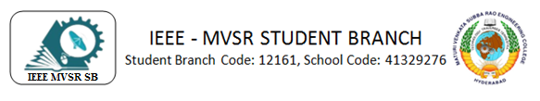
EXPLORING THE WORLD OF DIGITAL FORENSICS
IEEE MVSR SB Women in Engineering Student Chapter held a webinar on "exploring the world of digital forensics" on September 4, 2023. This program's primary goal is to increase participants' knowledge of digital forensics.

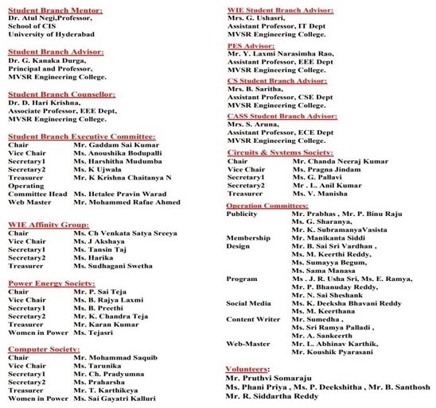

Session Details:
Date: 4th September 2023
Timings: 7:00PM – 8:30 PM
No. of Attendees: 40; No of IEEE members = 20; No of Non-IEEE members = 20
Speaker: Dr. Vasavi Bande
Dr. Vasavi Bande, is an Associate Professor at MVSR Engineering College, having 16-year teaching career, 20 research articles, and three patents in IT. She actively participates in workshops on Advanced Cyber Security, Cyber Forensics, and Data Analysis, and is dedicated to continuous learning in the digital realm.
Event Poster

Ms. Ch. Venkata Satya Sreeya, IEEE MVSR WIE Affinity Group Chairperson, commenced the meeting by extending a warm welcome to all of the students as well as the session's speaker, Dr. Vasavi Bande, Dr. D. Hari Krishna, IEEE Student Branch Counsellor, and Mrs. G. Ushasri, IEEE WIE Affinity Group Advisor. Later, Dr. D. Hari Krishna, IEEE Student Branch Counsellor addressed the gathering and welcomed everyone while providing information about the Benefits of IEEE and IEEE Xtreme programme. He commended the WIE affinity group for organising the first technical event. Mrs. Ushasri, IEEE WIE Student Branch Advisor addressed the gathering and thanked Dr. Vasavi Bande for her assistance in spreading the knowledge. Ms. Tansin Taj, IEEE MVSR WIE Secretary, took over hosting the meeting and offered an overview of IEEE, its affiliation groups, membership requirements and she also introduced the speaker Dr. Vasavi Bande.

Dr. Vasavi Bande thanked Dr. Harikrishna, Mrs. Usha Sri, IEEE WIE Affinity Group Advisor, Ms. Ch. Venkata Satya Sreeya, IEEE MVSR WIE Affinity Group Chairperson, and Ms. Tansin Taj, Secretary, IEEE MVSR WIE Affinity Group for the introduction. The topic on digital forensics was introduced by Dr. Vasavi Bande. She explained the main intentions of this session are to clarify the need for digital forensics, as well as its limitations in enterprise networks and practical difficulties. She went on to say that while India's expanding digital infrastructure is good for the country's economy, it could also be used by online criminals including thrill-seekers, vandals, thieves, and even state-sponsored con artists. A report published by her; India is the fifth most exposed nation to cyberattacks.
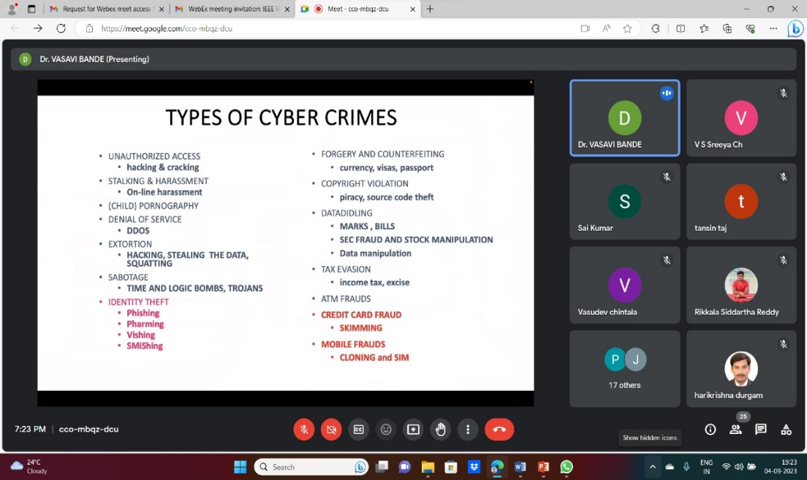
Dr. Vasavi Bande explaining about Cybercrimes

Dr. Vasavi Bande gave an explanation of the numerous types of cybercrimes. A few of these actions include unauthorised access, stalking and harassment, pornography, service denial, exportation, and sabotage. Phishing is one of the most prevalent forms of cybercrime overall. She gave statistics on the most common forms of cybercrime. she provided a phishing email example and a description of how they track their informing via phishing process.The expenses of global cybercrime damage were discussed by the speaker. She displayed all the data that cybersecurity ventures have projected for 2021.

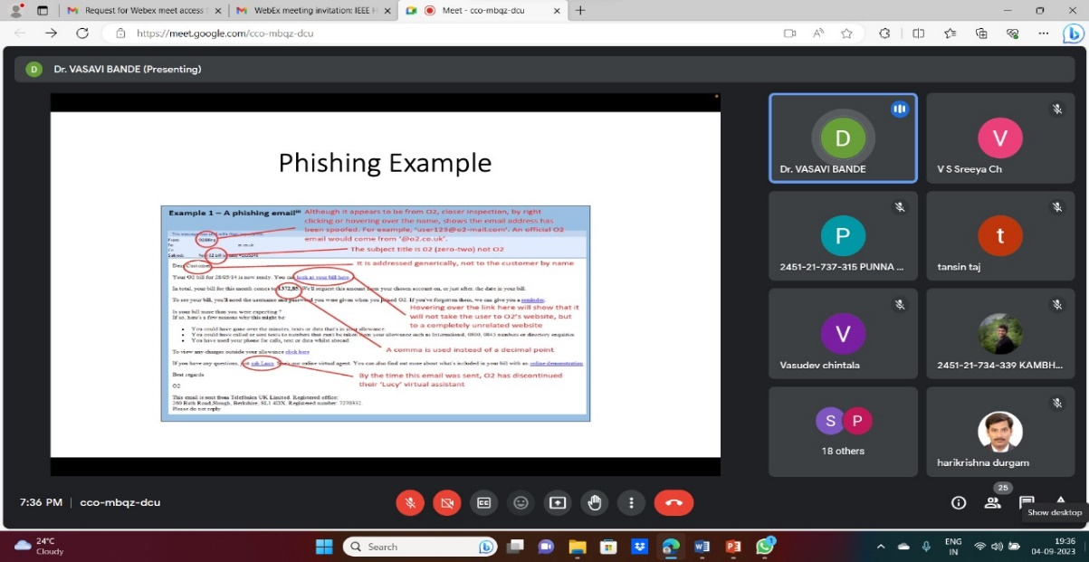
Speaker explaining about Phishing with an example

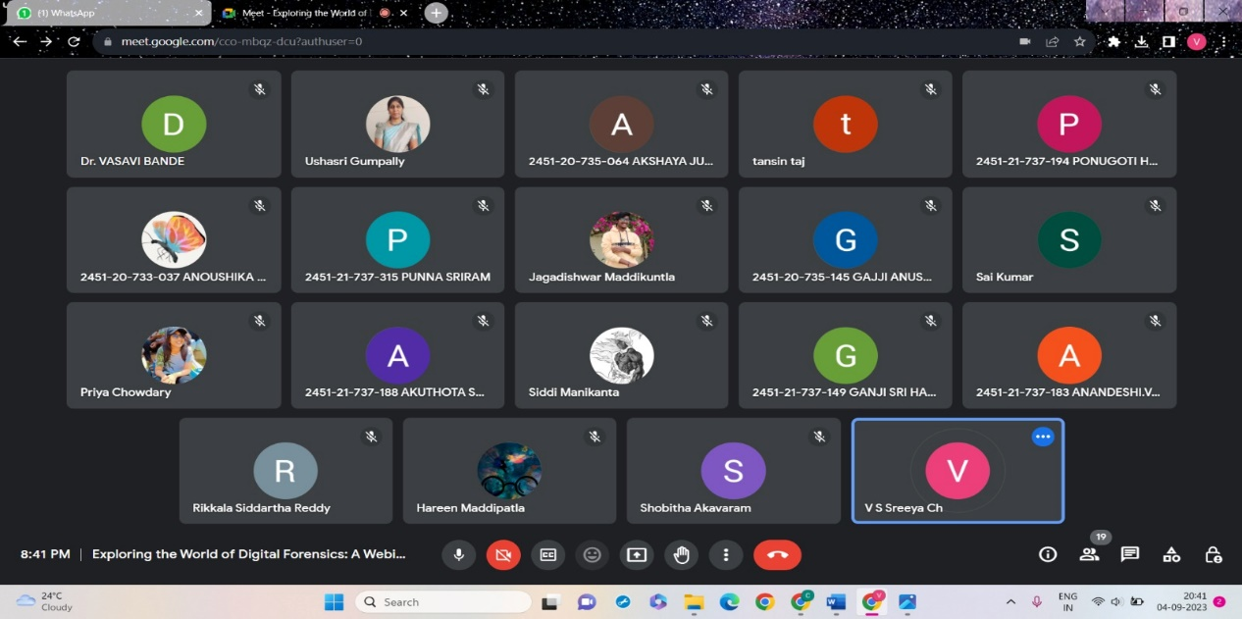
Participants attending the meet

In this way, the webinar given by Dr. Vasavi Bande, came to an end after a detailed explanation about all the important concepts of the stages of a digital forensic investigation and the fundamental Dos and Don'ts of gathering evidence. Before concluding the class, she later responded to all of the attendees' questions.

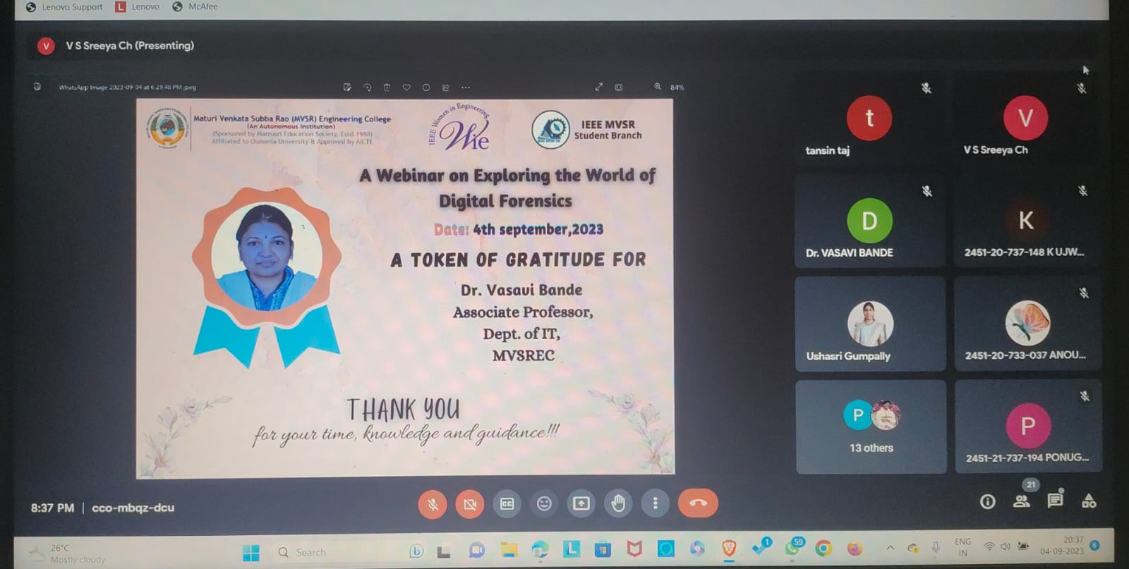
Mrs. G. Ushasri, IEEE WIE Affinity Group Advisor presenting virtual memento to the speaker Dr. Vasavi Bande.

With Ms. J. Akshaya, Vice Chairperson, IEEE MVSR SB WIE Affinity Group vote of thanks, the meeting has come to a conclusion. Dr. Vasavi Bande was complimented for giving of her time and leading an informative workshop for all of the attendees. She thanked our honourable principal, Dr.G Kanaka Durga and the management of MVSR Engineering College, for their support. She thanked Dr. Harikrishna, IEEE Student Branch Counsellor and Mrs. G. Ushasri, IEEE WIE Affinity Group Advisor and all the students for attending the webinar.

S.NO | Name of the participant | Roll No | IEEEID
1 | Dr. D. Hari Krishna | Faculty | 90436180
2 | Mrs. G. Ushasri | Faculty | 98612138
3 | Gajji.Anusha | 2451-20-735-145 | NA
4 | Punna Sriram | 2451-21-737-315 | NA
5 | V Sri Harsha | 2451-20-735-082 | NA
6 | Maddikuntla Jagadishwar | 2451-22-735-074 | NA
7 | Shobhitha Akavaram | 2451-20-733-170 | NA
8 | Siddartha Reddy Rikkala | 2451-20-735-116 | 99494252
9 | Hareen Maddipatla | 2451-19-733-041 | 96254183
10 | Pragna Jindam | 2451-20-735-080 | 98194494
11 | K Ujwala | 2451-20-737-148 | 97508428
12 | Chintala Vasudeva Reddy | 2451-21-735-027 | 99469411
13 | Harshitha Mudumba | 2451-20-735-063 | 98194561
14 | Banavath Harshitha | 2451-20-735-106 | NA
15 | Arrabothu Jhansi | 2451-21-737-184 | NA
16 | Pruthvi Somaraju | 2451-20-735-062 | 98708642
17 | Sheshank Reddy Mothupally | 2451-20-735-065 | NA
18 | Anandeshi.Vaishnavi | 2451-21-737-183 | NA
19 | Prathyusha  Chitimalla | 2451-20-733-141 | NA
20 | Sandeep Kambhampati | 2451-21-734-339 | 99240989
21 | Muddam Aishwarya | 2451-21-737-179 | NA
22 | Ganji Sri Harini | 2451-21-737-149 | NA
23 | Anandeshi.Vaishnavi | 2451-21-737-183 | NA
24 | Salagrama Aditya | 2451-21-733-183 | 99220532
25 | Bolla Sriteeja | 2451-20-735-083 | NA
26 | B.Keerthi Reddy | 2451-21-737-192 | Na
27 | K.Vijaya Keerthi | 2451-20-735-087 | 98194568
28 | Teja Rapolu | 2451-20-735-008 | 975208814
29 | Mannepu Keerthana | 2451-21-733-137 | 99220455
30 | Anoushika.B | 2451-20-733-037 | 98196593
31 | V.Manisha | 2451-20-735-309 | 98197389
32 | Chanda Neeraj Kumar | 2451-20-735-119 | 98194538
33 | Atla Someshwar Sai | 2451-20-735-067 | NA
34 | Nikitha Padakanti | 2451-20-735-077 | 98194515
35 | Mohammad | 2451-20-735-086 | NA
36 | Maligireddy Ravindhar Reddy | 2451-20-735-120 | NA
37 | Akuthota Sumana | 2451-21-737-188 | NA
38 | Kasani Sruthi | 2451-20-735-078 | NA
39 | R.Sai Lokesh | 2451-20-737-167 | 99229295
40 | G Sai Kumar | 2451-20-735-069 | 98196838
41 | Dr. Vasavi Bande | Speaker | 99288733

Reported By:
IEEE MVSR SB

