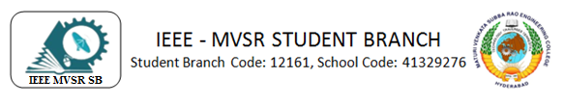
WIE General Body Meeting
IEEE MVSR SB Women in Engineering (WIE) Affinity Group, conducted its second General Body Meeting (GBM), on 28th November, 2023. The objective of this meeting was to plan future events to be organized, monitor the functioning of the WIE Affinity Group and set an appropriate timeline for all the events.
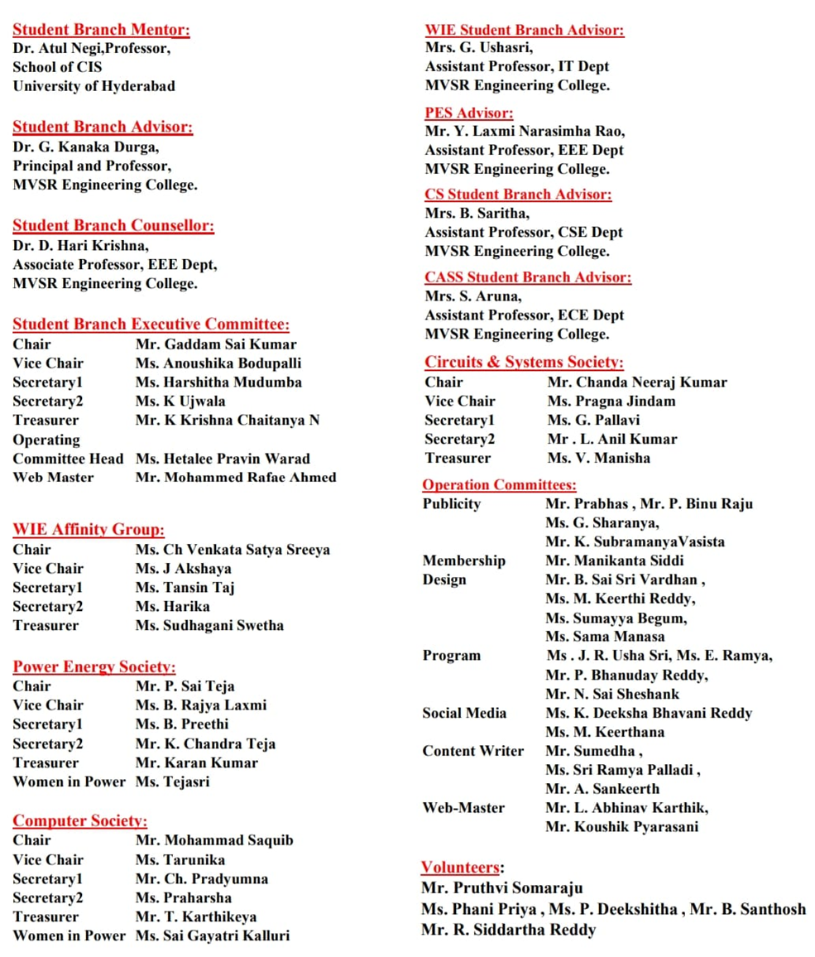

Session Details:
Date: 28th November, 2023
Timings: 1 p.m -2:30 p.m
No. of Attendees: 8
The IEEE MVSR WIE AG GBM was initiated by Ms. Ch Venkata Satya Sreeya, Chairperson, IEEEMVSR WIE AG, by welcoming Dr. D. Hari Krishna, Counsellor. IEEE MVSR SB, Mrs. G. Ushasri, Faculty Advisor IEEE MVSR WIE AG, Mrs. B. Saritha, Faculty Advisor, IEEE MVSR CS, and all the executive committee members were present at the meeting.
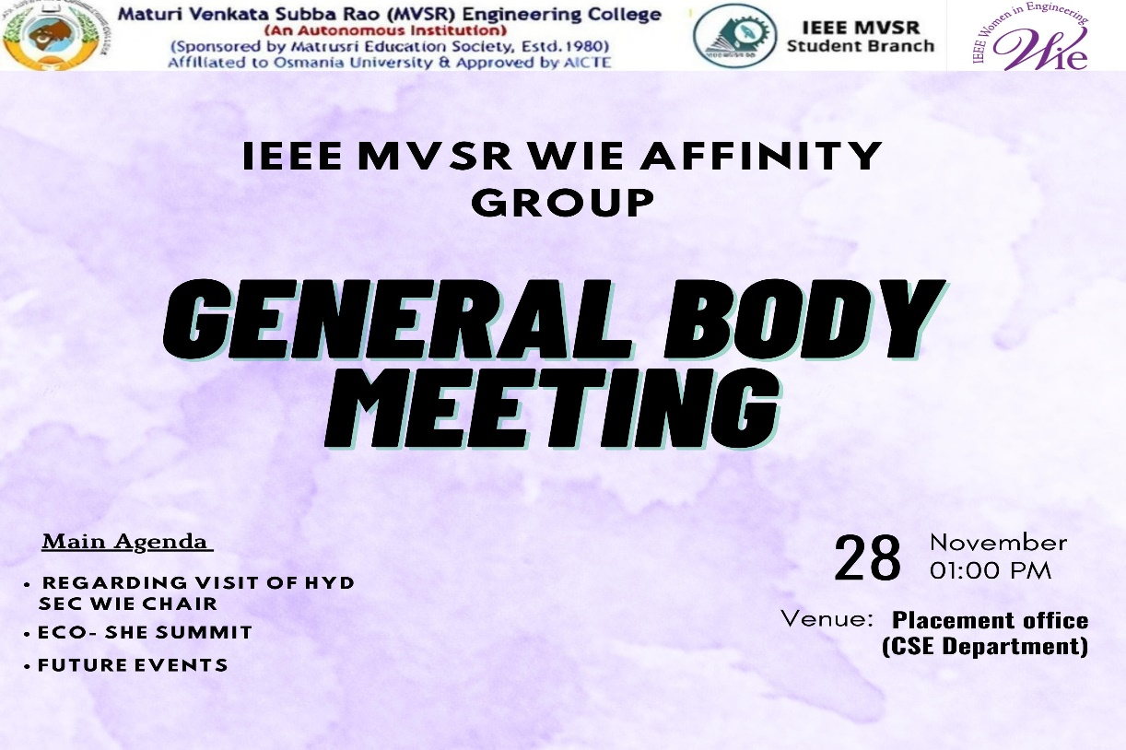

Following that, Mrs. G Ushasri, Faculty Advisor, WIE AG, addressed the members and gave various ideas regarding the events that can be conducted by WIE AG. Notably, she proposed a workshop on "Introduction to UI/UX Design," emphasizing a Hands-On Learning Bootcamp to impart the basics of design. This suggestion aimed at enhancing the practical skills of the students.
Thereafter, Ms. Satya Sreeya suggested Ms. Surabhi Seetha, IEEE EDSOC YP can be speaker for the workshop. Then, Ms. Harika, Secretary, IEEE MVSR SB WIEAG, gave some inputs on the date and venue for the hands-on workshop.
Later, Mrs B. Saritha, CS Faculty Advisor, informed about the Eco She Summit 2023 happening in Hyderabad, so few students can attend that event. She elaborated on the benefits of attending the Summit which will give information about activities and potential opportunities of WIE AG.
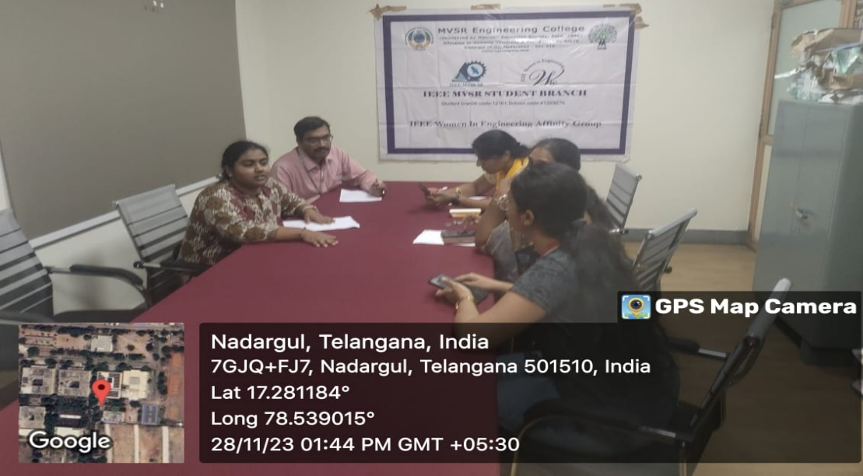
Members proposing their ideas in WIE AG GBM

Subsequently, Dr. D. Hari Krishna, SB Counsellor, proposed few more collaborative events and a seminar by Dr Harivardhagini Subhadra, Chair, WIE AG, IEEE Hyderabad Section. Ms. Tansin Taj, Secretary of IEEE MVSR SB WIE Affinity Group, built on this suggestion by proposing a session on "Awards and Funding Opportunities in IEEE WIE Affinity Group," adding to the proposed seminar.
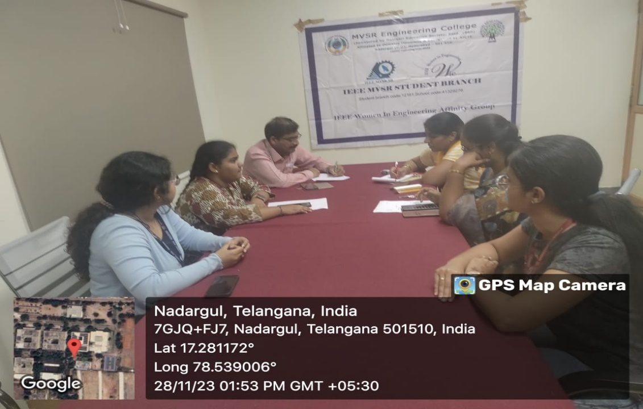
Members discussing in WIE AG GBM
The meeting was interactive and concluded with a vote of thanks delivered by Ms. Akshaya, Vice Chairperson of IEEE MVSR SB WIE AG. She expressed gratitude to Dr. D. Hari Krishna, Mrs. Ushasri, and Mrs. B. Saritha for generously contributing their time and expertise. Additionally, she extended appreciation to all the members of IEEE MVSR SB WIE AG for their active participation in the event.

List of Attendees:
S. No | Name | Roll Number | Designation / Year | IEEE ID
1 | Dr. D. Harikrishna | Faculty | IEEE MVSR SB Counsellor | 90436180
2 | Mrs. G. Ushasri | Faculty | IEEE MVSR WIE AG Faculty Advisor | 98612138
3 | Mrs. B. Saritha | Faculty | IEEE MVSR CS Faculty Advisor | 95070854
4 | Ch Venkata Satya Sreeya | 2451-20-737-151 | Chair, VII Sem | 97488096
5 | J. Akshaya | 2451-20-735-064 | Vice Chair, VII Sem | 99216652
6 | S. Swetha | 2451-20-734-060 | Treasurer, VII Sem | 99241090
7 | Tansin Taj | 2451-21-733-059 | Secretary, IV Sem | 99228530
8 | P. Harika | 2451-21-737-194 | Secretary, IV Sem | 99229064

Reported by:
IEEE MVSR SB

