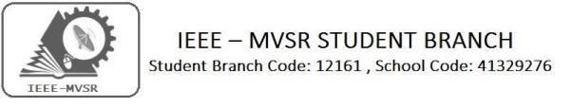

GENERAL BODY MEETING-CASS

IEEE MVSR SB Circuits and Systems Society (CASS) has conducted its General body meet on 30th September 2019. The aim of the session was to plan the upcoming events.

Student Branch Mentor:

Dr. Atul Negi,
Professor, School of CIS,
University of Hyderabad.

Student Branch Advisor:

Mr. V. Ashwini Kumar, Assoc. Professor, IT Dept., MVSR Engineering College.

PES Advisor:
Dr. D. Hari Krishna,
Assoc. Professor, EEE Dept.,
MVSR Engineering College.

Student Branch Executive Committee:

R. Ramyasri - Chairperson
K. Akshitha - Vice Chair
M. Shreya - Secretary
K. Vinay Kumar - Joint Secretary
V. Vineeth - Treasurer

Computer Society:
S. Sai Teja - Chair
G. Suradhya - Vice Chair
M. VamsiKrishna - Secretary
A. Phani Sahasra - Joint Secretary

V. Manikanta- Treasurer

Circuits and Systems Society:
D.Siddartha -Chair
K.Jaideep -Vice Chair
D.V.B Parthiv -Secretary
D.Venkat -Joint Secretary
P.Shravya -Treasurer
WIE Student Branch Advisor:

Mrs. Dr. G. Kanaka Durga,
Principal,
MVSR Engineering College.

Student Branch Counsellor:

Dr. D. Hari Krishna,
Assoc. Professor, EEE Dept.,
MVSR Engineering College.

CS Student Branch advisor:
Mrs. B. Saritha
Assoc. Professor, CSE Dept.,
MVSR Engineering College

CASS Student Branch Advisor:
Mrs. S. Aruna
Asst. Professor, ECE Dept.,

MVSR Engineering College.

WIE Affinity Group:

A. Sai Pratyusha - Chairman
M. Shresta - Vice Chair
N. Sahithya- Secretary

L. Ruthvika- Joint Secretary
R. Ruchitha - Treasurer

Power Energy Society:
E. PavanKumar - Chair
Jayasree k - Vice Chair

N. Avinash - Secretary
B.Nikita Reddy - Joint Secretary

S. Satvika - Treasurer

Operating Committees:
P. Varun Kumar-Operating committee Head
Ch. Jinesh- Publicity Committee
M.V.S.S.S.R Sahith-Membership Committee
Hemish& Y. Sai Sameer - Design Committee

M. Sai Sri Teja- Program Committee
Session details:
Date : 30th September, 2019.
Time : 10:30am – 12:30pm.
Venue: M.E Lab, ECE department, MVSR Engineering College.

No. of attendees: 15

The session began with a brief introduction regarding the planning and necessity of activities to be conducted in the near future. The time required to plan an event and the necessary actions to be taken to ensure quality and quantity.
The minutes of the meeting include deciding the types of events with various agendas, to conduct a PDP in the next week or 10 days. It was also planned to actively advice juniors about the benefits and advantages of these workshops and events and to have them participate actively in the upcoming events

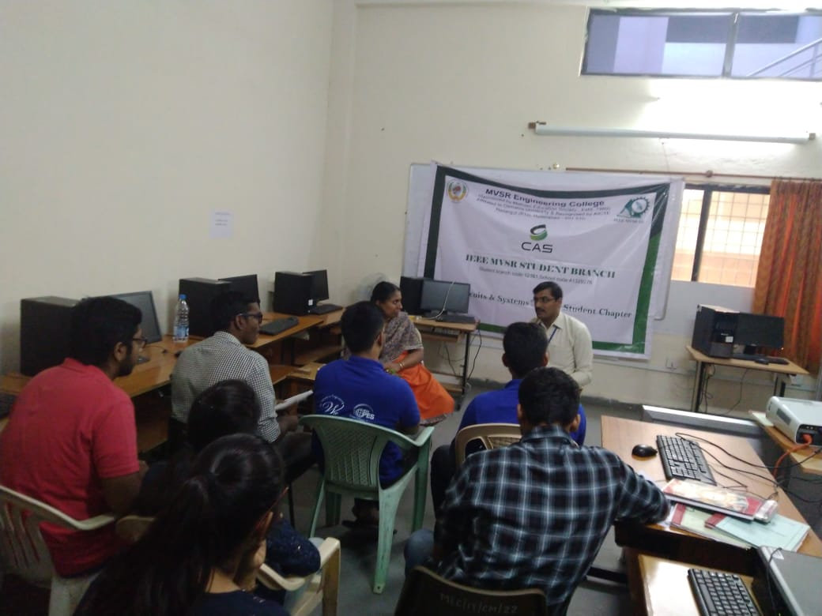
Dr. D. Hari Krishna student branch counsellor addressing the gathering

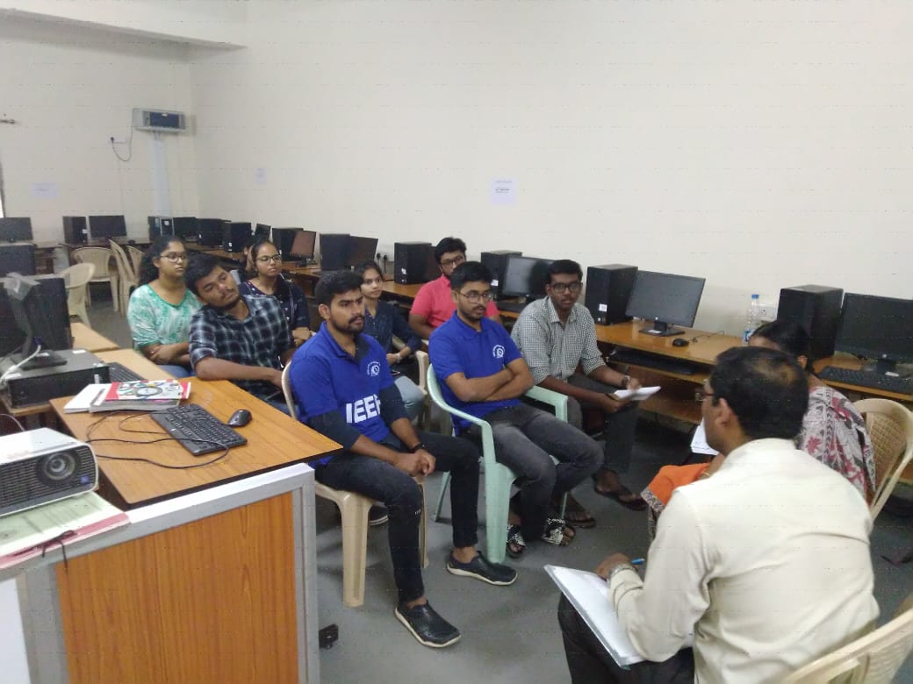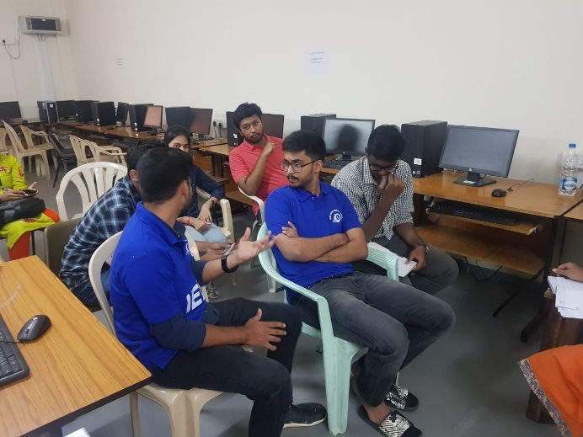

Workshop and event proposals:
- Conducting PDP (Cadence tools) in one week
- IOT/ML workshop
- Technical talk in October
- Technovanza plans for next semester
- 10th IEEE day event organization- Event on “Awareness on IEEE”
- Organization of a mentor/mentee program
- Conducting interviews for prospective Ex-Com

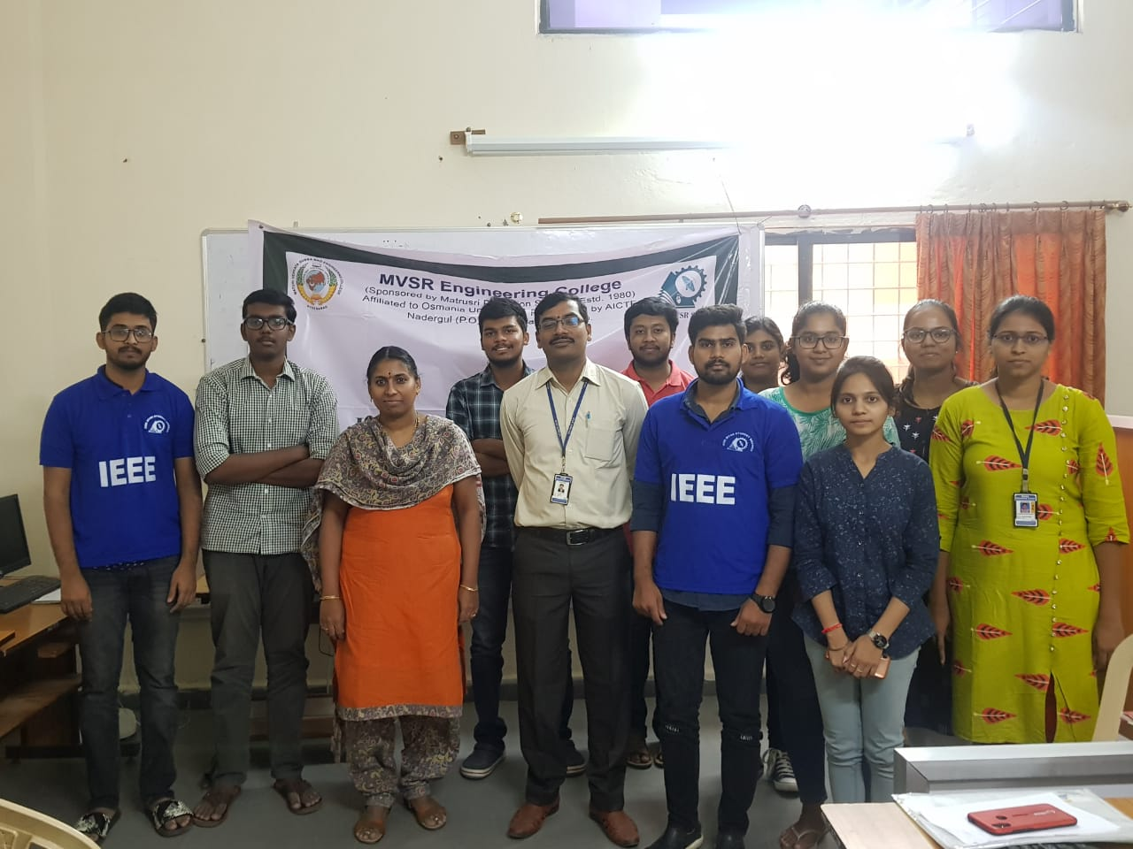
Group Photo of CASS Members.

Reported by:
IEEE MVSR SB.

