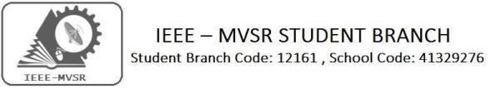

CASS Inaugural
The IEEE Student Branch of MVSR Engineering college is with an at most interest in knowing the developing technology. To strengthen the student inherent talents, we have initiated IEEE Circuits and Systems Society (IEEE-CASS). The mission of launching Circuits and Systems Society is to provide a platform for sharing Scientific and Engineering Information on Technical concepts for the betterment of society and preferred professional development source to its members.

Student Branch Mentor:

Dr. Atul Negi,
Professor, School of CIS,
University of Hyderabad.

Student Branch Advisor:

Mr. V. Ashwini Kumar, Assoc. Professor, IT Dept., MVSR Engineering College.

PES Advisor:
Dr. D. Hari Krishna,
Assoc. Professor, EEE Dept.,
MVSR Engineering College.

Student Branch Executive Committee:

R. Ramya Sri - Chairperson
K. Akshitha - Vice Chair
M. Shreya - Secretary
K. Vinay Kumar - Joint Secretary
V. Vineeth - Treasurer

Computer Society:
S. Sai teja - Chair
G. Suradhya - Vice Chair
M. Vamsi Krishna - Secretary
A. Phani Sahasra - Joint Secretary

V. Manikanta - Treasurer

Circuits and Systems Society:
D.Siddartha -Chair
K.Jaideep -Vice Chair
D.V.B Parthiv -Secretary
D.Venkat -Joint Secretary
P.Shravya -Treasurer
WIE Student Branch Advisor:

Mrs. Dr. G. Kanaka Durga,
Principal,
MVSR Engineering College.

Student Branch Counsellor:

Dr. D. Hari Krishna,
Assoc. Professor, EEE Dept.,
MVSR Engineering College.

CS student branch advisor:
Mrs. B. Saritha
Assoc. Professor, CSE Dept.,
MVSR Engineering College

CASS Student Branch Advisor:
Mrs. S. Aruna
Assoc. Professor, ECE Dept.,

MVSR Engineering College.

WIE Affinity Group:

A. Sai Pratyusha - Chairman
M. Shresta - Vice Chair
N.Sahithya - Secretary

L. Ruthvika - Joint Secretary
R. Ruchitha - Treasurer

Power Energy Society:
E. Pavan Kumar - Chair
Jayasree k - Vice Chair

N. Avinash - Secretary
B.Nikita - Joint Secretary

S. Satvika - Treasurer
Operating Committees:
P. Varun kumar - Operating committee Head
Ch. Jinesh - Publicity Committee
M.V.S.S.S.R Sahith - Membership Committee
V.Hemish & Y. Sai sameer - Design Committee

M. Sai Sri Tej - Program Committee
Session details:

Date : 07th September 2019.

Time : 10:00 am – 1:00 pm.
Venue: ECE Seminar Hall, MVSR Engineering College.

No. of IEEE students attended: 39
No. of Non-IEEE members attended: 76

Guest Speakers:
Dr. Arifuddin Sohel
(Chairperson, IEEE-CASS Hyderabad Section)

Dr. P Vijaya Shankar Rao
(IEEE Hyderabad Section CASS Treasurer)

The Inaugural Ceremony of our CASS chapter was held on 07th September 2019
Dr.G.Kanaka Durga (Principal of MVSR engineering college),

Dr. Hari Krishna (IEEE MVSR Student Branch Counsellor),
Dr.S.P Venu Madhava Rao (Head of ECE Department),
Mr. Ashwini Kumar (Student branch advisor, IEEE MVSR SB),
Mrs.S.Aruna (CASS advisor) were also invited for occasion.

The event was initiated by our IEEE MVSR SB CASS Chair Siddhartha and commenced with a prayer song by Mrs. M. Deepthi, Assistant professor,ECE department, followed by lighting of lamp by dignitaries.

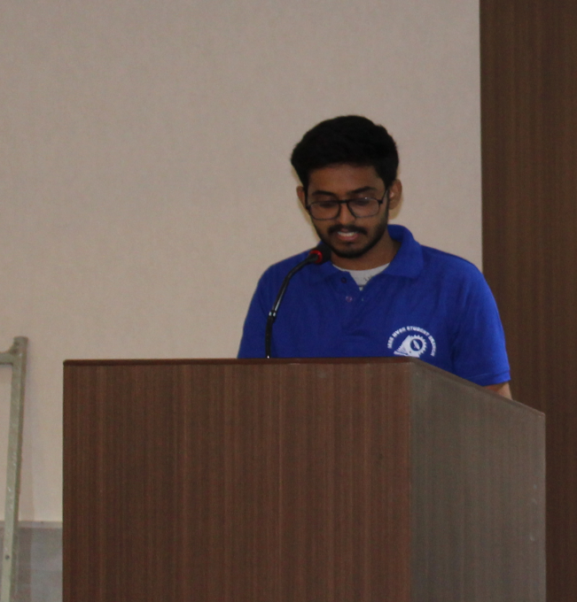
D.Siddhartha,IEEE MVSR CASS chair addressing the gathering
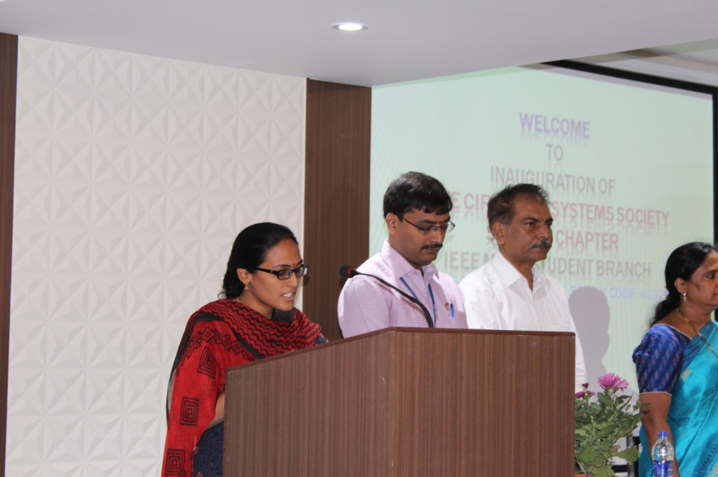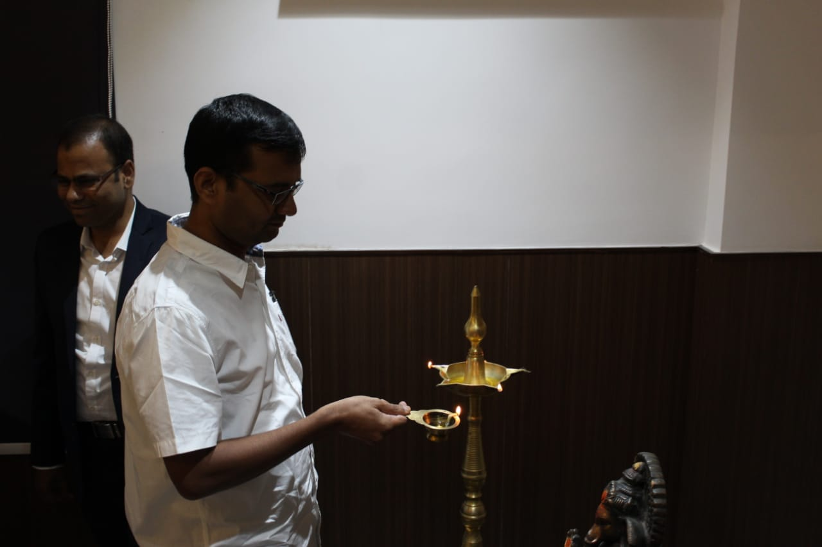
Prayer song by Mrs. Deepthi, Asst.prof,ECE Department and Chief guest Dr. Arifuddin Sohel and Dr.P.Vijay Shankar lighting the lamp

Later, Mr. Dr.S.P Venu Madhava Rao, Head ,ECE Department addressed the gathering. He thanked our chief guests for accepting the invitation and spending their precious time in acknowledging the importance of Circuits and Systems Society.

Next, our IEEE-CASS Advisor Mrs.S.Aruna spoke about the Importance of IEEE-CASS
After which, Dr. Hari Krishna, IEEE MVSR SB Student Branch Counsellor shared his views with the students. He was glad that his students, with their hard work and dedication has initiated and formed a new society under IEEE. and CASS to the students in developing their career, followed by Mr. Ashwini Kumar, student branch advisor, IEEE MVSR SB. He promised to give all the support required and encouraged other students to join and work for IEEE. He explained the benefits and advantages of IEEE. The chief guests released the IEEE-CASS Welcome note and handed it over to the faculty and IEEE chair.

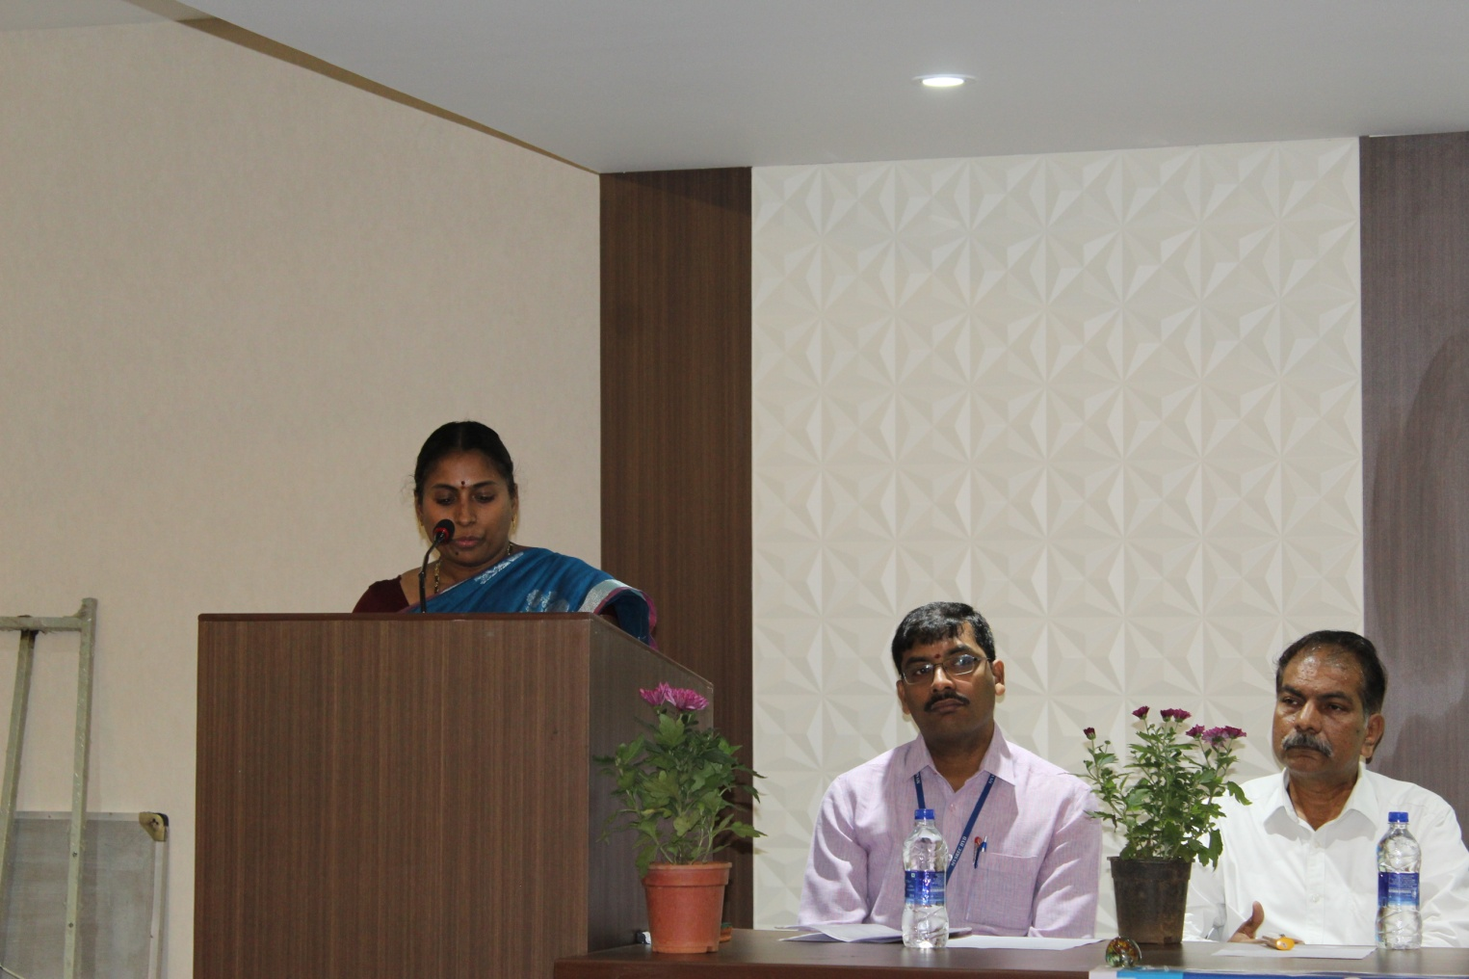
IEEE-CASS advisor addressing the gathering.

Dr.G.Kanaka Durga ,Principal, MVSR Engineering College, on this occasion appreciated the students for actively conducting events and initiating a new society under IEEE. She extended her gratitude towards the guests and expressed her happiness for sharing their knowledge with the students.
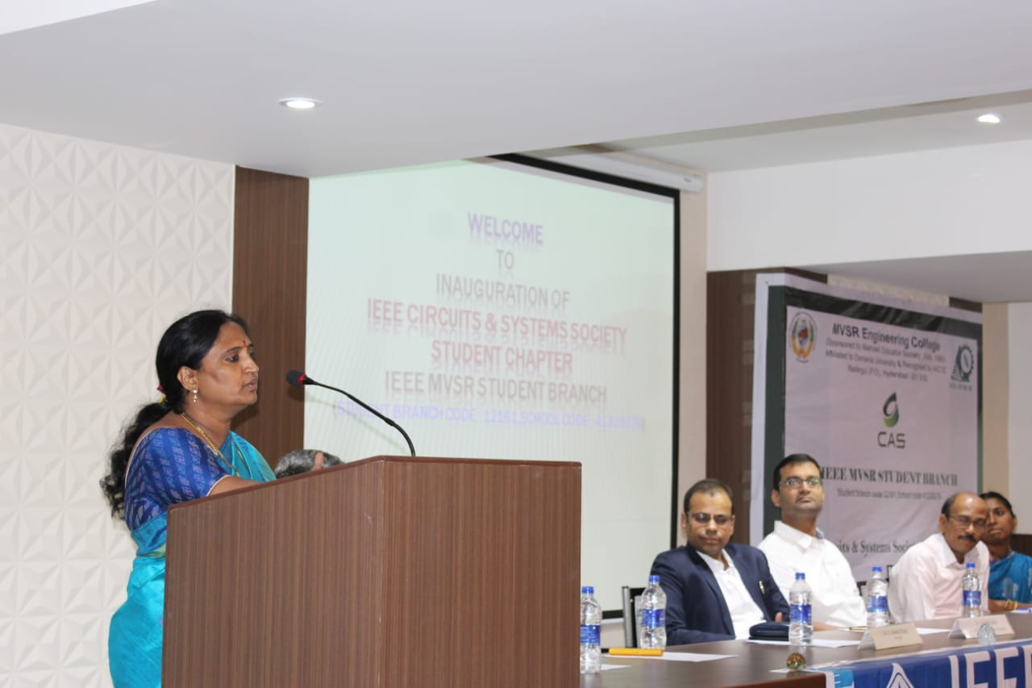
Dr. G. Kanaka Durga, principal,MVSR Engineering college addressing the gathering

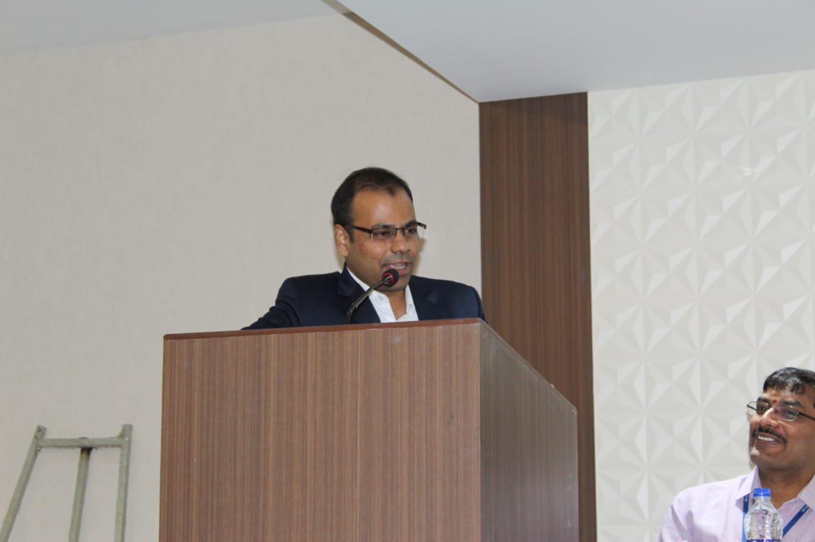
Dr. Arifuddin Sohel addressing the gathering

Later on, Dr. Arifuddin Sohel was requested to address the students. He firstly congratulated all the Volunteers and Student Branch members for taking a step forward and initiating the new society in the Student Branch. He mentioned all the advantages we gain through Circuits and Systems Society and also suggested to take up events which would encourage research in New Technologies. He told the students to utilize their best potentials for the improvement of curricular and co-curricular activities.

In this regard, IEEE-CASS will provide a platform for improving the knowledge, skills and abilities of both students and professionals. He further mentioned the importance for being a part of this society. He motivated students to sharpen their skills by taking part actively in such events and learn new things. Also, He explained about all the resources available and that can be utilized at this platform. All the students got to know how IEEE and CASS help them in future endearments.

Further, it was followed by the interaction of Dr. P Vijaya Shankar Rao. He congratulated students for forming a new society and talked about the objectives of IEEE- CASS. He gave many ideas and techniques on how to conduct events in a quality manner. He discussed about latest technologies in the field of Circuits and Systems Society and explained its role in our college curriculums and how we can develop further in it to work on. Students felt keen to know about advanced technologies in today’s world. He advised students to work on these areas under CASS. He further said that IEEE CASS chapter will benefit the students in their academic education. He also said that in the era of evolution, IEEE CASS is the need of the hour. In this regard, every initiative will be taken for the betterment of the students and professionals of the Electronic and Communication Engineering. He assured his support in all means of possibility to the society.

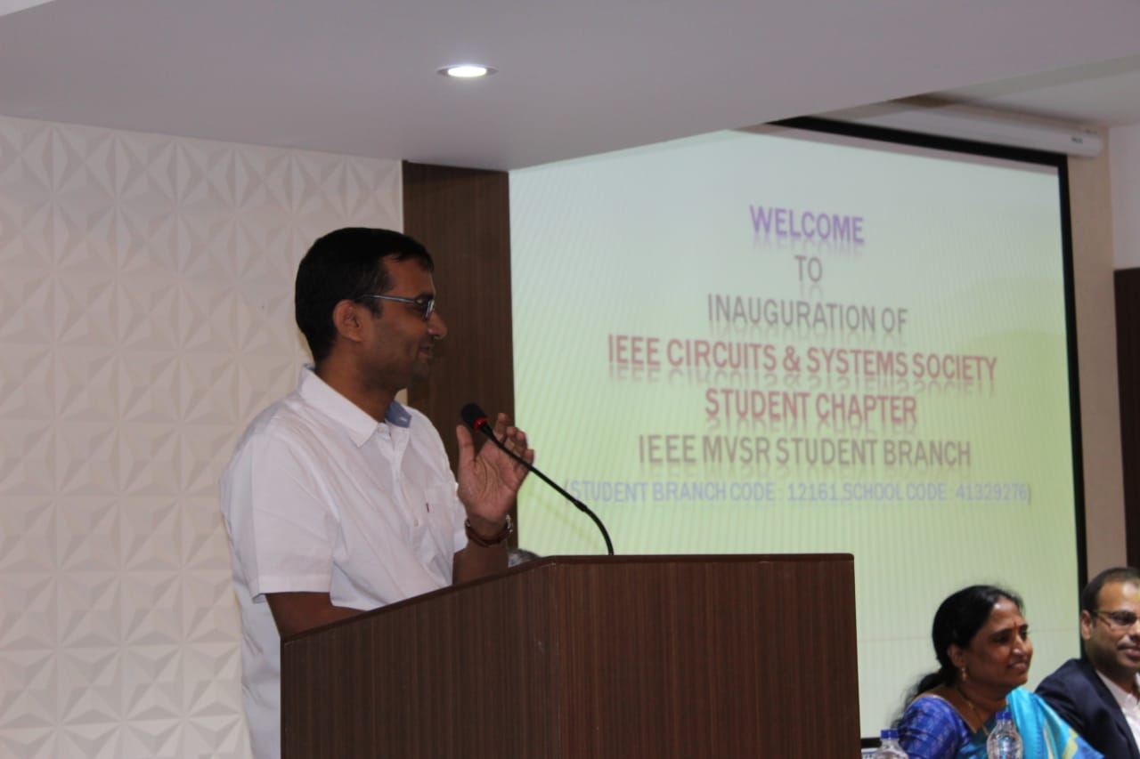
Dr.P.Vijay Shankar guiding the students and members for successful working of IEEE-CAS

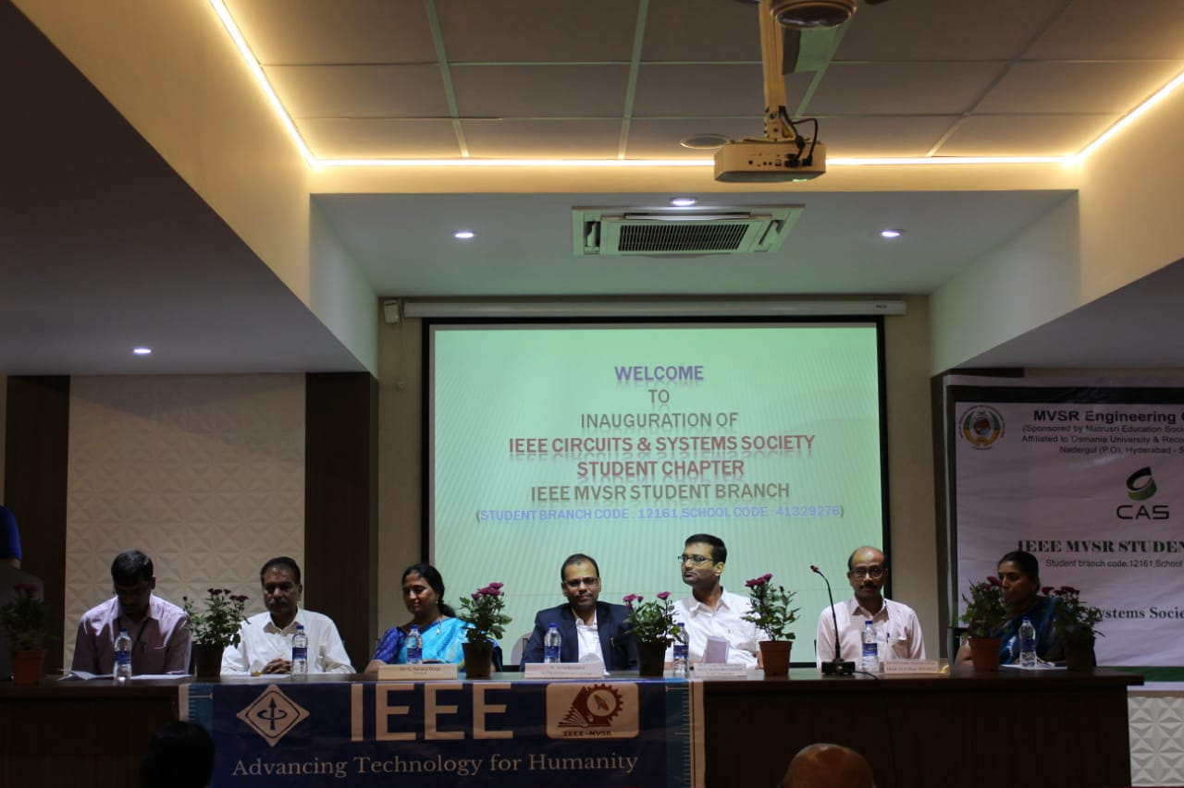
Dignitaries on the dais.

After the talks by honorable Guests, P.Shravya, Treasurer IEEE-CASS, has thanked all the guests for spending their valuable time with the students and share their knowledge to make them understand what Circuits and Systems Society is all about. She also thanked all the dignitaries on the dais, faculty and students for attending the inauguration and felicitated chief guest as a token of gratitude.

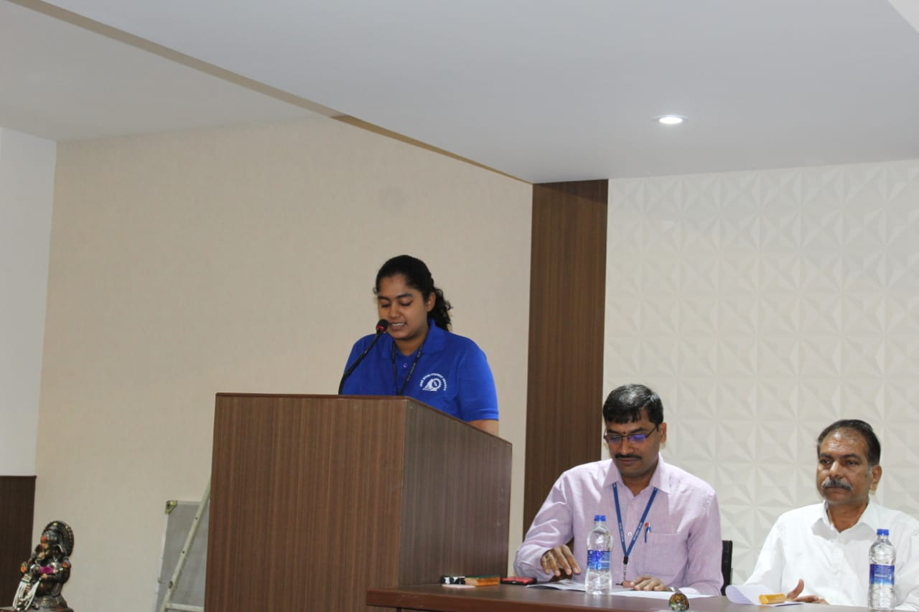
P.Shravya ,treasurer IEEE MVSR CASS delivering Vote Of Thanks.

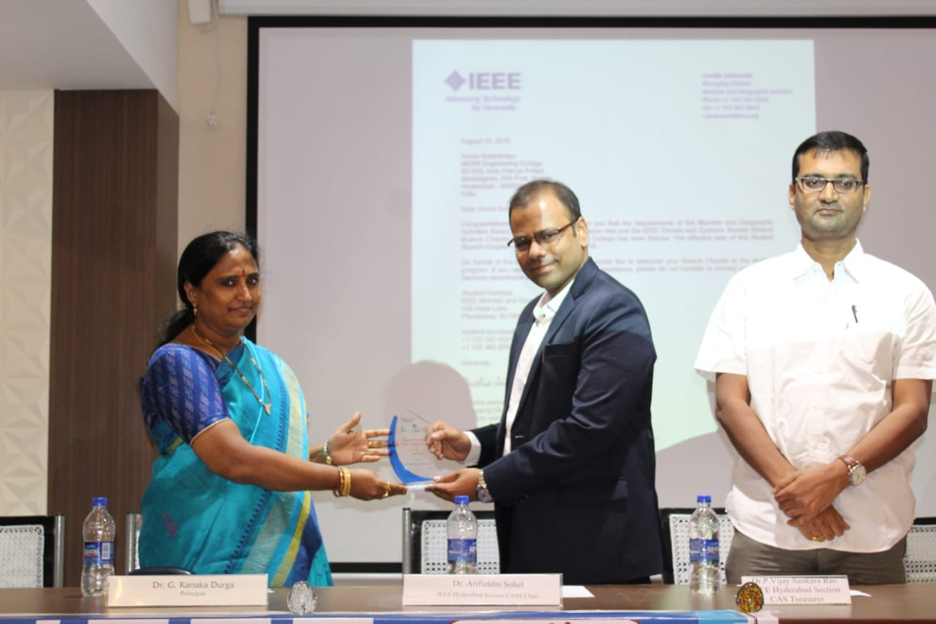

Principal presenting Memento to Dr. Arifuddin Sohel.

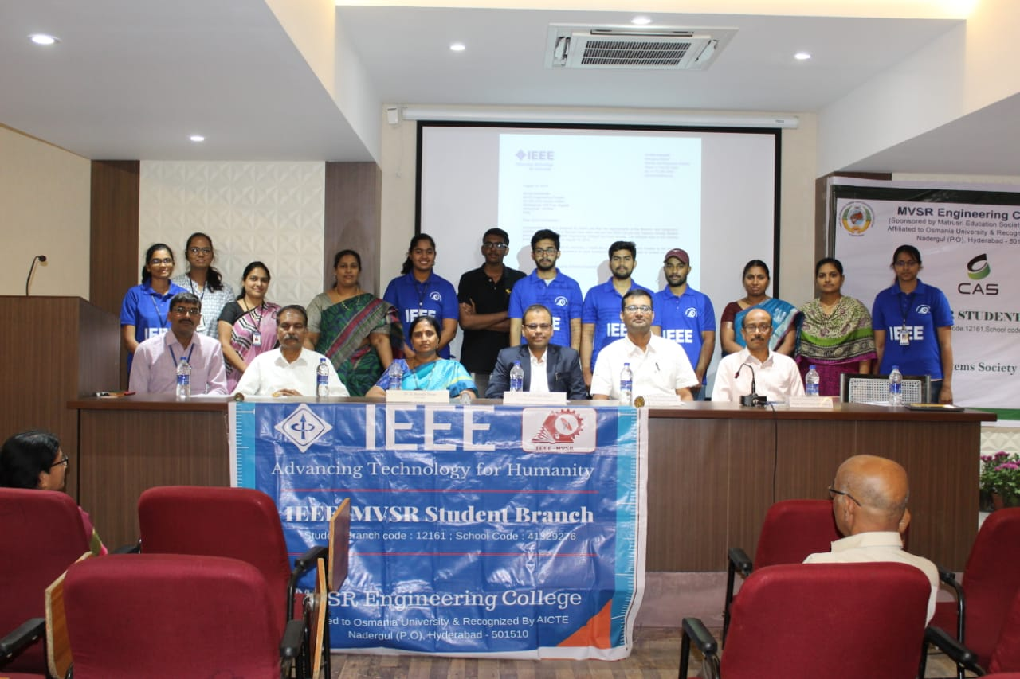
Executive Committee of IEEE MVSR SB with the dignitaries on the Dias

Reported by:
IEEE, MVSR SB.

