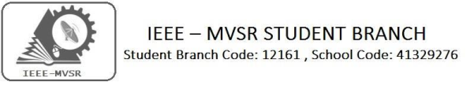

Helping Hands

On the occasion of Independence day we the volunteers of IEEE MVSR SB forming a team ahead had visited an Orphanage in B.N Reddy .The main motto is to educate the students about the ethics and moral values as well as about the importance of the day .

Student Branch Mentor: WIE Student Branch Advisor:

Dr.AtulNegi, Dr. G. Kanaka Durga,
Professor, School of CIS, Principal & Professor,
University of Hyderabad. MVSR Engineering College.
Student Branch Advisor: PES Advisor:
Mr.V.AshwiniKumar, Dr.D.HariKrishna,
Assoc.Professor,ITDept., Assoc.Professor,EEEDept.,
MVSR Engineering College. MVSR Engineering College.
CS Student Branch Advisor:
Mrs. B. Saritha,
Assoc. Professor, CSE Dept.,
MVSR Engineering College.
Student Branch Counsellor:
Dr. D. Hari Krishna,
Assoc. Professor, EEE Dept.,
MVSR Engineering College.

WIE Affinity Group:
A.Prathyusha - Chairman
M.Shresta Reddy - Vice Chair N.Sahitya - Secretary L.Ruthvika - Joint Secretary
Ruchitha Reddy - Treasurer

Student Branch Executive Committee:
R.Ramya Sri - Chairperson
K.Akshitha - Vice Chair
Shreya Maqtedar - Secretary
K.Vinay Kumar - Joint Secretary
V.Vineeth - Treasurer

Power Energy Society:
E.Pavan Kumar - Chair
K.Jaya Sree - Vice Chair
N.Avinash - Secretary
B.Nikitha Reddy - Joint Secretary
S.Satvikka - Treasurer

––

Computer Society:
S.Sai Teja - Chairperson
G.Suradhya - Vice Chair
M.Vamshi Krishna - Secretary
Phani Sahasra - Joint Secretary
V.Manikanta - Treasurer
Operating Committees:
P.Varun Kumar-Operating Committee Head
Ch.Jinesh- Publicity Committee Head
M V S S R Sahith Rao-Membership Committee Head
Sai Sameer & Hemish - Design Committee Head
M.Sai Sri Teja - Program Committee Head

Event details:

Date : 15th August 2019.
Time : 4:00 pm – 8:00 pm.
Venue: Safe Charitable Foundation, B.N.Reddy Nagar.

IEEE MVSR SB has taken an initiative to visit an orphanage named Safe Charitable Foundation and spend time with the children there and make our 73rd Indian Independence Day a memorable one. It is a non - profitable Organization, with 30 young girl students.

The initiation was taken by R. Ramya Sri Chairperson IEEE MVSR SB. The team volunteers organized and implemented the event successfully under her guidance. Our Student Branch Counsellor Dr. D. Hari Krishna joined with us.
The evening started with a warm welcome from the orphanage children and orphanage organiser Prasad Rao. Mr. Rao explained us how he manages and support the children in orphanage.

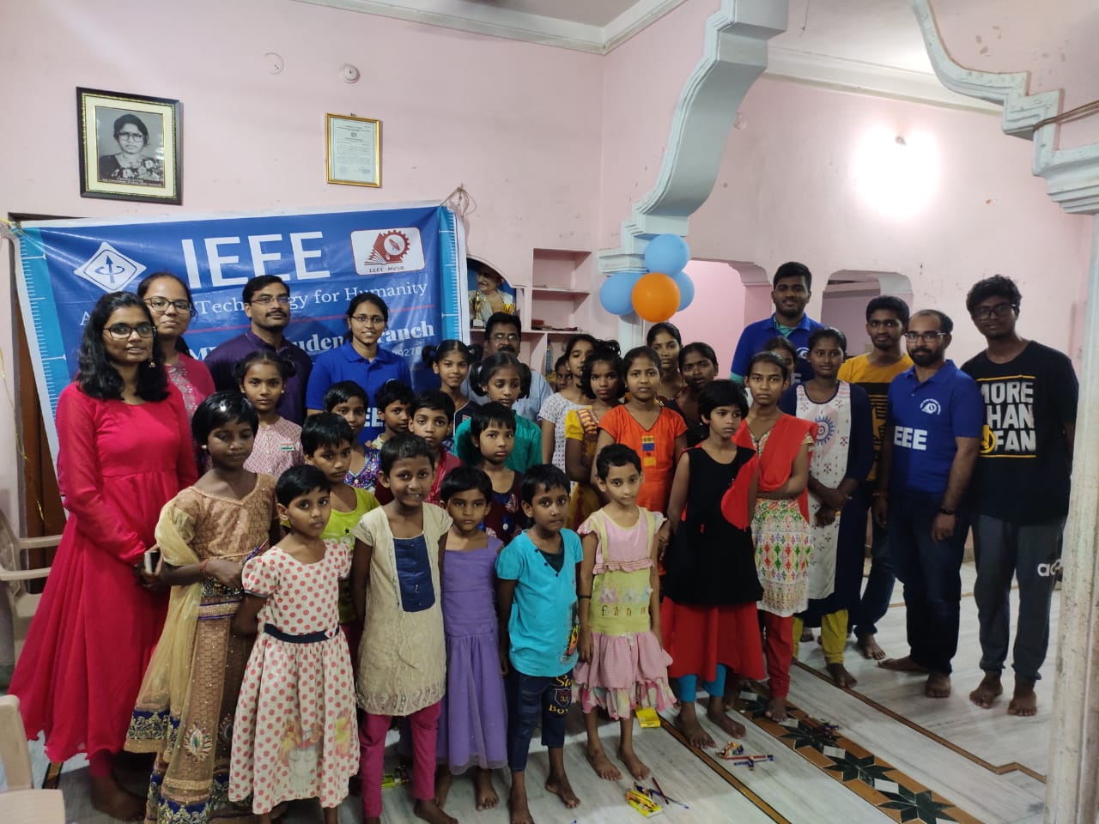
Group Photo of volunteers and orphanage children.

All the girls were full of enthusiasm. Everyone were friendly and communicative, as the day also coincides with the Festival Rakshabhandhan, which symbolizes the bond between brother and sister. All the volunteers and orphanage children tied rakhis to each other. All the children and volunteers expressed their happiness as they could celebrate this beautiful festival with one another.

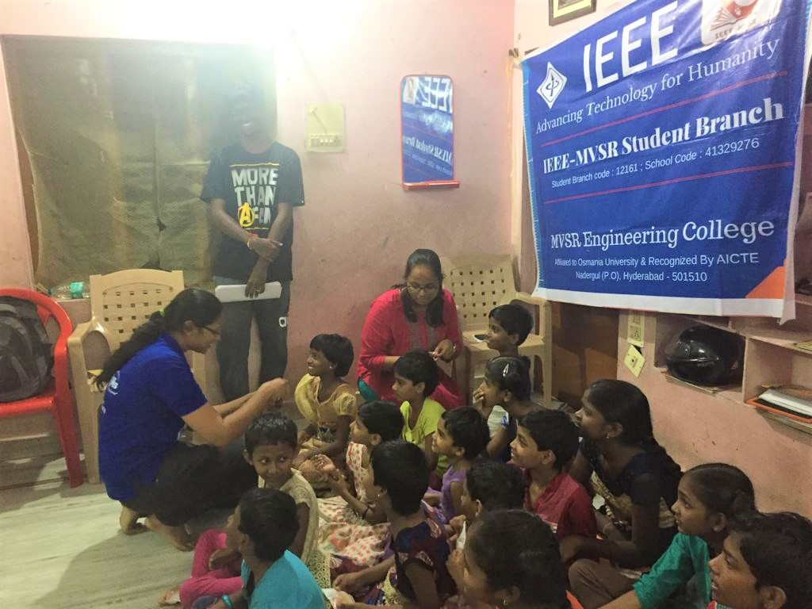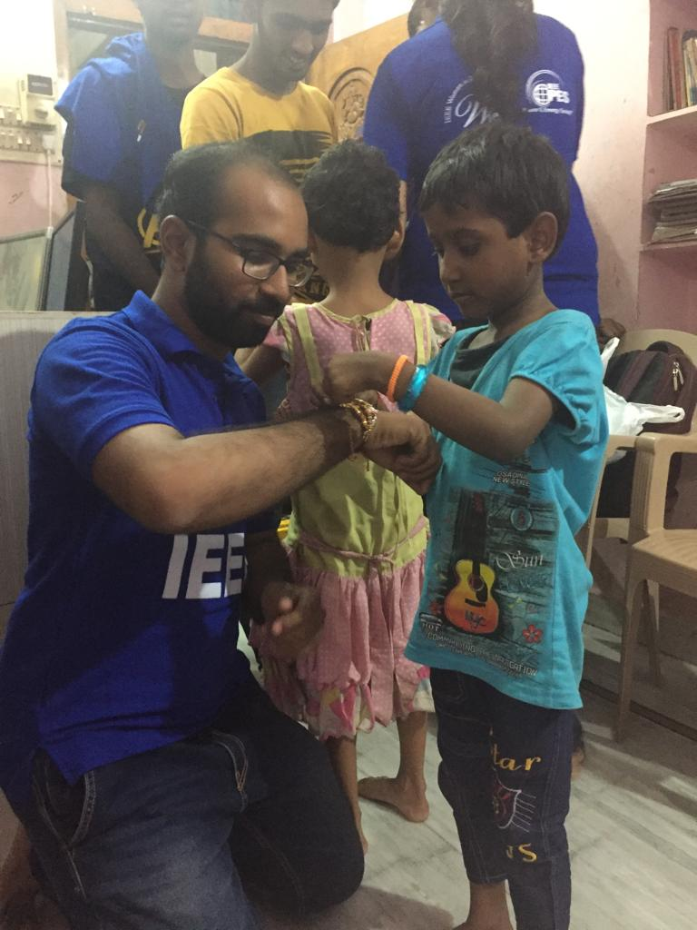
Volunteers and Orphanage girls exchanging Rakhis.

A painting competition was conducted, where every girl participated wholeheartedly. Even though we did not provide them with any specific theme, they took it on themselves to share their opinions on the burning issues of the society, like conserving water, trees and some depicted their outlook towards the Indian Independence Day. Although it was a tough choice, finally 3 paintings were selected as the best among all and prizes were distributed accordingly.

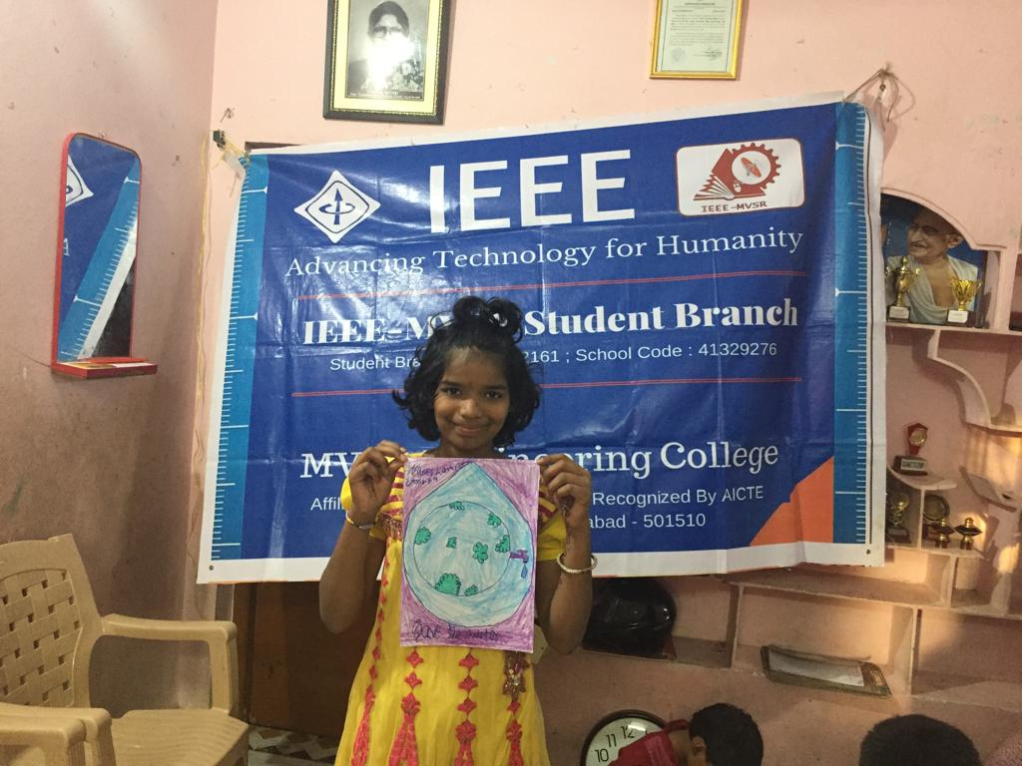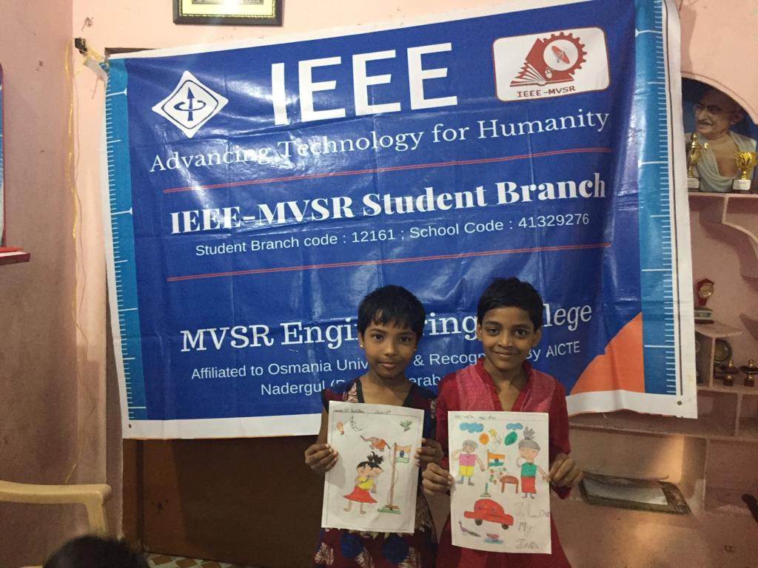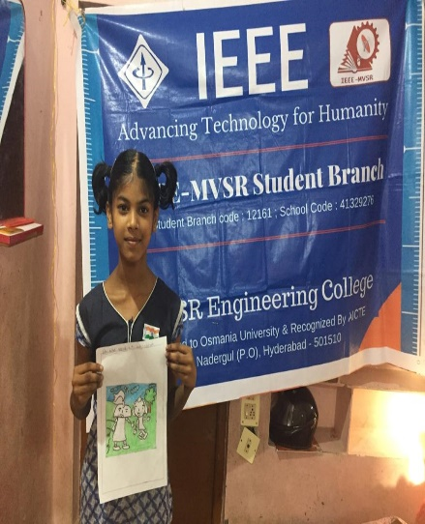Children presenting their paintings.
We distributed stationary to all girls including geometry boxes to girls from grade 7 and above.
Later we interacted with the girls, tried to understand their lifestyle, know the problems they are overcoming or facing daily. The girls were divided in to two groups and played Anthyakshari. Followed by dance performances.
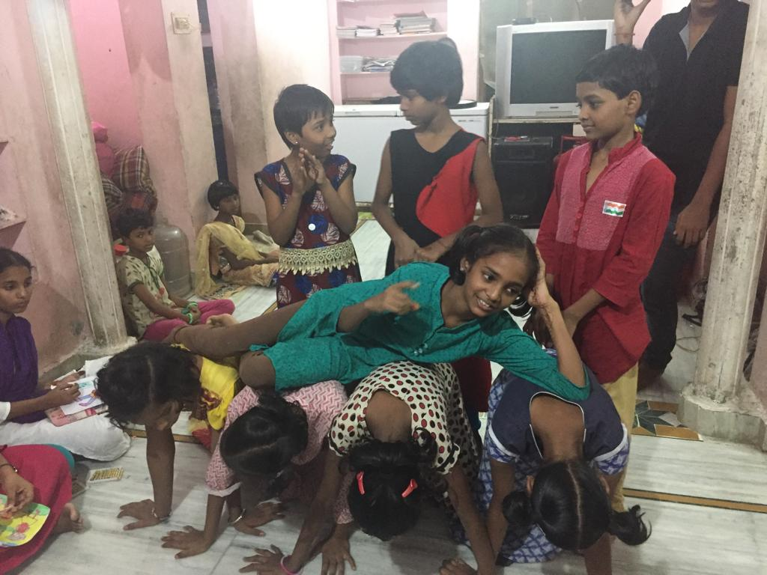
Children showing their dancing talent.

In the end ,we distributed chocolates and sweets to the children and sadly we bid a good bye to those energetic souls, but we were happy to meet them and had the chance to be one of the many reasons for their smiles.

Reported by:
IEEE MVSR SB.

