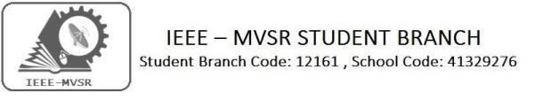
IEEE CS GENERAL BODY MEETING

IEEE MVSR SB Computer Society Student Chapter has conducted its general body meet on 19th September 2019.The aim of the meet was to create an interactive session for the members of IEEE CS and also encouraging them to come up with innovative ideas for further events planned to be organized by IEEE.

Student Branch Mentor:

Dr. AtulNegi,
Professor, School of CIS,
University of Hyderabad.

Student Branch Advisor:

Mr. V. Ashwini Kumar, Assoc. Professor, IT Dept., MVSR Engineering College.

PES Advisor:
Dr. D. Hari Krishna,
Assoc. Professor, EEE Dept.,
MVSR Engineering College.

Students Branch Executive Committee:

R. RamyaSree - Chairperson
K. Akshitha - Vice Chair
M. Shreya - Secretary
K. Vinay Kumar - Joint Secretary
V. Vineeth - Treasurer
P. Varun kumar-Operating committee Head

Computer Society:
S. Sai teja - Chair
G. Suradhya - Vice Chair
M. VamsiKrishna - Secretary
A. PhaniSahasra - Joint Secretary

V. Manikanta- Treasurer

Circuits and Systems Society:
D.Siddartha -Chair
K.Jaideep -Vice Chair
D.V.B Parthiv -Secretary
D.Venkat -Joint Secretary
P.Shravya -Treasurer
WIE Student Branch Advisor:

Mrs. Dr. G. Kanaka Durga,
Principal,
MVSR Engineering College.

Student Branch Counsellor:

Dr. D. Hari Krishna,
Assoc. Professor, EEE Dept.,
MVSR Engineering College.

CS student branch advisor:
Mrs. B. Saritha
Assoc. Professor, CSE Dept.,
MVSR Engineering College

CASS Student Branch Advisor:
Mrs. S. Aruna
Assoc. Professor, ECE Dept.,

MVSR Engineering College.

WIE Affinity Group:

A. Sai Pratyusha - Chairman
M. Shresta - Vice Chair
Sahithyanamani- Secretary

L. Ruthvika- Joint Secretary
R. Ruchitha - Treasurer

Power Energy Society:
E. PavanKumar - Chair
Jayasree k - Vice Chair

N. Avinash - Secretary
B.Nikita Reddy - Joint Secretary

S. Satvika - Treasurer

Operating Committees:
Ch. Jinesh- Publicity Committee
M.V.S.S.S.R Sahith-MembershipCommittee
V.Hemish& Y. Sai sameer - Design Committee

M. Sai Sri Teja- Program Committee
Session Details:
Date: 19th September 2019. Time: 12:30 pm – 02:00 pm.
Venue: CS 203, MVSR Engineering College. No. of students attended: 20
Agenda of the session:
To have a discussion on the following:
- Quantum computing
- IoT training
- Internships by SkillTern
- Internships by Virtual Labs
- Hands on session for Data Analytics
- IEEE Xtreme
- Technovanza
- MUN
- Satellite Events of HYDCON-2020
- Webinar
- Mentor-Mentee Programs

The meet aimed to create an interactive session for the members of IEEE CS and also encouraging them to come up with innovative ideas for further events planned to be organized by IEEE.

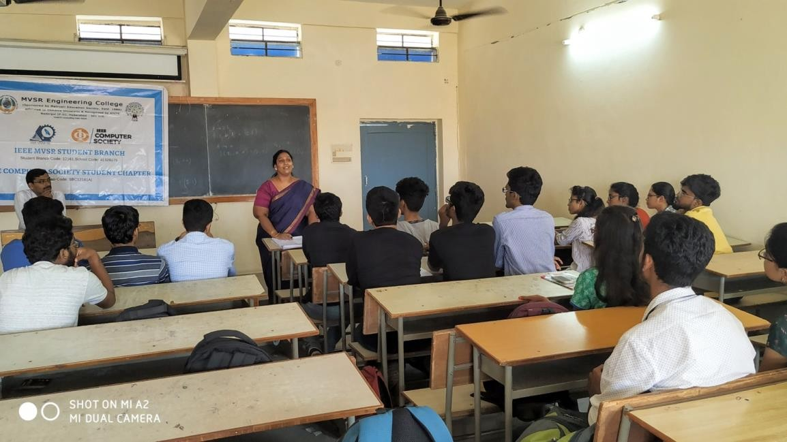
The session started by Dr.D.Hari Krishna, Student Branch Counselor, IEEE MVSR. Following which was a briefing given by Mrs B.Saritha, IEEE-CS-Advisor IEEE MVSR who discussed the future events that are to be organized by IEEE-CS, the IEEE Xtreme Event, internship by virtual labs, hands-on session for data analytics, internships by SkillTern. Furthermore, she explained to the students about how to use the IEEE website and the benefits of being an IEEE member, Special Interest Groups, IoT training and webinars by IEEE.
Mrs. B. Saritha (IEEECS-Advisor) interacting with the students.

P.Varun Kumar further explained to the students about Quantum Computing(Special Interest Groups), Satellite Events, Webinars and Mentor-Mentee Program by IEEE.
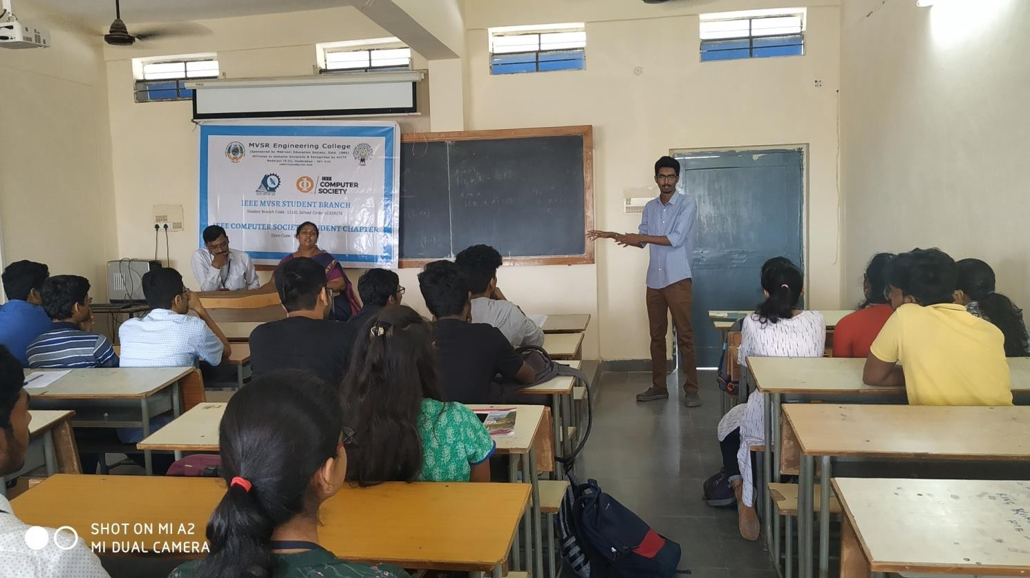
P.Varun Kumar (IEEE-Operations Committee Head) interacting with students.

Reported by:
IEEE MVSR SB.

