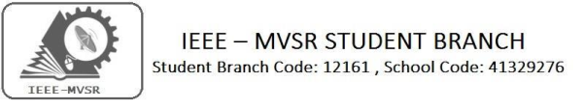

IEEE PES GENERAL BODY MEETING

IEEE MVSR SB - Power and Energy Society had conducted General Body Meeting on 6th July 2019. The aim of the Session was to plan the upcoming events in power and energy society of student branch and how to improve the IEEE memberships in MVSREC.

StudentBranchMentor: WIEStudentBranchAdvisor:

Dr.AtulNegi, Dr. G. Kanaka Durga,
Professor, School of CIS, Principal & Professor,
University of Hyderabad. MVSR Engineering College.
StudentBranchAdvisor: PES Advisor:
Mr.V.AshwiniKumar, Dr.D.HariKrishna,
Assoc.Professor,ITDept., Assoc.Professor,EEEDept.,
MVSR Engineering College. MVSR Engineering College.
CS Student Branch Advisor:
Mrs. B. Saritha,
Assoc. Professor, CSE Dept.,
MVSR Engineering College.
Student Branch Executive Committee:
R.Ramya Sri - Chairperson
K.Akshitha - Vice Chair
Shreya Maqtedar - Secretary
K.Vinay Kumar - Joint Secretary
V.Vineeth - Treasurer

StudentBranchCounsellor:
Dr. D. Hari Krishna,
Assoc. Professor, EEE Dept.,
MVSR Engineering College.

WIEAffinityGroup:
A.Prathyusha - Chairman
M.Shresta Reddy - Vice Chair N.Sahitya - Secretary L.Ruthvika - Joint Secretary
Ruchitha Reddy - Treasurer

Power Energy Society:
E.Pavan Kumar - Chair
K.Jaya Sree - Vice Chair
N.Avinash - Secretary
B.Nikitha Reddy - Joint Secretary
S.Satvikka - Treasurer

––

Computer Society:
S.Sai Teja - Chairperson
G.Suradhya - Vice Chair
M.Vamshi Krishna - Secretary
Phani Sahasra - Joint Secretary
V.Manikanta - Treasurer
Operating Committees:
P.Varun Kumar-Operating Committee Head
Ch.Jinesh- Publicity Committee Head
M V S S R Sahith Rao-Membership Committee Head
Sai Sameer & Hemish - Design Committee Head
M.Sai Sri Teja - Program Committee Head

Session details:
Date: 6th July 2019.
Time: 10:00am – 12:00 noon.
Venue: QEEE HALL, MVSR Engineering College.

The Power and Energy Society of IEEE MVSR Student Branch has conducted General Body Meeting. The meeting was initiated by the student branch counsellor Dr. D. Hari Krishna, congratulating the PES executive committee members.

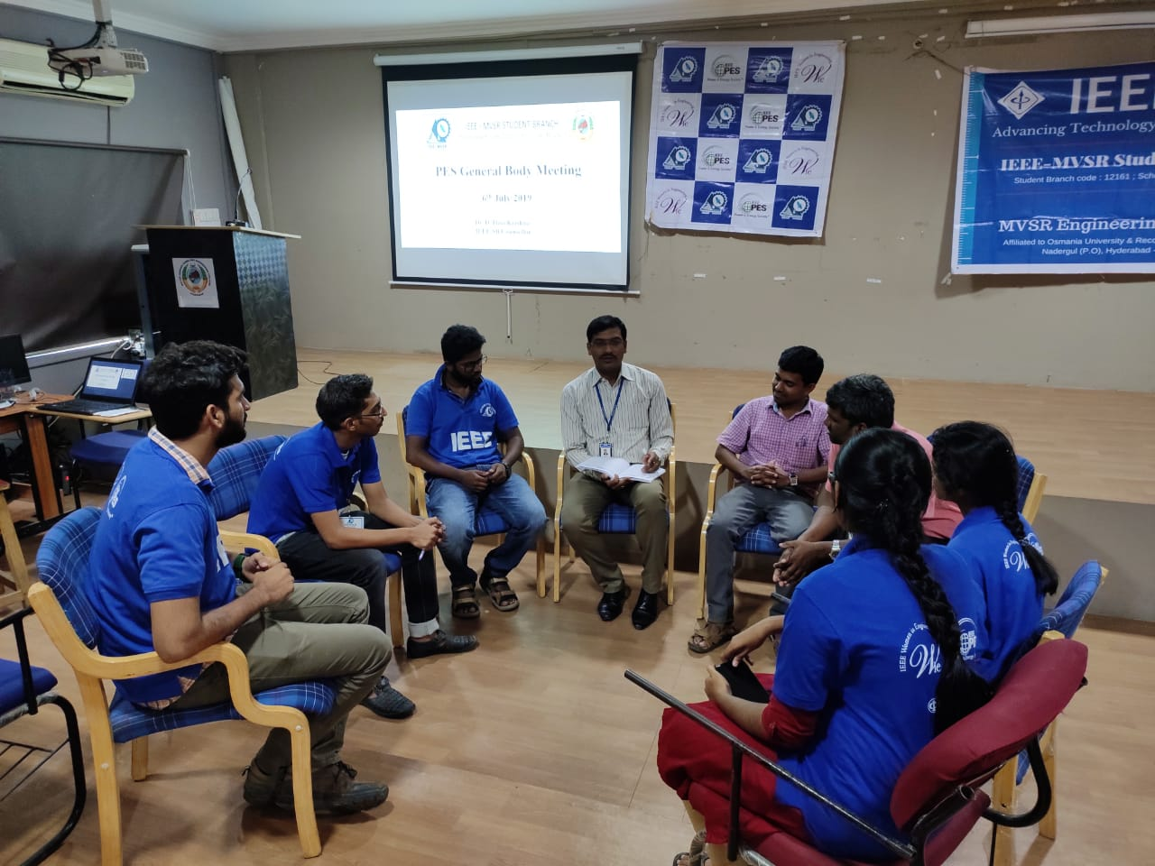
Dr. D. Hari Krishna giving his insights to the Executive Committee Members.

Dr D. Hari Krishna has informed all the members to plan some quality events and increase the IEEE membership. He also shared about the Student Section Congress 2019(SSC) to be held on 10th August 2019.

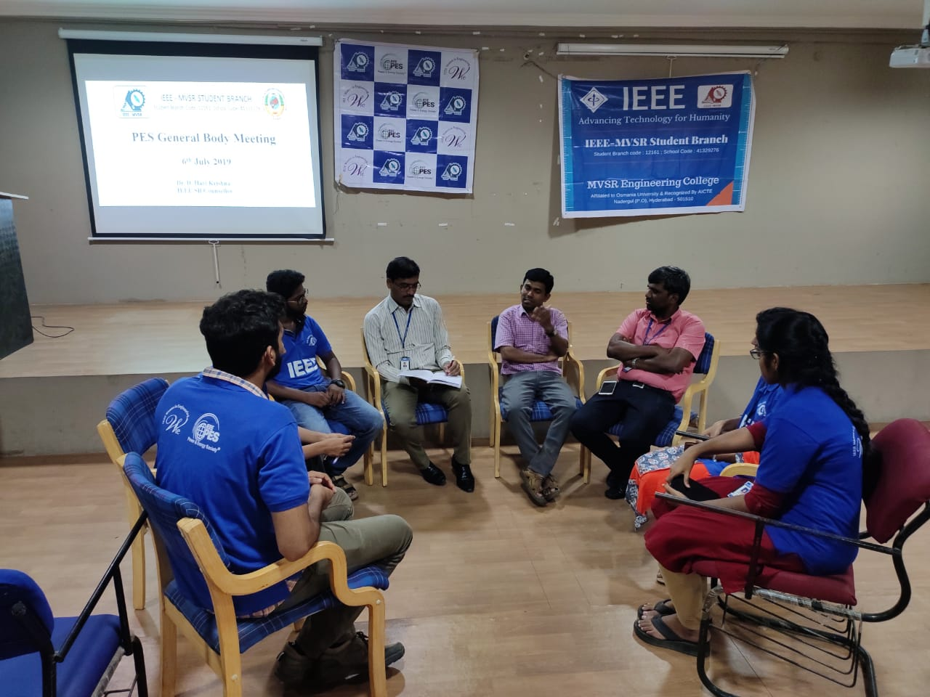
Dr. More Raju explaining the importance of IEEE.

Dr. More Raju, IEEE faculty coordinator explained about the advantages of IEEE, being an IEEE member and its key role in long run.

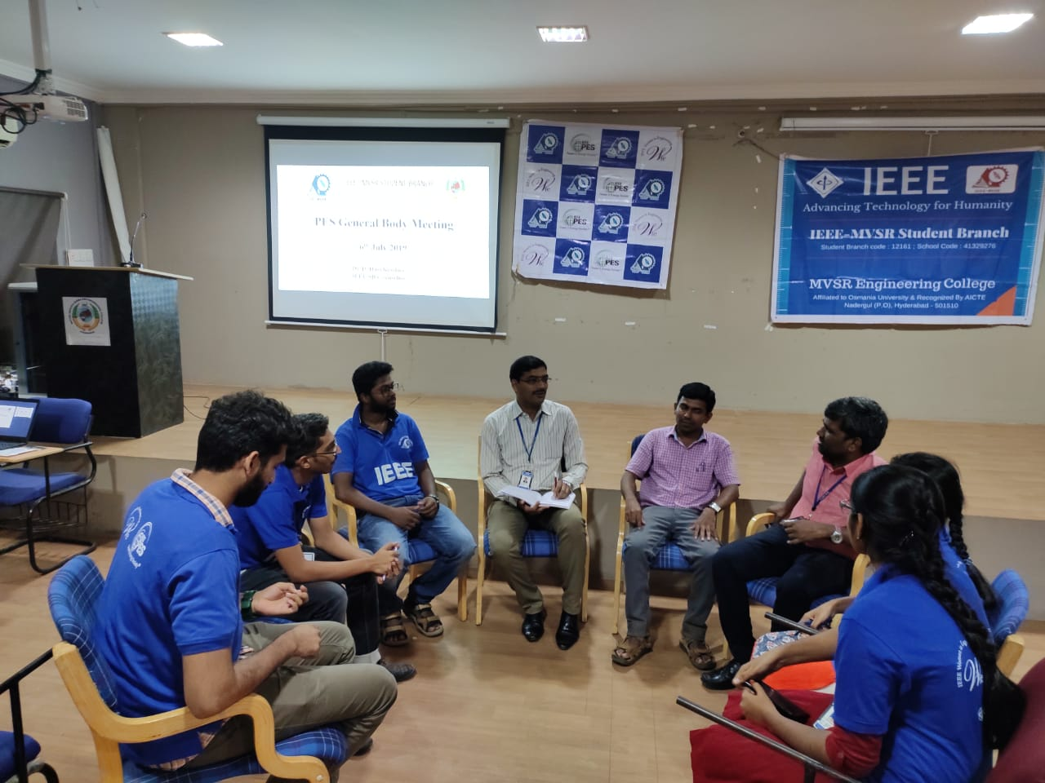
Mr. I. N .Swamy, shared his own experience in IEEE

Mr. I. N .Swamy, IEEE faculty coordinator shared his own experience in IEEE and explained about its importance of IEEE resources.

Then there was a conversation among the members to plan quality events such as competitions, workshops, presentations and field visits. The meeting also discussed about the role of members in strengthening the IEEE MVSR SB by increasing the memberships which would of course help all the members in their bright futures. To increase the usage of IEEE resources by sharing knowledge to member on how to use IEEE website and resources.

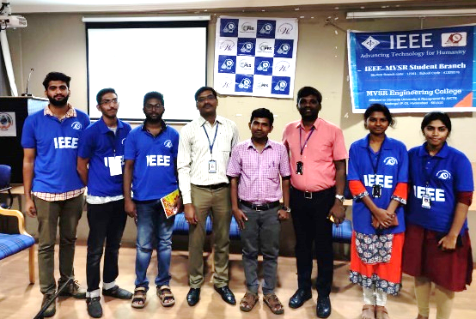

Finally, the session ended with a group photo of SB counsellor, faculty coordinators and PES EXCOM students.

There were some resolutions in the PES general body meeting of IEEE MVSR SB:
- To conduct some quality events.
- To increase the membership and strengthening the student branch.
- To increase usage of IEEE resources by members.

Reported by:
IEEE MVSR SB.

