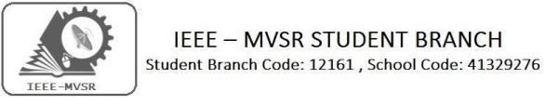
WORKSHOP ON POWER ELECTRONICS APPLICATION IN RENEWABLE ENERGY USING MATLAB AND IOT

IEEE MVSR Student Chapter Power and Energy Society (PES) in association with EEE department has conducted a Three Day Workshop on Power Electronics Application in Renewable Energy using MATLAB and IOT from 19th September 2019 to 21st September 2019.The main motto is to promote innovation and to provide new ideas to the faculty and students.
Student Branch Mentor:

Dr. Atul Negi,
Professor, School of CIS,
University of Hyderabad.

Student Branch Advisor:

Mr. V. Ashwini Kumar, Assoc. Professor, IT Dept., MVSR Engineering College.

PES Advisor:
Dr. D. Hari Krishna,
Assoc. Professor, EEE Dept.,
MVSR Engineering College.

Student Branch Executive Committee:

R. Ramya Sri - Chairperson
K. Akshitha - Vice Chair
M. Shreya - Secretary
K. Vinay Kumar - Joint Secretary
V. Vineeth - Treasurer

Computer Society:
S. Sai Teja - Chair
G. Suradhya - Vice Chair
M. Vamsi Krishna - Secretary
A. Phani Sahasra - Joint Secretary

V. Manikanta- Treasurer

Circuits and Systems Society:
D.Siddartha -Chair
K.Jaideep -Vice Chair
D.V.B Parthiv -Secretary
D.Venkat -Joint Secretary
P.Shravya -Treasurer
WIE Student Branch Advisor:

Mrs. Dr. G. Kanaka Durga,
Principal,
MVSR Engineering College.

Student Branch Counsellor:

Dr. D. Hari Krishna,
Assoc. Professor, EEE Dept.,
MVSR Engineering College.

CS student branch advisor:
Mrs. B. Saritha
Assoc. Professor, CSE Dept.,
MVSR Engineering College

CASS Student Branch Advisor:
Mrs. S. Aruna
Asst. Professor, ECE Dept.,

MVSR Engineering College.

WIE Affinity Group:

A. Sai Pratyusha - Chairman
M. Shresta - Vice Chair
Sahithya namani- Secretary

L. Ruthvika- Joint Secretary
R. Ruchitha - Treasurer

Power Energy Society:
E. PavanKumar - Chair
Jayasree k - Vice Chair

N. Avinash - Secretary
B.Nikita Reddy - Joint Secretary

S. Satvika - Treasurer

Operating Committees:
P. Varun Kumar-Operating committee Head
Ch. Jinesh- Publicity Committee
M.V.S.S.S.R Sahith-Membership Committee
V. Hemish& Y. Sai Sameer - Design Committee

M. Sai Sri Teja- Program Committee
Session detail:

Dates : 19th September 2019, 20th September 2019, 21st September 2019.

Time : 9.30 am–4.00 pm.
Venue: CAED Lab, EEE Department, MVSR Engineering College.

No. of students attended: 50

Resource persons for the Workshop were from the PANTECH SOLUTIONS.
DAY-1: The session began with brief introduction regarding the workshop program by Mr. C V Gopala Krishna Rao, HOD of EEE Department and Mr. G.Satyanarayana, Assistant Professor of EEE Department. Later the session was handover to Mr. Aravindha Swamy, trainer of Simulink from Pantech Solutions.
Mr. Aravindha Swamy started the program with a power point presentation on various power electronics devices and its applications, then he gave a brief description of MATLAB. He explained about all the tools and how to create a Simulink model in MATLAB.
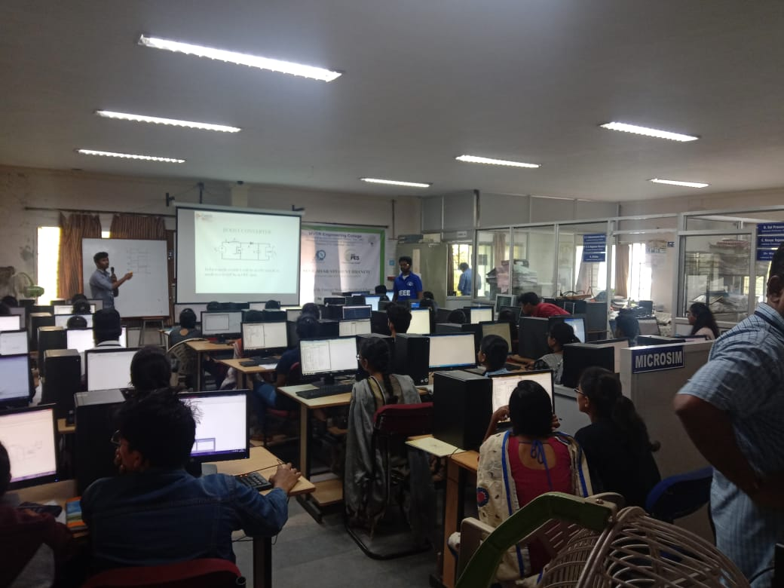
Mr. Aravindha Swamy, trainer, explaining various circuits to the students.
Later, various circuits like single phase inverter, boost converter, boost converter with pi controller, Fuzzy logic, three phase inverter were explained by the trainer. The other Pantech trainers also helped the students to design the above circuits using Simulink. Students have created the above models and checked the output.
DAY-2:
The session began with a PowerPoint presentation on the Renewable Energy System by Mr. Aravindha Swamy. The Solar Panel model was explained and designed by the trainer. The students were thought to design solar panel models with the help of other trainers. Then, the multilevel inverter was designed by all the students. Now, the solar panel model is interfaced with multilevel inverter and output voltage, output waveforms are observed.
In the afternoon session, a wind turbine was created using Simulink. Later a Hybrid Connection was developed using the designed solar and wind models. Then a task was given to all the students by Mr. Aravindha Swamy. Mr. Swamy encouraged the students to perform the task well.
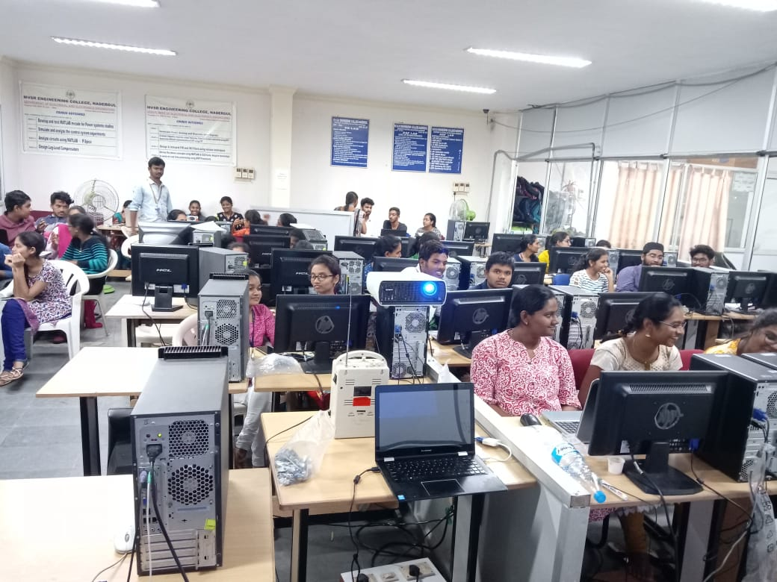
Students performing the task given by the Trainer
DAY-3:
The session was taken over by Miss. Hema Rani, a trainer from Pantech Solutions on the day 3. She introduced about, Arduino Controller and IOT to the students through a PowerPoint presentation. She explained the codes used for the application of IoT. Different codes were developed to check how to turn ON/OFF a LED. This was extended for two and three LEDS. Later, code was generated to control the Motor speed and a buzzer was connected to check the speed control. There is a Valedictory Function at the end of Day 3.
Valedictory:
The gathering was addressed by Mr.Y.Lakshmi Narasimha Rao, Assistant Professor of EEED. He gave a brief description regarding the topics discussed in workshop. Mr. C V Gopala Krishna Rao, HOD of EEE Department, Dr. G. Kanaka Durga, Principal of MVSREC, and Mr. Aravindha Swamy were called on to the dais and Saplings were presented to them.
Later, the HOD of EEED discussed the outcomes of the workshop and encouraged the students to explore in their field.

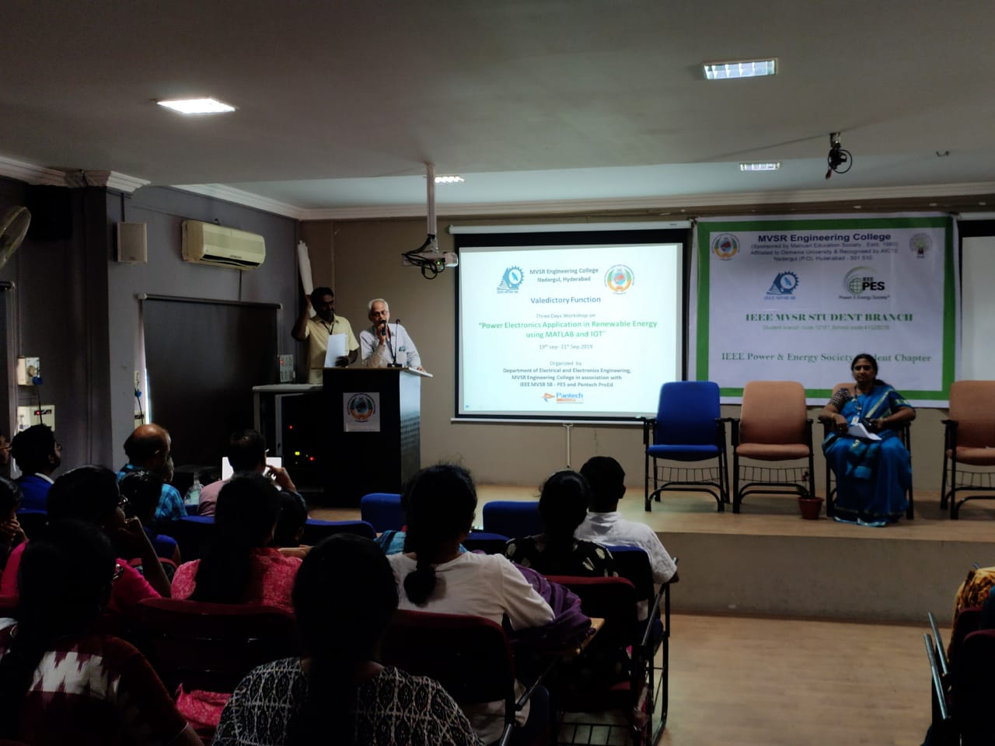
Mr. C V Gopala Krishna Rao, HOD of EEE Department, addressing the students.

Later, the Principal of MVSREC, Dr. G. Kanakadurga was requested to address the gathering.
Dr. G. Kanakadurga encouraged the faculty to conduct many workshops like this and congratulated everyone for conducting the workshop successfully.

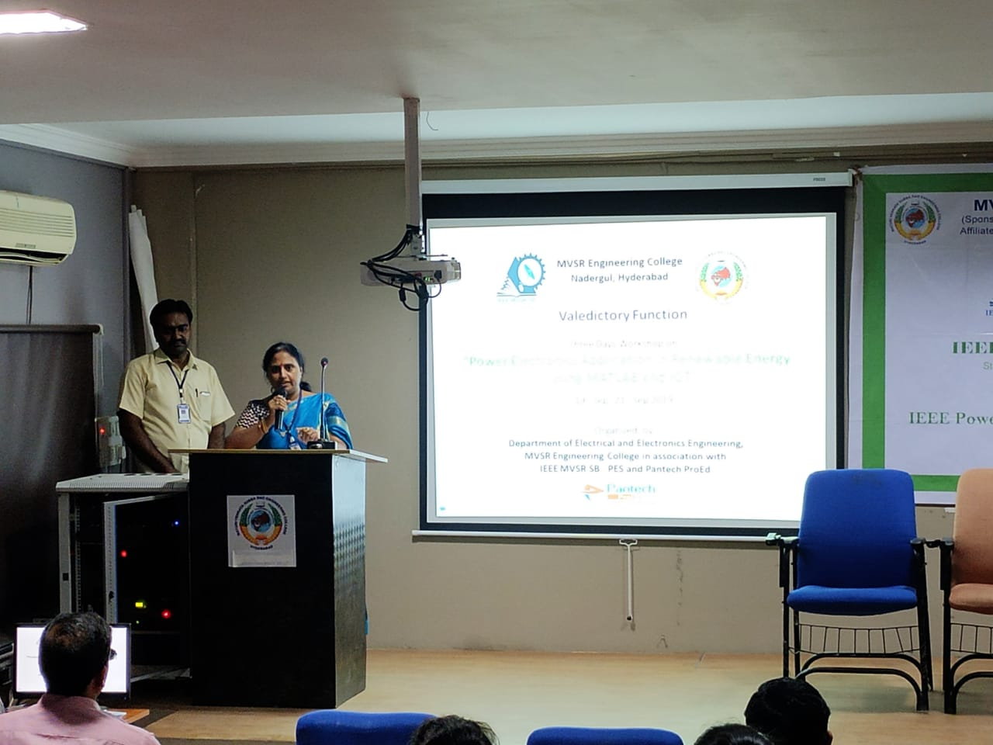

Dr.G.Kankadurga, principal of MVSREC congratulating the faculty and Pantech Solutions team.
Later, Mr. Aravindha Swamy was requested to talk few words. He gave few suggestions to students how to develop their skills in MATLAB.

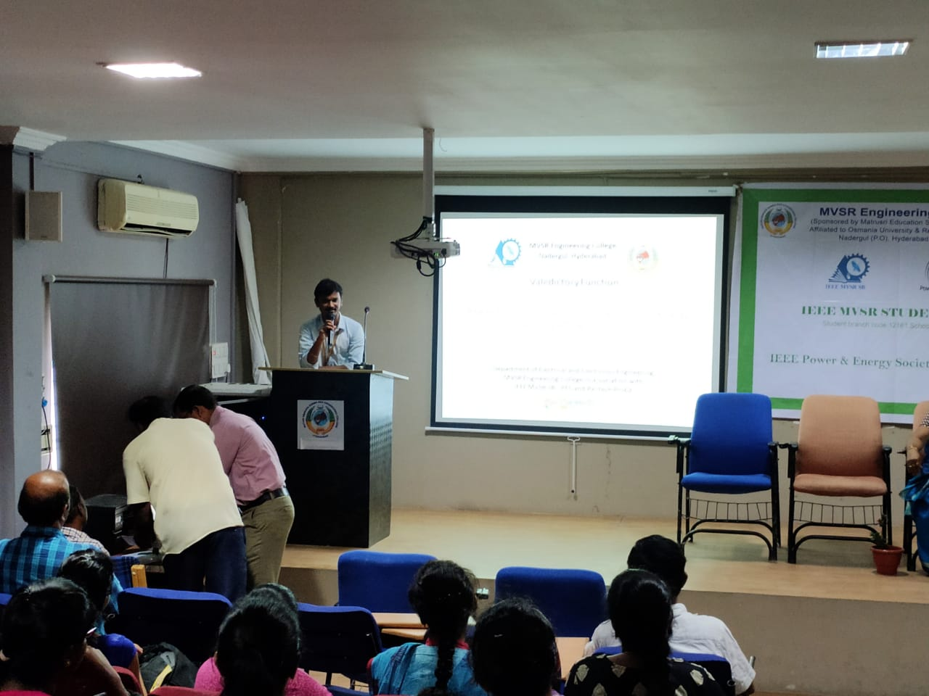
Mr. Aravindha Swamy, trainer from Pantech Solutions addressing the students.

Then, Mementos were presented to the Pantech Solution Trainers by the principal of MVSREC.

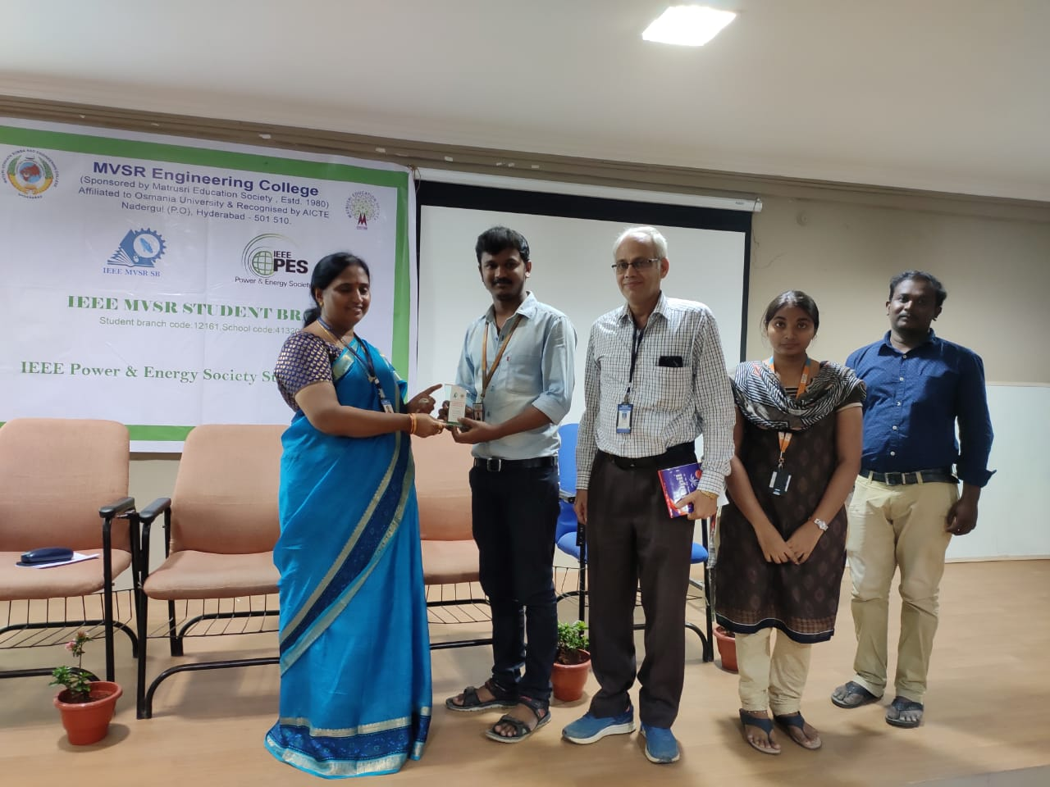

Presentation of Memos to Pantech Trainers by the principal.
The feedback is taken from the students regarding workshop and certificates were distributed to them by the principal and HOD of EEED. Finally, session ended with the group pic.

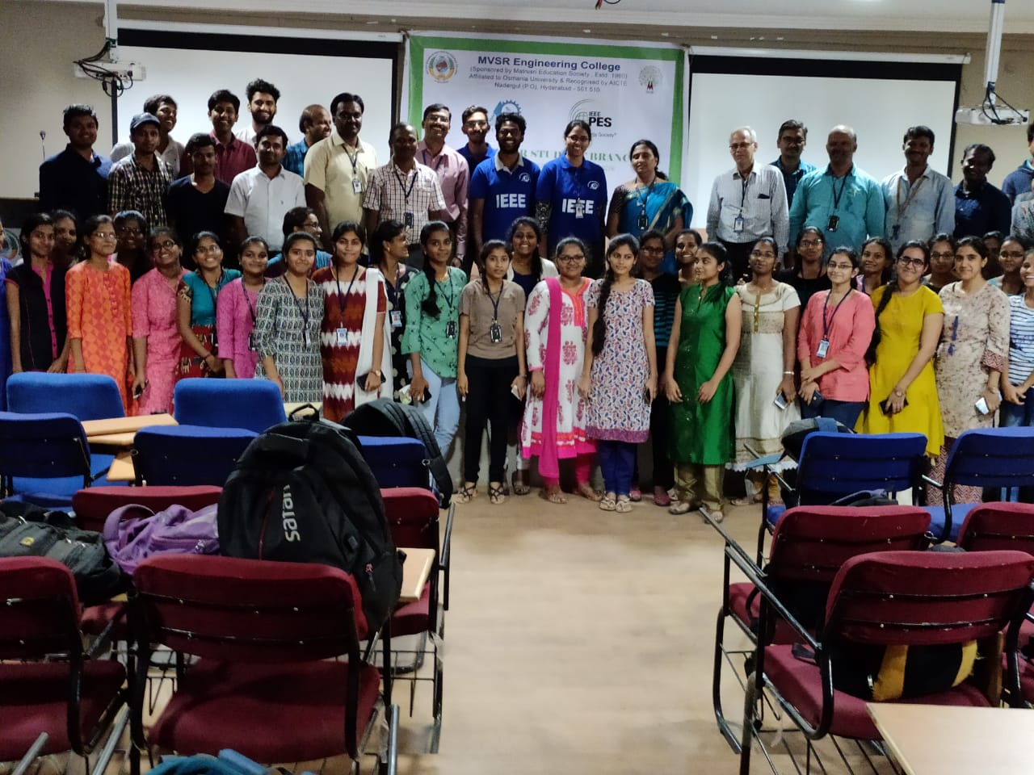

Group pic with the volunteers, students and faculty coordinators participated in workshop.

The session was concluded by Mr. Y. Lakshmi Narasimha Rao by giving Vote of Thanks.

Reported by:
IEEE MVSR SB.

